Data Supplement
Figure A1: Adjusted predictions (with 95% C.I.) of being treated, age*gender*deprivation interaction, at the means of nationality and pre-existing health conditions.
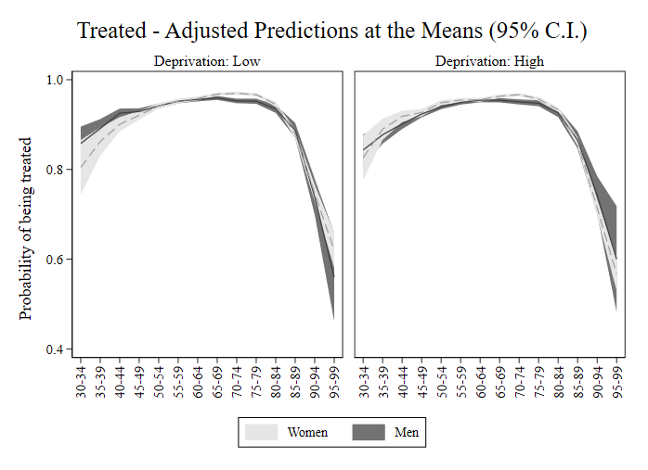
Figure A2: Adjusted predictions (with 95% C.I.) of being in therapeutic compliance, age*gender*deprivation interaction, at the means of nationality and pre-existing health conditions.
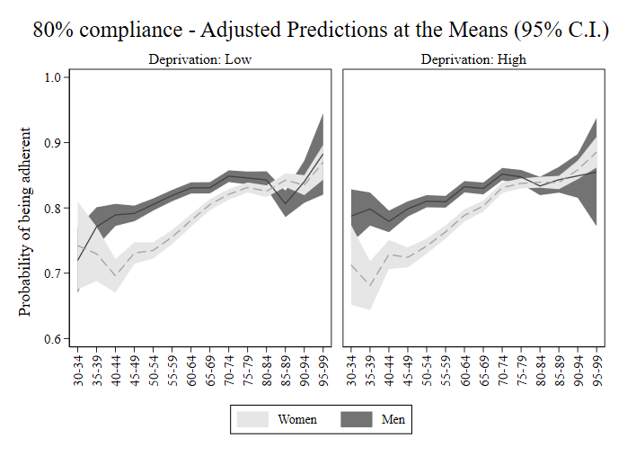

Figure A3: Adjusted predictions (with 95% C.I.) of death from all causes, age*gender*deprivation interaction, at the means of pre-existing health conditions and therapeutic compliance.
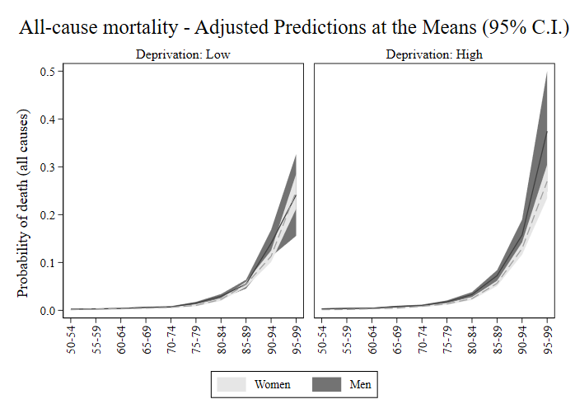

Figure A4: Adjusted predictions (with 95% C.I.) of death from CVDs, age*gender*deprivation interaction, at the means of pre-existing health conditions and therapeutic compliance.
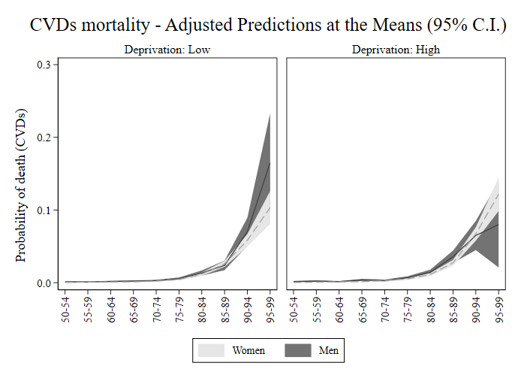

Figure A5: Adjusted predictions (with 95% C.I.) of death from all causes, age*gender*compliance interaction, at the means of deprivation index and pre-existing health conditions.
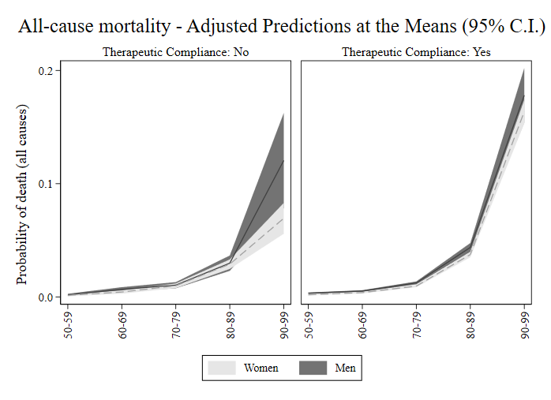

Figure A6: Adjusted predictions (with 95% C.I.) of death from CVDs, age*gender*compliance interaction, at the means of deprivation index and pre-existing health conditions.
