Supplementary Tables and Figures

Title: Endurance rivalry and female choice jointly influence male mating success in the emerald treefrog (Zhangixalus prasinatus), a lek-chorusing anuran

Yuan-Cheng Cheng, Yi-Huey Chen, Chunwen Chang, Ming‐Feng Chuang, Yuying Hsu

Table S1 The effect of ambient temperature on call properties.
Simple linear regression models (a-j) evaluating the effect of ambient temperature on each of the 10 call properties. N = 24 for all models. P values ≤ 0.05 are marked in bold.
 | Call property | b ± SE | F | P
(a) | Duration | -0.009 ± 0.00 | 28.14 | <0.001
(b) | Rate | 0.011 ± 0.02 | 0.23 | 0.640
(c) | Interval | -0.041 ± 0.05 | 0.71 | 0.408
(d) | Rise time | -0.008 ± 0.00 | 31.31 | <0.001
(e) | Fall time | -0.000 ± 0.00 | 0.04 | 0.839
(f) | Pulse number | 0.026 ± 0.06 | 0.20 | 0.657
(g) | Pulse rate | 1.751 ± 0.16 | 124.94 | <0.001
(h) | Dominant frequency | 0.129 ± 7.13 | 0.00 | 0.986
(j) | FM-rise | -3.459 ± 6.27 | 0.30 | 0.586
(j) | FM-fall | -14.902 ± 8.55 | 3.04 | 0.095

Table S2 Basic statistics of the 10 call properties.
The mean ± SE and the range of the 10 call properties. N = 24.
Call property | Mean ± SE | Range
Duration_{adj} (s) | 0.19 ± 0.01 | 0.14-0.25
Rate (1/s) | 0.65 ± 0.07 | 0.23-1.70
Interval (s) | 1.69 ± 0.15 | 0.42-3.53
Rise time_{adj} (s) | 0.14 ± 0.00 | 0.10-0.18
Fall time (s) | 0.05 ± 0.00 | 0.03-0.07
Pulse number | 7.08 ± 0.18 | 6.00-9.00
Pulse rate_{adj} (number/s) | 38.93 ± 0.48 | 34.59-43.70
Dominant frequency (Hz) | 1532.46 ± 21.98 | 1205.90-1722.70
FM-rise (Hz) | 506.04 ± 19.43 | 258.65-689.00
FM-fall (Hz) | -213.54 ± 28.10 | -430.70-0.00

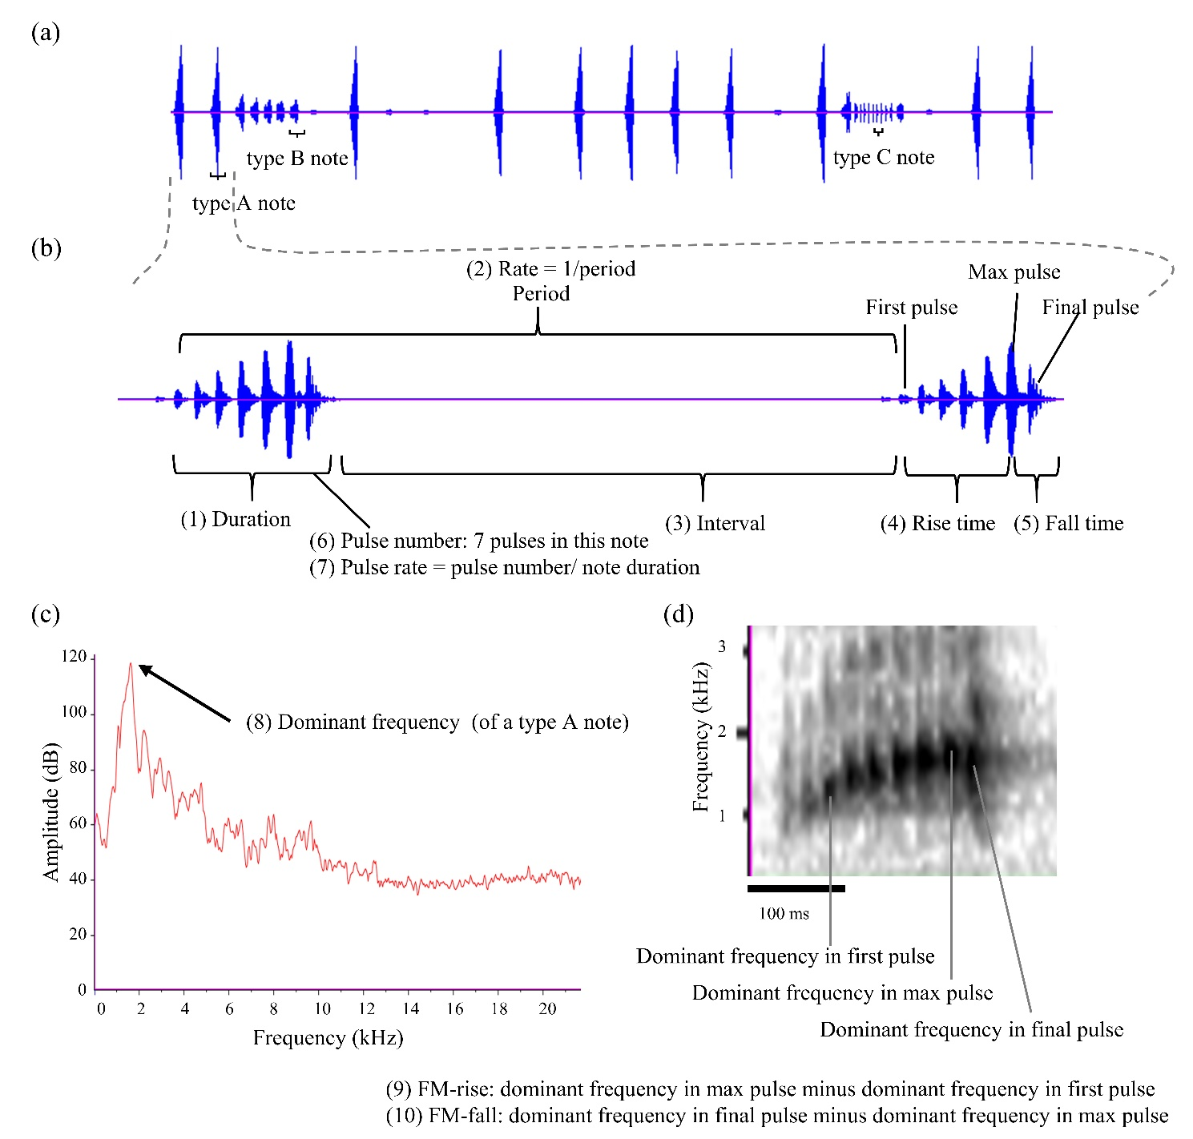
Fig. S1 Illustrations of the acoustic properties of the advertisement call of male Z. prasinatus.
(a) A section of the advertisement call that contains 3 types of notes: A, B and C. (b) The temporal properties of a type A note. (c) The power spectrum of a type A note showing the dominant frequency of the note (i.e., the frequency corresponding to the largest energy peak). (d) Spectrograms showing frequency modulation (FM) in a type A note: the dominant frequency was lower in the first pulse and increased to the highest in the max pulse, and rapidly decreased in the final pulse.

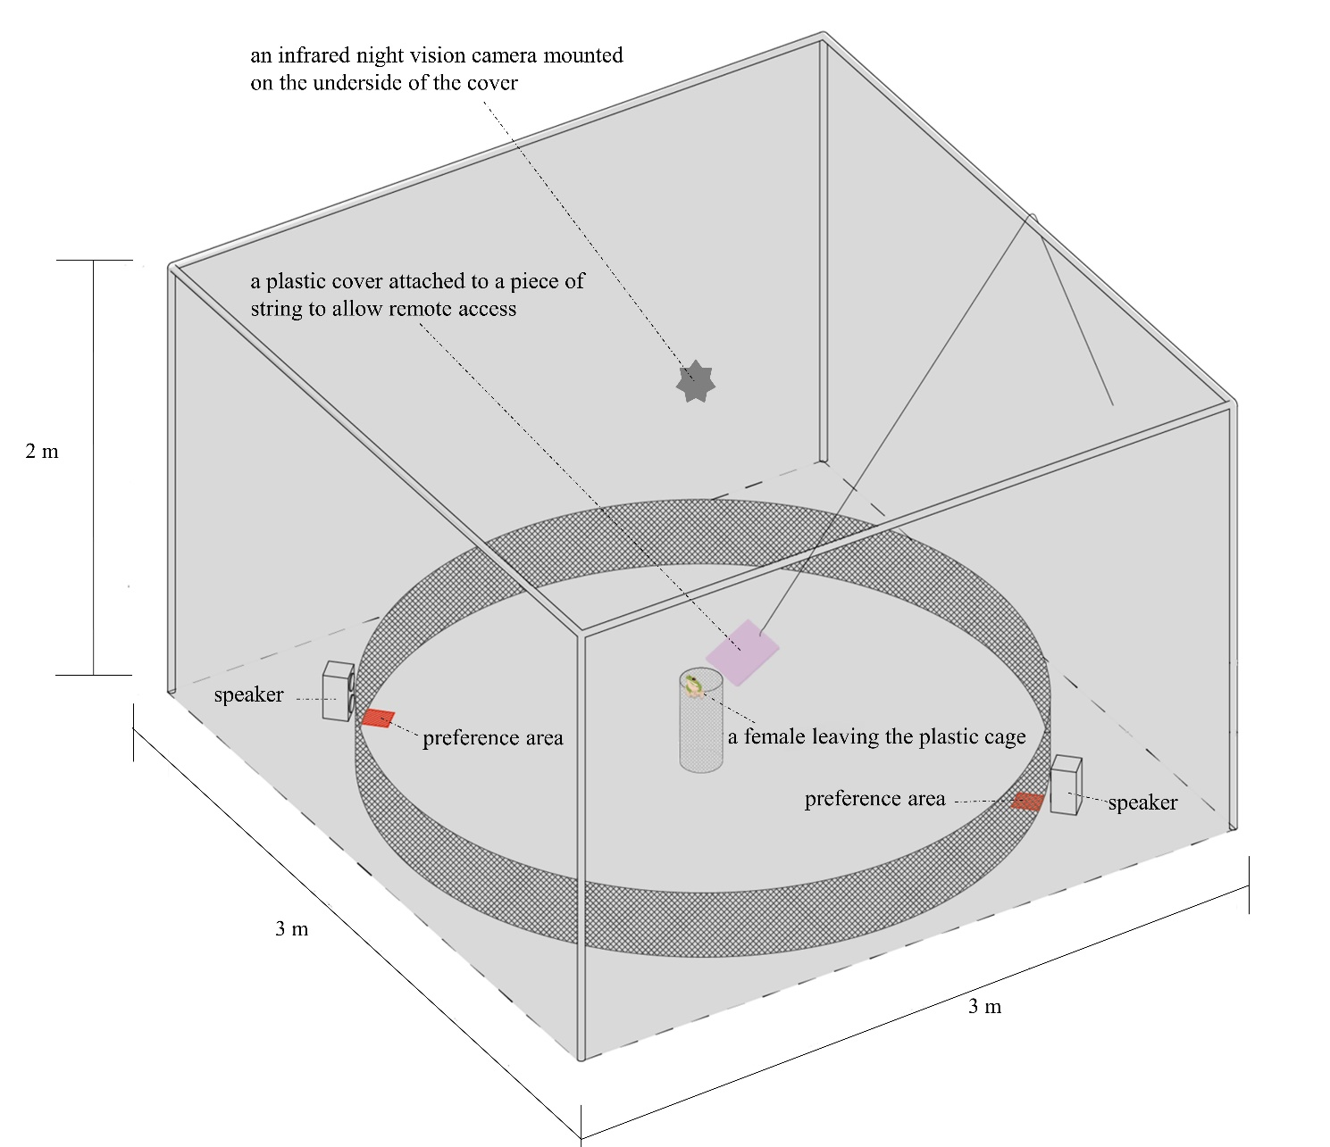
Fig. S2 The setup of the semi-anechoic chamber for the two-choice playback experiments.

