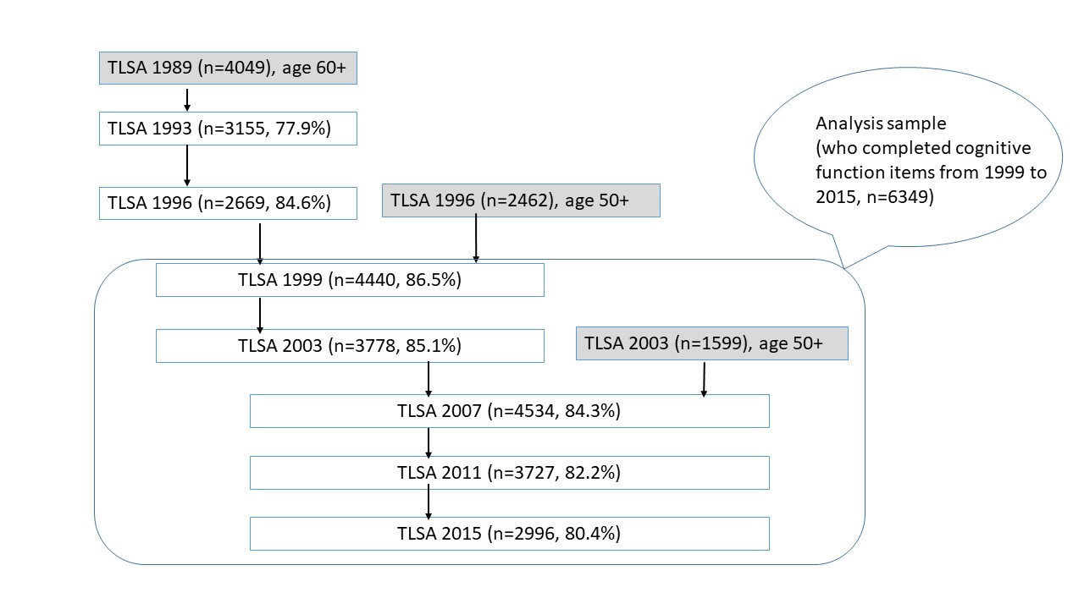
Figure S1. The sample of TLSA

Table S1. Descriptive analysis of the city/county characteristics across 5 waves, 1999-2015
City-level indicators | 1999 | 2003 | 2007 | 2011 | 2015
Population density (100 kilometer²) | 14.20 (21.88) | 14.53 (21.91) | 14.79 (22.00) | 15.02 (22.18) | 15.33 (22.52)
Older people % | 9.74% | 10.55% | 11.43% | 11.90% | 13.1%
High education % | 19.32% | 23.56% | 28.65% | 33.20% | 36.83%
Medical personnel (per 10 thousand population) | 65.14 (26.01) | 77.59 (26.96) | 86.79 (32.53) | 99.78 (37.69) | 109.85 (41.44)
Hospital beds (per 10 thousand population) | 58.77 (24.89) | 65.40 (24.38) | 68.52 (26.34) | 71.35 (27.77) | 69.99 (26.55)
Green land | 5.77 (6.42) | 4.12 (3.82) | 5.28 (5.48) | 5.80 (5.12) | 7.03 (4.98)
Crime (per 100 thousands population) | 833.74 (272.98) | 704.47 (189.60) | 1039.39 (321.70) | 1045.99 (276.46) | 1164.04 (329.43)
Low income rate | 0.91% | 1.21% | 1.30% | 1.55% | 1.53%
Median income (10 thousands NT) | 72.45 (15.05) | 70.53 (15.73) | 72.79 (16.84) | 72.55 (17.20) | 76.36 (15.18)
Unemployment% | 2.53% | 4.72% | 3.80% | 4.09% | 3.53%
Gini | 0.3100 (0.0277) | 0.3203 (0.0247) | 0.3286 (0.0316) | 0.3300 (0.0240) | 0.3348 (0.0258)

Table S2. Correlations of city-level indicators by year of 22 cites in Taiwan
1999 | population density | elderly percentage | medical professional | bed no. | crime rate | low income rate | median income NT | unemployment rate | High education | Gini
population density | 1
elderly percentage | -.288 | 1
medical professional | .654** | -.343 | 1
bed no. | .307 | -.143 | .790** | 1
crime rate | .314 | -.049 | .221 | .407 | 1
low income rate | -.244 | .703** | -.206 | .042 | .136 | 1
median income NT | .529* | -.466* | .371 | -.031 | -.296 | -.668** | 1
unemployment rate | .204 | -.525* | .274 | .377 | .515* | -.306 | -.121 | 1
high education | .855** | -.442* | .729** | .322 | .074 | -.426* | .717** | .119 | 1
Gini | -.168 | .459* | .137 | .407 | .262 | .650** | -.690** | .144 | -.252 | 1
2003 | population density | elderly percentage | medical professional | bed no. | crime rate | low income rate | median income NT | unemployment rate | high education | Gini
population density | 1
elderly percentage | -.265 | 1
medical professional | .692** | -.318 | 1
bed no. | .324 | -.118 | .838** | 1
crime rate | .358 | .208 | .506* | .525* | 1
low income rate | -.177 | .547** | -.032 | .112 | .101 | 1
median income NT | .566** | -.500* | .392 | .120 | -.297 | -.557** | 1
unemployment rate | .106 | -.166 | .096 | .064 | .419 | .057 | -.456* | 1
high education | .875** | -.516* | .760** | .394 | .281 | -.347 | .666** | .079 | 1 | -.446*
Gini | -.341 | .498* | -.019 | .193 | .057 | .671** | -.575** | .027 | -.446* | 1
2007 | population density | elderly percentage | medical professional | bed no. | crime rate | low income rate | median income NT | unemployment rate | high education | Gini
population density | 1
elderly percentage | -.226 | 1
medical professional | .653** | -.198 | 1
bed no. | .305 | -.042 | .870** | 1
crime rate | .311 | -.148 | .694** | .675** | 1
low income rate | -.157 | .473* | .063 | .167 | -.045 | 1
median income NT | .580** | -.635** | .140 | -.150 | -.170 | -.540** | 1
unemployment rate | .080 | .066 | .381 | .303 | .770** | .135 | -.370 | 1
high education | .898** | -.468* | .709** | .375 | .438* | -.316 | .646** | .149 | 1
Gini | -.231 | .609** | -.018 | .196 | -.080 | .592** | -.596** | -.176 | -.351 | 1
2011 | population density | elderly percentage | medical professional | bed no. | crime rate | low income rate | median income NT | unemployment rate | high education | Gini
population density | 1
elderly percentage | -.192 | 1
medical professional | .651** | -.120 | 1
bed no. | .313 | .042 | .874** | 1
crime rate | .338 | .011 | .529* | .496* | 1
low income rate | -.139 | .343 | -.006 | .085 | -.085 | 1
median income NT | .624** | -.642** | .137 | -.166 | -.010 | -.444* | 1
unemployment rate | .142 | .218 | .403 | .314 | .607** | .211 | -.294 | 1
high education | .903** | -.422 | .730** | .389 | .449* | -.276 | .693** | .196 | 1
Gini | -.491* | .689** | -.132 | .181 | -.054 | .354 | -.627** | -.053 | -.546* | 1
2015 | population density | elderly percentage | medical professional | bed no. | crime rate | low income rate | median income NT | unemployment rate | High education | Gini
population density | 1
elderly percentage | -.084 | 1
medical professional | .632** | .060 | 1
bed no. | .345 | .193 | .887** | 1
crime rate | .219 | .560** | .503* | .640** | 1
low income rate | -.112 | .299 | .095 | .161 | .368 | 1
median income NT | .677** | -.568** | .259 | -.016 | -.235 | -.522* | 1
unemployment rate | .124 | .395 | .428* | .386 | .612** | .199 | -.130 | 1
high education | .918** | -.258 | .723** | .442* | .148 | -.184 | .754** | .188 | 1
Gini | -.395 | .362 | -.141 | .097 | .425 | .518* | -.632** | -.159 | -.463* | 1

Table S3. Mixed linear modeling of older adults’ cognitive function with individual and city indicators by TLSA 1999-2015 (cognitive function measured by 10 items)
Variables | Model S1. Individual factors at intercept and time slope  B (SE) | Model S2: City indicators at intercept and time slope  B (SE)
Fixed effects
Individual-level
Intercept | 9.850 (0.511)*** | 15.929 (2.214)***
Sex (male) | 0.182 (0.119)
Marital status (having spouse) | 0.156 (0.113)
Children (yes) | -0.090 (0.383)
Living arrangement (alone) | -0.061 (0.185)
Smoking (no) | -0.023 (0.126)
Smoking (quitted) | -0.063 (0.145)
Drinking alcohol | -0.051 (0.029)
Exercise (regular) | 0.009 (0.084)
Work (yes) | 0.193 (0.096)*
Social group participation (yes) | 0.125 (0.082)
Ethnicity (Hakka) | -0.012 (0.108)
Ethnicity (mainlander) | 0.232 (0.146)
Ethnicity (others) | -0.977 (0.319)**
Age (ordinal) | -0.274 (0.030)***
Education (ordinal) | 0.542 (0.040)***
Disease number | 0.004 90.037)
Self-rated health | 0.161 (0.047)**
ADL disability no. | 0.025 (0112)
IADL disability no. | -0.311 (0.066)***
Nagi function difficulties | -0.027 (0.015)
Contact outside households | 0.104 (0.037)**
Depressive symptoms | -0.010 (0.010)
Stress | -0.058 (0.023)*
Providing instrumental help | -0.042 (0.041)
Receiving emotional support | 0.097 (0.024)***
Receiving instrumental support | -0.094 (0.054)
Economic satisfaction | 0.135 (0.049)**
Religiousness | 0.038 (0.010)***
Migration times | 0.194 (0.098)*
Time | 0.108 (0.058) | -0.176 (0.181)
Time square | -0.001 (0.001) | -0.016 (0.002)***
Sex (male)*time | -0.030 (0.012)**
Marital status (having spouse) *time | -0.022 (0.012)
Children (yes) *time | 0.001 (0.045)
Living arrangement (alone) *time | 0.017 (0.017)
Smoking (no) *time | -0.004 (0.013)
Smoking (quitted) *time | 0.019 (0.015)
Drinking alcohol*time | 0.005 (0.003)
Exercise regular*time | 0.006 (0.008)
Work (yes) *time | -0.006 (0.010)
Social group participation (yes) *time | 0.003 (0.008)
Ethnicity (Hakka) *time | -0.013 (0.010)
Ethnicity (mainlander) *time | 0.002 (0.015)
Ethnicity (others) *time | -0.006 (0.031)
Age (ordinal) *time | -0.014 (0.003)***
Education (ordinal) *time | 0.013 (0.004)**
Disease number*time | -0.001 (0.003)
Self-rated health | -0.015 (0.005)**
ADL disability number*time | 0.010 (9.009)
IADL disability number*time | 0.002 (0.005)
Nagi function difficulties*time | -0.003 (0.001)*
Contact outside households*time | 0.006 (0.004)
Depressive symptoms*time | -0.001 (0.001)
Stress*time | 0.007 (0.002)**
Providing instrumental help*time | -0.002 (0.002)
Receiving emotional support*time | 0.004 (0.006)
Receiving instrumental support*time | -0.006 (0.005)
Economic satisfaction*time | -0.008 (0.001)
Religiousness*time | -0.023 (0.001)
Migration*time | -0.023 (0.009)*
City-level indicators
Population density |  | 0.029 (0.008)***
Older people percentage |  | -0.132 (0.077)
Hospital beds |  | 0.002 (0.006)
Crime rate |  | -0.0004 (0.0004)
Low income rate |  | -0.345 (0.179)
Median income |  | -0.044 (0.014)**
Unemployment |  | -0.241 (0.080)**
Greenland |  | -0.012 (0.022)
Gini |  | -6.666 (4.765)
Population density*time |  | -0.001 (0.001)*
Older people *time |  | 0.009 (0.005)
Hospital beds*time |  | -0.0004 (0.0004)
Crime rate*time |  | <0.001 (<0.001)
Low income rate*time |  | 0.014 (0.013)
Median income*time |  | 0.003 (0.001)**
Unemployment*time |  | 0.025 (0.014)
Greenland*time |  | -0.003 (0.002)
Gini*time |  | 0.060 (0.468)
Random effect
Repeated | 4.856 (0.065) | 7.529 (0.105)
Intercept (city) | 0.088 (0.034) | 0.211 (0.097)
Model fit
-2 log likelihood | 50783.591 | 50655.473
AIC | 50787.591 | 50659.473
BIC | 50802.263 | 50673.966
Note: Observations=12040. AIC: Akaike’s Information Criterion; BIC: Schwarz’s Bayesian Criterion. Reference groups: sex (female), marital stats (no spouse), children (no), living arrangement (with others), exercise (irregular), work (no), social group participation (no), ethnicity (Fuchien); other variables are ordinal or continuous. p<0.1, *p<0.05, **p<0.001, ***p<0.001.
Table S4. Multi-level mixed linear modeling of older adults’ cognitive function with individual and city indicators by TLSA 1999-2015 (cognitive function measured by 8 items of SPMSQ)
 |  | 95% C.I.
Variables | B (SE) | Lower | Upper
Fixed effects
Individual-level
Intercept | 7.459 (0.237)*** | 6.995 | 7.923
Sex (male) | 0.126 (0.043)** | 0.042 | 0.211
Work (yes) | 0.067 (0.040) | -0.012 | 0.146
Ethnicity (Hakka) | 0.040 (0.049) | -0.057 | 0.137
Ethnicity (mainlander) | 0.102 (0.070) | -0.035 | 0.238
Ethnicity (others) | -0.262 (0.138) | -0.532 | 0.009
Age (ordinal) | -0.009 (0.013) | -0.034 | 0.017
Education (ordinal) | 0.073 (0.019)*** | 0.036 | 0.109
Self-rated health | 0.010 (0.018) | -0.025 | 0.046
IADL disability | -0.187 (0.021)*** | -0.229 | -0.145
Contact outside households | 0.018 (0.016) | -0.0139 | 0.049
Stress | -0.014 (0.009) | -0.032 | 0.003
Receiving emotional support | 0.015 (0.008) | -0.001 | 0.031
Economic satisfaction | -0.018 (0.020) | -0.057 | 0.022
Religiousness | 0.004 (0.004) | -0.005 | 0.013
Time | -0.043 (0.025) | -0.092 | 0.006
Sex (male)*time | 0.012 (0.003)** | 0.005 | 0.018
Work (yes) *time | -0.007 (0.004) | -0.014 | 0.001
Ethnicity (Hakka) *time | -0.003 (0.004) | -0.010 | 0.005
Ethnicity (mainlander) *time | -0.001 (0.006) | -0.0117 | 0.011
Ethnicity (others) *time | -0.020 (0.011) | -0.042 | 0.002
Age*time | -0.011 (0.001)*** | -0.013 | -0.009
Education (ordinal) *time | 0.011 (0.001)*** | 0.009 | 0.014
Self-rated health | -0.002 (0.002) | -0.005 | 0.002
IADL disability number*time | -0.002 (0.002) | -0.005 | 0.001
Contact outside households*time | 0.003 (0.002) | -0.0003 | 0.006
Stress*time | 0.001 (0.001) | -0.0005 | 0.003
Receiving emotional support*time | 0.001 (0.001) | -0.0009 | 0.002
Economic satisfaction*time | 0.004 (0.002)* | 7.414E-5 | 0.008
Religiousness*time | 0.007 (0.001) | -0.0001 | 0.002
City-level indicators
Population density | 0.003 (0.001)** | 0.001 | 0.006
Median income | -0.005 (0.003) | -0.010 | 0.0002
Unemployment | 0.027 (0.017) | -0.007 | 0.060
Population density*time | -0.0001 (9.854E-5) | -0.0004 | 7.497E-6
Median income*time | 0.0004 (0.0002)* | 4.105E-5 | 0.001
Unemployment*time | -0.005 (0.004) | -0.012 | 0.002
Random effect
Repeated | 0.553 (0.010)
Intercept (city) | 0.305 (0.014)
Model fit
-2 log likelihood | 25309.509
AIC | 25313.509
BIC | 25327.886
Note: Observations=12040. AIC: Akaike’s Information Criterion; BIC: Schwarz’s Bayesian Criterion. Reference groups: sex (female), work (no), ethnicity (Fuchien); other variables are ordinal or continuous. p<0.1, *p<0.05, **p<0.001, ***p<0.001.

