Table S1. Model information and set-ups in MEMIP
Model version | Brief description | Reference
SOM models
Biome-BGC | The model has a 7-pool structure of soil organic carbon (SOC), with 3 litter and 4 soil pools. The C passed from plant pools are decomposed to litter and soil through a cascade of different pools. Fractions of them are respired. The structure of soil organic nitrogen (SON) follows the same path to SOC pools, with fixed C:N rates for different pools. The N scalar (ξ_{N}) affects the decomposition of all 7 pools.  Soil temperature (ξ_{T}) and moisture (ξ_{W}) scalars are considered as following:  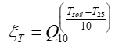 (S1)  where Q₁₀ is the temperature sensitivity of soil respiration. T_{soil} is the soil temperature. T₂₅ is the reference temperature of 25 ℃.  (S2)  where Ψ_{j} is the soil water potential in layer j, Ψ_{min} and Ψ_{max} are the low and saturated soil water potential limits.  In the single layer members, ξ_{T} and ξ_{W} are weighted means of top 5 layers. In multi-layer branches, ξ_{T} and ξ_{W} are explicitly calculated for each layer.  In the multilayer branches, additional depth scalar is considered as following:  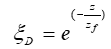 (S3)  where z and z_{f} are the depth and e-folding depth for decomposition. | (Golinkoff, 2010; Oleson et al., 2010)
CENTURY | The model has a 6-pool structure of SOC, with 3 litter pools and 3 soil pools. The CN coupling mode is the same as BGC model but with different C:N rates. ξ_{N} only affects the decomposition of the soil C pools.  The functions of environmental scalars are the same as the BGC model. | (Oleson et al., 2013; Parton et al., 1993)
LPJ | The LPJ scheme is a 4-pool model, with C transitions from the above- and below-ground litter pools to the fast soil pool with a fixed proportion and the rest to the slow soil pool. Soil respiration occurs during C transferring.  ξ_{T} and ξ_{W} are considered as following:  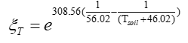 (S4)  (S5)  where W is the soil water content in the top soil layers, which is set as the mean value for top 5 layers in MEMIP. | (Sitch et al., 2003)
JULES | The model follows a framework of Roth-C scheme with plant materials input to decomposable (DPM) and resistant (RPM) litter pools. C goes into the two soil pools and then transfers between each other. Respiration happens during the C transfer.  ξ_{T} and ξ_{W} are considered as following:  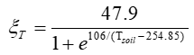 (S6)  (S7)  where W_{opt} and W_{min} are the optimum and minimum soil water content, respectively. | (Clark et al., 2011)
CABLE | The model is a 5-pool model with similar structure to the CENTURY model but with a different C transfer scheme. ξ_{T} is a Q₁₀ scheme similar to Eqn. S1. ξ_{M} is considered as following:  (S8) | (Law et al., 2011; Wang et al., 2011)
The multi-layer model
Vertical resolved biogeochemistry model | The model explicitly represents SOM dynamics at each soil layer of different depth, with the consideration of vertical exchange. The soil depth is 3.8m, which is the same as the soil hydrological depth in CLM 4.0. The vertical C input and active layer modules were also incorporated. | (Koven et al., 2009, 2013)

Fig. S1. Matrix model validations for each branch: (a) spatial pattern of the model difference between the regular and matrix form, and (b) the pixel level correlationships.

Fig. S2. The C storage potential (X_{p}) for the 4 branches (i.e., BGC_sg, CEN_sg, BGC_ml and CEN_ml) from 1900 to 2000.

Fig. S3. Correlations of soil temperature and soil water potential of C-only and CN models. Values are global mean annual outputs of top 5 layers from 1900 to 2000.

Fig.S4. Vertical distribution of soil temperature and soil water potential for global, high latitude land (latitude > 60°) and the rest land from CEN-ML and BGC-ML. The upper panel represents soil temperature and the lower panel represents soil water potential.

Fig.S5. Model outputs of (a) Mineral N, (b) Soil mineral N to plant, (c) N limitation to GPP and (d) LAI for different model members.

Text S1. The soil-vegetation N competition
In the model, the N scalar for soil decomposition (ξ_{N}) is calculated as the result of N competence between vegetation and soil:
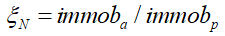 (S9)
where immob_{a} is the actual immobilization and immob_{p} is the potential immobilization. The former is quantified as a N competition between soil and vegetation:
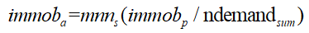 (S10)
where mnn_{s} is the total mineral N for a time step, ndemand_{sum} is the sum of N demand of soil and plant (i.e., immob_{p} + ndemand_{plant}). immob_{p} is proportional to C pool size in the model.
Combining the above two equations, the equation to get ξ_{N} can be rewritten as:
(S11)
The corresponding N limitation to GPP (fpg) is calculated as following:
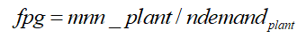 (S12)
where mnn_plant is the available mineral N to plant, which is the difference between mnn_{s} and immob_{a}.
mnn_{s} is the sum of N fixation and N deposition. The N deposition is from data. So it is the same for all simulations. N fixation is proportional to global NPP based on the model construction.
Different SOC decomposition and layer schemes directly influence the immob_{p}, with varying τ’_{E} and CN ratios. Higher immob_{p} induces stronger N competition between soil and vegetation, and therefore causes lower NPP and ndemand_{plant}. Lower NPP then changes the ndemand_{plant}. From Eqn. S12, the final variation of ξ_{N} depends on the balance between the variations in immob_{p} and the corresponding variations in mnn_{s} and ndemand_{plant}. The former two terms decrease ξ_{N}, and the last term increase ξ_{N}.
In a pairwise comparison, the difference of ξ_{N} can be expressed as following:
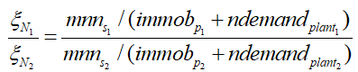 (S13)
The equation can then be converted to the following form:
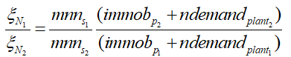 (S14)
Here, we assumed the following relationships:
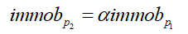 (S15)
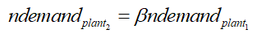 (S16)
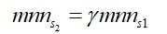 (S17)
where
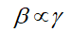 (S18)
Eqn.S14 can then be converted to:
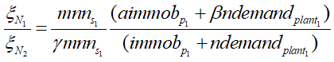 (S19)
It can be tell from Eqn. S19 that if a > 1 and assuming constants for the other terms on the right side, then ξ_{N1} > ξ_{N2}, i.e., Model 2 with higher immob_{p} induces lower ξ_{N} and then benefit SOC increase and vice versa.
If β,γ > 1 and assuming ndemand_{plant} >> immob_{p}, then ξ_{N1}/ξ_{N2} depends on β/γ. If β >γ, then ξ_{N1} > ξ_{N2}, i.e., Model2 with higher vegetation production induces lower ξ_{N} and then benefit SOC increase and vice versa.

Text S2. Structural elements in soil baseline residence time (τ’_{E})
The fundamental structural elements of the SOC models are defined in τ’_{E}. According to the 3D model decomposition scheme, τ’_{E} for a single layer case can be represented as the following:
(S20)
where A is the C transition matrix, representing the horizontal C flows among different pools. For example, A in the CENTURY model is as following:
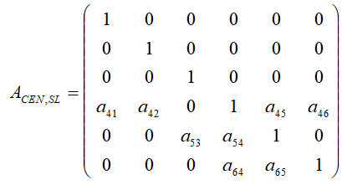
A in the BGC model is as following:
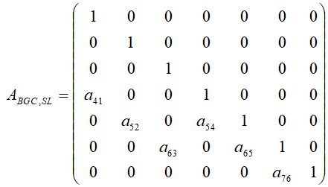
where a_{ij} is the C transition rates from pool j to pool i.
K is the matrix for baseline turnover rates:
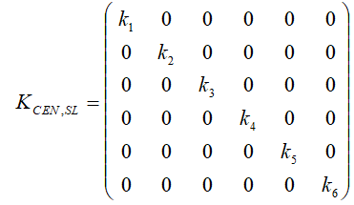
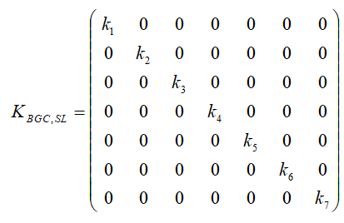
B is the vector of C partitioning coefficient:
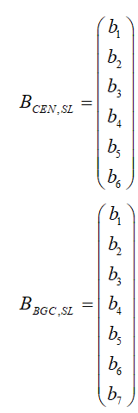
Then τ’_{E} can be rewritten as the following:
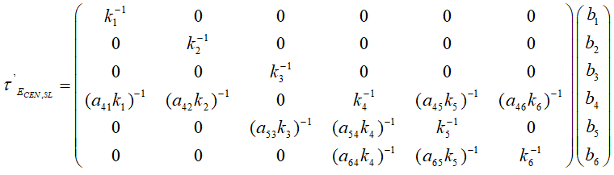
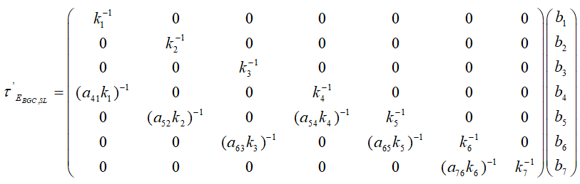
By fixing the other components in calculating SOC, it is easy to quantify and compare inter-model difference from τ’_{E} as each component in A and K are time invariable.
While in a ML model, the situation is much more complex with the incorporation of the vertical mixture term (V) and the vertical profile of C input (D):
(S21)
For a layer t, the second term on the right side of Eqn.S10 equals:
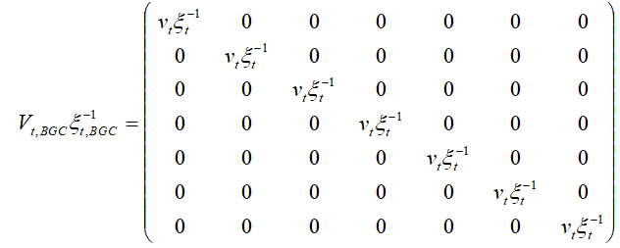
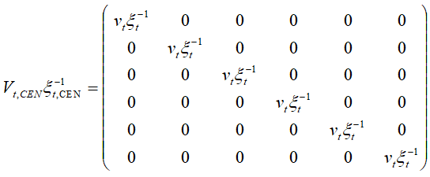
where each diagonal component represents the vertical mixture rates of layer t against layer (t-1) and layer (t+1), modified by environmental scalars, i.e., the ξ term.
The third term, P, is the vector of vertical C allocation coefficient, i.e., [p_{1,}p_{2,..}p_{t..}p₁₀]. The component is a function of soil depth and so the same for different model schemes.
For C pool i in layer t, τ’_{E} can then be represented as following:
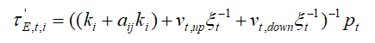 (S22)
where v_{t,up} and v_{t,down} are terms of the C exchange rate of layer t with the upper layer and the lower layer. In the model, these two terms are simulated through a diffusion scheme (Koven et al., 2009):
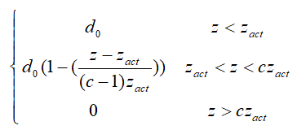 (S23)
where d₀ is the baseline diffusion rate. c is the parameter for maximum mixing depth. z and z_{act} are soil depth and the depth to the base of the active layer. So v_{t,up} and v_{t,down} terms are determined by the depth of layer and the variations of active layer, which relates to the seasonal dynamics of soil temperature.
So in a ML model, τ’_{E} is not only determined by internal model structure. With the incorporation of vertical C mixture, τ’_{E} of ML models varied in different layers. With more layers considered in ML models, the total τ’_{E} is higher than τ’_{E} of SL models.
Because both the biogeophysical modules and ξ functions are the same for CEN and BGC members in this study, so τ’_{E} difference due to ξ change is small in this study. Further evaluations would be needed once different biogeophysical modules and ξ functions incorporated into MEMIP.

Text S3. Distinguish the contributions of model difference from process and feedback
- Soil temperature and moisture scalars:
Process-based changes of soil temperature and moisture scalars are from the different use of soil temperature and moisture. In the single-layer (SL) models, the soil temperature and moisture from top 5 layers are averaged as the input to quantify the scalars. In multi-layer (ML) models, soil temperature and moisture from all 10 layers are used to calculate the scalars for the corresponding layers.
N feedback-based changes of soil temperature and moisture are through the modification of vegetation structure such as LAI (Fig. S7), which is from N competition between soil and vegetation.
2. N scalars of soil decomposition:
Process-based changes of N scalar are the different sets of C and N pools structure and the stoichiometry of C and N for each pool. The ML structure also influences the results with explicit representation of C and N pools at each layer.
N feedback-based changes of N scalar are from the modification of C_{in} due to N competition between soil and vegetation.

References:
Clark, D.B., Mercado, L.M., Sitch, S., Jones, C.D., Gedney, N., Best, M.J., Pryor, M., Rooney, G.G., Essery, R.L.H., Blyth, E., Boucher, O., Harding, R.J., Huntingford, C., Cox, P.M., 2011. The Joint UK Land Environment Simulator (JULES), model description – Part 2: Carbon fluxes and vegetation dynamics. Geosci. Model Dev. 4, 701–722. https://doi.org/10.5194/gmd-4-701-2011
Koven, C., Friedlingstein, P., Ciais, P., Khvorostyanov, D., Krinner, G., Tarnocai, C., 2009. On the formation of high‐latitude soil carbon stocks: Effects of cryoturbation and insulation by organic matter in a land surface model. Geophys. Res. Lett. 36.
Koven, C.D., Riley, W.J., Subin, Z.M., Tang, J.Y., Torn, M.S., Collins, W.D., Bonan, G.B., Lawrence, D.M., Swenson, S.C., 2013. The effect of vertically resolved soil biogeochemistry and alternate soil C and N models on C dynamics of CLM4. Biogeosciences 10, 7109–7131. https://doi.org/10.5194/bg-10-7109-2013
Law, R., Corbin, K., Stevens, L., Srbinovsky, J., Matear, R., Lenton, A., Wang, Y., 2011. The Carbon Cycle in ACCESS.
Oleson, K., Lawrence, D., Bonan, G., Drewniak, B., Huang, M., Koven, C., Levis, S., Li, F., Riley, W., Subin, Z., 2013. Technical Description of version 4.5 of the Community Land Model (CLM)(NCAR Technical Note No. NCAR/TN-503+ STR). Citeseer. Natl. Cent. Atmospheric Res. PO Box 3000.
Parton, W., Scurlock, J., Ojima, D., Gilmanov, T., Scholes, R., Schimel, D.S., Kirchner, T., Menaut, J., Seastedt, T., Garcia Moya, E., 1993. Observations and modeling of biomass and soil organic matter dynamics for the grassland biome worldwide. Glob. Biogeochem. Cycles 7, 785–809.
Sitch, S., Smith, B., Prentice, I.C., Arneth, A., Bondeau, A., Cramer, W., Kaplan, J.O., Levis, S., Lucht, W., Sykes, M.T., 2003. Evaluation of ecosystem dynamics, plant geography and terrestrial carbon cycling in the LPJ dynamic global vegetation model. Glob. Change Biol. 9, 161–185.
Wang, Y.P., Kowalczyk, E., Leuning, R., Abramowitz, G., Raupach, M.R., Pak, B., van Gorsel, E., Luhar, A., 2011. Diagnosing errors in a land surface model (CABLE) in the time and frequency domains. J. Geophys. Res. Biogeosciences 116.

