High-Hole-Mobility Metal-Organic Framework as Dopant-Free Hole Transport Layer for Perovskite Solar Cells
Ruonan Wang,^{a‡} Weikang Yu,^{a,b‡} Cheng Sun,^{a‡} Kashi Chiranjeevulu,^{c} Shuguang Deng,^{d} Jiang Wu,^{e} Feng Yan,^{f} Changsi Peng,^{g} Yanhui Lou,*^{,a} Gang Xu,*^{,c} Guifu Zou*^{,a}
ª College of Energy, Soochow Institute for Energy and Materials Innovations, and Key Laboratory of Advanced Carbon Materials and Wearable Energy Technologies of Jiangsu Province, Soochow University, Suzhou 215123, China.
^{b} School of Resources Environmental & Chemical Engineering, Nanchang University, 999 Xuefu Avenue, Nanchang 330031, China.
^{c} State Key Laboratory of Structural Chemistry, Fujian Institute of Research on the Structure of Matter, Chinese Academy of Sciences, Fuzhou, Fujian 350002, China.
^{d} School for Engineering of Matter, Transport and Energy, Arizona State University, 551 E. Tyler Mall, Tempe, AZ 85287, USA.
^{e} Institute of Fundamental and Frontier Sciences, University of Electronic Science and Technology of China, Chengdu 610054, P. R. China.
^{f} College of Chemistry, Chemical Engineering and Materials Science, Soochow Universit, Suzhou 215123 (China).
^{g} School of Optoelectronic Science and Engineering and Collaborative Innovation Center of Suzhou Nano Science and Technology, Soochow University, Suzhou, 215006, China.
‡ These three authors contributed equally to the work.
* Email: yhlou@suda.edu.cn; gxu@fjirsm.ac.cn; zouguifu@suda.edu.cn

Content:
Supporting figures

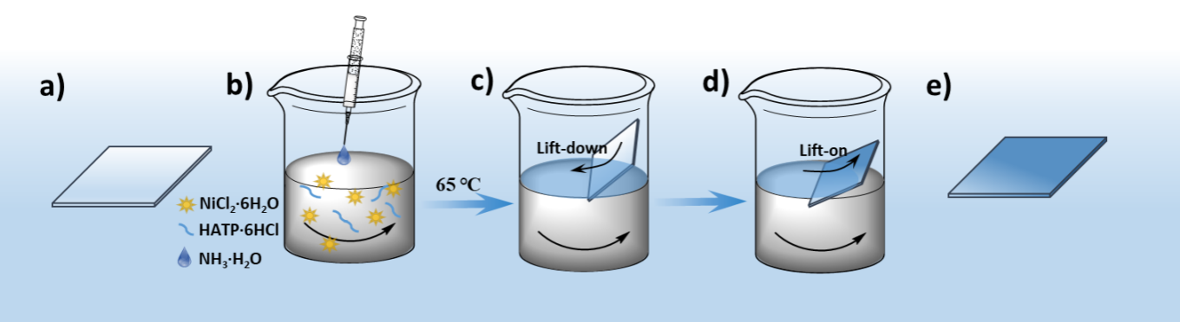
Figure S1. Illustration of the assembly process for the Ni₃(HITP)₂ film. a) The cleaned ITO substrate; b) The precursor solution for synthesis of Ni₃(HITP)₂ film; c) After the Ni₃(HITP)₂ film is formed, lift-down ITO along of the beaker; d) Lift-on the membrane by slowly raising the ITO and e) ITO substrate coated with complete Ni₃(HITP)₂ film.
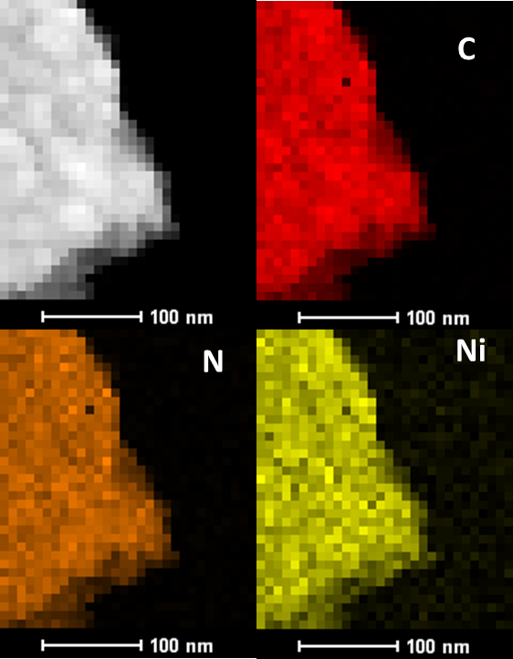
Figure S2. EDX mapping of the Ni₃(HITP)₂ membranes.

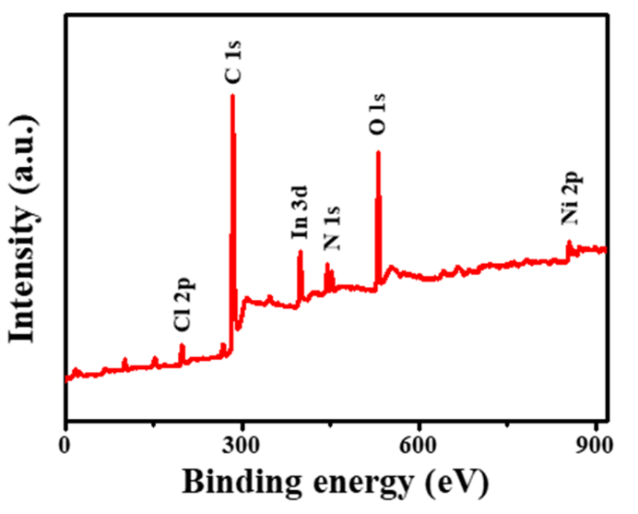
Figure S3. XPS spectra of the Ni₃(HITP)₂ membranes.

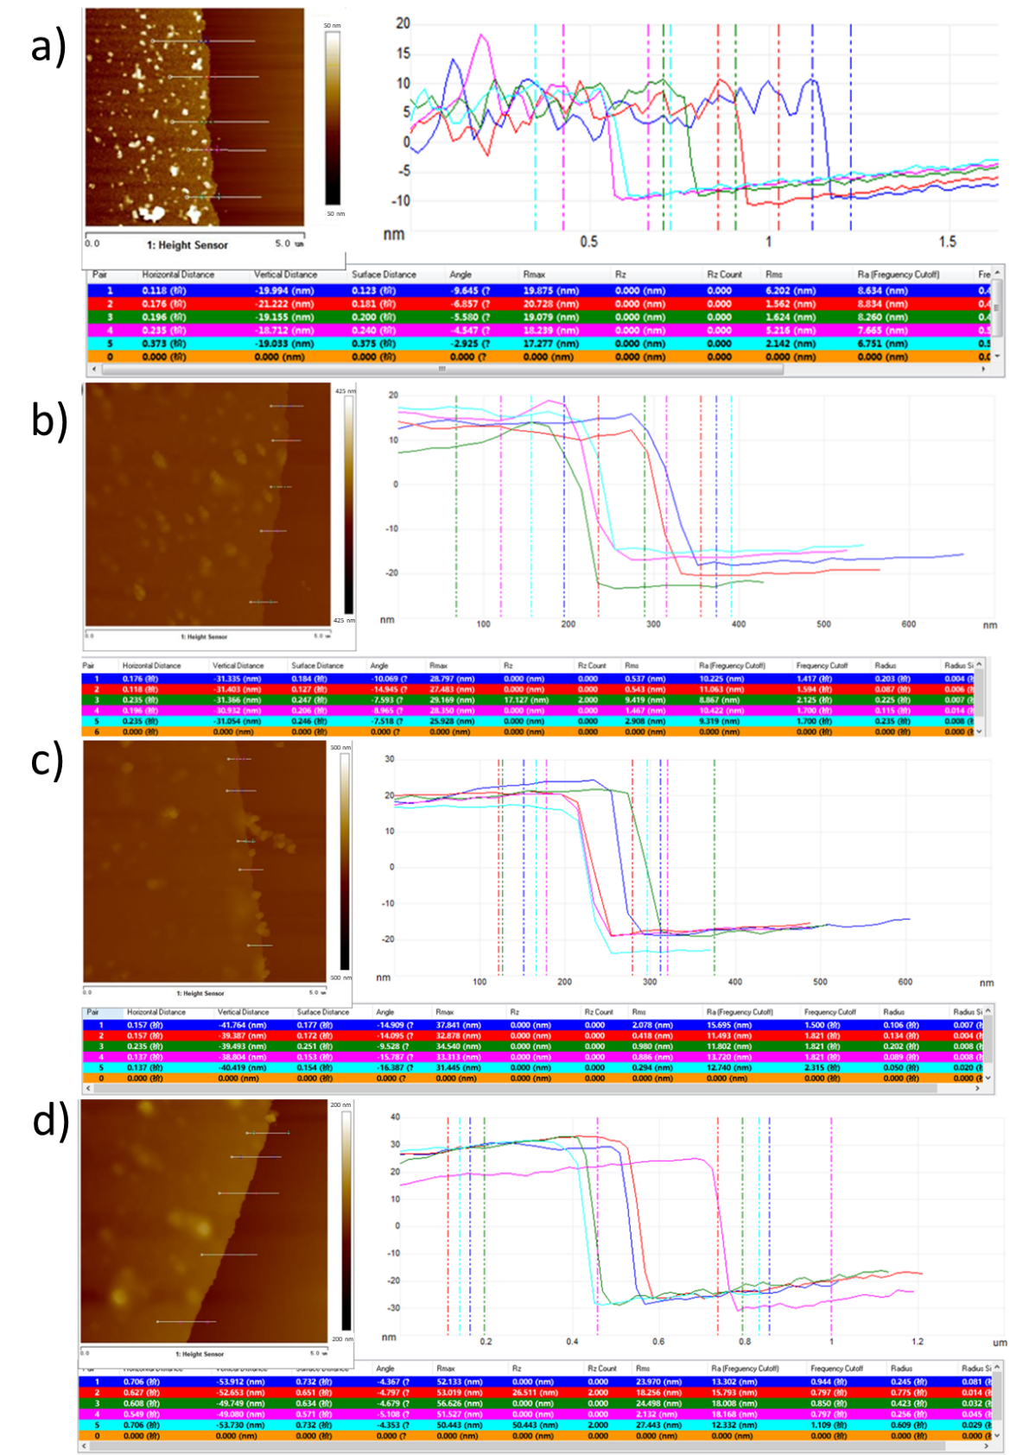
Figure S4. AFM images of different thickness of Ni₃(HITP)₂ membranes.

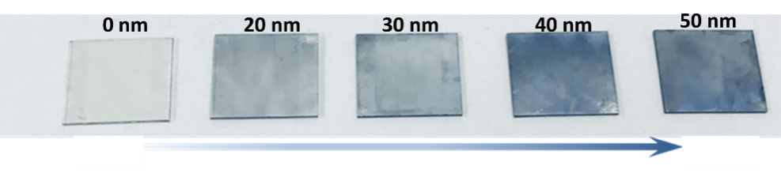
Figure S5. Photographs of the bare ITO glass and with different thickness of Ni₃(HITP)₂ membranes.

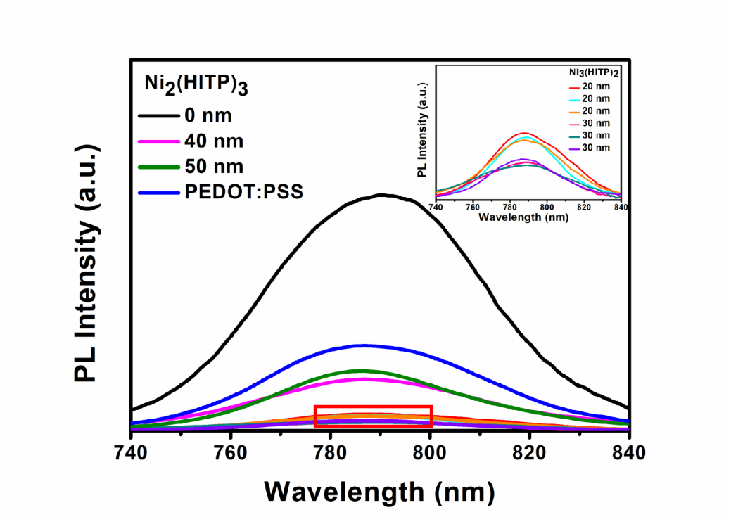
Figure S6. Steady-state PL spectra of perovskite/ITO based on 20nm, 30nm, 40nm, and 50nm Ni₃(HITP)₂ film and PEDOT/PSS; Inset: the enlarged steady-state PL spectra of perovskite on the 20nm and 30nm Ni₃(HITP)₂ film repeated by three times, respectively.

Figure S7. Time-resolved PL spectra of perovskite on the ITO substrate with different thicknesses of Ni₃(HITP)₂ film and PEDOT/PSS.

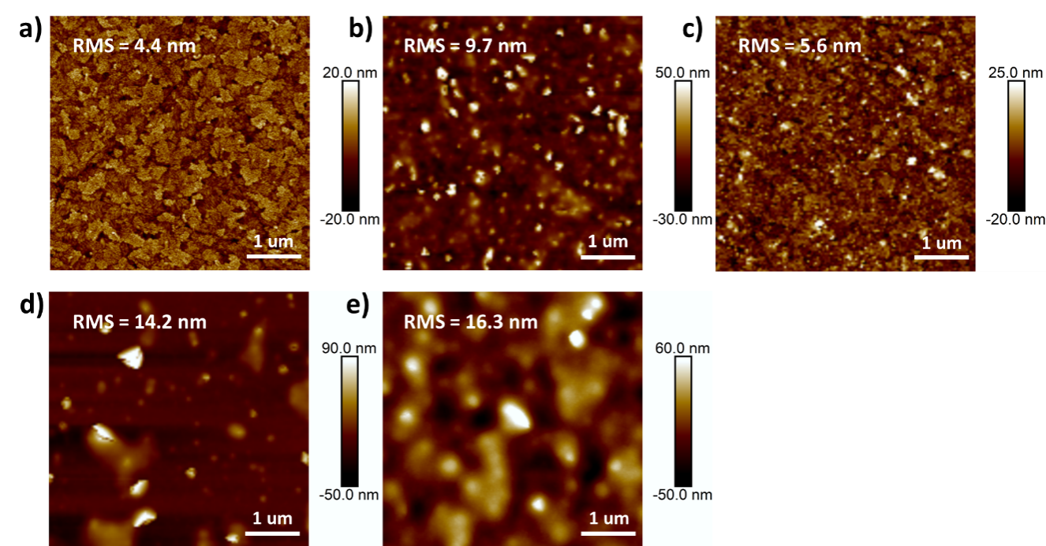Figure S8. AFM images of different thickness of Ni₃(HITP)₂ membranes. a) Bare ITO glass, b)-e) Corresponding to 20 nm, 30 nm, 40nm and 50 nm Ni₃(HITP)₂ membranes, respectively.

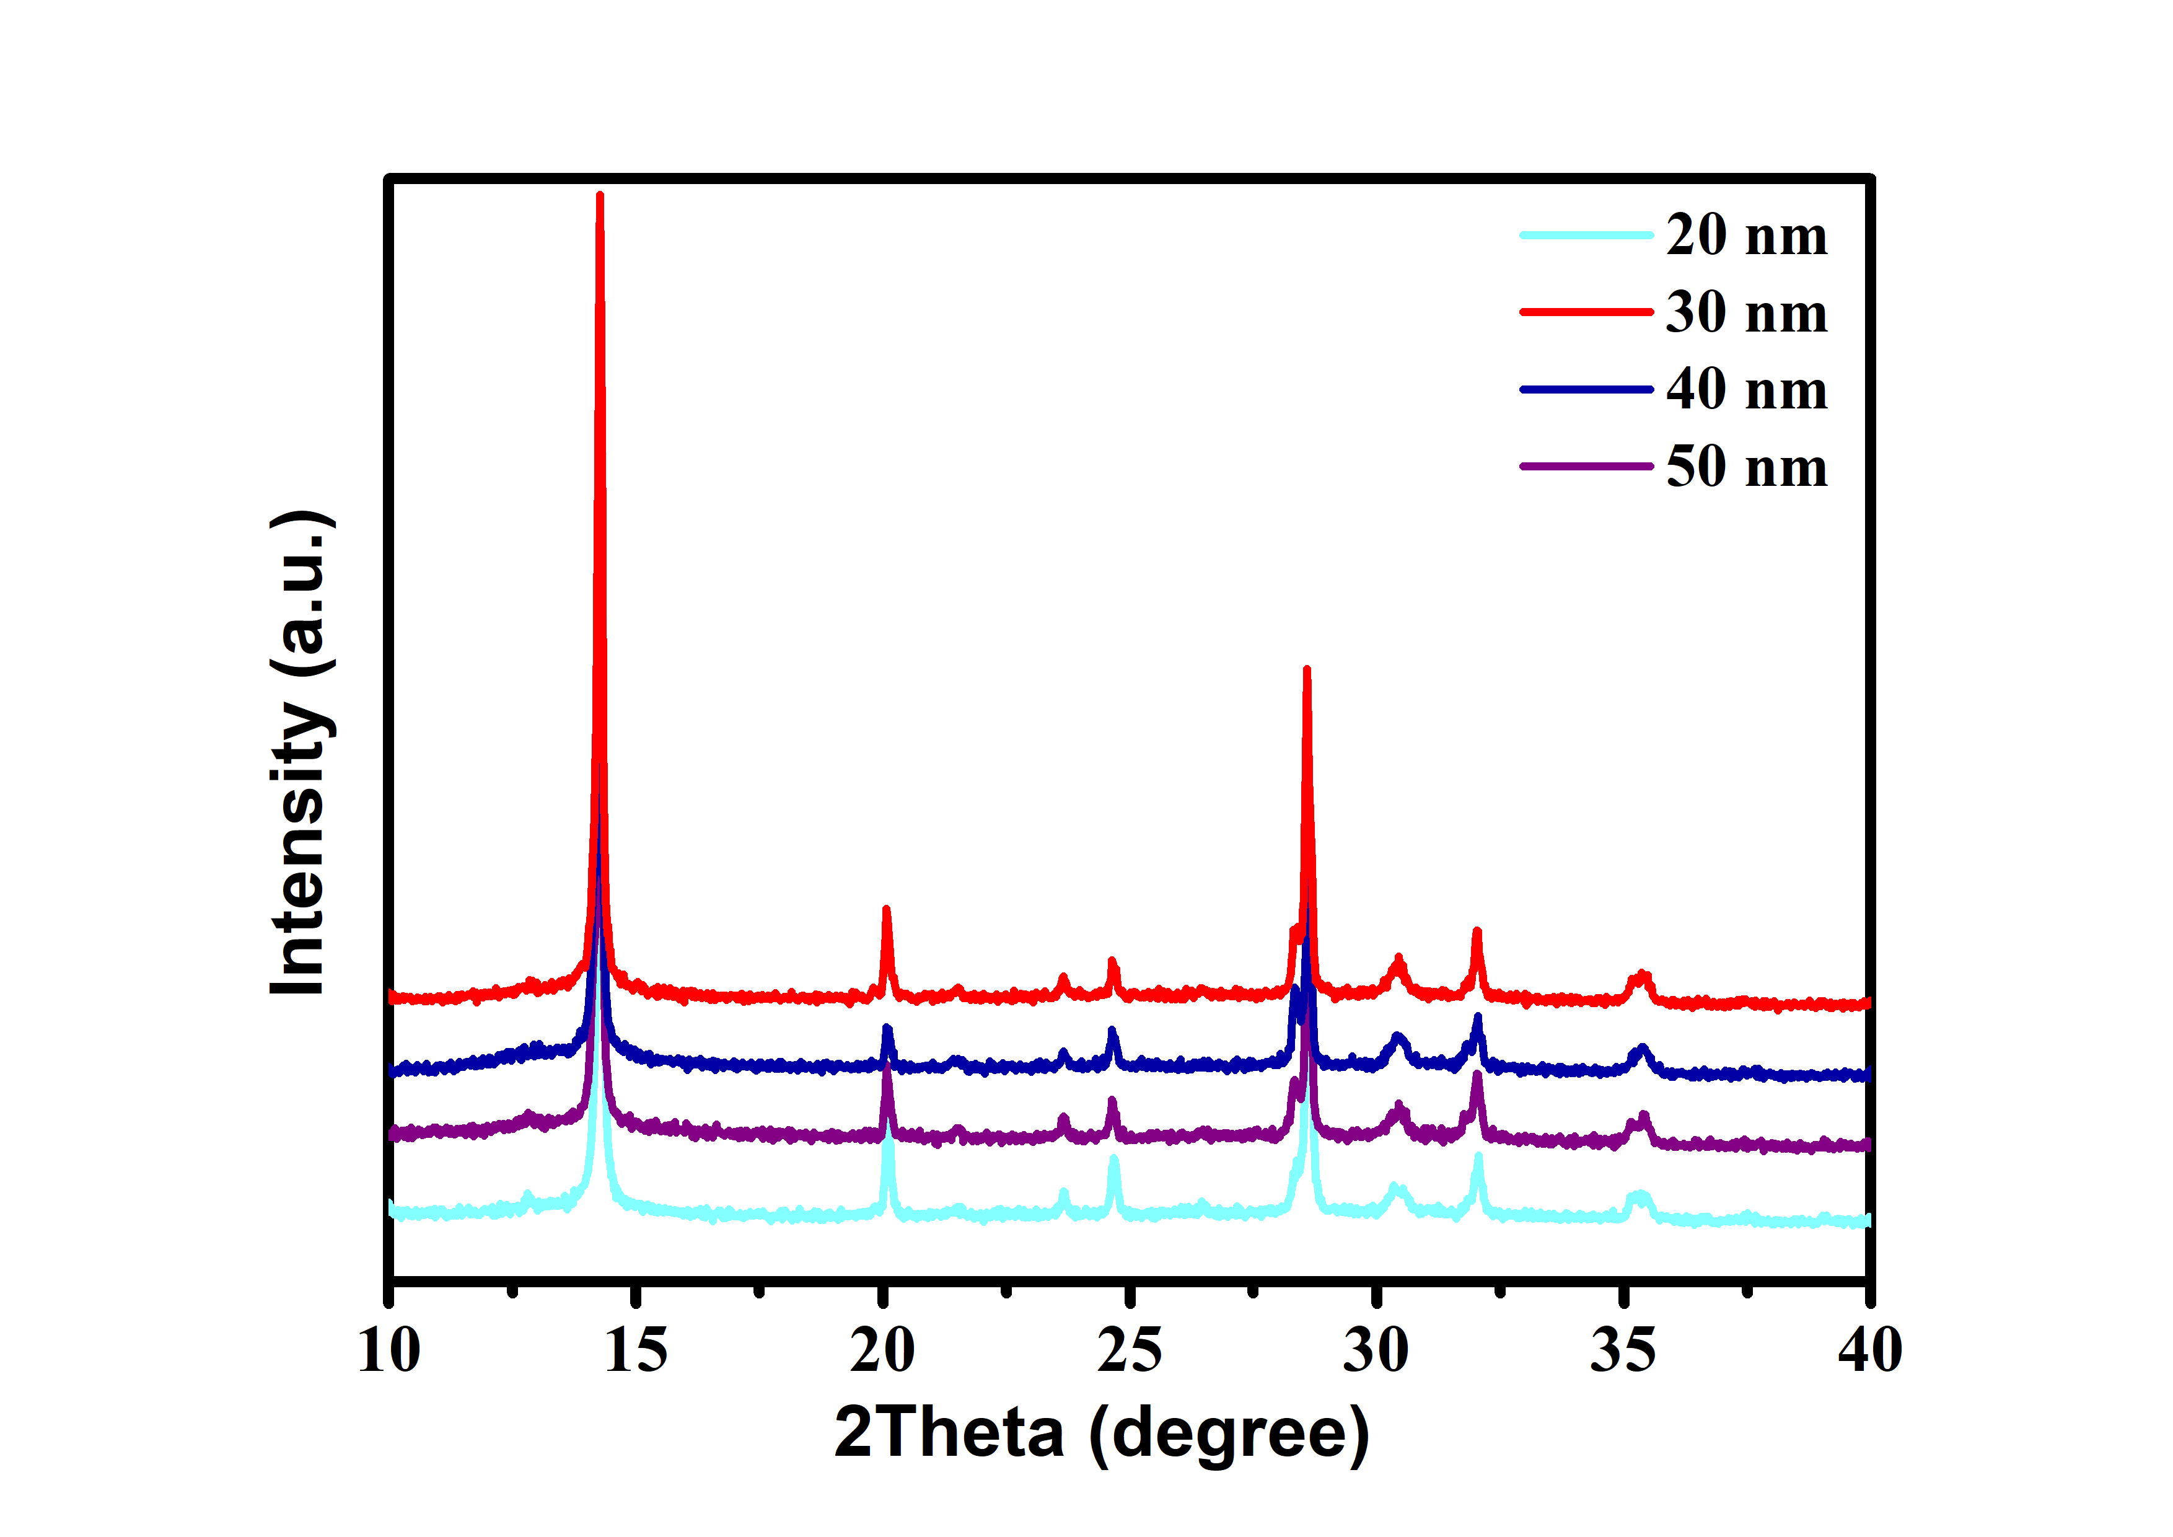
Figure S9. XRD pattern of perovskite films deposition on different thickness of Ni₃(HITP)₂ membranes.

Table S1. The average decay lifetimes of the perovskite/ITO with different hole transport layers.
 | Without | PEDOT/PSS | Ni₃(HITP)₂ (20 nm) | Ni₃(HITP)₂ (30 nm) | Ni₃(HITP)₂ (40 nm) | Ni₃(HITP)₂ (50 nm)
Average τ(ns) | 18.14 | 6.17 | 1.89 | 1.18 | 2.82 | 3.02

