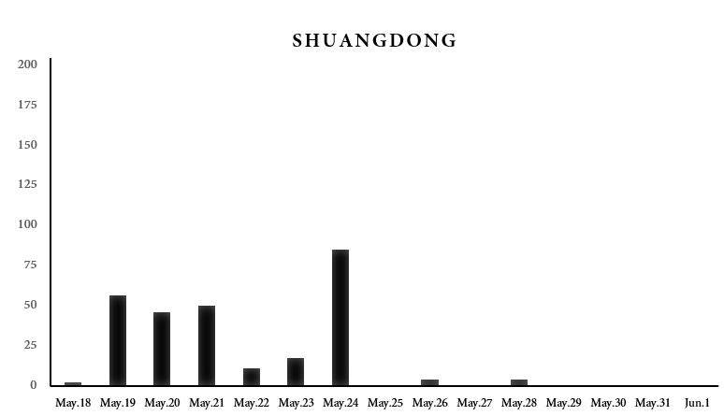

Figure S1. Two-week daily precipitation prior to the M_{L}6.5 2013 Nantou earthquake at the weather station of Shuangdong near the epicenter.

