Supplementary material for:
Length of Hospital stay after delivery among Danish women with Congenital Heart Disease: A register-based cohort study
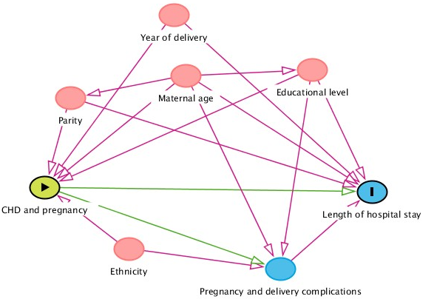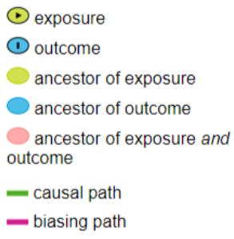
Figure S1. Simplified Directed Acyclic Graph (DAG) highlighting variables of importance in the analysis of the association between maternal congenital heart disease and length of hospital stay.

Table S1. Association between congenital heart disease and length of hospital stay after delivery given by relative ratio (RR) and 95% confidence interval (95% CI). Length of hospital stay is truncated at 30 days. Denmark, 1997-2014.
 |  | Number of days of admission after delivery |  | Unadjusted |  |  | Adjusted#
 | N* | Mean (SD) | Median (IQR) | RR | 95 % CI | p-value | RR | 95 % CI | p-value
Maternal congenital  heart disease |  |  |  |  |  | <0.001 |  |  | <0.001
No | 935,959 | 3.5 (3.3) | 3 (1-4) | 1 (ref) | - |  | 1 (ref) | -
Simple | 2,242 | 3.8 (3.7) | 3 (2-5) | 1.09 | 1.05-1.14 |  | 1.11 | 1.07-1.16
Moderate | 1,093 | 4.0 (3.6) | 3 (2-5) | 1.14 | 1.07-1.21 |  | 1.15 | 1.08-1.22
Complex | 384 | 4.8 (5.3) | 4 (2-5) | 1.37 | 1.20-1.56 |  | 1.39 | 1.22-1.59
*number of births in the unadjusted analysis
#adjusted for maternal age, year of delivery, parity, ethnicity, and educational level

Table S2. Association between congenital heart disease and length of hospital stay after delivery given by relative ratio (RR) and 95% confidence interval (95% CI). Length of hospital stay is truncated at 100 days. Denmark, 1997-2014.
 |  | Number of days of admission after delivery |  | Unadjusted |  |  | Adjusted#
 | N* | Mean (SD) | Median (IQR) | RR | 95 % CI | p-value | RR | 95 % CI | p-value
Maternal congenital  heart disease |  |  |  |  |  | <0.001 |  |  | <0.001
No | 935,959 | 3.6 (4.1) | 3 (1-4) | 1 (ref) | - |  | 1 (ref) | -
Simple | 2,242 | 4.0 (5.4) | 3 (2-5) | 1.12 | 1.05-1.19 |  | 1.14 | 1.07-1.21
Moderate | 1,093 | 4.0 (4.2) | 3 (2-5) | 1.13 | 1.06-1.21 |  | 1.14 | 1.07-1.22
Complex | 384 | 5.1 (6.8) | 4 (2-5) | 1.42 | 1.22-1.66 |  | 1.45 | 1.24-1.70
*number of births in the unadjusted analysis
#adjusted for maternal age, year of delivery, parity, ethnicity, and educational level

Table S3. Association between congenital heart disease and length of hospital stay after delivery given by relative ratio (RR) and 95% confidence interval (95% CI). Length of hospital stay >50 days have been excluded. Denmark, 1997-2014.
 |  | Number of days of admission after delivery |  | Unadjusted |  |  | Adjusted#
 | N* | Mean (SD) | Median (IQR) | RR | 95 % CI | p-value | RR | 95 % CI | p-value
Maternal congenital  heart disease |  |  |  |  |  | <0.001 |  |  | <0.001
No | 934,929 | 3.5 (3.4) | 3 (1-4) | 1 (ref) | - |  | 1 (ref) | -
Simple | 2,235 | 3.8 (3.6) | 3 (2-5) | 1.08 | 1.03-1.13 |  | 1.10 | 1.05-1.14
Moderate | 1,092 | 4.0 (3.5) | 3 (2-5) | 1.13 | 1.07-1.20 |  | 1.15 | 1.08-1.21
Complex | 383 | 4.9 (6.3) | 4 (2-5) | 1.41 | 1.21-1.64 |  | 1.44 | 1.23-1.68
*number of births in the unadjusted analysis
#adjusted for maternal age, year of delivery, parity, ethnicity, and educational level

Table S4. Multilevel analysis of the association between congenital heart disease and length of hospital stay after delivery given by relative ratio (RR) and 95% confidence interval (95% CI). Denmark, 1997-2014.
 |  | Number of days of admission after delivery |  | Unadjusted |  |  | Adjusted#
 | N* | Mean (SD) | Median (IQR) | RR | 95 % CI | p-value |  | RR | 95 % CI | p-value
Maternal congenital  heart disease |  |  |  |  |  | <0.001 |  |  |  | <0.001
No | 935,959 | 3.6 (3.7) | 3 (1-4) | 1 (ref) | - |  |  | 1 (ref) | -
Simple | 2,242 | 3.9 (4.4) | 3 (2-5) | 1.10 | 1.06-1.14 |  |  | 1.11 | 1.07-1.15
Moderate | 1,093 | 4.0 (3.8) | 3 (2-5) | 1.14 | 1.08-1.19 |  |  | 1.14 | 1.09-1.20
Complex | 384 | 5.1 (6.7) | 4 (2-5) | 1.31 | 1.20-1.42 |  |  | 1.32 | 1.22-1.43
Random effect (SE) |  |  |  | .50(0.00) |  |  |  | 0.47(0.00)
*number of births in the unadjusted analysis
#adjusted for maternal age, year of delivery, parity, ethnicity, and educational level

