Table S1. ICD codes
Diagnosis | ICD 9 | ICD 10
Hypertension | 401.0, 401.1, 401.9, 403.00, 403.01, 403.10, 403.11, 409.90, 403.91, 404.01, 404.91, 405.99 | I10, I11.0, I11.9, I12.0, I13.0, I15.9
Hyperlipidemia | 272.0, 272.1, 272.3, 272.4, 272.8 | E75.5, E78.0, E78.1, E78.2, E78.3, E78.4, E78.5, E78.9
Gout | 274.0, 274.11, 274.82, 274.89 | M10.00, M10.9, M1A.9X, M10.011, M10.012, M10.019, M10.021, M10.022, M10.029, M10.031, M10.032, M10.039, M10.041, M10.042, M10.049, M10.051, M10.059, M10.061, M10.062, M10.069, M10.071  N20.0, M10.40, M10.411, M10.412, M10.419, M10.421, M10.422, M10.429, M10.431  M10.432, M10.439, M10.441, M10.442, M10.449, M10.451  M10.452, M10.459, M10.461, M10.462, M10.469, M10.71
Chronic obstructive pulmonary disease | 491.20, 491.21, 491.8, 492.8, 493.20, 493.22, 493.90, 493.91, 494.0, 494.1, 496 | J44.9, J44.0, J44.1, J41.8, J44.9, J45.902, J45.991, J45.909, J45.991, J45.998, J47.9, J47.0, J47.1, J44.9
Heart failure | 402.11, 402.91, 404.11, 428.0, 428.1, 428.9 | I50.1, I50.20, I50.23, I50.31, I50.9
Peripheral arterial occlusive disease | 443.81, 443.89, 443.9, 444.0, 444.21, 444.22, 444.81, 444.9 | I73.89, I73.9, I74.09, I74.19  I74.2, I74.3, I74.4, I74.9
Atrial fibrillation | 427.31 | I48.0, I48.1, I48.2, I48.91
Atrial flutter | 427.32 | I48.4, I48.92
Transient ischemia accident | 435.9 | G45.3, G45.4, G45.8, G45.9
Ischemic stroke | 436 | I67.89
Coronary artery disease | 411.81, 414.00, 414.01, 414.02, 414.03, 414.04, 414.8, 414.9 | I20.0, I20.9, I25.10, I25.11, I25.82, I25.84, I25.9
Acute myocardial infarction | 410.00, 410.01, 410.02, 410.10, 140.11, 410.12, 410.20, 410.21, 410.22, 410.30, 410.31, 410.32, 410.40, 410.41, 410.42, 410.50, 410.51, 410.52, 410.61, 410.81 | I21.01, I21.02, I21.09, I21.11, I21.19, I21.21, I21.29, I21.3, I21.4, I22.1, I22.8, I24.9
Valvular heart disease | 394.0, 394.1, 394.2, 394.9, 395.0, 395.1, 395.2, 395.9, 396.0, 396.1, 396.2, 396.3, 396.8, 396.9, 397.0, 397.1, 397.9, 398.0, 398.90, 398.91, 398.99., 424.0, 424.1, 424.2, 424.3, 424.90, 424.91, 424.99 | I05.0, I05.1, I05.2, I05.8, I05.9, I06.0, I06.1, I06.2, I06.8, I06.9, I07.0, I07.1, I07.2, I07.8, I07.9, I08.0, I08.1, I08.2, I08.3, I08.8, I08.9, I09.0, I09.1, I09.2, I09.81, I09.89, I09.9, I34.0, I34.1, I34.2, I34.8, I34.9, I35.0, I35.1, I35.2, I35.8, I35.9, I36.0, I36.1, I36.2, I36.8, I36.9, I37.0, I37.1, I37.2, I37.8, I37.9
Chronic kidney disease | 593.9 | N18.1, N18.2, N18.3, N18.4, N18.5, N18.9, N19
Cancer | ICD - O International Classification of Diseases for Oncology  C00~C80

Table S2. Number of visits during follow up in each subgroup
 | Underweight | Normal | Overweight | Obesity class 1 | Obesity class 2 | Obesity class 3
Outpatient visits (mean, Q1~Q3) | 37.8 (6.0-49.5) | 43.2 (8.0-60.0) | 43.1 (9.0-60.0) | 42.9 (9.0-60.0) | 42.6 (8.0-59.0) | 42.8 (8.0-60.0)
Inpatient visits (mean, Q1~Q3) | 2.6 (1.0-3.0) | 1.0 (1.0-3.0) | 1.0 (1.0-3.0) | 2.6 (1.0-3.0) | 1.0 (1.0-3.0) | 1.0 (1.0-3.0)
BMI (mean, Q1~Q3) | 31.9 (7.0-45.0) | 33.9 (6.0-47.0) | 32.3 (6.0-45.0) | 32.5 (6.0-45.0) | 32.8 (6.0-45.0) | 32.9 (6.0-45.0)

Figure S1. Hazard ratios for developing AF across different BMI categories separated by gender
Male | Female
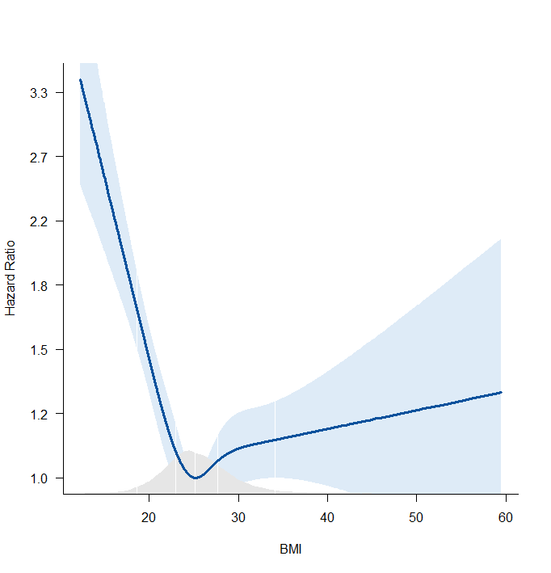 | 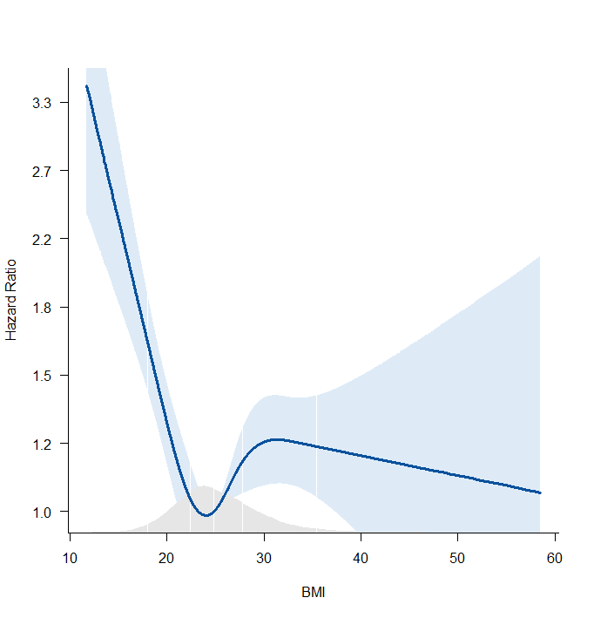
Age adjusted (Male) | Age adjusted (Female)
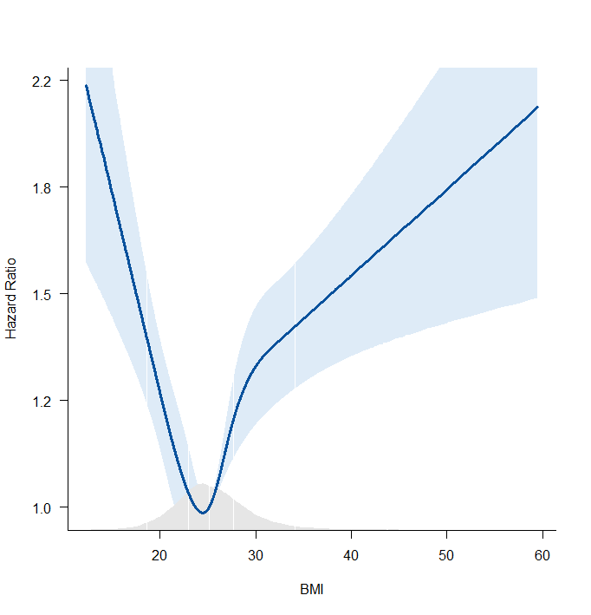 | 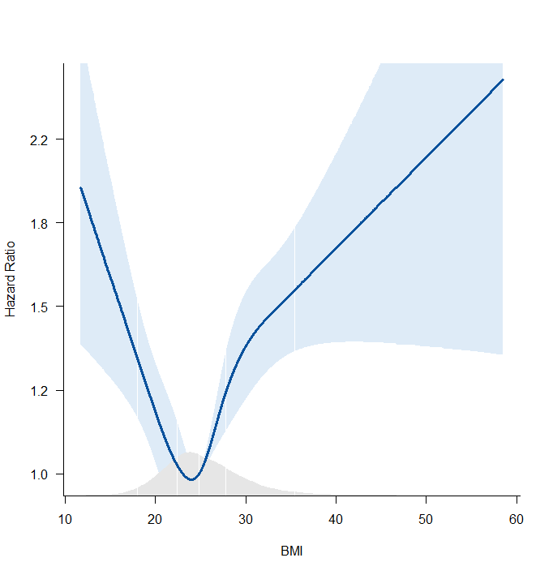
Model 1 (Male) | Model 1 (Female)
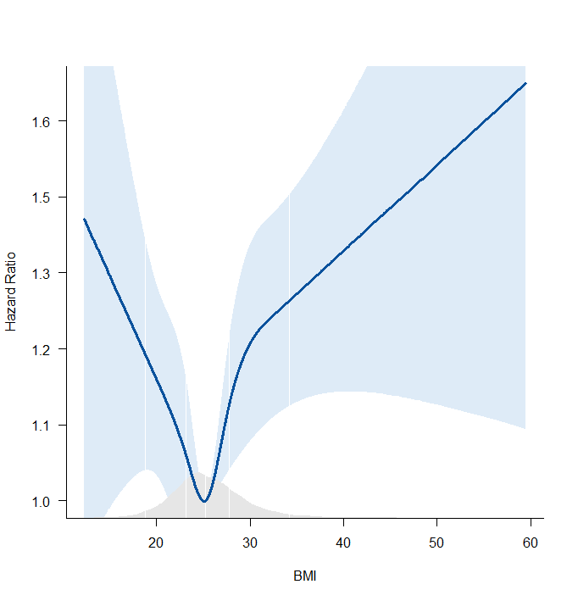 | 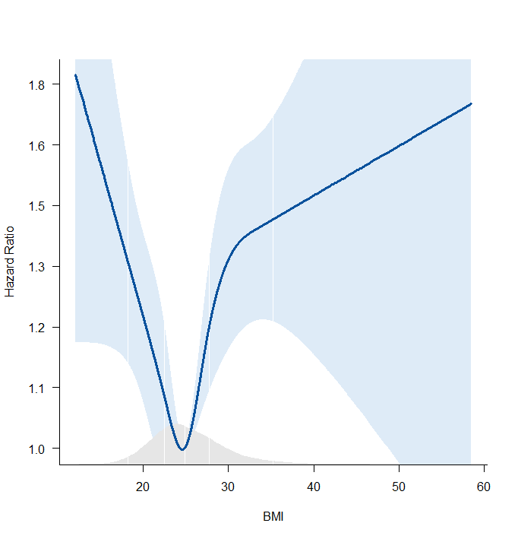
Model 2 (Male) | Model 2 (Female)
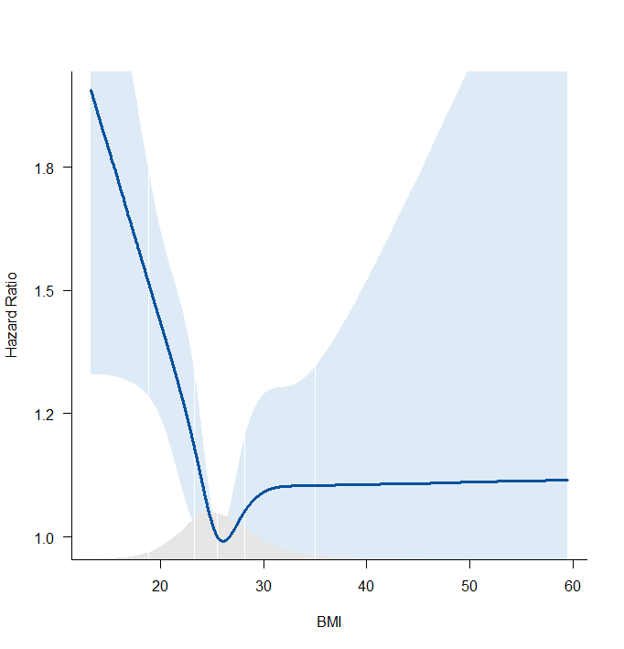 | 