Additional data to:

Mutational signature analysis in non-small cell lung cancer patients with a high tumor mutational burden
Guus R.M. van den Heuvel, MDᵃ; Leonie I. Kroeze, PhDᵇ; Marjolijn J.L. Ligtenberg, PhDᵇ,ᶜ; Katrien Grünberg, PhDᵇ; Erik A.M. Jansen, BScᶜ; Daniel von Rhein, PhDᶜ; Richarda M. de Voer, PhDᶜ **; Michel M. van den Heuvel, MD, PhDᵃ **

ᵃ Department of Pulmonology, Radboud university medical center, Nijmegen, Netherlands
ᵇ Department of Pathology, Radboud university medical center, Nijmegen, Netherlands
ᶜ Department of Human Genetics, Radboud university medical center, Nijmegen, Netherlands
** These authors contributed equally to this work

Running title: Mutational Signatures in Lung Cancer Patients
Corresponding author: M.M. van den Heuvel, Department of Pulmonology, Radboud University Medical Center, Postbox 9101, 6500 HB, Nijmegen, The Netherlands. Email: michel.vandenheuvel@radboudumc.nl
Funding: The authors received no financial support for the research, authorship, or publication of this article
Conflict of interests: The participating authors have no conflicts of interest to declare

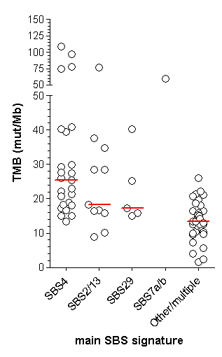
Additional file 2: Figure S1: Tumor mutational burden (TMB) in samples for which mutational signatures could be determined. When a single mutational signature contributed >20% in a tumor sample it was assigned to the specific SBS signature. Red line represents the median TMB.

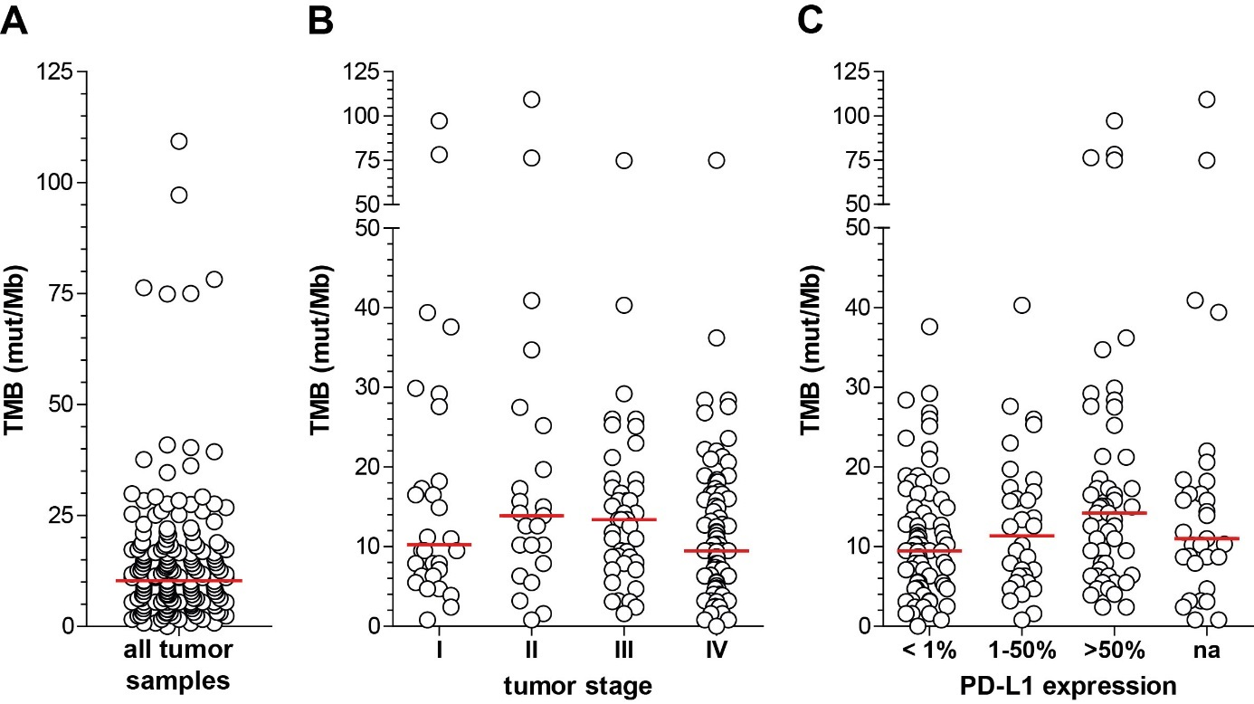

Additional file 2: Figure S2: Tumor mutational burden (TMB) of non-small cell lung cancer samples. A) TMB all tumor samples. B) TMB according to tumor stages. C)
TMB according to PD-L1 expression. Red line represents the median TMB.

Additional file 2: Table S2: Patient and tumor characteristics according to TMB status
Characteristic | All patients | Patients with total TMB < 10 | Patients with total TMB ≥ 10 | P-value**
Age at enrollment - years
Mean ± SD | 66.8 ± 9.2 | 68.4 ± 9.3 | 65.4 ± 9.0 | .0247
Median (range) | 68 (34-88) | 70 (42-88) | 67 (34-84)
Sex - no. (%)
Female | 88 (45) | 40 (45) | 48 (55) | .8860
Male | 107 (55) | 50 (47) | 57 (53)
Histologic diagnosis - no. (%)
Adenocarcinoma | 110 (56) | 57 (52) | 53 (48) | .08284
Squamous-cell carcinoma | 42 (22) | 17 (40) | 25 (60) | .48540
Large cell neuroendrocrine carcinoma | 11 (6) | 4 (36) | 7 (64) | .55090
Other | 32 (16) | 12 (38) | 20 (62) | .33460
Clinical stage - no. (%)*
I | 30 (15) | 15 (50) | 15 (50) | .69340
II | 23 (12) | 6 (26) | 17 (74) | .04623
III | 44 (23) | 16 (36) | 28 (64) | .16980
IV | 98 (50) | 53 (54) | 45 (46) | .03128
Smoking status - no. (%)
Active or former | 180 (92) | 81 (45) | 99 (55) | .29190
Never | 13 (7) | 9 (69) | 4 (31) | .09370
Unknown | 2 (1) | 0 (0) | 2 (100) | .50040
PD-L1 status – no. (%)
<1% | 80 (41 | 44 (55) | 36 (45) | .04218
1-50% | 32 (16) | 15 (47) | 17 (53) | 1
>50% | 52 (27) | 19 (37) | 33 (63) | .14340
Unknown | 31 (16) | 12 (39) | 19 (61) | .43400
* According to the IASLC TNM classification 8th edition
** Fisher’s exact test for number of samples in each category
TMB: tumor mutational burden, defined as number of somatic mutations per megabase

Additional file 2: Table S3: Genes somatically mutated according to TMB status
Gene | Total number of patients (%) | Median  TMB | Number of patients with total TMB < 10 | Number of patients with total TMB ≥ 10 | P-value*
TP53 | 138 (71) | 12.2 | 55 (28) | 83 (43) | 0.0073
KRAS | 56 (29) | 11.4 | 25 (13) | 31 (16) | 0.8742
STK11 | 26 (13) | 14.2 | 6 (3) | 20 (10) | 0.0117
EGFR | 20 (10) | 5.5 | 13 (7) | 7 (4) | 0.0975
KEAP1 | 15 (8) | 13.6 | 4 (2) | 11 (6) | 0.1767
PIK3CA | 14 (7) | 9.5 | 7 (4) | 7 (4) | 0.7877
BRAF | 7 (4) | 10.2 | 2 (1) | 5 (3) | 0.4545
FGFR1 | 4 (2) | 8.26 | 2 (1) | 2 (1) | 1
CDK4 | 3 (2) | 15.0 | 0 (0) | 3 (2) | 0.2506
ALK | 3 (2) | 3.2 | 2 (1) | 1 (.5) | 0.5962
ERBB2 | 3 (2) | 11.2 | 1 (.5) | 2 (1) | 1
KIT | 2 (1) | 11.0 | 1 (.5) | 1 (.5) | 1
PDGFRA | 1 (.5) | 12.6 | 0 (0) | 1 (.5) | 1
HRAS | 1 (.5) | 39.4 | 0 (0) | 1 (.5) | 1
CDK6 | 1 (.5) | 4.7 | 1 (.5) | 0 (0) | 0.4615
CCND1 | 1 (.5) | 17.3 | 0 (0) | 1 (.5) | 1
MET | 1 (.5) | 17.3 | 0 (0) | 1 (.5) | 1
* Fisher’s exact test for number of samples in each category
TMB: tumor mutational burden, defined as number of somatic mutations per megabase
Amplification was established once in KRAS (13 copies), 4 times in EGFR (5, 8, 15 and 103 copies), 3 times in PIK3CA (10, 15 and 20 copies), twice in FGFR1 (7 and 10 copies), once in CDK4 (29 copies), once in ERBB2 (92 copies), once in KIT (16 copies), once in HRAS (10-20 copies) and twice in MET (12 and 15 copies).

Additional file 2: Table S4: Genes somatically mutated according to presence of specific mutational signatures
Gene (% mutated) | Total number of patients (n = 76) | SBS4  (n = 25) | SBS2/13  (n = 11) | SBS29  (n = 5)
TP53 | 60 (79) | 22 (88) | 9 (82) | 3 (60)
KRAS | 25 (33) | 6 (24) | 3 (27) | 2 (40)
STK11 | 15 (20) | 6 (24) | 0 (0) | 1 )20)
EGFR | 6 (8) | 2 (8) | 1 (9) | 0 (0)
KEAP1 | 8 (11) | 2 (8) | 1 (9) | 0 (0)
PIK3CA | 6 (8) | 0 (0) | 3 (27) | 0 (0)
BRAF | 3 (4) | 1 (4) | 1 (9) | 0 (0)
FGFR1 | 1 (1) | 0 (0) | 0 (0) | 1 (20)
CDK4 | 3 (4) | 1 (4) | 0 (0) | 0 (0)
ALK | 1 (1) | 0 (0) | 0 (0) | 0 (0)
ERBB2 | 1 (1) | 0 (0) | 0 (0) | 0 (0)
HRAS | 1 (1) | 1 (4) | 0 (0) | 0 (0)
CCND1 | 1 (1) | 1 (4) | 0 (0) | 0 (0)
MET | 1 (1) | 1 (4) | 0 (0) | 0 (0)
Amplification was established once in KRAS (13 copies), 2 times in EGFR (15 and 103 copies), once in CDK4 (29 copies), once in HRAS (10-20 copies) and once in MET (12 copies).

