Supplementary material
Beneficial effect of gelatin on iron gall ink corrosion
Alice Gimat¹, Anne Michelin¹, Pascale Massiani², Véronique Rouchon¹

¹ Sorbonne Université, Muséum National d'Histoire Naturelle, Centre de Recherche sur la Conservation des Collections (CRC, CNRS USR 3224), 36 rue Geoffroy St Hilaire 75005 Paris, France
² Sorbonne Université, Campus UPMC, Laboratoire de Réactivité de Surface, CNRS UMR 7197, 4 place Jussieu, 75005 Paris, France
Corresponding author: alice.gimat@mnhn.fr

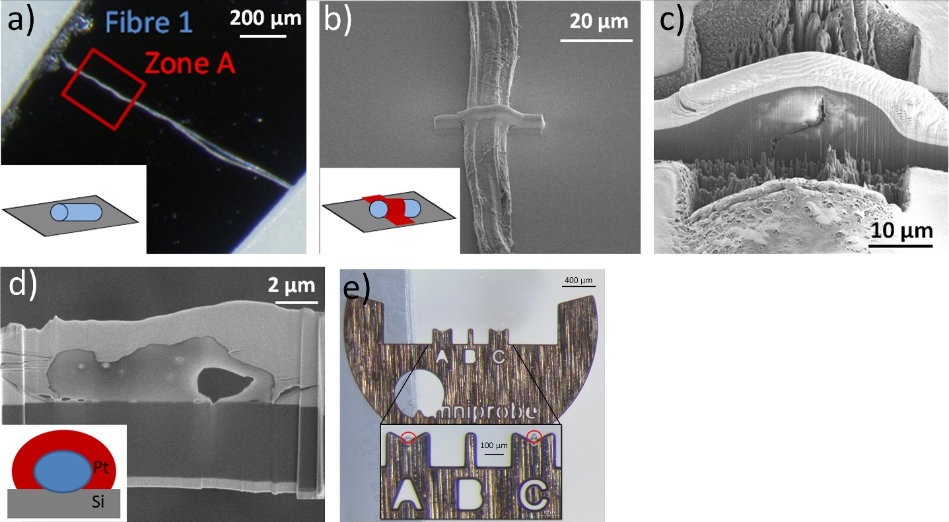
Fig. S1 Sample preparation protocol by Focussed Ion beam (FIB). a inked fiber on a silicon wafer; b) Pt deposit to protect the fiber and avoid sample charging; c) trenches done with FIB (Ga ions beam) from each sides of the section; d) thin cross-section of the sample fiber, surrounded by Pt (above) and Si wafer (below); d) thin cross-sections on the A and C V-shape copper sample holder.

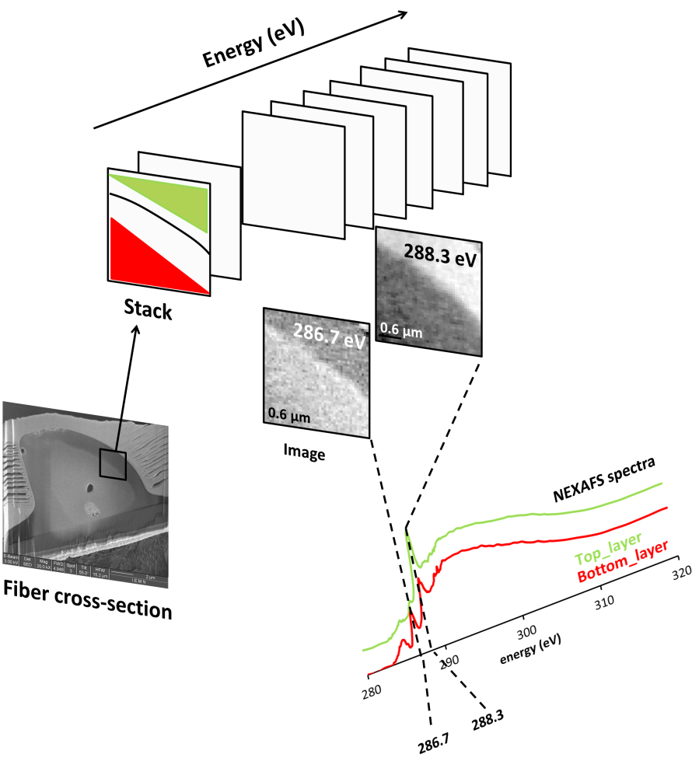
Fig. S2 STXM principle
An area of the fiber cross-section is scanned in x and y (2D map) at every chosen soft X-rays energy to obtain a 3D stack. Each 2D image can then be visualized at each energy and gives a more or less bright area depending on the absorption. For example, at 286.7 eV, the bottom layer (red) is brighter than the top layer (green) as Rag cellulose absorbs more than gelatin at this energy. At 286.3 eV, the trend is reversed. From the stack, a spectrum can also be extracted by selecting a region of interest: the red and green regions give the respective spectra which show specific absorption of the components.
Tab. S1 STXM NEXAFS measurements conditions
C K-edge
Start E (eV) | End E (eV) | Range (eV) | Points | Step (eV) | Dwell time (ms)
270 | 283 | 13 | 15 | 1 | 1
283.2 | 292 | 8.8 | 89 | 0.1 | 1
292.2 | 305 | 12.8 | 27 | 0.492 | 1
305.2 | 325 | 19.8 | 14 | 1.523 | 1

N K-edge
Start E (eV) | End E (eV) | Range (eV) | Points | Step (eV) | Dwell time (ms)
395 | 398 | 3 | 7 | 1 | 1
398.2 | 408 | 9.8 | 66 | 0.1 | 1
408.2 | 415 | 6.8 | 15 | 0.492 | 1
415.5 | 435 | 19.5 | 21 | 1.523 | 1

Fe K-edge
Start E (eV) | End E (eV) | Range (eV) | Points | Step (eV) | Dwell time (ms)
700 | 706 | 6 | 7 | 1 | 1
706.2 | 714 | 7.8 | 40 | 0.2 | 1
714.2 | 720 | 5.8 | 7 | 0.9677 | 1
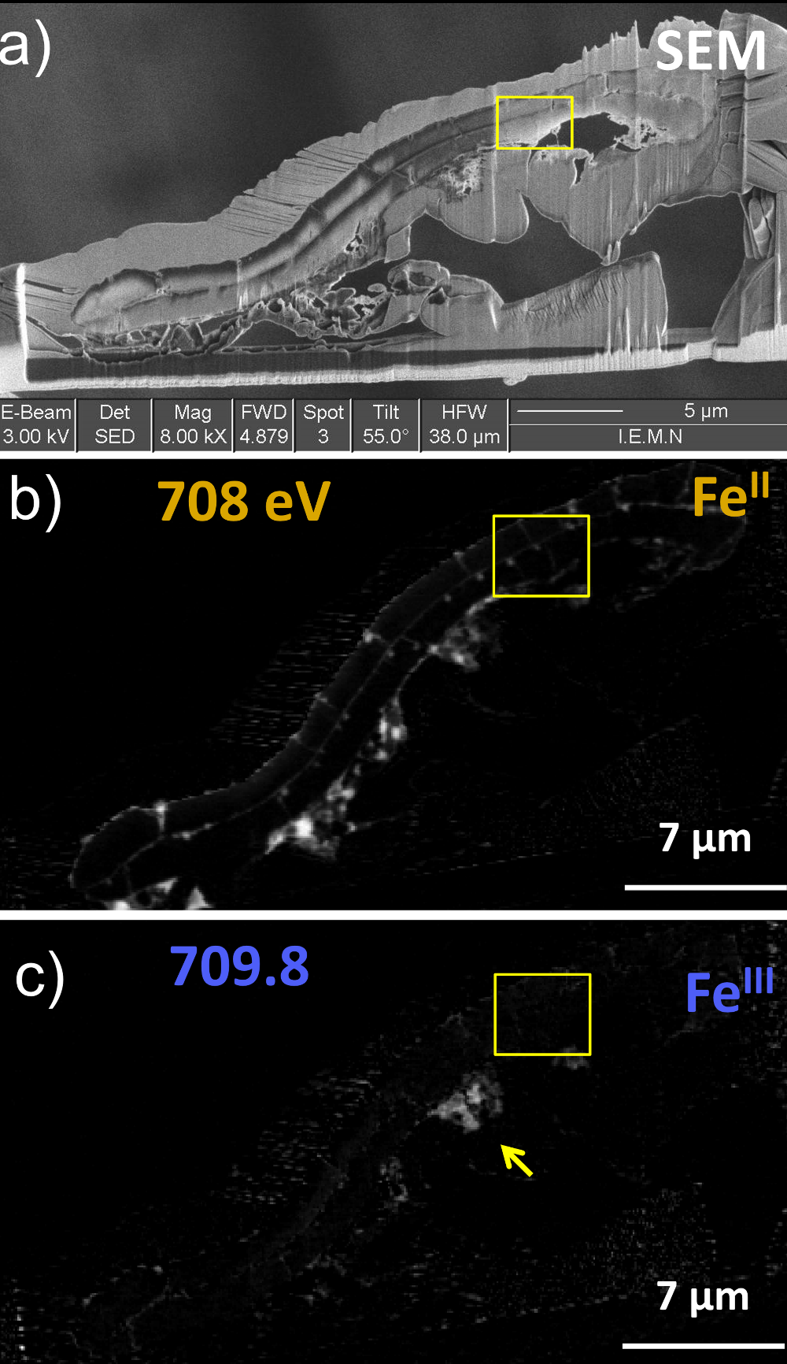
Fig. S3 Fiber I thin cross-section: a) SEM observation, b) and c) STXM maps at the Fe L-edge. Map at 708 eV (after subtraction of map at 700 eV) represent Fe^{II} distributions; map at 709.8 eV (after subtraction of map at 708 eV) represents Fe^{III} distributions. Arrow represents a region with a precipitate deposit at cross-section surface.

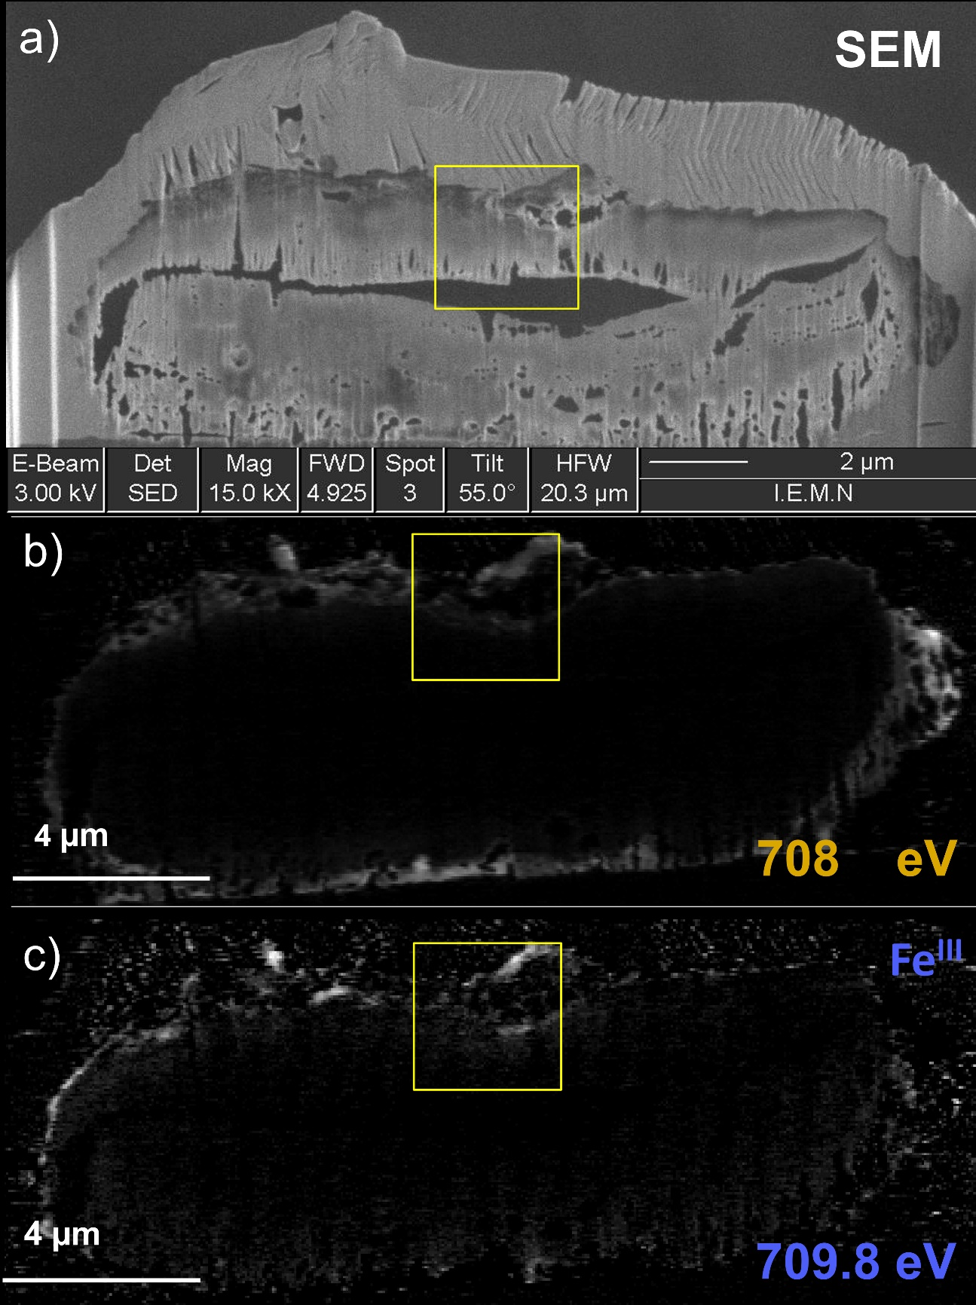
Fig. S4 Fiber G_I thin cross-section: a) SEM observation, b) and c) STXM maps at the Fe L-edge. Map at 708 eV (after subtraction of map at 700 eV) represent Fe^{II} distributions; map at 709.8 eV (after subtraction of map at 708 eV) represents Fe^{III} distributions.

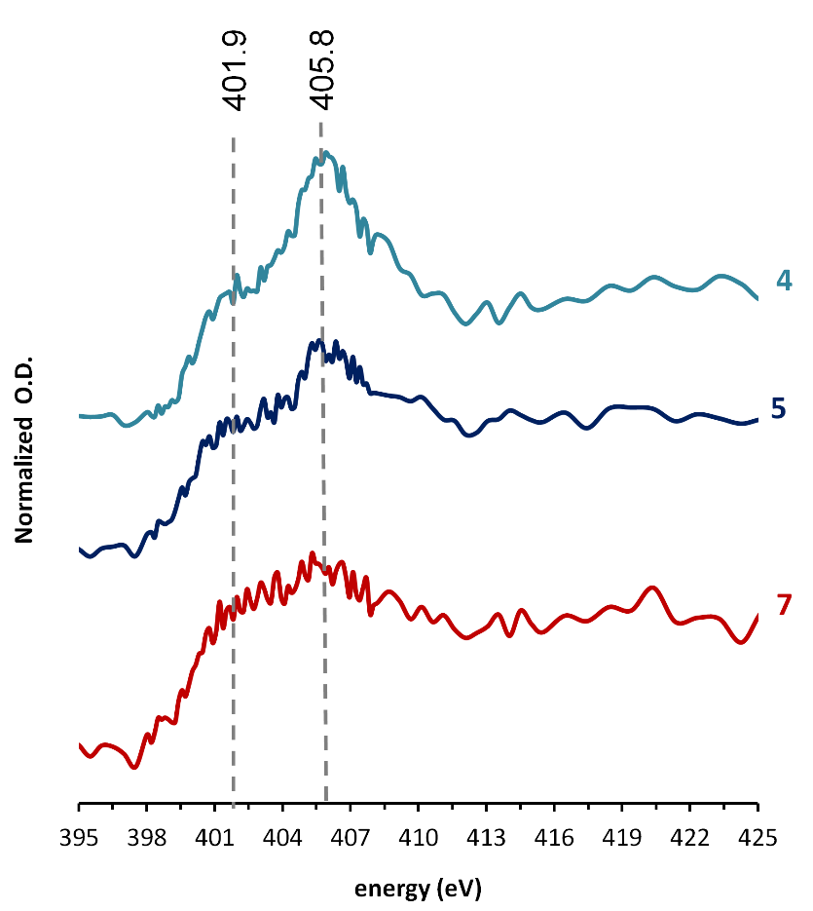
Fig. S5 NEXASF spectra of three different regions of fiber G_I at the N-K edge (see Fig. 4).
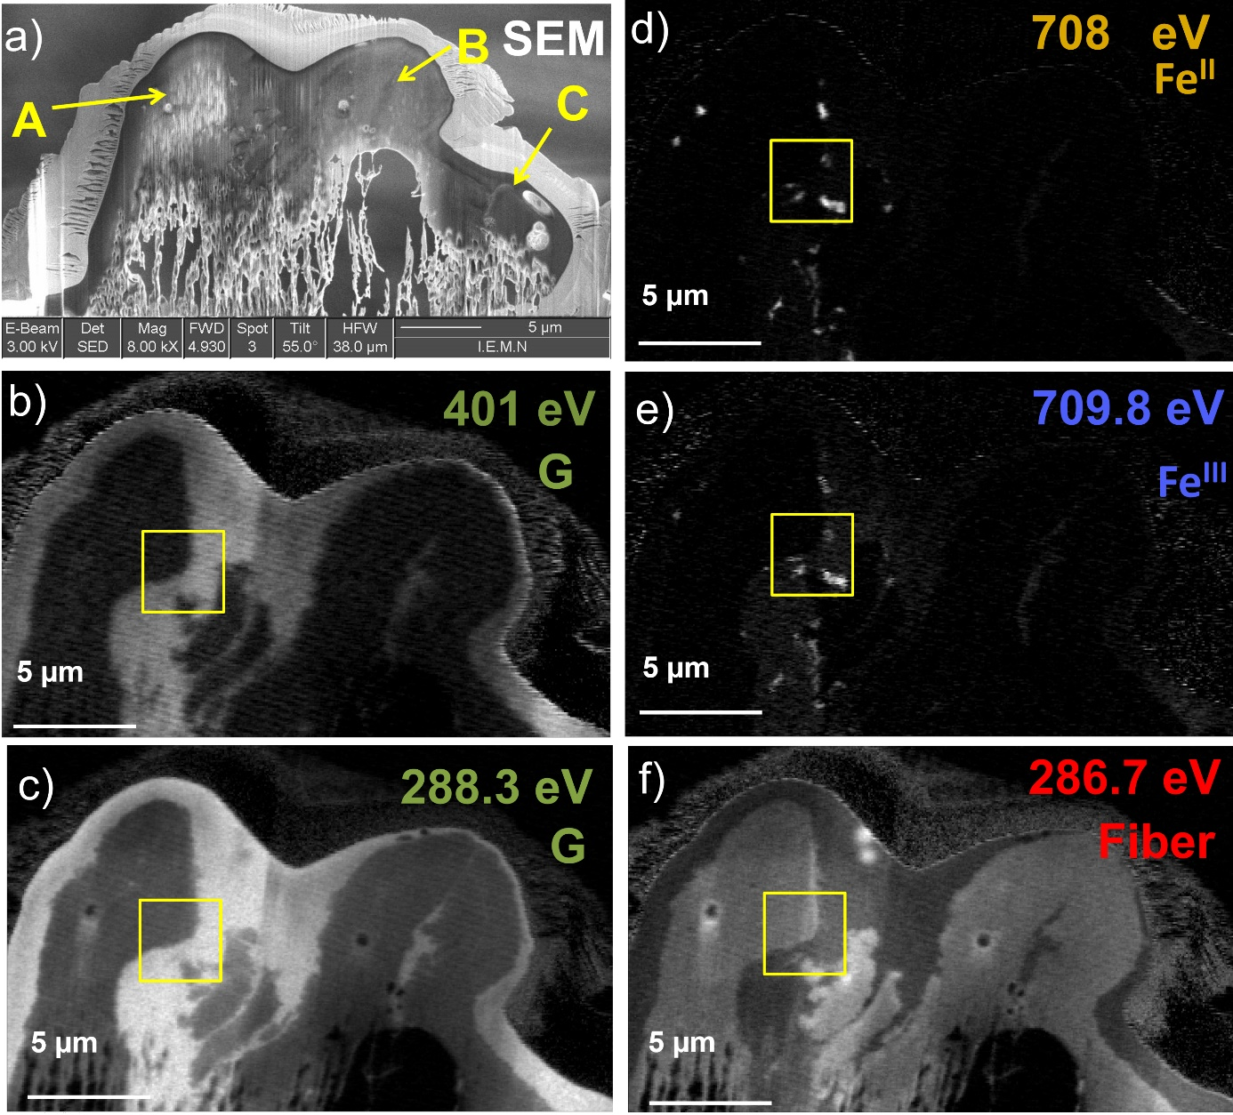
Fig. S6 Fiber I_G thin cross-section: a) SEM observation, b) STXM map at N K-edge: 401 eV (subtracted by maps at 398 eV) representing gelatin distribution c) and f) STXM at the C K-edge at 288.3 eV and 286.7 eV (from which maps at 280 eV were subtracted), representing respectively gelatin and fiber major presence in bright. d) and e) STXM maps at the Fe L-edge. Map at 708 eV (after subtraction of map at 700 eV) represent Fe^{II} distributions; map at 709.8 eV (after subtraction of map at 708 eV) represents Fe^{III} distributions.

