Supplemental Information for:

Facilitating population genomics of non-model organisms through optimized experimental design for reduced representation sequencing
Henrik Christiansen^{1*}, Franz M. Heindler¹, Bart Hellemans¹, Quentin Jossart², Francesca Pasotti³, Henri Robert⁴, Marie Verheye⁴, Bruno Danis⁵, Marc Kochzius², Frederik Leliaert^{3,6}, Camille Moreau^{5,7}, Tasnim Patel⁴, Anton P. Van de Putte^{1,4,5}, Ann Vanreusel³, Filip A. M. Volckaert¹ & Isa Schön⁴

¹ KU Leuven, Laboratory of Biodiversity and Evolutionary Genomics, Leuven, Belgium
² Vrije Universiteit Brussel (VUB), Marine Biology Group, Brussels, Belgium
³ Ghent University, Marine Biology Research Group, Ghent, Belgium
⁴ Royal Belgian Institute of Natural Sciences, OD Nature, Brussels, Belgium
⁵ Université Libre de Bruxelles (ULB), Marine Biology Laboratory, Brussels, Belgium
⁶ Meise Botanic Garden, Meise, Belgium
⁷ Université de Bourgogne Franche-Comté (UBFC) UMR CNRS 6282 Biogéosciences, Dijon, France

*Correspondence: Henrik Christiansen
henrik.christiansen@kuleuven.be

Additional File 3. Comparisons of empirical and in silico restriction enzyme digestions. Empirical Bioanalyzer results (left figure panels) with digested DNA are shown as concentration over fragment size and estimated loci numbers over locus size from in silico digestions (right figure panels) for all target taxa except fish (these are shown in Fig. 1).

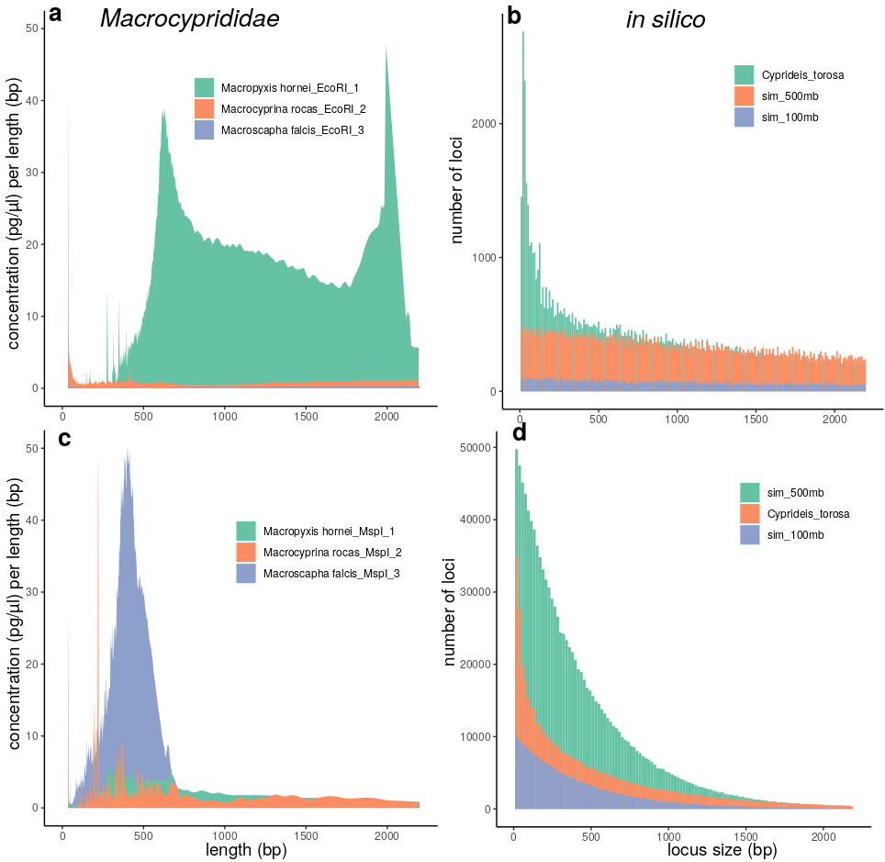
Figure S3.1. Empirical Bioanalyzer results with digested DNA are shown as concentration over fragment size (a, c) and estimated loci numbers over locus size from in silico digestions (b, d). The tests were conducted with restrictions enzymes EcoRI (a, b) and MspI (c, d). Results for the ostracod species Macropyxis hornei, Macrocyprina rocas and Macroscapha falcis are shown next to in silico estimates using a related reference genome of Cyprideis torosa and two simulated genomes of 100 and 500 Mb size.

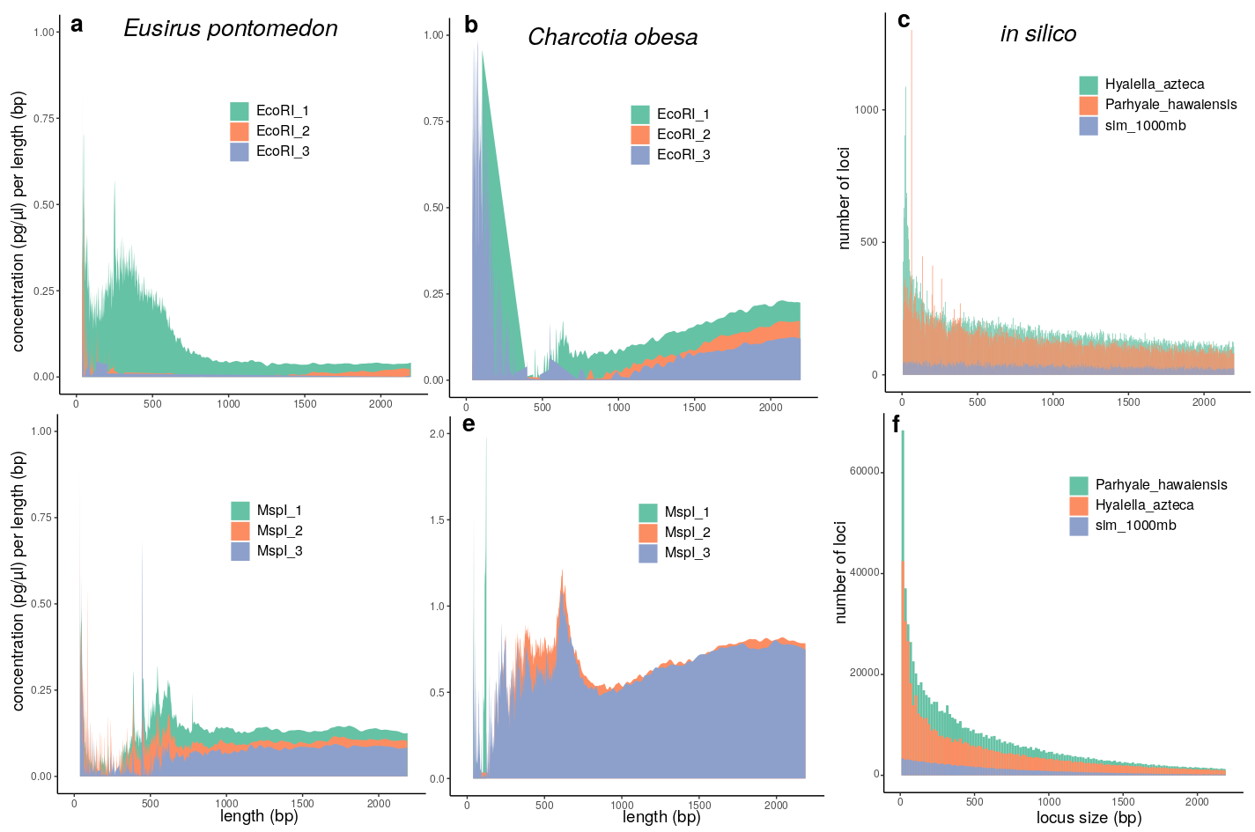Figure S3.2. Empirical Bioanalyzer results with digested DNA are shown as concentration over fragment size (a, b, d, e) and estimated loci numbers over locus size from in silico digestions (c, f). The tests were conducted with restrictions enzymes EcoRI (a, b, c) and MspI (d, e, f). Results for the amphipods species Eusirus pontomedon (b, e) and Charcotia obesa (a, d) are shown next to in silico estimates using reference genomes of Hyalella azteca, Parhyale hawaiensis and one simulated genome of 1000 Mb size (note that this was the absolute size used for in silico computations, but resulting estimates were extrapolated to 10,000 Mb).

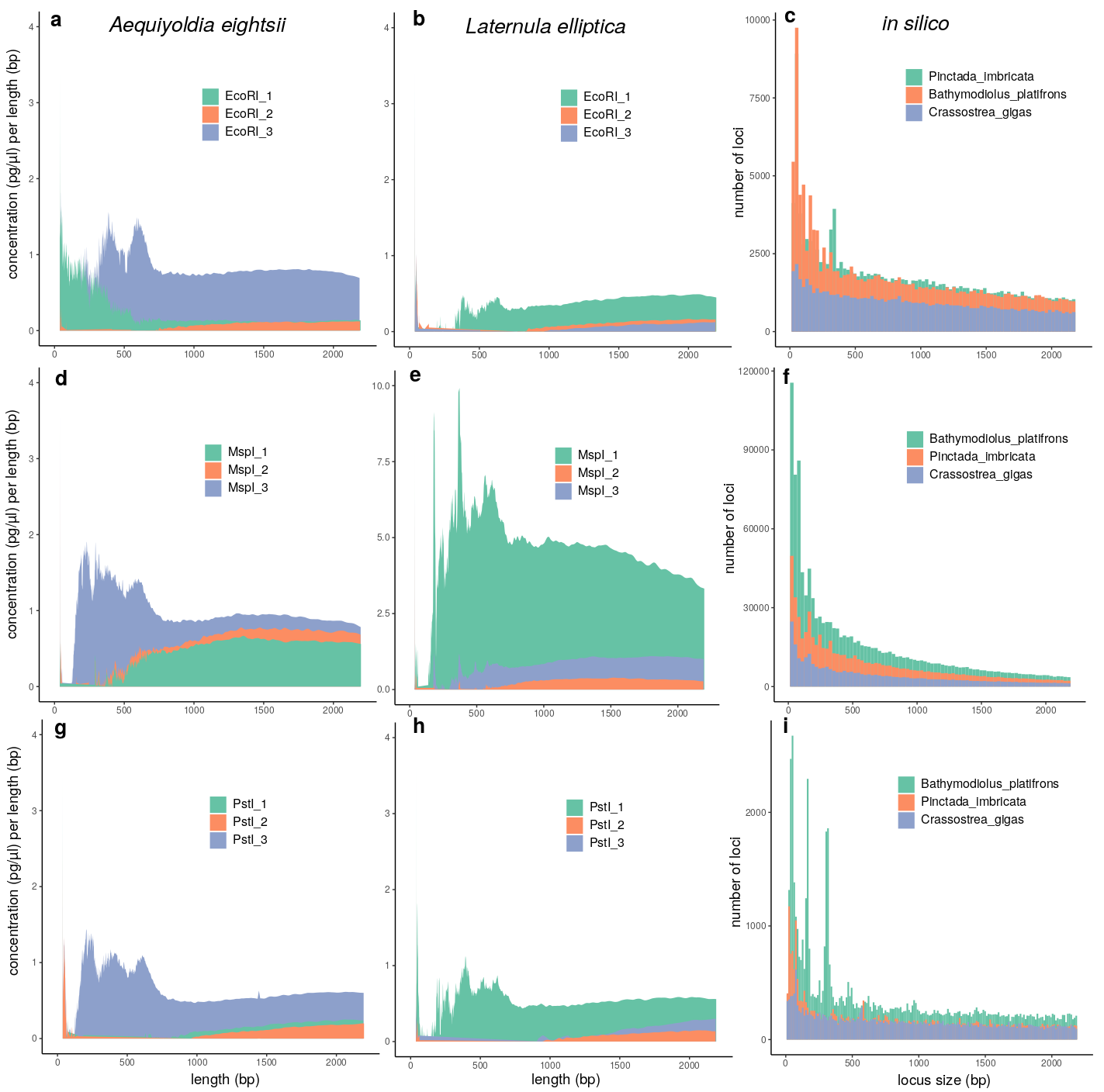Figure S3.3. Empirical Bioanalyzer results with digested DNA are shown as concentration over fragment size (a, b, d, e, g, h) and estimated loci numbers over locus size from in silico digestions (c, f, i). The tests were conducted with restrictions enzymes EcoRI (a, b, c), PstI (d, e, f) and MspI (g, h, i). Results for the bivalve species Aequiyoldia eightsii (a, d, g) and Laternula elliptica (b, e, h) are shown next to in silico estimates using reference genomes of Bathymodiolus platifrons, Crassostrea gigas and Pinctada imbricata.

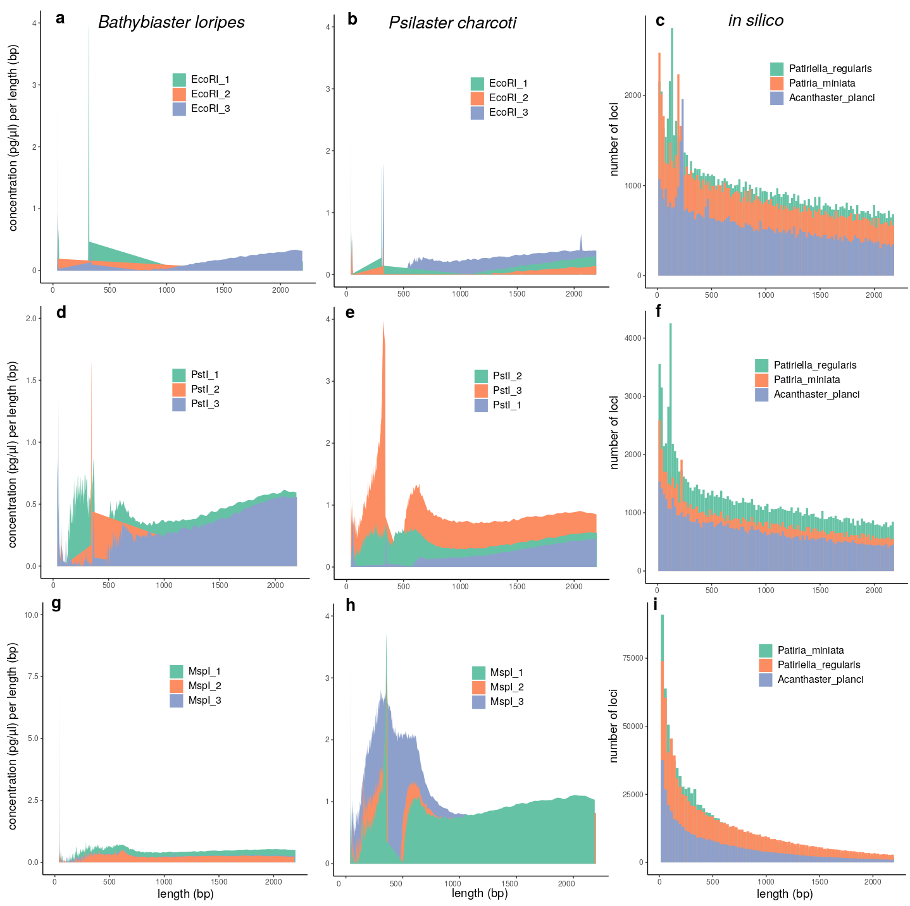Figure S3.4. Empirical Bioanalyzer results with digested DNA are shown as concentration over fragment size (a, b, d, e, g, h) and estimated loci numbers over locus size from in silico digestions (c, f, i). The tests were conducted with restrictions enzymes EcoRI (a, b, c), PstI (d, e, f) and MspI (g, h, i). Results for the sea star species Bathybiaster loripes (a, d, g) and Psilaster charcoti (b, e, h) are shown next to in silico estimates using reference genomes of Acanthaster planci, Patiria miniata, and Patiruella regularis.

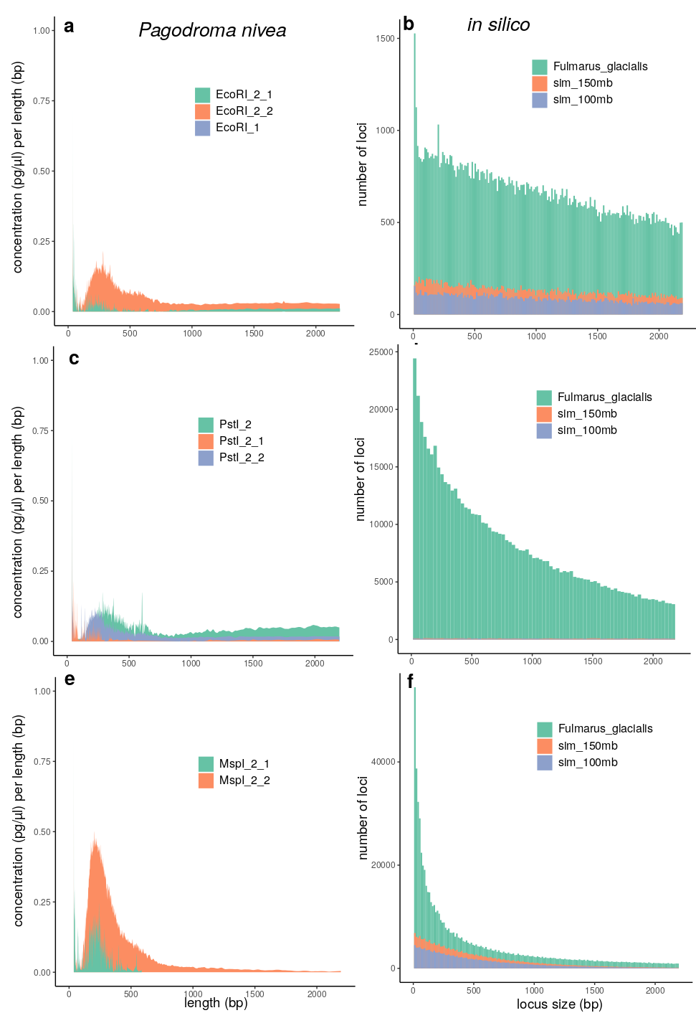
Figure S3.5. Empirical Bioanalyzer results with digested DNA are shown as concentration over fragment size (a, c, e) and estimated loci numbers over locus size from in silico digestions (b, d, f). The tests were conducted with restrictions enzymes EcoRI (a, b), PstI (c, d) and MspI (e, f). Results for the bird species Pagodroma nivea are shown next to in silico estimates using a related reference genome of Fulmarus glacialis and two simulated genomes of 100 and 150 Mb size (note that this was the absolute size used for in silico computations, but resulting estimates were extrapolated to 1000 and 1500 Mb).

