Additional file 7: Fig. S1. Relationship between theoretical probability of identity and number of loci assayed using four heterozygosity levels.
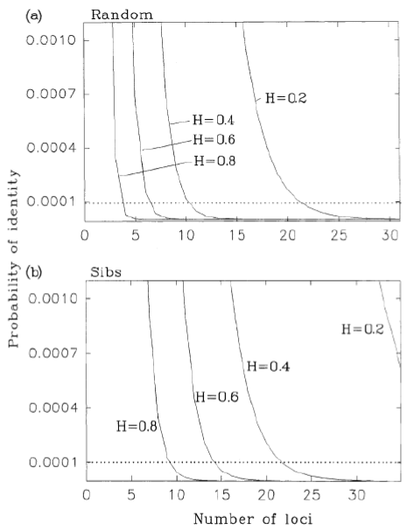
(a) randomly sampled individuals and (b) sibs. From [37].

