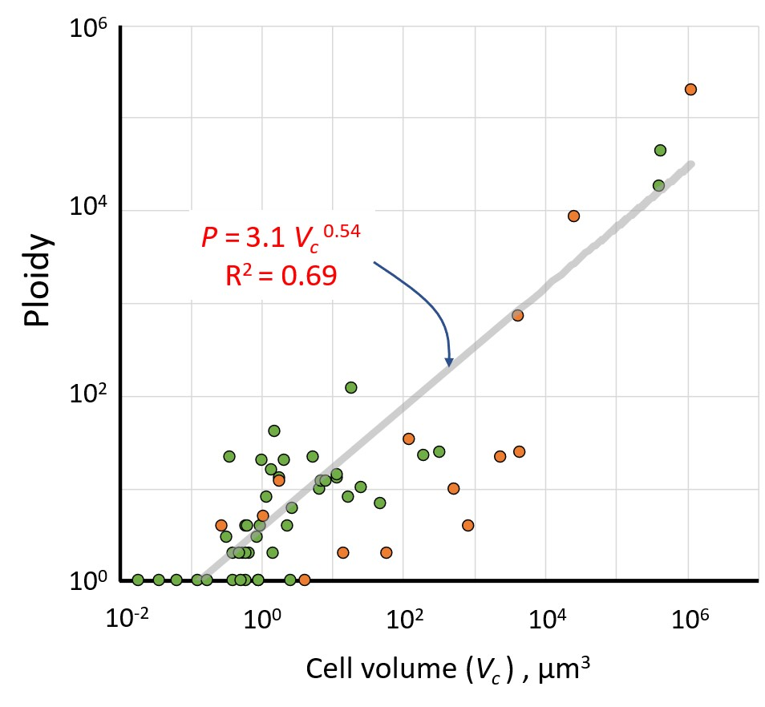
Fig. S3. Relationship between ploidy (P) and cell volume (V_{c}) in microbes (n = 56), plotted as a log/log graph. The grey line is a power fit with the equation displayed in red type (fit statistics are in Suppl. Table 2). Datapoints belonging to eukaryotes are in orange, those for prokaryotes in green.

