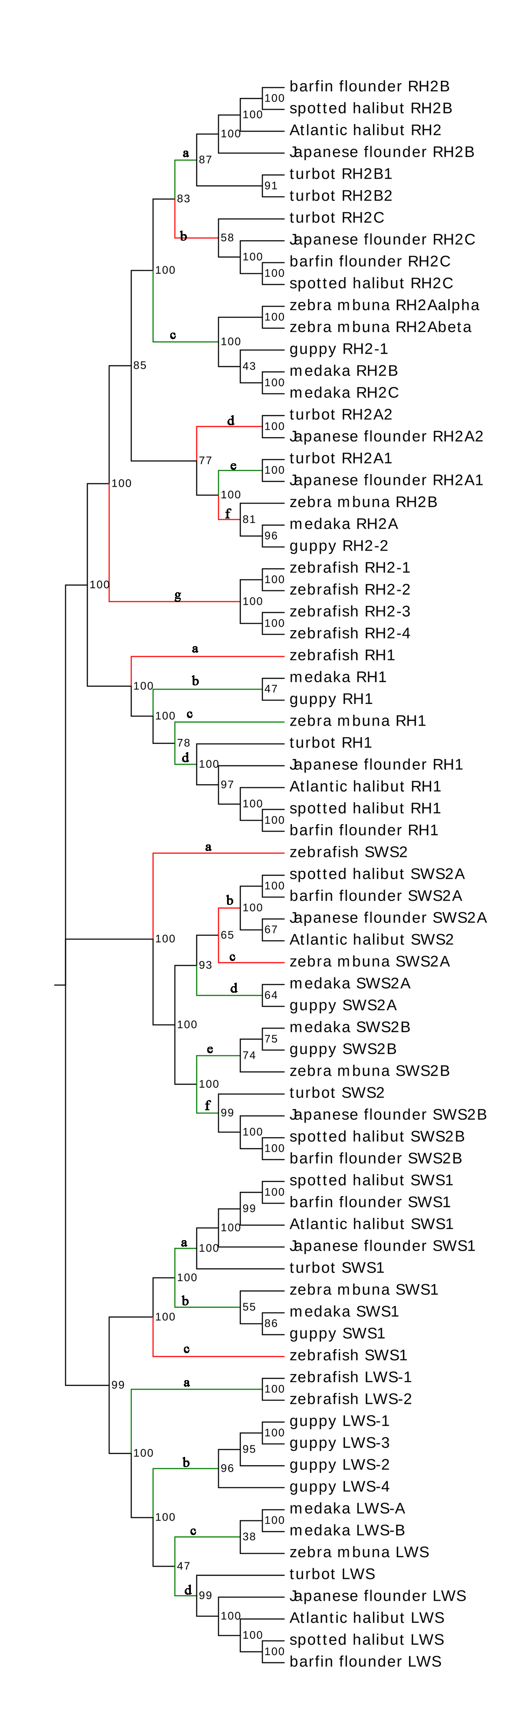
Fig. S1: Phylogenetic tree used for branch and branch-site test of selection which obtained by the neighbor-joining method. The bootstrap test (1000 replicates) scores are shown on the nodes. Branches marked in red or green were selected for branch-site models analysis: red indicates that several sites under positive selection were detected, and green indicates the opposite. Different letters marked near the branches represent the settings of the different foreground branches introduced in section 2.2.

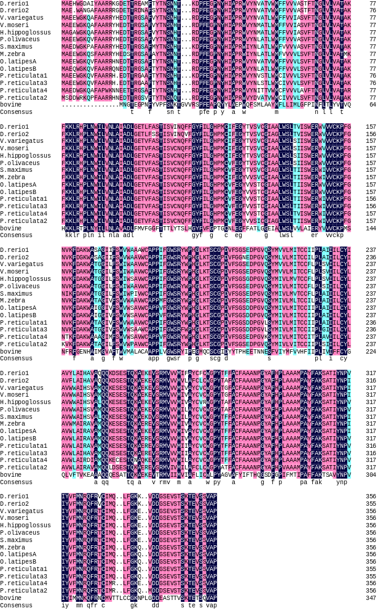
Fig. S2: The amino acid alignments of teleost LWS opsins.

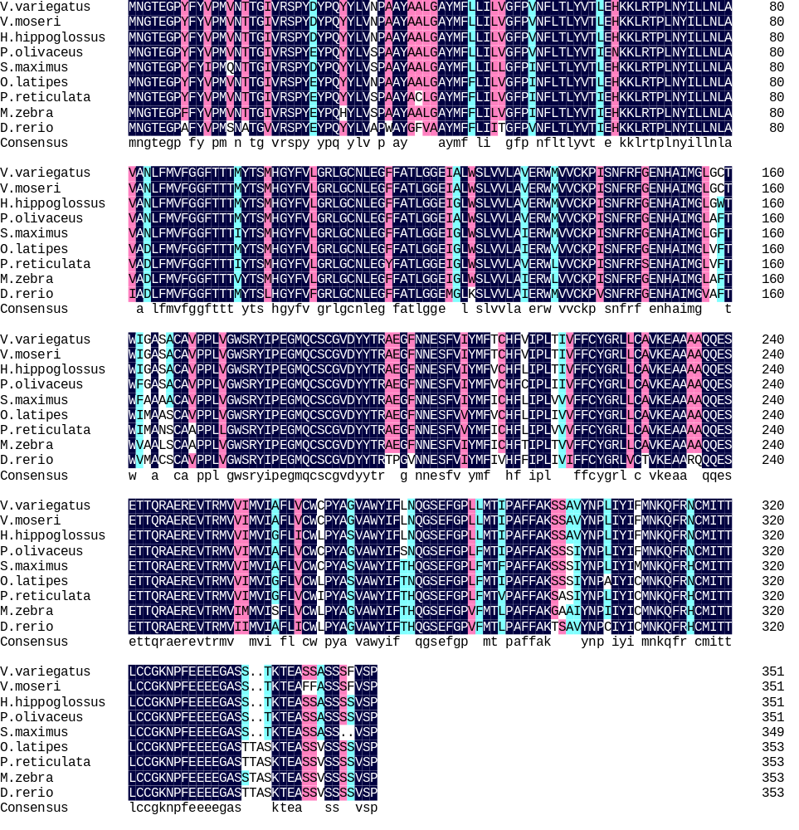
Fig. S3: The amino acid alignments of teleost RH1 opsins.

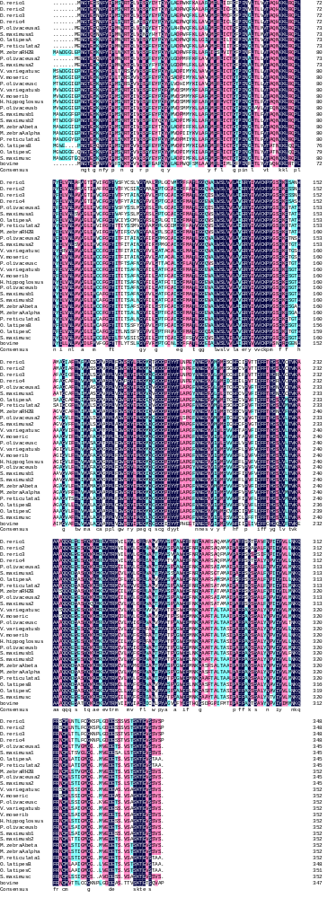
Fig. S4: The amino acid alignments of teleost RH2 opsins.
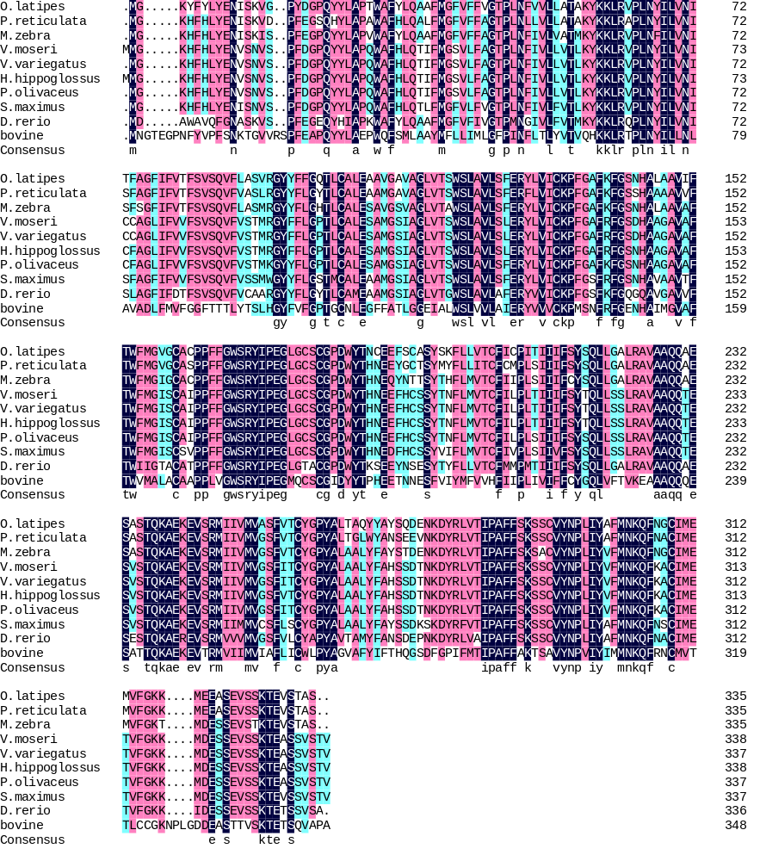
Fig. S5: The amino acid alignments of teleost SWS1 opsins.

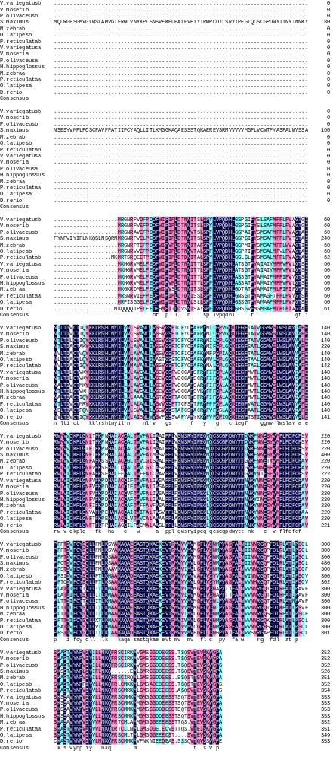
Fig. S6: The amino acid alignments of teleost SWS2 opsins.
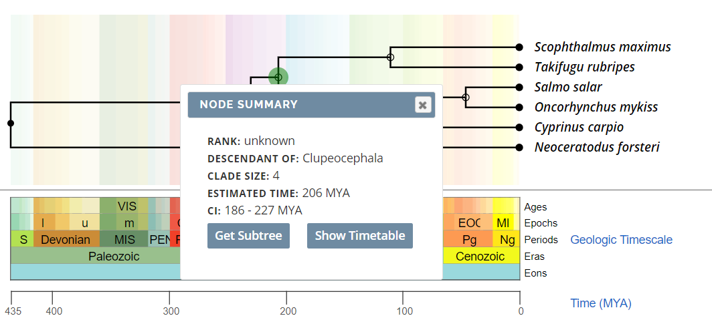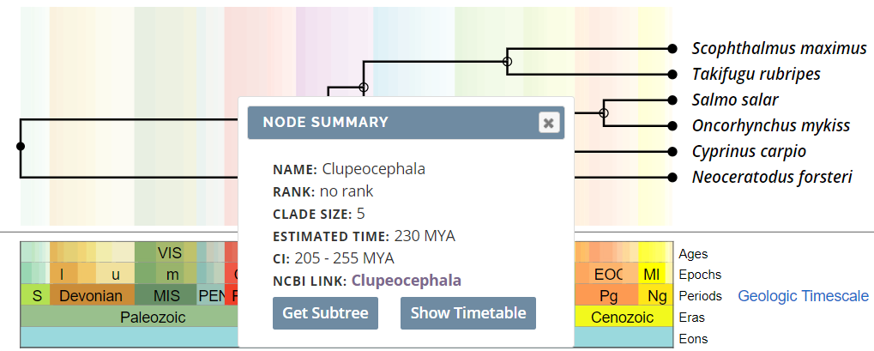

Fig. S7: The fossil calibrations adopted from TimeTree.

Table S1. Nucleotide sequences of oligonucleotide primers.
Gene | Primer sequence (5’—3’) | PCR efficiency (%) | Annealing temperature (℃)
RH1 | AACGACTGAAGGCTAATGT | 102.6 | 57
 | AACTCTGTAATGGGCTGAC | 102.6 | 57
LWS | TATTGCGTATGCTGGGGAC | 95.9 | 58
 | TGGGTTGTATATGGTGGCG | 95.9 | 58
SWS1 | AAACACTTCCACCTGTATGAG | 100.4 | 58
 | TGACGAGGATGTAGTTGAGA | 100.4 | 58
SWS2 | CATACCCTCCTGCCTCTCCA | 93.8 | 58
 | AATCCTCATCATCGCCTCCA | 93.8 | 58
RH2A1 | GCAGTCAAACGATTCCCAT | 98.0 | 58
 | GTTCCTCTAACAACCACCAAAA | 98.0 | 58
RH2A2 | CTATCCACCAGCAAGACAGAAG | 105.3 | 58
 | CCATTTCAAGTTAGCCATTCAG | 105.3 | 58
RH2B1 | TTGACCAGTGACGAATGGCTCC | 95.1 | 57
 | GCTGAGAGATTCCTGTTCCCCG | 95.1 | 57
RH2B2 | TTACCGATTGCTTCCAGATTTC | 99.3 | 58
 | ATGAGGCGGCATTCCTTTGTGT | 99.3 | 58
RH2C | CTGTGGACGCTCTCCTTGAC | 99.9 | 57
 | GACTTGCGAGTTGAGGTGAA | 99.9 | 57

Table S2. Comparison of representative spectral tuning sites among teleost SWS2 opsins.

Tuning site |  | 52 | 55 | 58 | 99 | 100 | 122 | 124 | 170 | 213 | 275 | 301
spotted halibut | SWS2A | F | V | T | V | G | M | T | A | L | T | S
spotted halibut | SWS2B | F | V | T | T | C | T | T | A | L | A | S
barfin flounder | SWS2A | F | V | T | V | G | M | T | A | L | T | S
barfin flounder | SWS2B | F | V | T | T | C | T | T | A | L | A | S
Atlantic Halibut | RH2 | F | V | T | V | G | M | T | A | L | A | S
Japanese flounder | SWS2A | F | V | T | V | G | M | T | A | L | A | S
Japanese flounder | SWS2B | F | V | T | T | C | T | T | A | L | A | S
turbot | SWS2 | F | V | T | T | C | S | T | A | L | A | S
cichlids | SWS2A | F | I | T | T | A | M | T | A | L | A | S
cichlids | SWS2B | F | V | T | T | C | T | S | A | L | A | S
medaka | SWS2A | F | V | T | T | A | A | T | A | L | A | S
medaka | SWS2B | V | V | T | T | C | T | A | A | L | A | S
guppy | SWS2A | F | V | T | T | T | V | T | A | L | A | S
guppy | SWS2B | F | V | T | T | C | T | T | A | L | A | S
zebrafish | SWS2 | F | I | T | V | A | T | T | A | L | A | C

Table S3. Comparison of representative spectral tuning sites among teleost SWS1 opsins.
Tuning site | 46 | 49 | 52 | 86 | 90 | 93 | 114 | 118
spotted halibut | S | F | T | F | S | Q | S | S
Barfin flounder | S | F | T | F | S | Q | S | S
Atlantic Halibut | S | F | T | F | S | Q | S | S
Japanese flounder | S | F | T | F | S | Q | S | S
turbot | F | F | T | F | S | Q | A | S
medaka | F | F | T | F | S | Q | A | A
guppy | F | F | T | F | S | Q | A | A
cichlids | F | F | T | F | S | Q | S | S
zebrafish | F | I | T | F | S | Q | A | S

Table S4. Comparison of representative spectral tuning sites among teleost LWS opsins.
Tuning site |  | 164 | 181 | 261 | 269 | 292
spotted halibut | LWS | A | H | Y | T | A
Barfin flounder | LWS | A | H | Y | T | A
Atlantic Halibut | LWS | S | H | Y | T | A
Japanese flounder | LWS | A | H | Y | T | A
turbot | LWS | P | H | Y | T | A
cichlids | LWS | A | H | Y | T | A
medaka | LWS-A | S | H | Y | T | A
medaka | LWS-B | S | H | Y | T | A
guppy | LWS-1 | A | H | Y | T | A
guppy | LWS-2 | P | H | F | A | A
guppy | LWS-3 | S | H | Y | T | A
guppy | LWS-4 | S | H | Y | T | A
zebrafish | LWS-1 | A | H | Y | T | A
zebrafish | LWS-2 | A | H | F | T | A

