Supplementary Info for:
Region-specific distribution of Olig2-expressing astrocytes in adult mouse brain and spinal cord
Hui Wang^{1,2}, Liang Xu³, Chuying Lai³, Kaiyu Hou³, Junliang Chen³, Yaowei Guo³, Abhijeet Sambangi², Shreya Swaminathan², Chunming Xie^{1,4*}, Zheng Wu^{2,3*}, Gong Chen^{2,3*}
¹Department of Neurology, Affiliated ZhongDa Hospital, School of Medicine, Southeast University, Nanjing, Jiangsu, China, 210009
²Department of Biology, Huck Institutes of Life Sciences, Pennsylvania State University, University Park, PA 16802, USA
³GHM Institute of CNS Regeneration, Jinan University, Guangzhou 510632, China
⁴Institute of Neuropsychiatry, Affiliated ZhongDa Hospital, Southeast University, Nanjing, Jiangsu, China, 210009
*Correspondence should be addressed to:
Chunming Xie, M.D. & Ph.D., Department of Neurology, Institute of Neuropsychiatry, Affiliated Zhongda Hospital, School of Medicine, Southeast University, Nanjing, China, 210009;
Tel: 0086-25-83262241
E-mail: chmxie@163.com
Or
Zheng Wu, Ph.D., Professor
GHM Institute of CNS Regeneration, Jinan University
Guangzhou 510632, China
Tel: (86)020-85228384
Email: zhengwu@jnu.edu.cn
Or
Gong Chen, Ph.D., Professor
GHM Institute of CNS Regeneration, Jinan University
Guangzhou 510632, China
Tel: (86) 156-2647-4467
Email: gongchen@jnu.edu.cn

Supplementary Table 1. Zeiss Confocal imaging acquisition parameters

Zeiss confocal microscope LSM 800 | Protein markers | Laser Wavelength | Detector Gain | Detector Digital Gain
Fig 1b-m, o, Fig 2 b-m, o, Fig 3 b-m, o, Fig 4 b-m, o, Fig 5 b-m, o, Fig 6 b-m, o, Fig 7 a-c, a’’-c’’ | Olig2 | 488nm: 1.00% | 700v | 1
Fig 1b-m, o, Fig 2 b-m, o, Fig 3 b-m, o, Fig 4 b-m, o, Fig 5 b-m, o, Fig 6 b-m, o, Fig 7 a’, a’’ | NG2 | 640nm: 1.20% | 750 | 1
Fig 1b-m, o, Fig 2 b-m, o, Fig 3 b-m, o, Fig 4 b-m, o, Fig 5 b-m, o, Fig 6 b-m, o | CNPase | 640nm: 1.50% | 750 | 1
Fig 1b-m, o, Fig 2 b-m, o, Fig 3 b-m, o, Fig 4 b-m, o, Fig 5 b-m, o, Fig 6 b-m, o, Fig 7 b’, b’’ | CC1 | 640nm: 1.90% | 660 | 1
Fig 1b-m, o, Fig 2 b-m, o, Fig 3 b-m, o, Fig 4 b-m, o, Fig 5 b-m, o, Fig 6 b-m, o | NeuN | 640nm: 5.00% | 800 | 1
Fig 1b-m, o, Fig 2 b-m, o, Fig 3 b-m, o, Fig 4 b-m, o, Fig 5 b-m, o, Fig 6 b-m, o | Iba1 | 640nm: 1.90% | 600 | 1
Fig 1b-m, o, Fig 2 b-m, o, Fig 3 b-m, o, Fig 4 b-m, o, Fig 5 b-m, o, Fig 6 b-m, o, Fig 7 c’, c’’ | S100β | 640nm: 1.00% | 660 | 1

Supplementary Table 2. The proportion (%) of S100β⁺ and Sox9⁺ cells with Olig2 signal in different CNS regions
 | S100β⁺ | Sox9⁺
OB | 90.1 ± 1.2 | 20.8 ± 5.5
AON | 14.5 ± 3.2 | 35.3 ± 6.2
MO | 14.6 ± 3.9 | 31.3 ± 1.7
STR | 10.6 ± 2.9 | 14.3 ± 4.2
SS | 9.7 ± 3.8 | 27.5 ± 1.3
VIS | 13.5 ± 3.4 | 29.0 ± 4.2
RSP | 9.0 ± 2.4 | 19.0 ± 1.8
HIP | 2.2 ± 1.3 | 10.8 ± 1.5
TH | 83.7 ± 2.6 | 71.0 ± 9.3
MB | 81.5 ± 2.4 | 54.0 ± 8.2
CB | 6.7 ± 1.1 | 25.5 ± 5.3
MY | 75.0 ± 2.5 | 69.8 ± 12.8
SC | 89.3 ± 3.1 | 93.3 ± 2.1

Supplementary Figure 1. The percentage of SOX9⁺ cells co-labeled with Olig2 in different adult mouse CNS regions.
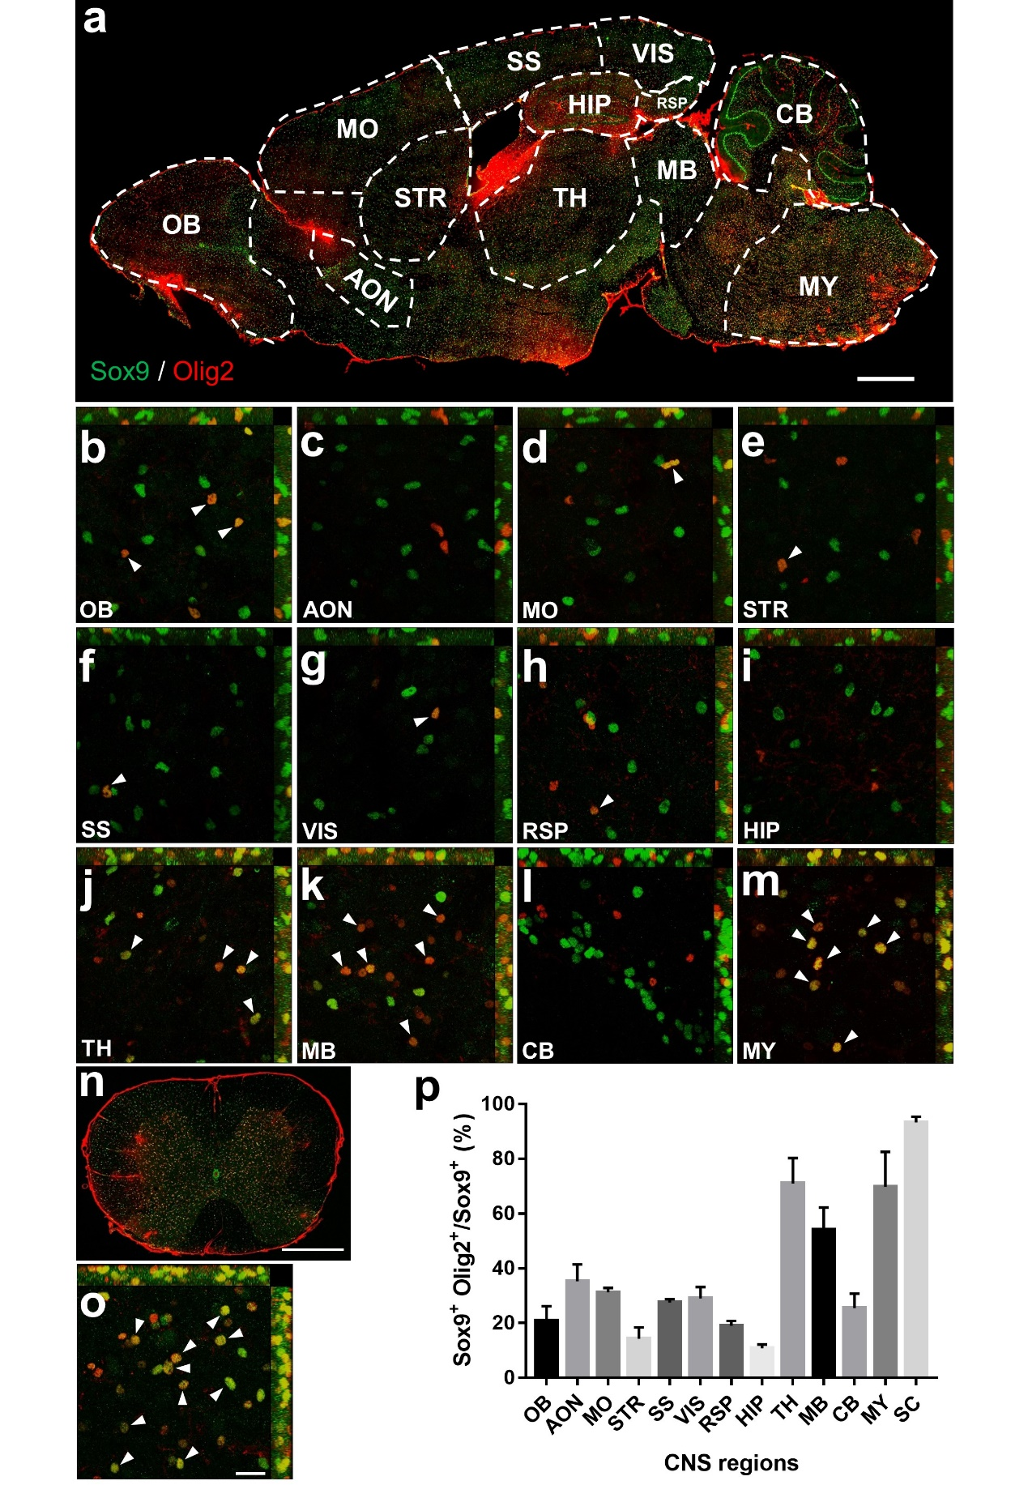
(a) Sagittal overview of the mouse brain indicating a variety of brain regions of interest. (b-m) 60x images showing the olig2 and Sox9 double immuno-staining in a variety of mouse brain regions of interest. The white arrowheads indicate Sox9-labeled astrocytes that express Olig2. In the OB (b), AON (c), STR (e), HIP (i), CB (l) and the cortical areas including the MO (d), SS (f), VIS (g) and the RSP (h), a relative low proportion of astrocytes (＜40%) express Olig2. In the MB (k), around half of the astrocytes express Olig2, while in the TH (j) and the MY (m), many more astrocytes (~70%) have Olig2 immune reactivity. (n) Coronal overview of the mouse SC indicating Olig2⁺ astrocytes. (o) The co-localization of Olig2 and Sox9 in the SC indicate that a majority of the astrocytes（93.3%）express Olig2. (p) The proportion of Olig2⁺ cells among all of the Sox9⁺ cells in different CNS regions. Data are represented as mean ± SEM. Scale bars: 1000 μm (a), 20 μm (b-m, o), 500 μm (n).

