Supplementary information
Title: Monocyte Chemoattractant Protein-1 promotes cancer cell migration via c-Raf/MAPK/AP-1 pathway and MMP-9 production in osteosarcoma
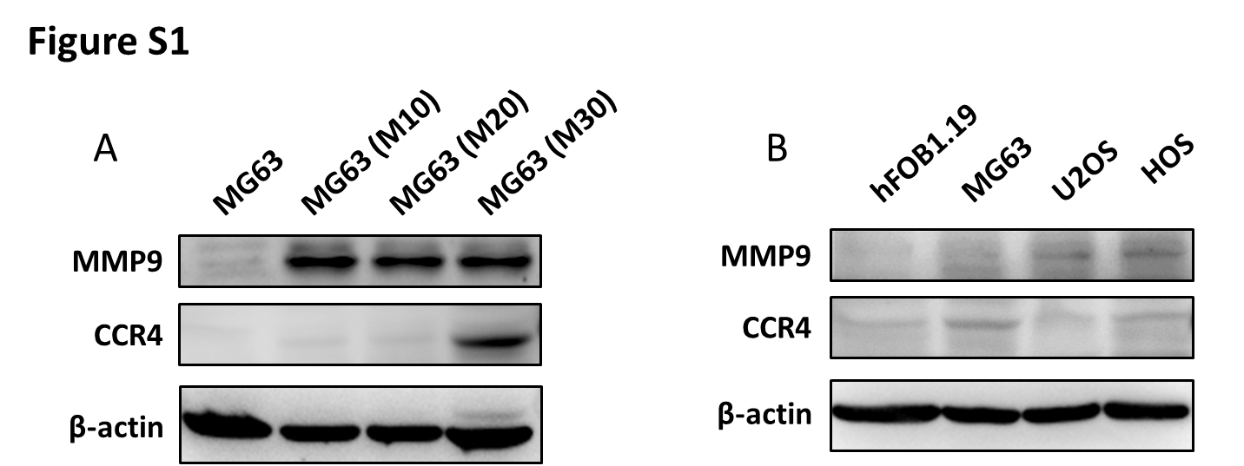
Authors: Ju-Fang Liu, Po-Chun Chen, Tsung-Ming Chang, and Chun-Han Hou* Hsun-Hsien Chang, Gon-Ann Lee and Chi-Feng Hung.
Figure S1. Expression levels of MMP9 and CCR4 in migration-prone subclones of MG63 osteosarcoma cells, osteosarcoma cell lines and normal osteoblasts.
Total proteins were collected from the indicated cell lines, then MMP9 and MCP-1 expression levels were evaluated by using Western blotting. β-actin was used as loading control.

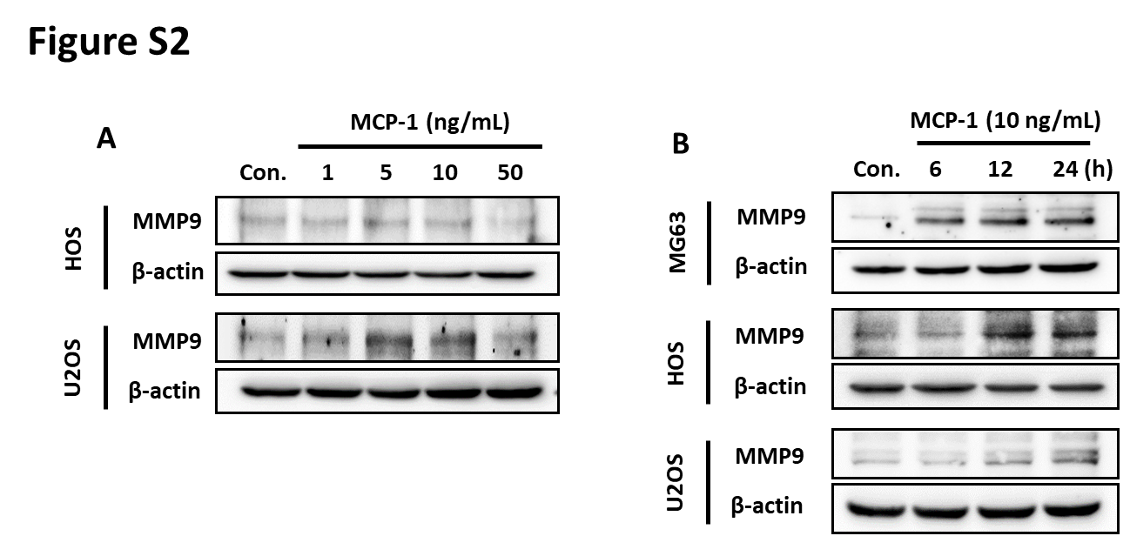
Figure S2. MPC-1 contributes to MMP-9 expression in osteosarcoma cell lines.
(A) MMP-9 protein expression levels were monitored by using Western blotting in the HOS and U-2OS cells after stimulation with different concentrations of MCP-1 (1, 5, 10, and 50 ng/mL) for 24h. (B) The osteosarcoma cells (MG63, HOS and U2OS) were incubated with MCP-1 (10 ng/mL) for different time intervals (0, 6, 12, 24 h), followed by investigation of MMP-9 expression by using Western blotting.

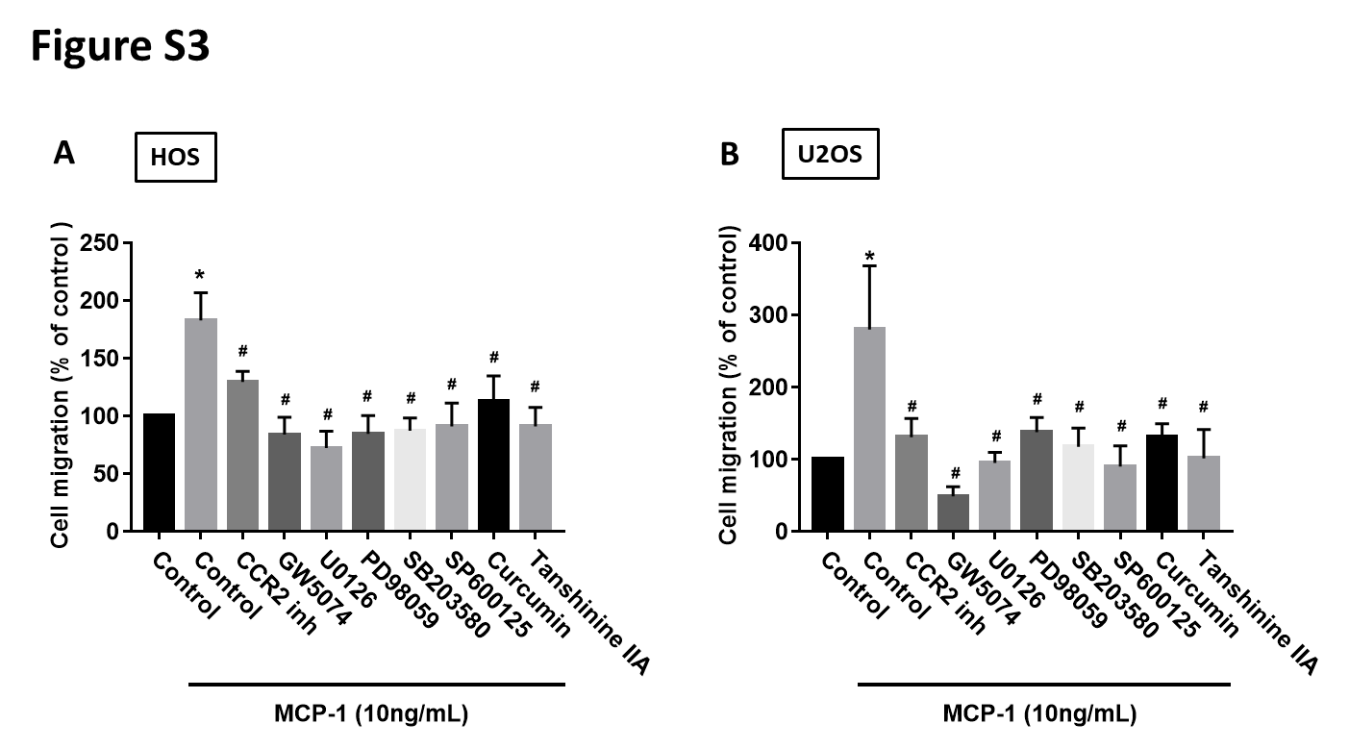
Figure S3. MCP-1 promotes osteosarcoma cells migration through CCR2, c-Raf, MAPK and AP-1 signal pathways.
The osteosarcoma cells (HOS and U2OS) were pretreated with indicated inhibitors (CCR2 inh, 400 nM; GW5074, 5 μM; U0126, 10 μM; PD98059, 10 μM; SB203580, 10 μM; SP600125, 10 μM; curcumin, 1 μM and tanshinone IIA, 5 μM) for 30 min, followed by MCP-1 stimulation for 24 h. The cell migration assays were conducted after 24 h later. Results are expressed as mean ± SEM, n=4. *p < 0.05 compared with control group; #p < 0.05 compared with the MCP-1-treated group.

