Table S1:

Name in study | Product labelling | Order number | Picture
Swab 1 | ∑ Transwab | #MW176S, MWE | 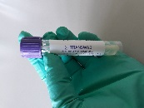
Swab 2 | eSWAB | #480, Copan | 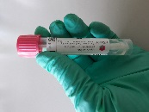
Swab 3 | ∑ Virocult | #MW950S, MWE | 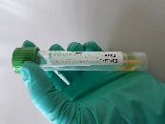
Swab 4 | Virus Sampling Kit | #MT0301, Yocon | 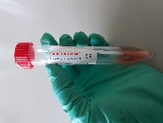
Swab 5 | Liquid Amies Midia – virus transport kit | Jinan Babio Biotechnology | 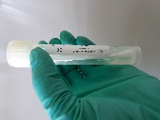
Swab 6 | Virus Sample Stabilizer | #R513-02, Vazyme | 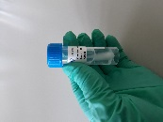
Swab 7 | Dry Swab | #155C, Copan | 