**Appendix A: Public Sector Entities**

* The **central government** is made up of two broad components:
  + The **budgetary central government** is most commonly tied to theoretical research through the budgeting process. Any bills passed through parliament concerning budgetary allocation would be included here.
  + **Extrabudgetary funds** are as vast and they are diverse across countries. These would generally include any nonmarket entity that is controlled by government but works with some degree of autonomy from the budget, for example generates some of its own revenue and is governed by a separate board of governors (i.e. hospital, universities, SPVs, PPPs, etc.)
* **Subnational (local/state) governments** must have autonomous authority to design/legislate fiscal policy in their region (i.e. set tax rates) and the ability to incur debt and or sell assets by their own accord. This means that, in order to officially qualify as a local/state government requires the freedom to set policy agendas, irrespective of national government objectives.
* **Social security funds** are government entities that are devoted to the operation of one or more social security schemes. These schemes can vary quite a bit in terms of management and purpose, but they would be responsible for managing funds responsibly.[1]

With respect to the market side of the public sector, these can be broadly classified into three categories of:

* **A central bank.** This is a unique public corporation with an overall objective of issuing currency, maintaining price stability and surveilling/regulating financial corporations.
* **Financial public corporations**. These would include all government-controlled banks, insurance companies, shadow banks or other financial institutions. These types of financial institutions served the majority of individuals in developing countries in the early 2000s (Caprio *et al*. 2004) and public banks continue to hold large market shares in many of the world’s developed and developing countries.[2]
* **Nonfinancial public corporations**: These would include any government-controlled company that sells goods/services at market prices. Some examples that remain prominent in emerging economies would be airlines and railways, electricity, gas, water supply, broadcasting, natural resource extraction, telecommunications, shipbuilding, textiles, and tourism (see World Bank, 2006).

**Appendix B: Public Corporations**

Public corporations are likely the most understudied part of the public sector making it difficult to obtain accurate and comparable financial statistics for them. Despite being publicly owned most SOEs have few (or no) reporting requirements and often report directly to the ministry that oversees it, and is directly involved in its management leading to the conclusion that ‘a lack of transparency is one of the most common, and unfortunate, shortcomings of SOEs. Opacity undermines performance monitoring, limits accountability at all levels, and can conceal liabilities that can have an impact on national budgets and even financial stability’ (World Bank, 2006). Where data is available, definitions and underlying methods for compiling financial statistics for SOEs tend to vary across countries and over time (see PWC, 2015).[3] Most of the existing empirical research has relied on one-off datasets created by the authors of the research project. In 2006, SOEs were found to account for 20 percent of investment and 5 percent of employment across the globe with African SOEs producing around 15 percent of GDP, Asian SOEs producing around 8 percent of GDP, Latin American SOEs producing 6 percent of GDP, and Central and Eastern Europe SOEs accounted for between 20 to 40 percent of GDP. (World Bank, 2006). In 2015, public corporations were found to represent approximately 10 per cent of global gross domestic product with joint sales of $3.5 trillion (Bruton *et al*., 2015; Grossi, Papenfuß and Tremblay, 2015). In the same year, PWC found that the proportion of public corporations among the Fortune Global 500 has grown from 9% in 2005 to 23% in 2014, primarily driven by Chinese SOEs (see PWC, 2015). Public corporations also make up eight of the eleven largest employers in the world makes taking stock of the public sector a significant challenge.[4] These corporations are especially important in countries with high levels of state involvement in the market economy such as China and are situated across all levels of government. Empirical research has found that more than half of the public sector SOEs are located at the subnational government level where they undertake more than half of total public sectors investments and incur higher levels of debt than those controlled by the central government (Bertelsmann Foundation, 2008; Bertelsmann Foundation, 2013; Grossi and Reichard, 2008; Grossi, Papenfuß, and Tremblay, 2015).

The low degree of data availability for public corporations is surprising given long-lived debates about their existence and growth in the 21st century. Within the niche research into public corporations, they have been justified based on supporting national economic and strategic interests, ensuring continued national ownership of enterprises, supplying specific public goods or services that the market cannot supply at a desired price, performing business operations as a ‘natural’ monopoly, and creating or maintaining a state-owned monopoly (or oligopoly) where market regulation is deemed infeasible or inefficient (OECD, 2018; World Bank, 2006; PWC, 2015). They have been criticized for employing excess labor (Boyco *et al*, 1996), employing staff based on connections rather than skill (Kruger, 1990), corporate governance (OECD, 2005; Whincop, 2005; Bernier, 2015; Papenfuß, 2014; Bruton *et al*., 2015; Grossi, Papenfuß, and Tremblay, 2015), firm performance (Goldeng, Grünfeld, and Benito, 2008) and place their objectives based on social and political objectives as opposed to profit maximization which ‘impairs residual claimant incentives to monitor managers and, ultimately, degrades firm performance’ making them less technically efficient. (Dewenter and Malatesta, 2001).

**Appendix C: WEO and GFSY Metadata for Australia, Japan, Iceland, Greece**

Australia:

*WEO*

Central Government; State Government; Local Government; Social Security Funds;  
Valuation of public debt: Face value  
Instruments included in gross and net debt: Currency and Deposits; Securities Other than Shares; Loans; Our framework follows the Maastricht debt criteria.

*GFSY*

Data cover activities of subsectors Central budgetary (where BA=CG), State Governments (SG), and Local Goverrnments (LG). All data other than cash specific statements are recorded on an accrual accounting basis.

Japan:

*WEO*

Central Government; Local Government; Social Security Funds; Government in Japan consists of 3 layers: central, prefectural, and municipal. The latter two government levels are covered under local government. There is no government at the state level in Japan.  
Valuation of public debt: Current market value. Gross public debt is on unconsolidated basis.

*GFSY*

As for “Financial assets and liabilities,” the following flows and stocks are consolidated: “Debt securities,” “Loans,” “Equity and investment fund shares” and “Other accounts receivable/payable.” “Financial assets and liabilities” is compiled on a market value basis. “Other accounts receivable/payable” includes “Outward investment in securities” in which source data are unavailable for breakdowns into “Debt securities” and “Equity and Investment fund shares.”

Iceland:

Central Government; Local Government; Social Security Funds;  
Valuation of public debt: Face value  
Instruments included in gross and net debt: Securities Other than Shares; Loans;. Gross debt follows the Maastricht definition of gross debt, and excludes other accounts payable. Net debt is calculated as gross debt minus assets in the form of currency and deposits.

GFSY

BCG, SSF, LG

Greece:

 Central Government; Local Government; Social Security Funds;  
Valuation of public debt: Nominal value. General debt data, including historical data, are provisional and subject to revisions.  
Instruments included in gross and net debt: Currency and Deposits; Securities Other than Shares; Loans

GFSY

BCG, EBF, SSF, LG. Data for all subsectors are reported on a noncash basis, consistent with the European System of Accounts, 2010 (ESA2010)

**Appendix D: Public Sector Debt Metadata**

World Bank Quarterly Public Sector Debt Statistics

*South Africa*

1. Concepts and definitions: GFS guide

2. Classification / sectorization:

· Central Government: Budgetary Central Gov. + Extra-Budgetary Units + Social Security Funds

· Budgetary Central Government

· Financial Public Corporations: Public Financial Corporations (The data for the debt securities for financial public enterprises and corporations has been revised in line with ownership and distribution data from the Share Transactions Totally Electronic (STRATE) in an effort to improve the coverage of the public-sector debt in the Quarterly Bulletin. During the revision of this data, accounts payable was also affected).

· Non-Financial Public Corporations

3. Basis for recording: Stocks are valued and recorded according to the public sector debt guide methodology.

4. Instruments coverage: Debt securities, Loans, Insurance, pension and standardized guarantee schemes, Other accounts payable

5. Types of consolidation: Non Consolidation

6. Valuation: Debt instruments are nominal value

7. Unit of measure: National currency

8. Data source/compiling organization: Ministry of Finance (Budgetary Central), Public Corporations are sourced by the SA Reserve Bank.

9. Periodicity: Quarterly

10. Revision policy: Regular schedule’

IMF Public Sector Balance Sheet

*South Africa*

Financial Public Corporations (FPCs) were calculated as the consolidated sum of the central bank and the financial public corporations other than the central bank.

• FPCs other than the Central Bank were calculated as the consolidated sum of:

• Nonfinancial Public Corporations assets as reported in QB KB426

• Nonfinancial Public Corporations liabilities as reported in QB KB425

• Data of the Official Pension Funds as reported in QB KB 221

• Public Investment Commissioners assets as reported in QB KB212

• Public Investment Commissioners liabilities as reported in QB KB212

• Post Bank assets as reported in QB KB114

• Post Bank liabilities as reported in QB KB115

• Land and Agriculture Bank assets as reported in QB KB119

• Land and Agriculture Bank liabilities as reported in QB KB118 To eliminate the double count of official pension funds’ deposits with PIC the asset details of official pension funds were replaced with the value of pension fund deposits with the PIC, The residual value is reported as other assets. The liabilities of the official pension funds reported as equal to the assets were adjusted as follows: 4

• Using the GEPF Annual Report, (page 42) actuarial assessments of over or underfunding, the actual pension entitlement liabilities were calculated with the residual value of the total liability reported as either an asset or liability claim of the pension fund on the pension managers

• Total FPCs were calculated as the aggregation of the CB and other FPC. Stock data for debt securities issued by government were adjusted with market values as provided by the authorities Stock data for fixed assets were calculated using public corporations fixed capital stock at constant 2010 prices as reported in the Quarterly Bulletin, revalued to a current price using CPI headline prices re-indexed to 2010. Financial public corporations’ portion of the revalued fixed capital stock was calculated using ratios as reported in QB.

**Appendix E: D1 – D4 definitions of debt**

Public Sector Debt can be classified in a wide variety of way depending on coverage of subsectors (which parts of the public sector is covered) and instrument coverage. Throughout this paper, we relied in the D1-D4 IMF distinction which is defined and depicted below:

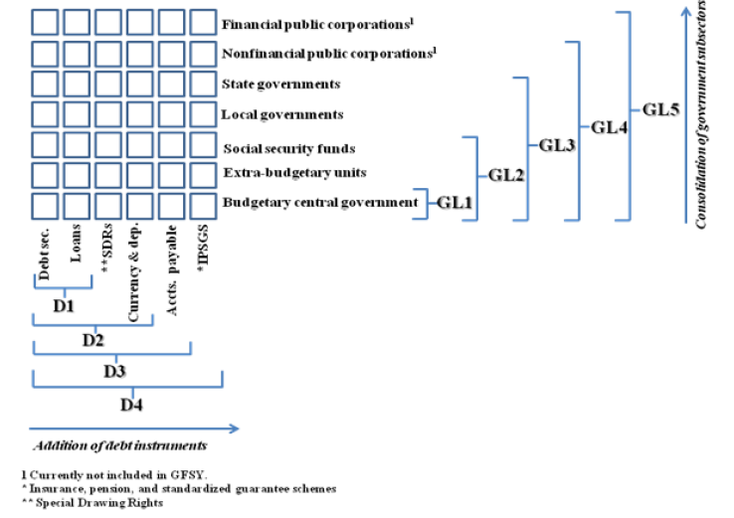

D1 = Debt Securities + Loans

D2 = D1 + currency/deposits + SDR liabilities

D3 = D2 + accounts payable

D4 = D3 + Insurance, Pension, and Standardized Guarantee Schemes

Source: IMF

**Appendix F: Differences in Reported Government and Public Corporation Debt Statistics between Databases**

Moving from specific cases to general variation across databases, we can see in Figure F1 below that significant overall difference emerge when comparing gross debt statistics from WEO, GFSY and WDI.

Figure F1: Difference in Gross Debt Data by Source (% GDP)





Data Sources: IMF World Economic Outlook, IMF Government Finance Statistics Yearbook and

World Bank World Development Indicators

The mean difference when comparing *WEO* and *GFSY* general government is -7.1% of GDP with a large standard deviation of 8.4. Moving to the top righthand side of Figure 5 which compares WEO general government with GFSY central government, the mean difference is much closer to zero (-0.8) but with a larger standard deviation of 14.3. Comparing WEO general government with WDI central government, the differences are similar to those from the top right-hand side, with a mean difference of 2.8% GDP and large standard deviation of 13.8. Lastly, when comparing GFSY central government with WDI central government, the mean difference is around 3.8% of GDP with a relatively smaller standard deviation of 6.9.

Moving from specific cases to general variation across databases, we can see in Figure F2 below that significant difference emerge when comparing gross debt statistics from IMF PSBS and WB QPSD.

Figure F2: Public Sector Corporation Gross Debt Statistics Database Discrepancies

(IMF PSBS and WB QPSD, % GDP)



Data Sources: IMF Public Sector Balance Sheet database and World Bank’s Quarterly

Public Sector Debt Statistics database, IMF World Economic Outlook

As was in the case in Figure F1 comparing government gross debt statistics across databases, significant general differences also appear when comparing public corporation gross debt between IMF PSBS and WB QPSD. In the case of public financial corporations, the mean difference was -34.2% of GDP with a standard deviation of around 43.2. In the case of nonfinancial public corporations, the mean difference was -15.9 % of GDP with a much smaller standard deviation of 6.2.

**Appendix G:** Sources and Composition of Measures of Public Sector Debt in the UK

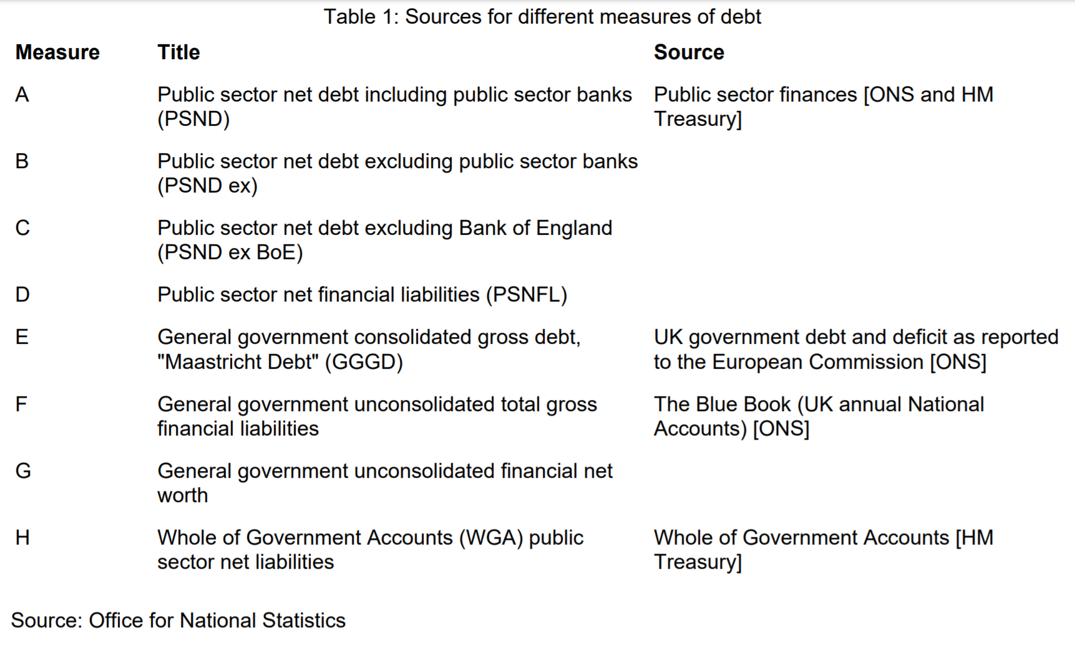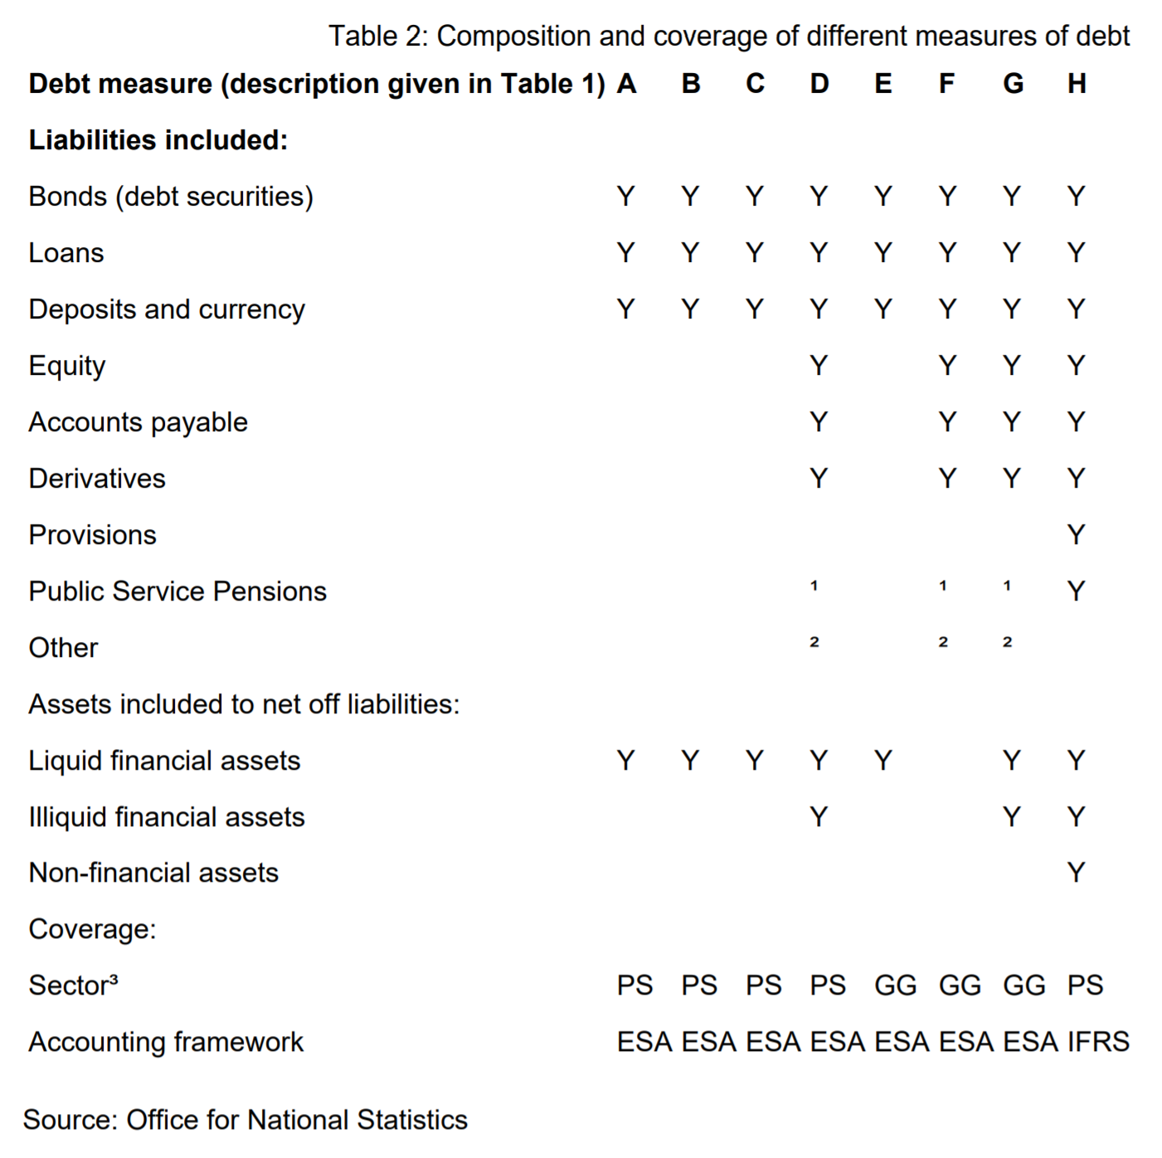

**Appendix H: Debt terminologies across National Media outlet**

 

** **

 

Public Net Debt (Bn) Public Net Debt (%GDP)

** **

1. Note that this does not include implicit liabilities from unfunded, or underfunded, pension schemes (see Brixi and Schick 2002 and Bloch and Fall, 2015).
2. Some examples from 2010 include: Indonesia (38%), Germany (32%), Iceland (41%), Slovenia (51%), Turkey (32%), Belarus (72%), UK (26%), Russia (41%), Argentina (44%), Brazil (44%), Costa Rica (54%), Uruguay (46%), Venezuela (33%), India (74%), Sri Lanka (59%), Burundi (49%). See Cull, Soledad, Peria, and Verrier (2017).
3. Some of the wide range of legal forms for SOEs, depend on factors such as: i) the level of government that owns the enterprise (central/federal, state/regional or local), ii) the way in which the enterprise was founded, iii) the position in the public administration hierarchy, iv) The purpose of the SOE, v) The status of the SOE if it is in the process of being privatized, vi) full, majority or minority ownership by the government vi) listing (or not) on a stock exchange vii) government shareholdings through vehicles such as government pension funds, asset management funds, restructuring corporations and development lenders, viii) State-enabled (for example enterprises which have been granted exclusive rights by the state) as opposed to state-owned (see PWC, 2015).
4. These are: US Department of Defense, Chinese People’s Liberation Army, UK National Health Service, China National Petroleum Corporation, State Grid Corporation of China, Indian Railways, Indian Armed Forces, China Post Group. (<https://www.forbes.com/sites/niallmccarthy/2015/06/23/the-worlds-biggest-employers-infographic/>)