[Pekka J. Vuorinen, Mervi Rokka, Tiina Ritvanen, Reijo Käkelä, Soili Nikonen, Tapani Pakarinen, and Marja Keinänen: Changes in thiamine concentrations, fatty acid composition, and some other lipid-related biochemical indices in Baltic Sea Atlantic salmon (Salmo salar) during the spawning run and pre-spawning fasting. Helgoland Marine Research 2020]

a)
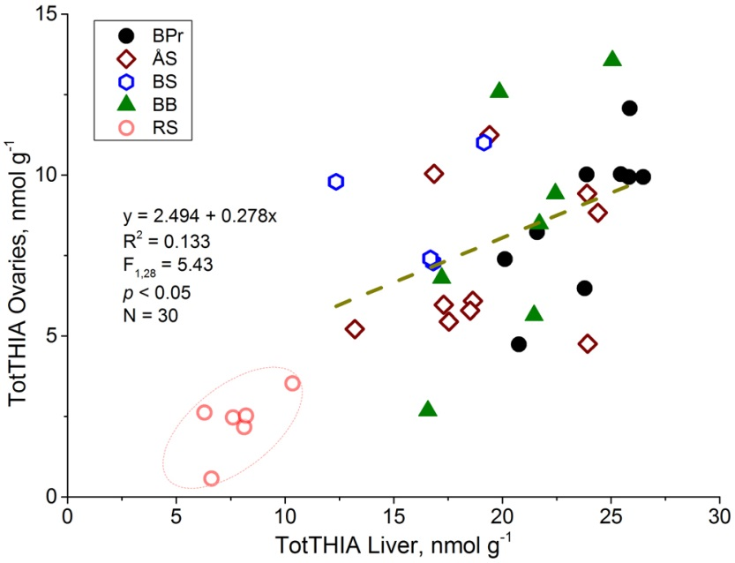
b)
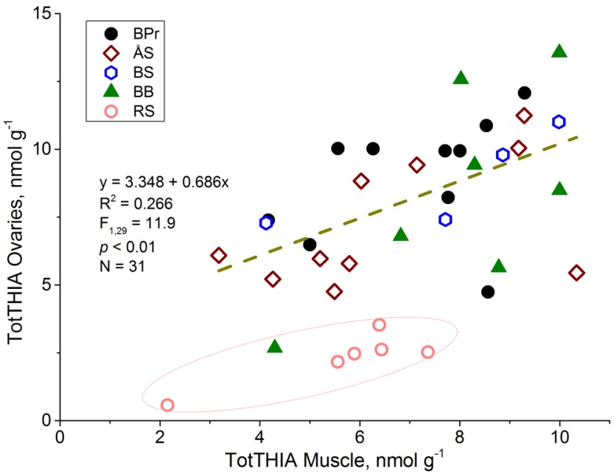

Additional file 3. Relationship of the total thiamine (TotTHIA) concentration of ovaries to that of a) the liver and b) muscle. The regression data is indicated for salmon sampled during the sea phase of the spawning run, and the salmon at the spawning time in the River Simojoki (RS, within the ellipse) are omitted from the calculations, because their TotTHIA concentrations deviated from others, as did their overall physiological status.

