[Pekka J. Vuorinen, Mervi Rokka, Tiina Ritvanen, Reijo Käkelä, Soili Nikonen, Tapani Pakarinen, and Marja Keinänen: Changes in thiamine concentrations, fatty acid composition, and some other lipid-related biochemical indices in Baltic Sea Atlantic salmon (Salmo salar) during the spawning run and pre-spawning fasting. Helgoland Marine Research 2020]

a)
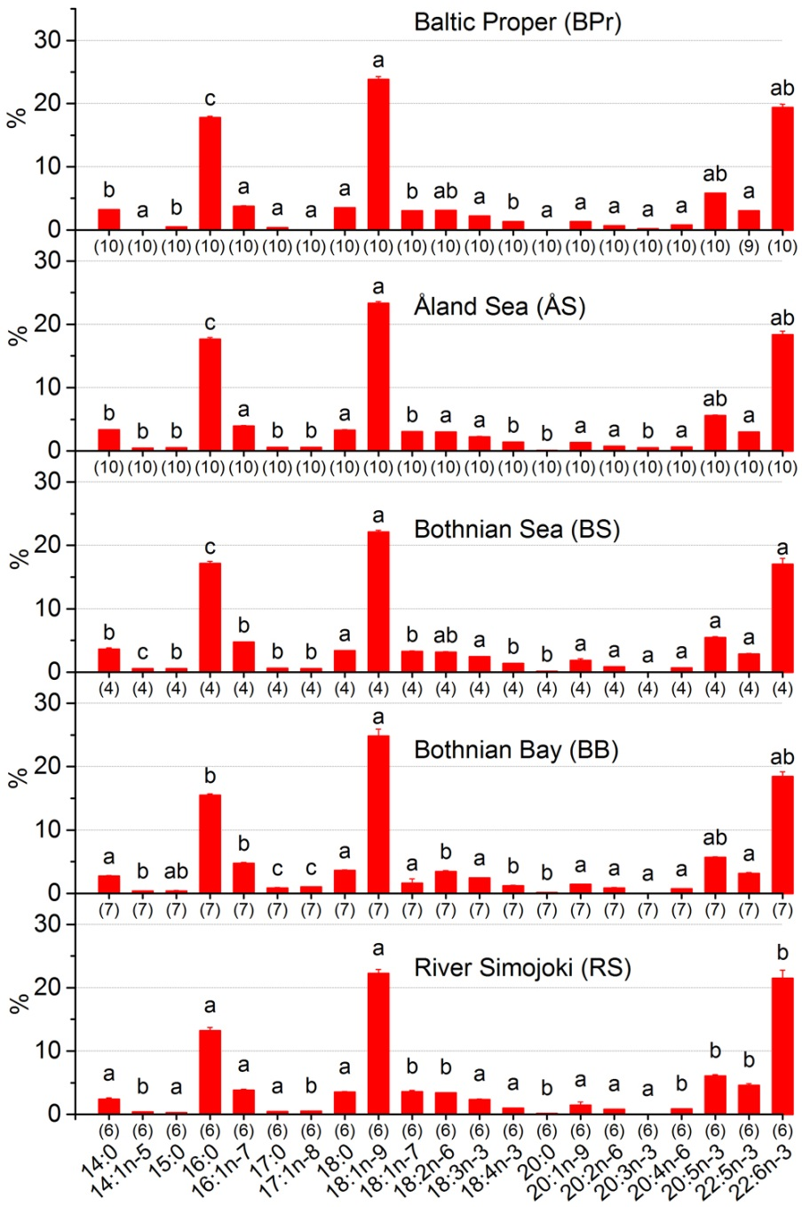

b)
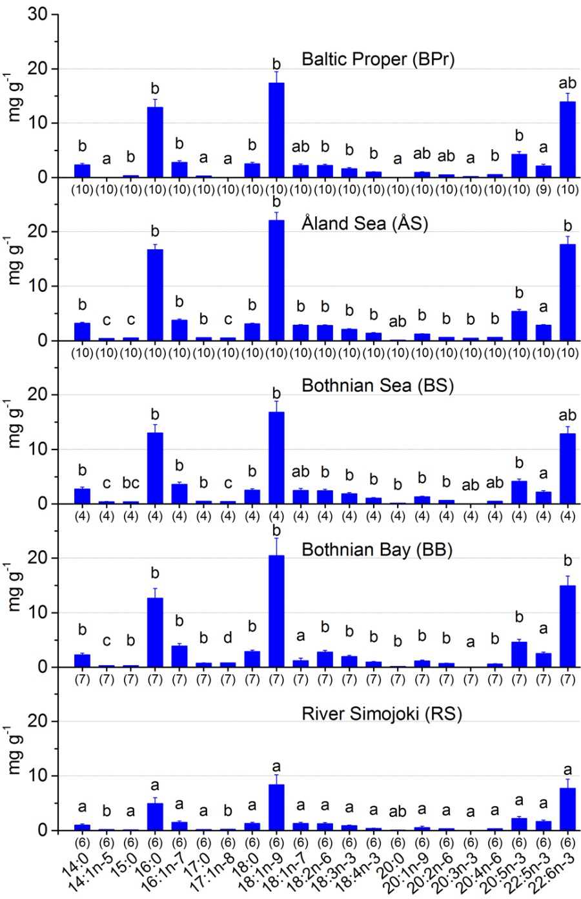
Additional file 2. Proportions (a) and concentrations (b) of fatty acids in the muscle of 2-sea-year-old salmon during the 1 400 km spawning run from the Baltic Proper through the Gulf of Bothnia to the north-eastern Bothnian Bay at four locations and at spawning time in the River Simojoki. Significant differences (p < 0.05, post hoc SNK in one-way ANOVA) in the means between the sampling locations are indicated with no common letter. The number of specimens is given in parentheses.

