Supplementary file

Definition of the area
Each area is defined as below based on the definition of the Japan meteorological agency.[1]
Northern area: Hokkaido, and Tohoku region
Eastern area: Kanto, Hokuriku, and Tokai region
Western area: Kinki, Shikoku, Chugoku, and north side of Kyusyu
Southern area: Okinawa

S-Fig 1. Definition of the area
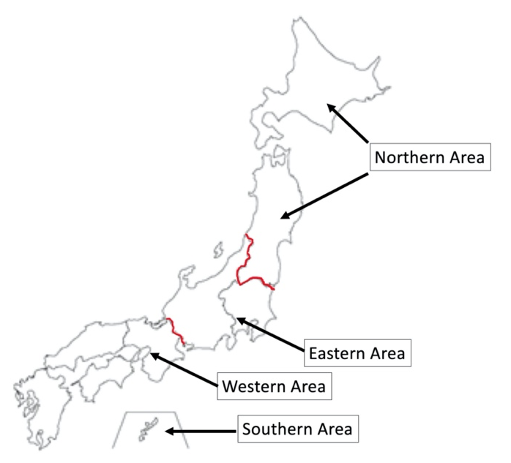

S-Table 1. The mean temperature of the largest city in each region in 2017. [1]
 | Jan | Feb | Mar | April | May | June | July | Aug | Sep | Oct | Nov | Dec
Northern | -3.9 | -2.0 | 1.4 | 7.7 | 14.4 | 16.0 | 22.9 | 21.7 | 17.7 | 11.3 | 4.3 | -2.0
Eastern | 5.8 | 6.9 | 8.5 | 14.7 | 20.0 | 22.0 | 27.3 | 26.4 | 22.8 | 16.8 | 11.9 | 6.6
Western | 6.2 | 6.3 | 9.2 | 15.7 | 21.1 | 22.7 | 28.8 | 29.2 | 24.4 | 18.4 | 12.6 | 7.0
Southern | 18.4 | 17.1 | 18.3 | 21.6 | 24.2 | 26.6 | 29.9 | 30.4 | 28.9 | 27.0 | 22.8 | 18.0
Northern area: Sapporo, Eastern area: Tokyo, Western area: Osaka, Southern area: Naha
Temperature (℃)
Additional analysis
Results
Among the 34,754 patients in the JAAM-OHCA database, 458 patients from 54 hospitals (tertiary center 45, non-tertiary center 9) were included in the additional analysis (S-Fig 2). The characteristics of the patients and in-hospital data were described in S-Table 2 and 3. In summary, the median [IQR] of the age are 75 [64-84] years, and almost half of the cases happened in winter (222/458, 48.5%), and most of the cases occurred except for summer (405/458, 88.4% in spring, autumn, and winter). The median [IQR] of core BT were 29.7 [26.0-31.2]. The one-month survival was 5.5% (25/458).

Predictive accuracy
The AUC values [95% CI] of the potassium were 0.840 [0.757-0.898]. The other AUC values [95%CI] were as follows: BT 0.650 [0.53-0.754], Age 0.655 [0.537-0.757], Lactate 0.854 [0.790-0.900], and pH 0.822 [0.722-0.892], (S-Fig3). The predictive ability in potassium were described in S-Tables 4. On setting the cutoff points of 7.0 (mmol/L) in serum potassium, it had the high sensitivity 0.96 [95%CI: 0.87-1.00] and a low LR- 0.09, which are suitable to rule-out one-month survival.

S-Fig 2. The study flowchart in additional analysis

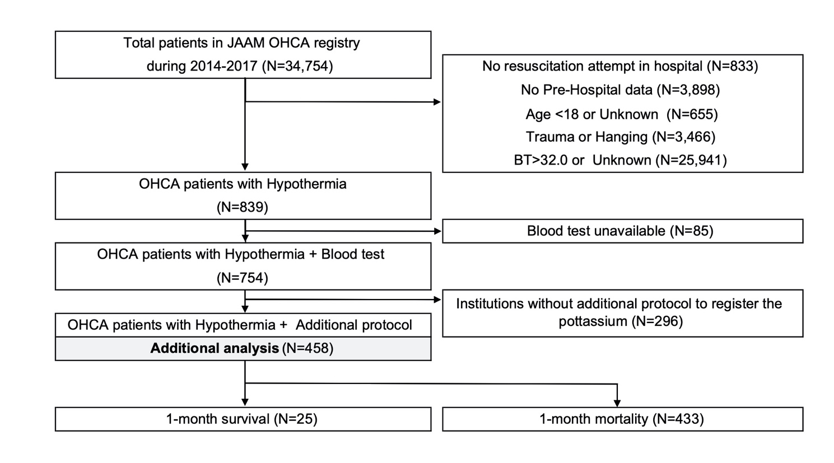
S-Table 2. The characteristics of the patients in the additional analysis
Variables |  | Total
 |  | (N=458)
Baseline characteristics
Sex (Men) |  | 265 (57.9%)
Age (year) |  | 75 [64-84]
 | 16-64 | 122 (26.6%)
 | 65-74 | 103 (22.5%)
 | ≥ 75 | 233 (50.9%)
Pre-hospital information
Bystander witness |  | 126 (27.5%)
Bystander CPR |  | 161 (35.2%)
Shockable on initial rhythm |  | 39 (8.5%)
Advanced airway |  | 218 (47.6%)
In-hospital information
Body temperature |  | 29.7 [26-31.2]
Measurement site
 | Rectal | 93 (20.3%)
 | Bladder | 84 (18.3%)
 | Tympanic | 48 (10.5%)
 | Other/Unknown | 233 (50.9%)
Cardiac rhythm on hospital arrival
 | ROSC | 17 (3.7%)
 | Shockable | 40 (8.7%)
 | PEA | 80 (17.5%)
 | Asystole | 321 (70.1%)
ECMO implementation |  | 41 (9%)
 | Before ROSC | 34 (82.9%)
ROSC after hospital arrival |  | 97 (21.2%)
Time course (min)
 | E-call to Hospital arrival | 34 [28-42]
 | E-call to Blood test | 40 [34-52]
 | E-call to ECMO | 70 [52.3-88]
 | E-call to ROSC after arrival | 57 [40-96]
Blood test on hospital arrival
 | pH | 6.8 [6.6-7]
 | (Missing) | 35 (7.6%)
 | Lactate (mg/dl) | 131.4 [79.2-180]
 | (Missing) | 39 (8.5%)
 | Potassium (mmol/l) | 6.6 [4.9-9.6]
 | (Missing) | 87 (19%)
Outcome
 | Admission to ICU or ward | 101 (22.1%)
 | Death in ER | 357 (77.9%)
 | 1-month Survival | 25 (5.5%)
 | 1-month CPC1,2 | 15 (3.3%)

Continuous variables are described as median [Interquartile range (IQR)]. Categorical variables are described as number (%). Shockable: ventricular fibrillation and pulseless ventricular tachycardia, CPR: Cardiopulmonary resuscitation, E-call: Emergency call for ambulance, ROSC: Return of spontaneous circulation, PEA: Pulseless electrical activity, ECMO: Extracorporeal membrane oxygenation, ER: Emergency room, CPC: Cerebral performance category[2]

S-Table 3. The other characteristics of the patients in the additional analysis

Variables |  | Total
 |  | (N=458)
Hospital Information
Hospital
 | Tertiary center (45 hospitals) | 432 (94.3%)
 | Non-tertiary center (9 hospitals) | 26 (5.7%)
 | The number of beds | 707 [388-938]
ECMO availability
 | Always | 377 (82.3%)
 | Partial | 61 (13.3%)
 | Unavailable | 20 (4.4%)
Geographical information and season
Area
 | Northern area | 139 (30.4%)
 | Eastern area | 136 (29.7%)
 | Western area | 183 (40%)
 | Southern area | 0 (0%)
Season
 | Spring | 85 (18.6%)
 | Summer | 53 (11.6%)
 | Autumn | 98 (21.4%)
 | Winter | 222 (48.5%)

Continuous variables are described as median [Interquartile range (IQR)]. Categorical variables are described as number (%).Shockable: ventricular fibrillation and pulseless ventricular tachycardia
E-call: Emergency call for ambulance, ROSC: Return of spontaneous circulation, ECMO: Extracorporeal membrane oxygenation, ER: Emergency room

S-Figure 2. Receiver operating curve and Area under the curve for one-month survival.
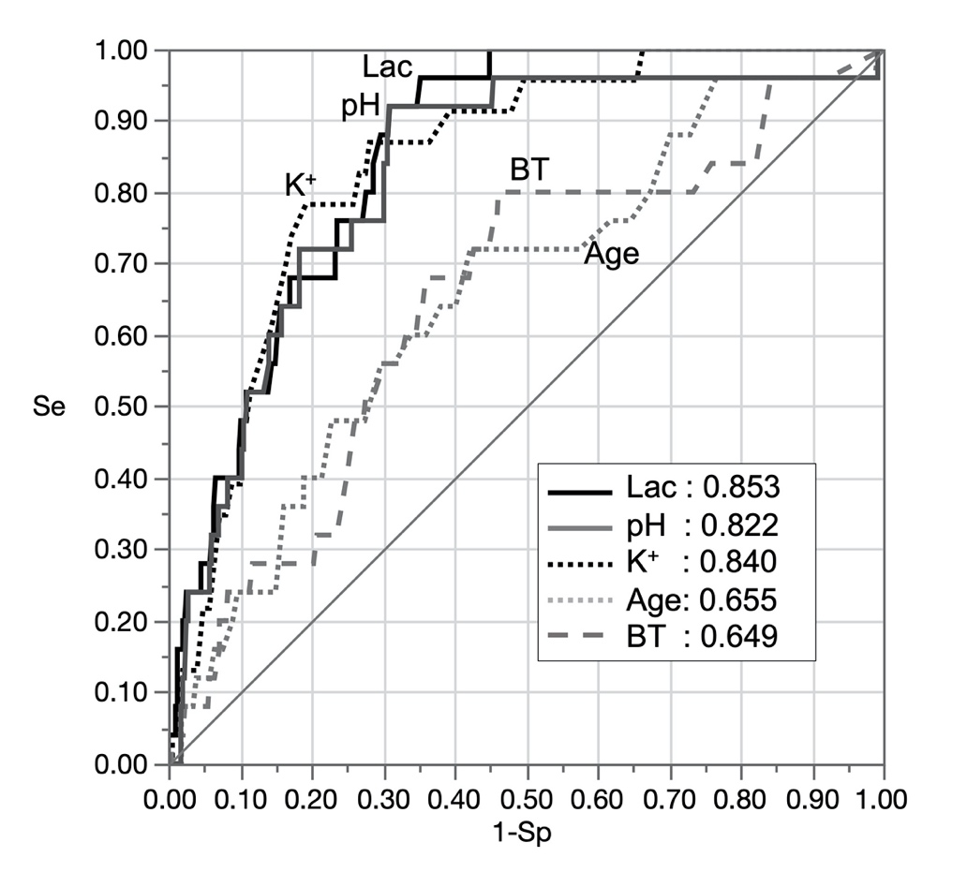
K⁺: Serum potassium, Lac = serum lactate, BT = body temperature, Se: Sensitivity, Sp: Specificity

S-Table 4. The predictive accuracy of potassium for 1-month survival

Cut-off (mmol/l) | Se | Sp | TP | TN | FP | FN | LR+ | LR- | PPV | NPV
4.0 | 0.48 | 0.90 | 11 | 312 | 36 | 12 | 4.6 | 0.58 | 0.23 | 0.96
5.0 | 0.78 | 0.77 | 18 | 267 | 81 | 5 | 3.4 | 0.28 | 0.18 | 0.98
6.0 | 0.87 | 0.64 | 20 | 221 | 127 | 3 | 2.4 | 0.21 | 0.14 | 0.99
7.0 | 0.96 | 0.49 | 22 | 172 | 176 | 1 | 1.9 | 0.09 | 0.11 | 0.99
8.0 | 0.96 | 0.39 | 22 | 136 | 212 | 1 | 1.6 | 0.11 | 0.09 | 0.99
9.0 | 1.00 | 0.31 | 23 | 109 | 239 | 0 | 1.5 | 0.00 | 0.09 | 1.00
10.0 | 1.00 | 0.21 | 23 | 72 | 276 | 0 | 1.3 | 0.00 | 0.08 | 1.00

TP: True-positive, TN: True-negative, FP: False-positive, FN: False-negative, Se: Sensitivity, Sp: Specificity, LR+: Positive likelihood ratio, LR-: Negative likelihood ratio, PPV: Positive predictive value, NPV: Negative Predictive value

Reference
1. Japan Meteorological Agency [https://www.jma.go.jp/jma/indexe.html]
2. Cummins RO, Chamberlain DA, Abramson NS, Allen M, Baskett PJ, Becker L, Bossaert L, Delooz HH, Dick WF, Eisenberg MS et al: Recommended guidelines for uniform reporting of data from out-of-hospital cardiac arrest: the Utstein Style. A statement for health professionals from a task force of the American Heart Association, the European Resuscitation Council, the Heart and Stroke Foundation of Canada, and the Australian Resuscitation Council. Circulation 1991, 84(2):960-975.

