**Supplementary figures**

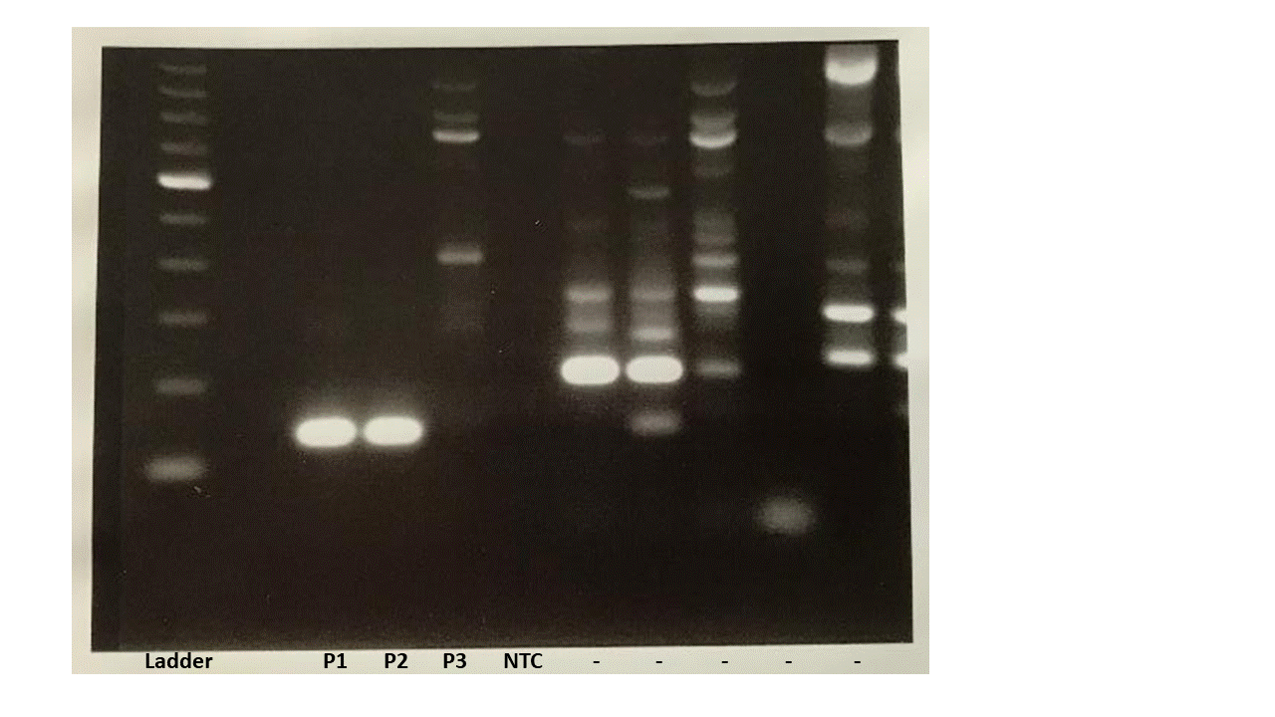

**Supplementary Figure 1.** Original image of the agarose gel in Figure 4D showing the RT-PCR result of the *KMT2A*-*MLLT4* gene fusion. P1 and P2 = patient 1 and 2 carrying *KMT2A*-*MLLT4* e8-e2 gene fusions, P3 = patient 3 with a *KMT2A*-*AFF1* gene fusion (negative control), NTC = non template control.

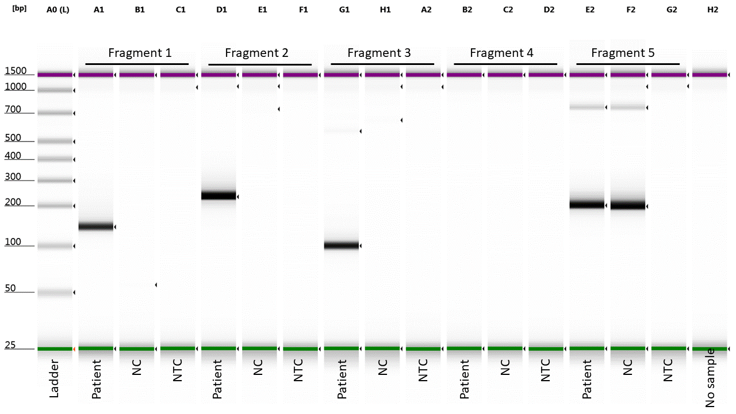



**Supplementary Figure 2.** Original image of the ScreenTape result and expected fragment sizes from the TapeStation analysis of the breakpoint verification of the *KMT2A* exon 6-*ARHGEF12* exon 22 fusion breakpoint using RT-PCR from Figure 6. Sample is from a patient with a *KMT2A*-*ARHGEF12* fusion. NC = negative control (cDNA from patient with no *KMT2A*-*ARHGEF12* fusion). NTC = non template control. Arrows with F1-F3: forward primers. Arrows with R1-R3: reverse primers.