Additional file 2.
Behavioral effects of a 14-week FBR administration on social deficits and perseverative behavior in adult ASD-like rats.
In order to verify whether the positive effects of FBR on social and perseverative behaviors were maintained until adulthood a longer FBR treatment (14 weeks) was carried out. Since male VPA-exposed rats showed a more severe ASD-like phenotype, only the male offspring of VPA-treated mothers were employed. Dams received an intraperitoneal injection of saline (0.2 ml/kg) or VPA (500 mg/kg) at gestational G 12.5. On PND 21 rats were weaned and randomly assigned to treatment groups: saline-exposed treated with standard diet (Saline-SD); saline-exposed treated with fenofibrate (FBR)-enriched diet (Saline-FBR); VPA-exposed treated with standard diet (VPA-SD); VPA-exposed treated with FBR-enriched diet (VPA-FBR). Saline- and VPA-exposed rats were fed the standard (SD) or FBR-enriched diet from weaning to the end of experimental procedures. From PND 120, rats were subjected to behavioral tests beginning with the three-chamber test to evaluate social behavior between 09:00 a.m. and 5:00 p.m. under red light illumination and noise-free condition. Adult VPA-exposed rats fed the standard diet showed clear-cut social deficits, whereas VPA-exposed rats fed the FBR-enriched diet performed similarly to the Saline-exposed groups (Figure S1 A-C). Similar results were obtained upon evaluating the effects of a 14 week-treatment with FBR on perseverative behavior using the marble burying test (Figure S1D). These results show that the 14-week FBR administration was successful to rescue behavioral changes in both ASD-like core domains of male VPA rats.

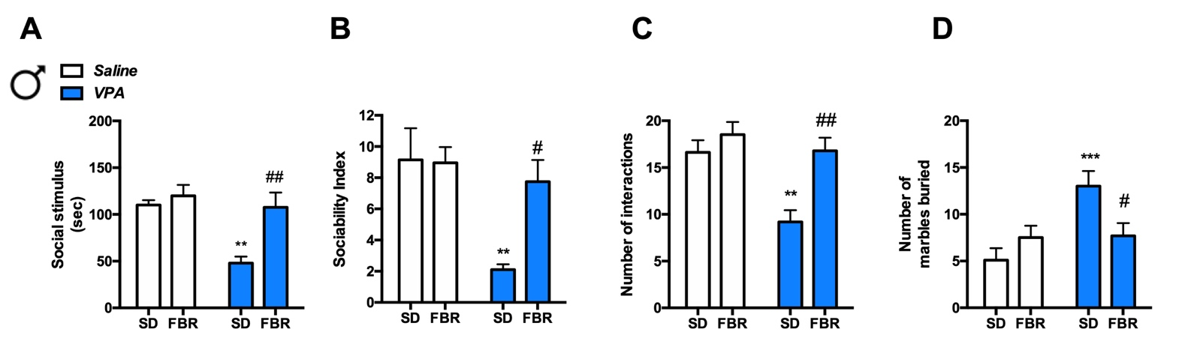

Figure S1. The time spent exploring the social stimulus (A), the sociability index (SI) (B), and the number of social interactions (C) were scored. (A) Two-way ANOVA, VPA exposure: F_{1, 36} = 11.97, p = 0.0014; FBR administration: F_{1, 36} = 10.36, p = 0.027; interaction: F_{1, 36} = 5.33, p = 0.0267; post hoc comparison: ** p < 0.01 vs. Saline-SD group; ##p < 0.01 vs. VPA-SD group. (B) Two-way ANOVA, VPA exposure: F_{1,36} = 9.48, p = 0.004; FBR administration: F_{1, 36} = 4.12, p = 0.0496; interaction: F_{1, 36} = 4.721, p = 0.0365; post hoc comparison: **p < 0.01 vs. Saline-SD group; #p < 0.05 vs. VPA-SD group. (C) Two-way ANOVA, VPA exposure: F_{1, 36} = 11.83, p = 0.0015; FBR administration: F_{1, 36} = 12.89, p = 0.0010; interaction: F_{1, 36} = 4.641, p = 0.0380; post hoc comparison: **p < 0.01 vs. Saline-SD group; ##p < 0.01 vs. VPA-SD group. (D) Two-way ANOVA, VPA exposure: F_{1, 36} = 8.46, p = 0.0062; FBR administration: F_{1, 36} = 1.085, n.s.; interaction: F_{1, 36} = 7.65, p = 0.0089; post hoc comparison: **p < 0.01 vs. Saline-SD group; #p < 0.05 vs. VPA-SD group. Values are expressed as means ± SEM; n = 10.

