Title page
Additional information for
Semi-continuous pilot-scale microbial oil production with Metschnikowia pulcherrima on starch hydrolysate

Felix Abeln,†, ‡ Robert H. Hicks,§ Hadiza Auta,‡ Mauro Moreno‐Beltrán,§ Luca Longanesi,‡ Daniel A. Henk,§ Christopher J. Chuck‡, *

† Centre for Sustainable and Circular Technologies, University of Bath, Bath, UK
‡ Department of Chemical Engineering, University of Bath, Bath, UK
§ Department of Biology & Biochemistry, University of Bath, Bath, UK

* Corresponding author.
E-mail address: C.Chuck@bath.ac.uk (C. J. Chuck).

This file includes on 7 pages (see navigation pane):
Table S1
Figures S1 to S5

Table S1
Table S1: Composition of Metschnikowia pulcherrima obtained from semi-continuous cultivation on glucose syrup on the 250 L scale (Day 10, Fig. 5). Focus is on the amino acid (AA) composition.
Specification | Value (%)
Moisture | 2.6
Crude protein (N x 6.25, Dumas) | 9.8
Ash | 1.7
Crude fibre | 0.6
Oil A (ether extract) | 4.4
Total oil (oil B) | 28.61
Alanine | 0.53
Arginine | 0.48
Aspartic acid | 0.83
Cystine | 0.14
Glutamic acid | 1.17
Glycine | 0.40
Histidine | 0.20
Iso-leucine | 0.39
Leucine | 0.52
Lysine | 0.58
Methionine | 0.13
Phenylalanine | 0.36
Proline | 0.32
Serine | 0.52
Threonine | 0.62
Tyrosine | 0.25
Valine | 0.52
Sum of AA | 7.96
Sum of AA/protein | 81.20
Pepsin digestibility (0.02%) | 50.6

Figure S1
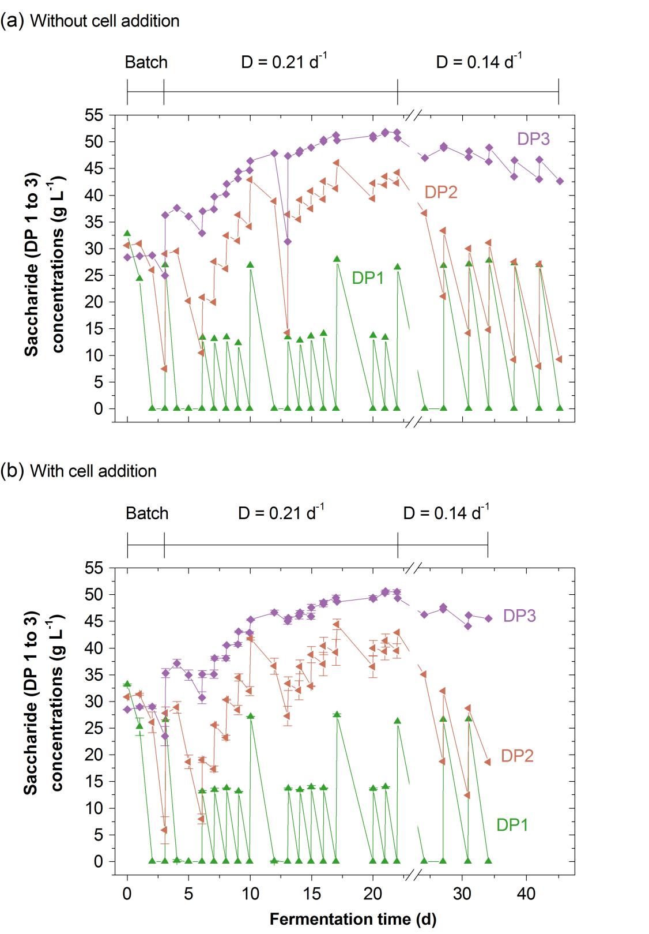
Figure S1: Saccharide concentrations in semi-continuous cultivation of Metschnikowia pulcherrima on glucose syrup at a high dilution rate (D) on the 2 L scale. (a) Profiles of glucose, maltose and maltotriose concentrations in cultivation of an evolved M. pulcherrima strain in stirred tank reactors at D = 0.21 d⁻¹ on glucose syrup and yeast extract (singlicate), and (b) when additionally preculture was added with every feed (duplicate, mean ± standard error). After 22 days the dilution rate was switched to D = 0.14 d⁻¹ (singlicate).

Figure S2
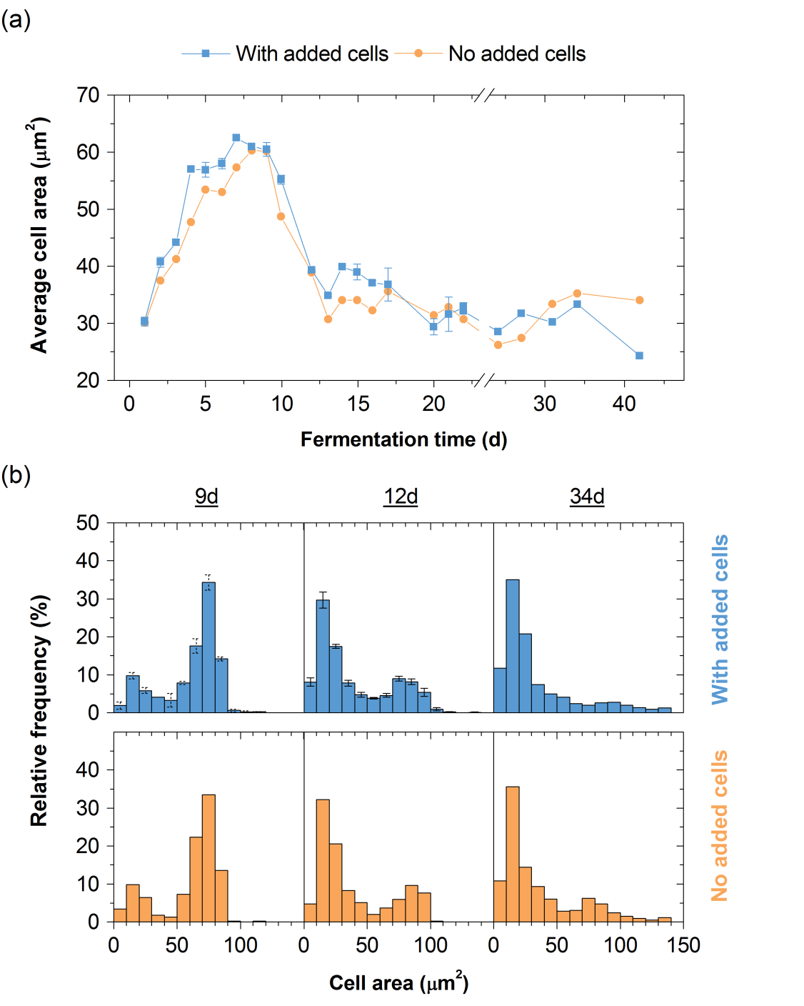
Figure S2: Cell size analysis of Metschnikowia pulcherrima in semi-continuous cultivation at a high dilution rate (D). (a) Average cell size, and (b) cell size distribution over time semi-continuous cultivations of an evolved M. pulcherrima strain in 2 L stirred tank reactors at D = 0.21 d⁻¹ on glucose syrup and yeast extract, when additional preculture was either added with every feed (blue; duplicate, mean ± standard error) or not (orange; singlicate).

Figure S3
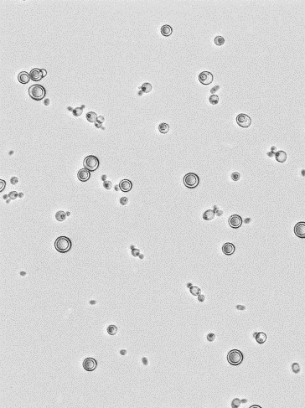
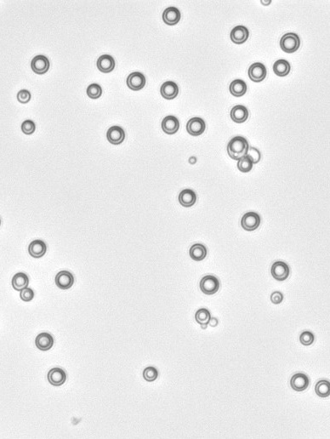
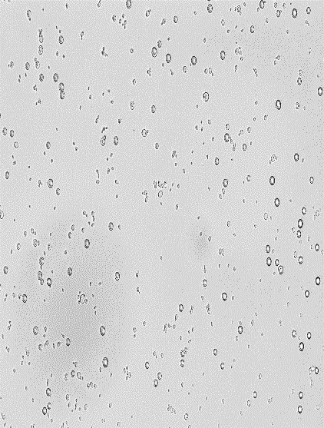
9 d 12 d 34 d

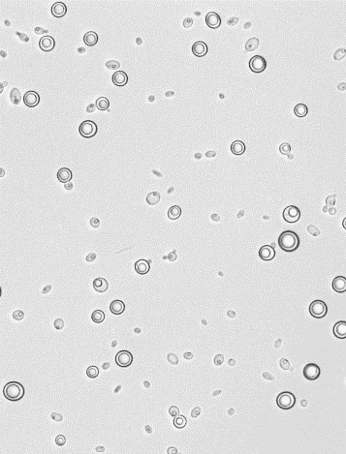
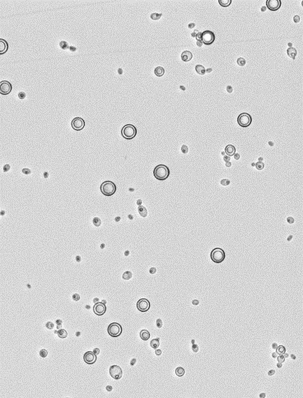
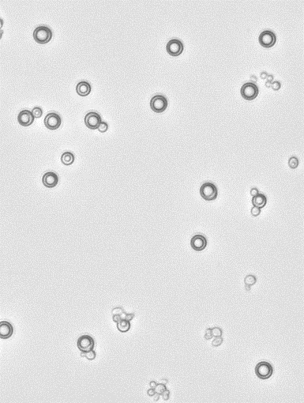

Figure S3: Micrographs of Metschnikowia pulcherrima at different sampling times in semi-continuous cultivation at a high dilution rate (D). The yeast was cultured semi-continuously in 2 L stirred tank reactors at D = 0.21 d⁻¹ on glucose syrup and yeast extract. Additional preculture was either added with every feed (blue) or not (orange). The scale bar represents 50 μm.

Figure S4
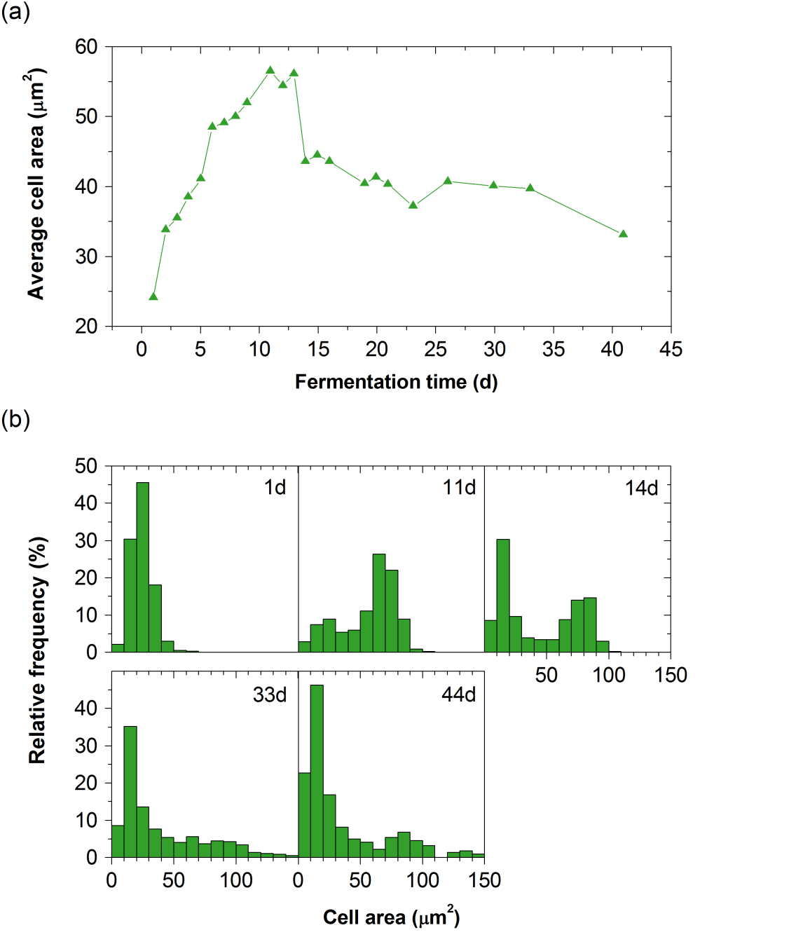
Figure S4: Cell size analysis of Metschnikowia pulcherrima in semi-continuous cultivation at a lower dilution rate (D). (a) Average cell size, and (b) cell size distribution over time in semi-continuous cultivation of an evolved M. pulcherrima strain in 2 L stirred tank reactors at D = 0.14 d⁻¹ on glucose syrup and yeast extract (singlicate).

Figure S5
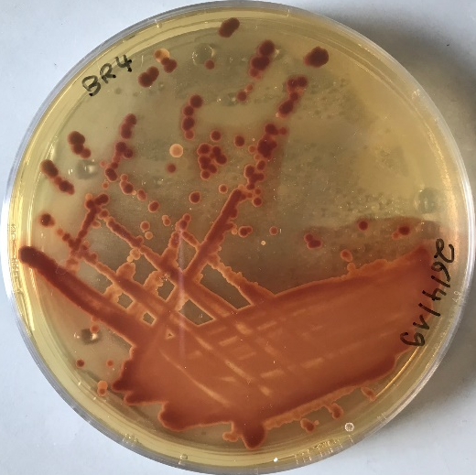
Figure S5: Metschnikowia pulcherrima plated on an iron-supplemented agar plate. The malt extract agar contains 0.02 mg L⁻¹ FeCl₃. High iron concentrations lead to the increased production of the red pigment pulcherrimin – a distinct characteristic of M. pulcherrima.

