Supplemental Table - Major Exclusions
Trial | Journal | Reason for Exclusion
Landes et al. [19] | JACC Cardiovasc Interv | Lack of radiation exposure
Mangner et al. [34] | J Interv Cardiol | Lack of radiation exposure
Watanabe et al. [35] | Am J Cardiol | Lack of radiation exposure
Berkovitch et al. [36] | J Invasive Cardiol | Lack of radiation exposure
Biancari et al. [37] | Int J Cardiol | Lack of radiation exposure
Guhu et al. [38] | J Am Heart Assoc | Different study design.
Zhang et al. [39] | J Am Heart Assoc | Different study design

Figures

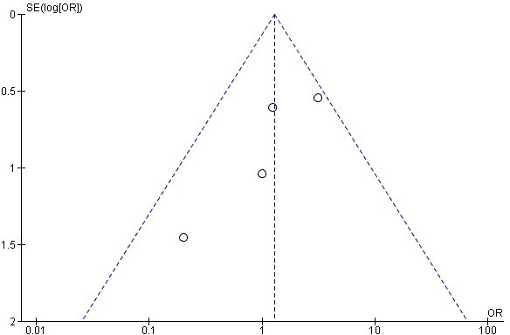
Figure 1 (Analysis 1.1)

Funnel plot of comparison: 30-day mortality.

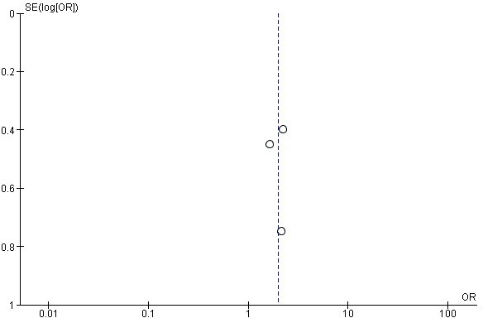

Funnel plot of comparison: 1 year mortality.

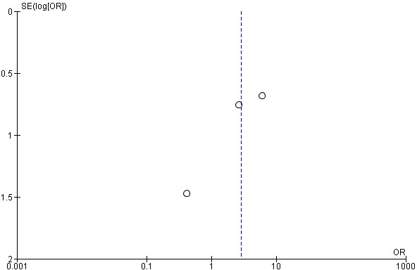

Funnel plot of comparison: Stroke.

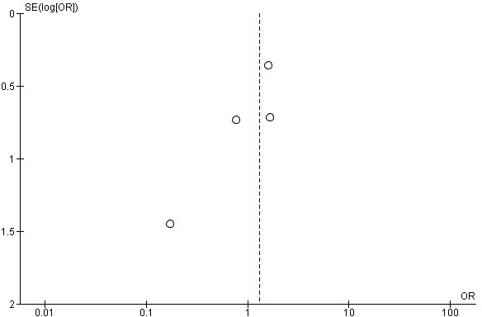

Funnel plot of comparison: Major bleeding.

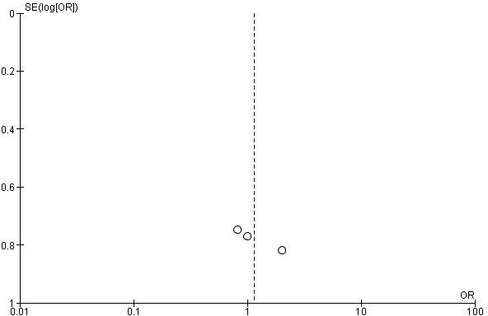

Funnel plot of comparison: Access related vascular complications.

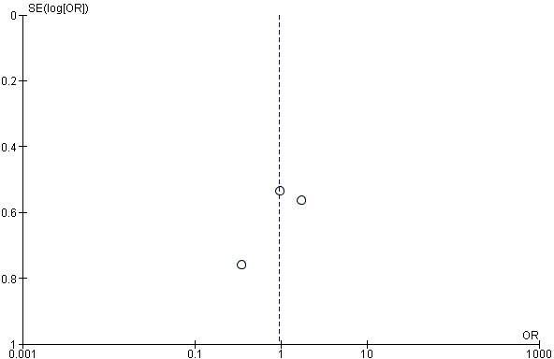

Funnel plot of comparison: Need for a pacemaker.

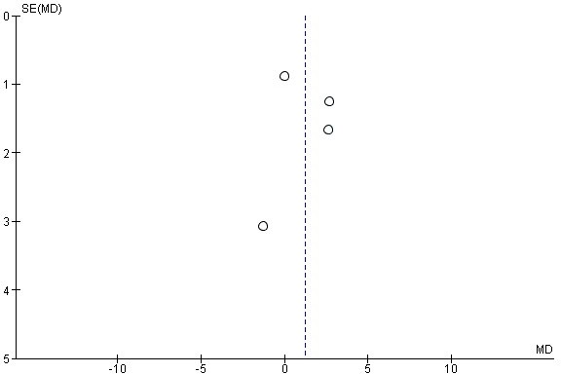

Funnel plot of comparison: Left ventricular ejection fraction.

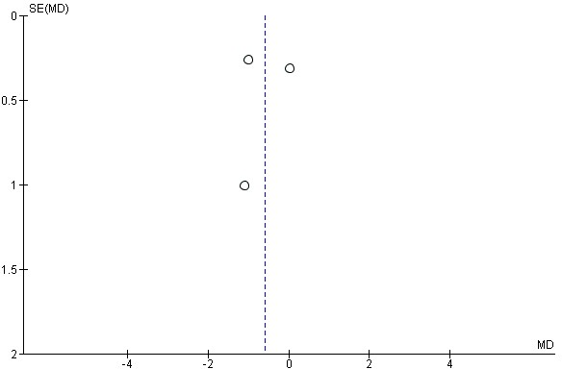

Funnel plot of comparison: Mean aortic valve gradient.

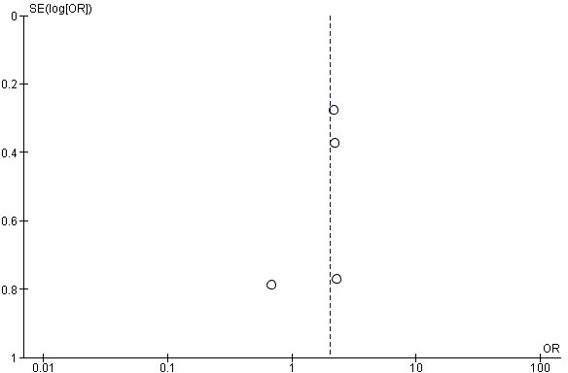

Funnel plot of comparison: Post-procedural worsening of congestive heart failure.

