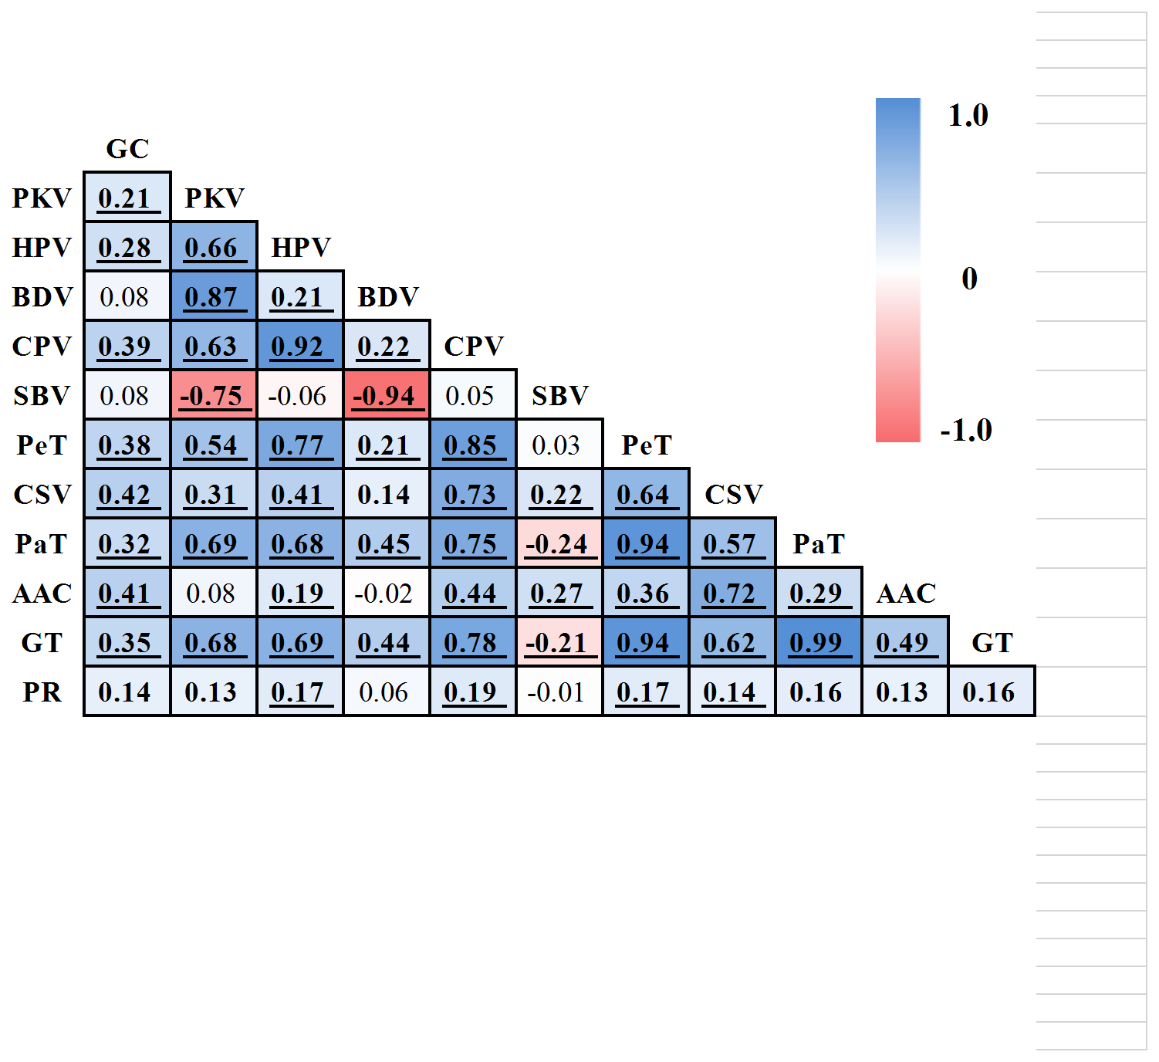
Figure S2. Phenotypic correlations among physical and chemical quality characters in RILs. Correlations with P <0.05 are in bold, while values with P <0.01 are in bold and underlined

