Additional file 9:
Figure S6
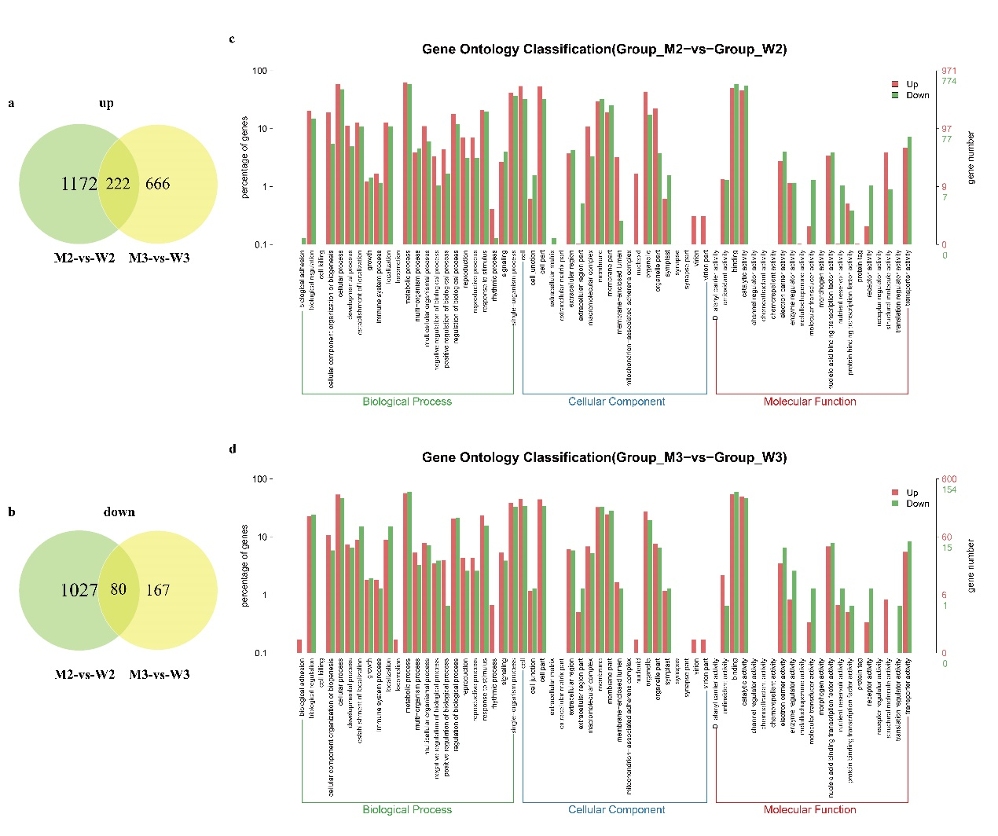

Figure S6 RNA-seq analysis of WT and wsl9 mutant grown at 20℃ and 30℃. a Up-regulated differentially expressed genes comparing M2 and W2 and M3 and W3. b Down-regulated differentially expressed genes for M2-vs-W2 and M3-vs-W3. c Go analysis of genes differentially expressed between M2 and W2. d Go analysis of genes differentially expressed for M3-vs-W3. W3 and W2 represent WT plants grown at 30℃ and 20℃, respectively. M3 and M2 represent wsl9 mutant plants grown at 30℃ and 20℃, respectively.

