Additional file 8:
Figure S5
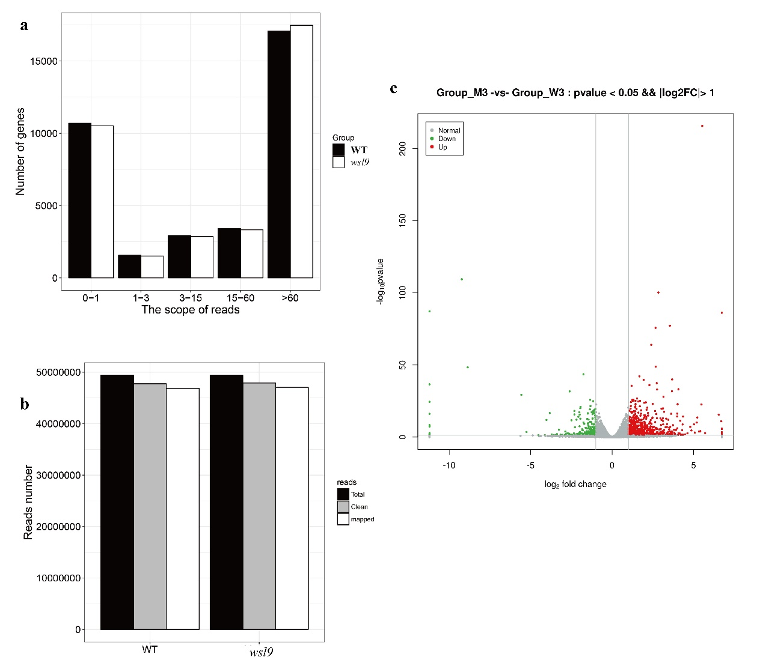
Figure S5 RNA-seq analysis of WT and wsl9 seedlings at 30℃. mRNA was enriched from total RNA isolated from 10-d-old WT and wsl9 mutant seedlings using oligo-(dT) fragmented and reverse-transcribed using random hexamer primers. The library was then constructed and sequenced using an Illumina HiSEquation 2000. a Frequencies of detected genes sorted according to expression level. b Read numbers of WT and wsl9 mutant sequences. c Volcano plot showing the overall alterations in gene expression in WT and wsl9 mutant b- Y-AXIS ‘Read number’.

