Additional file 7:
Figure S4
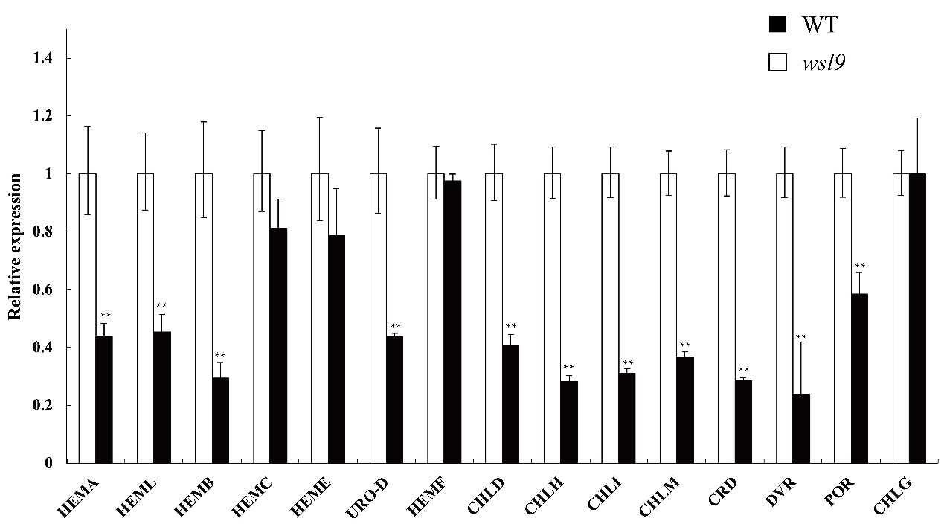

Figure S4 Expression levels of chlorophyll synthesis genes in wild type and wsl9 mutant (Student’s t-tests, ∗∗, P <0.01).

