Sniffin’ Sticks test
(I) Technical Specification:
Sniffin' Sticks are felt-tip pens filled with an odorant, each is held 2 cm in front of one nostril (the other is blocked with micro-foam) while the patient is blindfolded and is asked to take a sniff.
The patient is instructed neither to eat or drink anything other than water 15 min prior to the test including smoking or chewing gum. The test is performed in a well-ventilated room with very little odors to avoid smell contamination.
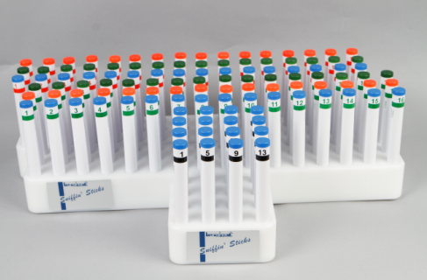
Burghart Sniffin’ Sticks – Extended n-Butanol Test

(II) Measured parameters:
(a) Threshold test for butanol (red labelled pens):
The smell threshold subtest is determined in a so-called staircase procedure. After a start concentration of the smell is found out, the dilution step is identified at which the smell can just be distinguished from non-smelling pens (blanks). The Threshold Test is available with n-butanol and with rose smell (2-phenyl-ethanol) as target.
The threshold is assessed in 16 steps representing the odorant at escalating concentrations with 30 sec duration between the consecutive steps; pens labelled–1 had the highest concentration while pen labelled–16 had the lowest. At the beginning, the patient smell pen labelled–1 to make hem familiar with the odor then the test is started by pens labelled–16 where the starting point is reached when the patient has 2 correct answers (identify the butanol containing pen from the other 2 having solvents). The turning points were determined 6 times by using lower and higher concentrations consecutively. On shifting from lower to higher concentrations, the turning point is determined by 2 correct answers while in the reverse direction, the turning point is identified by 1 wrong answer. The threshold is quantified as the mean of the last 4 turning points.
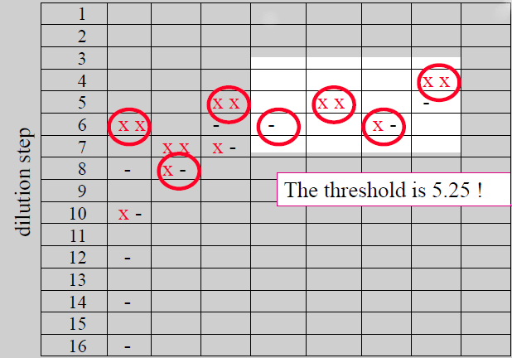
The threshold is the mean of the last 4 turning points; turning points 4 – 7
(b) Discrimination test (green labelled pens):
Discrimination of odors is based on comparison of 3 smell presentations (triplet). To this end, two times the same odor is presented (non-target) and one time a different smelling one (target). The subject’s task is to indicate which one smells different. The discrimination score corresponds to the number of correct responses out of the 16 triplets.
(c) Identification test:
This subtest examines the ability of the subject to identify everyday smells. It is a multiple-choice procedure where the subject must make a forced choice from a list of 4 written proposals for each odorant pen. Each pen has a super-threshold concentration allowing for odor identification and is presented only once and an interval of at least 30 seconds is observed between each presentation to avoid olfactory desensitization. The identification score corresponds to the number of correct responses.
 | Target odor | Alternative response
Item-1 | Orange | Blueberry | Strawberry | Pineapple
Item-2 | Leather | Smoke | Glue | Grass
Item-3 | Cinnamon | Honey | Vanilla | Chocolate
Item-4 | Peppermint | Chives | Fir | Onion
Item-5 | Banana | Coconut | Walnut | Cherry
Item-6 | Lemon | Peach | Apple | Grapefruit
Item-7 | Licorice | Caramel | Chewing gum | Biscuit
Item-8 | Turpentine | Mustard | Rubber | Menthol
Item-9 | Garlic | Onion | Sauerkraut | Carrot
Item-10 | Coffee | Cigarette | Wine | Candle smoke
Item-11 | Apple | Melon | Peach | Orange
Item-12 | Clove | Pepper | Cinnamon | Mustard
Item-13 | Pineapple | Pear | Plum | Peach
Item-14 | Rose | Chamomile | Raspberry | Cherry
Item-15 | Aniseed | Rum | Honey | Fir
Item-16 | Fish | Bread | Cheese | Ham
(d) TDI (threshold, discrimination and identification) score:
This global olfactory score is the sum of the previous 3-scores; 31 – 48 normosmia, 16 – 30 hyposmia and ≤ 15 functional anosmia.
(III) Reference:
- Rumeau C, Nguyen DT, Jankowski R. How to assess olfactory performance with the Sniffin’ Sticks test. European Annals of Otorhinolaryngology, Head and Neck diseases. 2016; 133: 203–6. doi: 10.1016/j.anorl.2015.08.004

