Bland Altman plots

A – Bland Altman Plots with 95% limits of agreement for corresponding GEDI and SDQ domains, stratified by age groups

Figure 1: GEDI domain SOC_1 (overall social competence with peers) and SDQ domain peers (peer relationship problems)
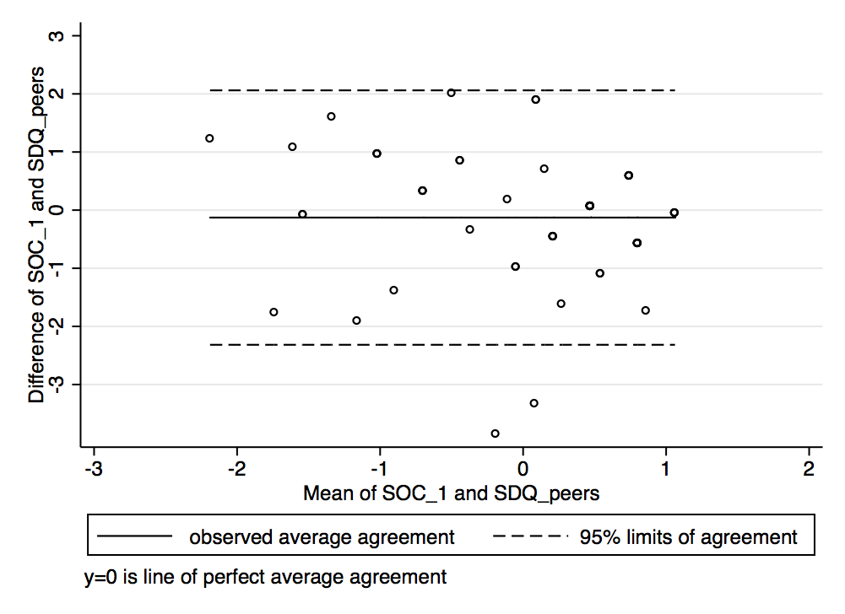  A) age 3 [95% limits of agreement: -2.32 to 2.06] | 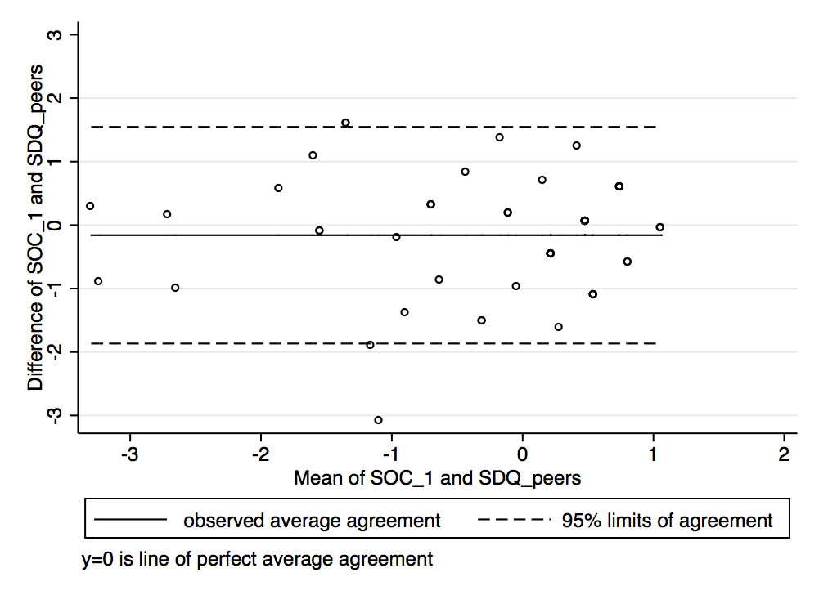  B) age 4 [95% limits of agreement: -1.87 to 1.55]
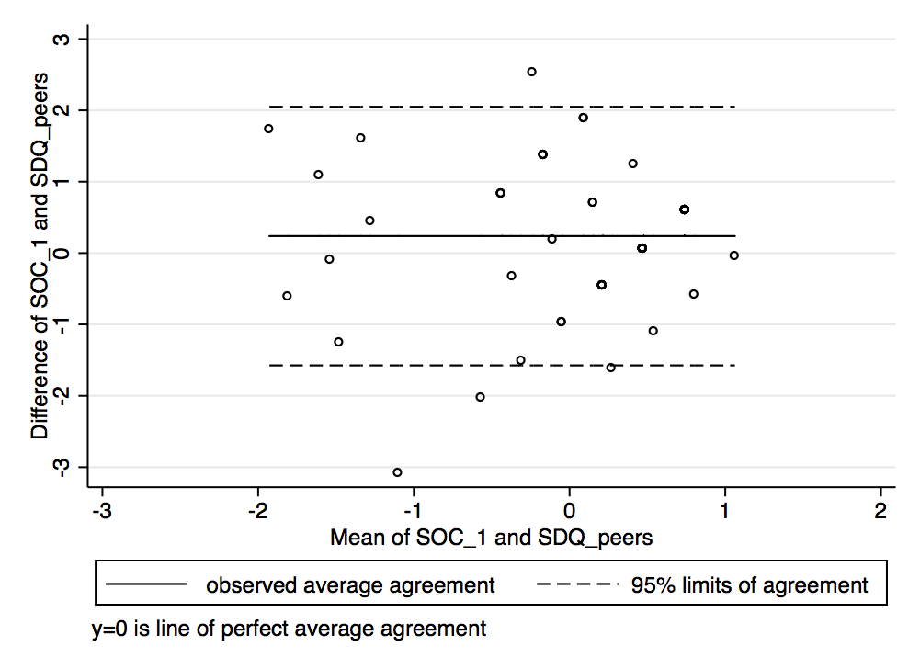  C) ages 5 & 6 [95% limits of agreement: -1.57 to 2.05] | 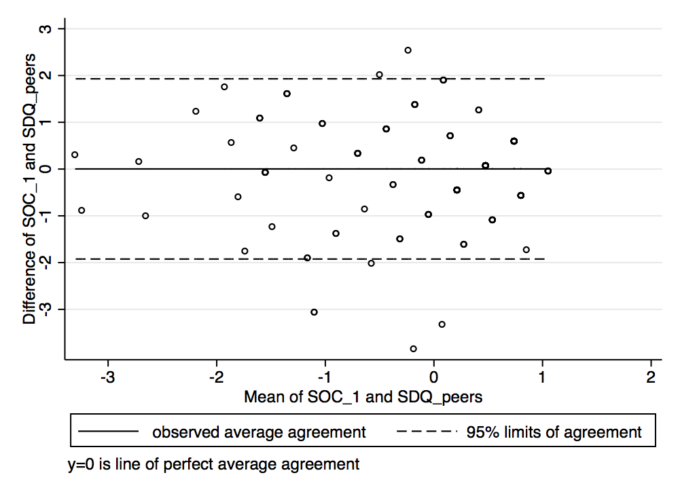  D) overall sample [95% limits of agreement -1.92 to 1.93]

Figure 2: GEDI domain EMO_1 (prosocial and helping behavior) and SDQ domain peers (peer relationship problems)
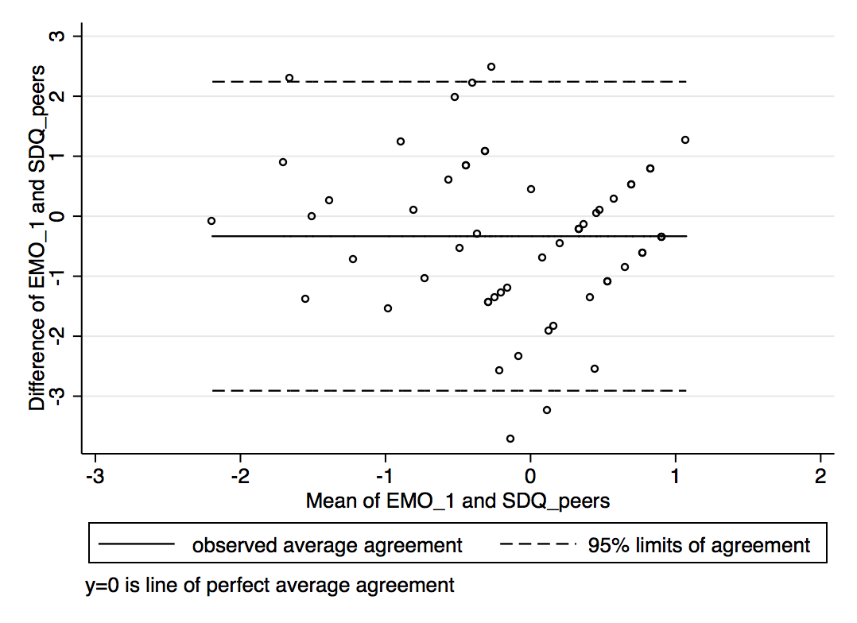  A) age 3 [95% limits of agreement: -2.91 to 2.24] | 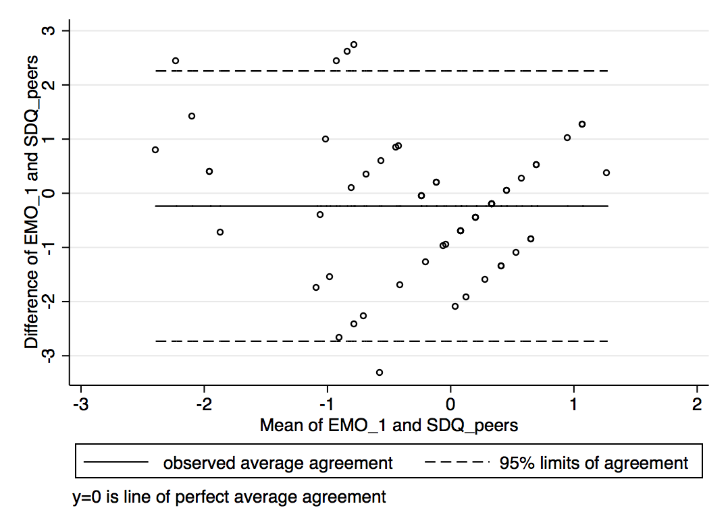  B) age 4 [95% limits of agreement: -2.73 to 2.26]
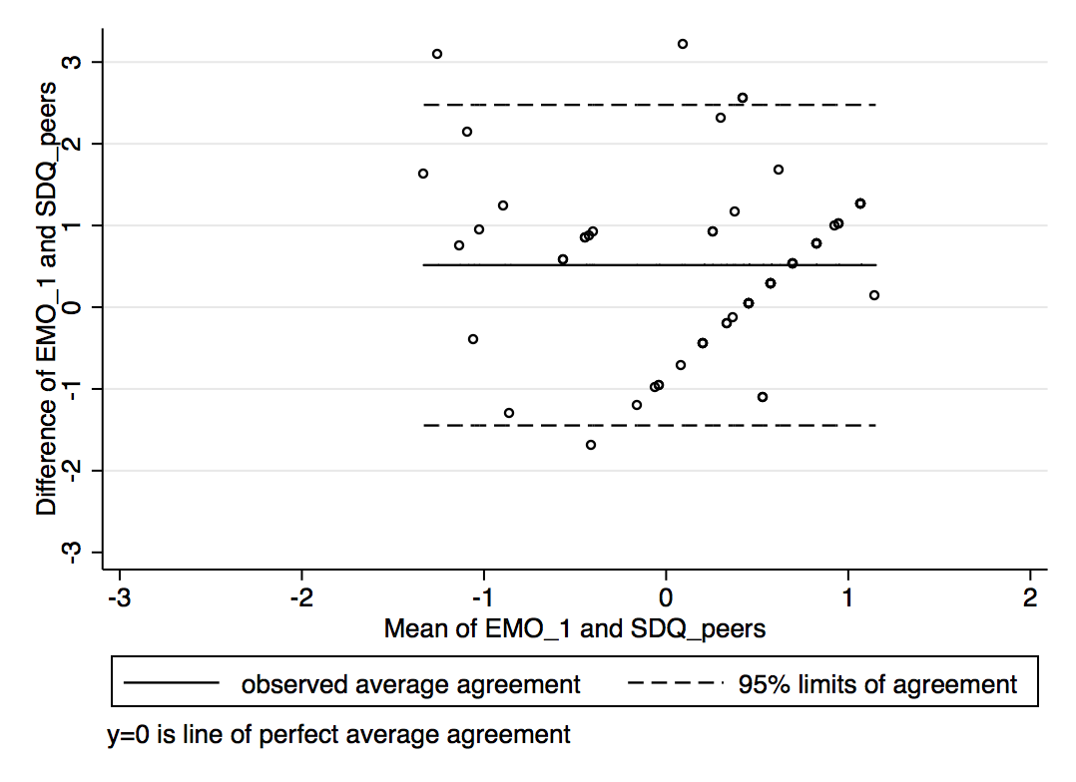  C) ages 5 & 6 [95% limits of agreement: -1.45 to 2.48] | 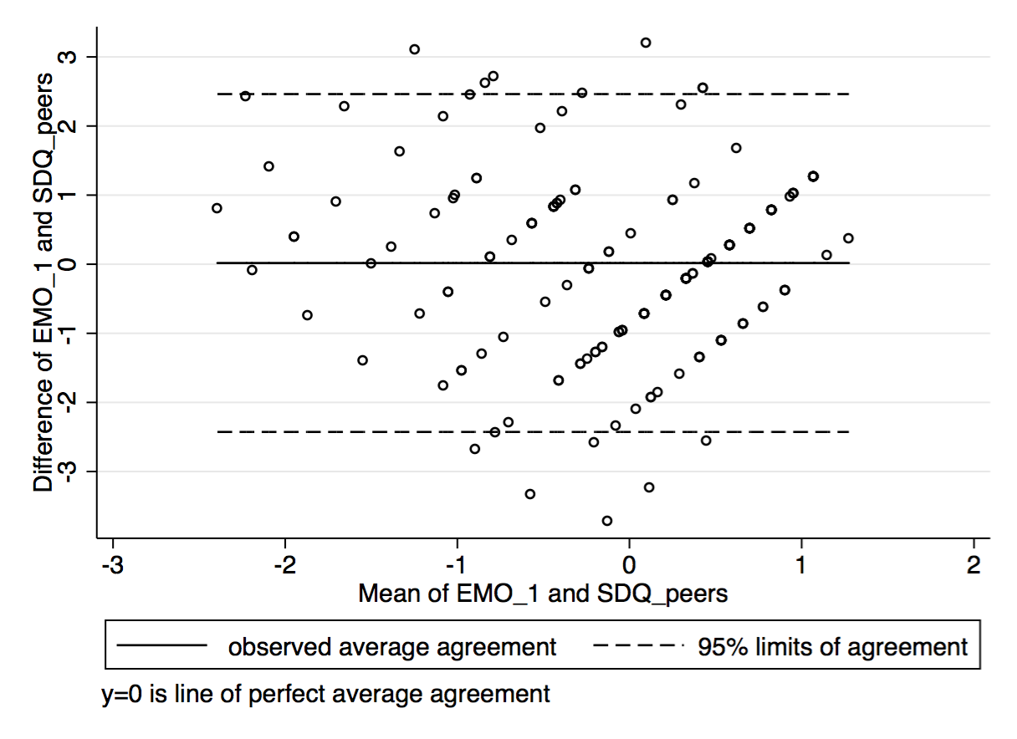  D) overall sample [95% limits of agreement -2.43 to 2.46]

Figure 3: GEDI domain EMO_1 (psosocial and helping behavior) and SDQ domain prosoc (prosocial behaviour)
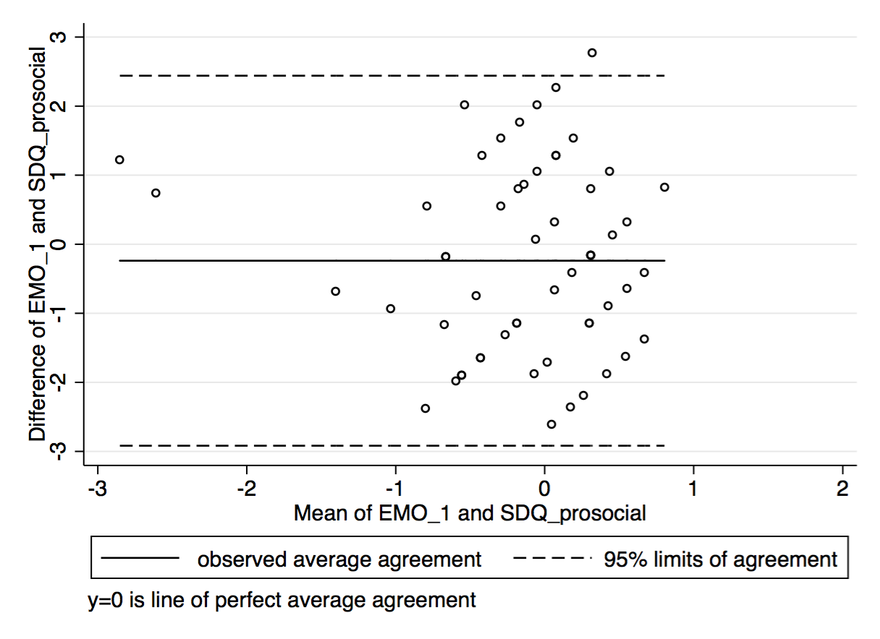  A) age 3 [95% limits of agreement: -2.92 to 2.44] | 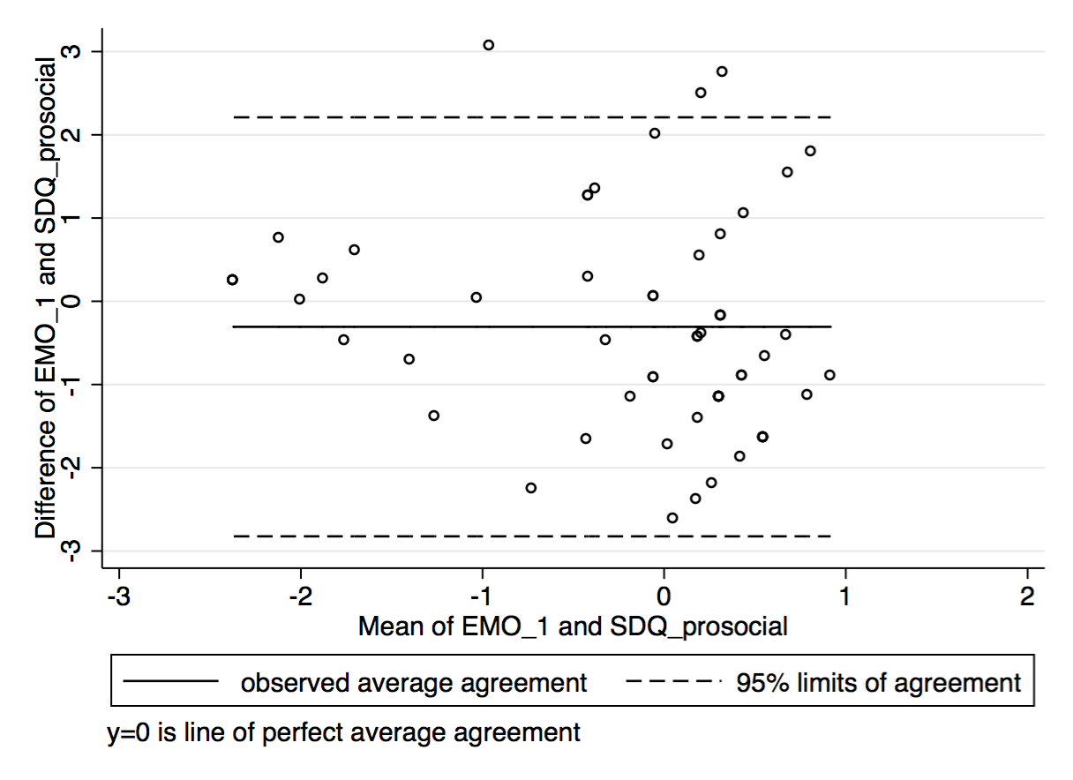  B) age 4 [95% limits of agreement: -2.82 to 2.21]
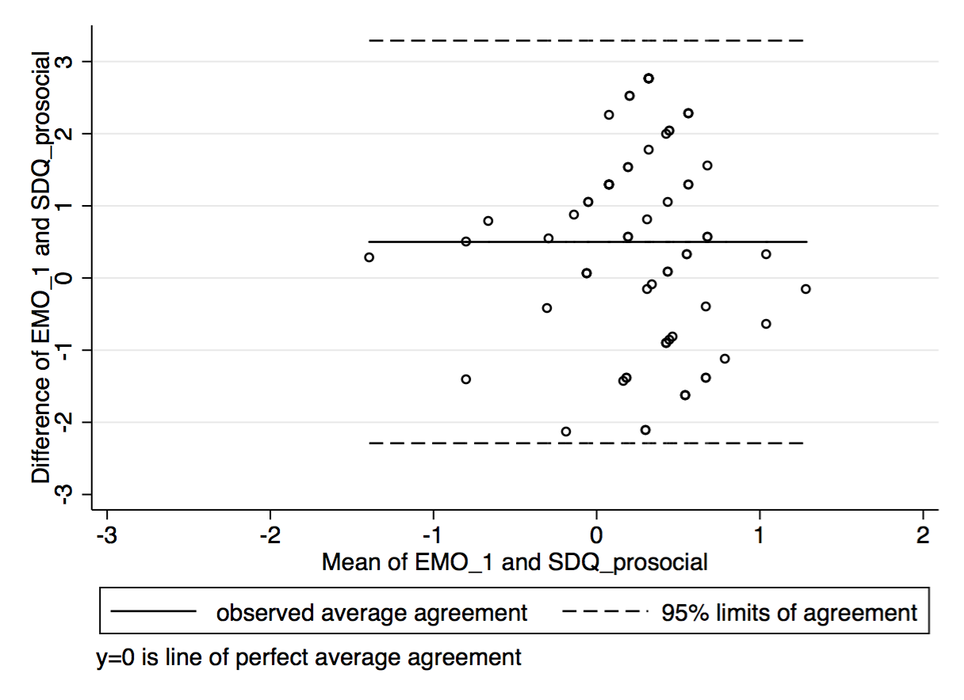  C) ages 5 & 6 [95% limits of agreement: -2.29 to 3.29] | 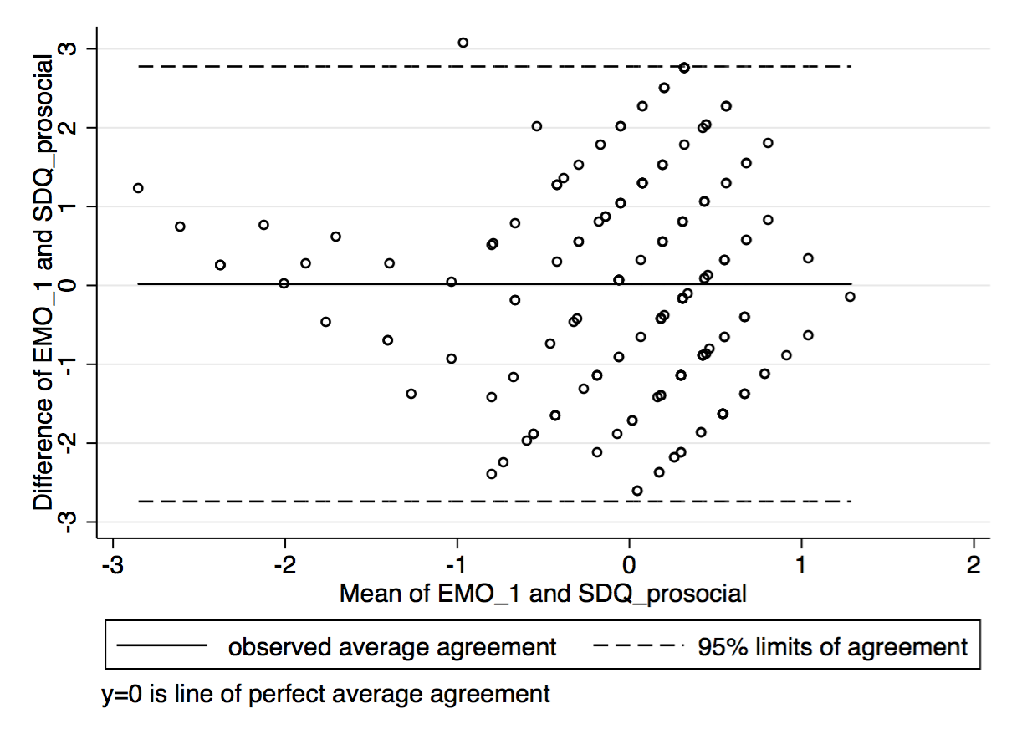  D) overall sample [95% limits of agreement -2.74 to 2.78]

Figure 4: GEDI domain EMO_3 (aggressive behaviour) and SDQ domain conduct (conduct problems)
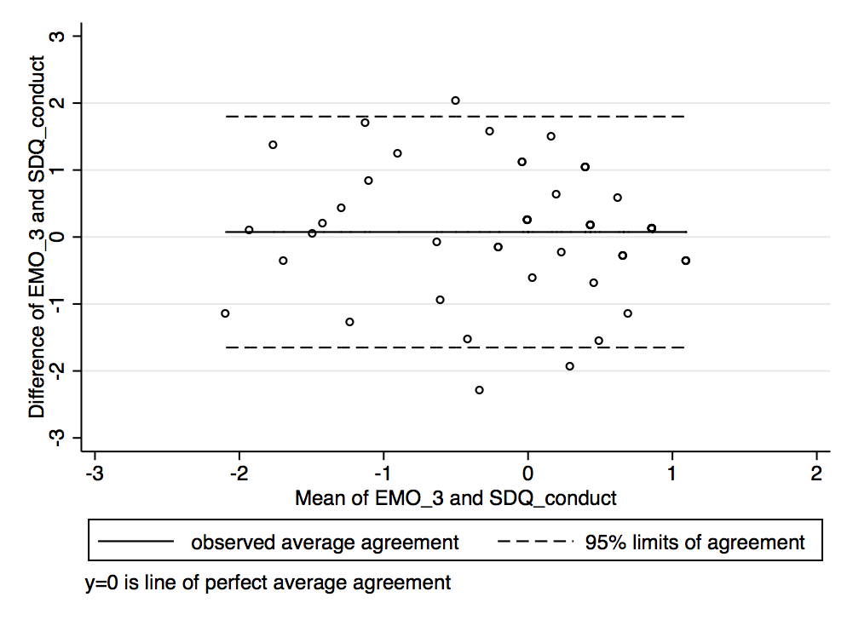  A) age 3 [95% limits of agreement: -1.65 to 1.8] | 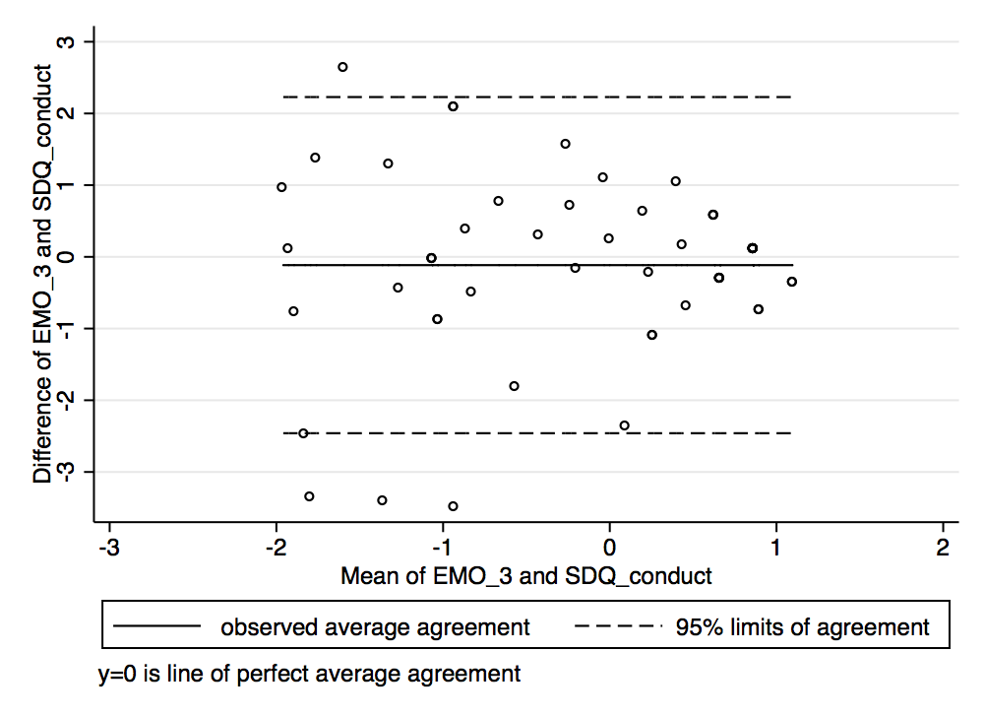  B) age 4 [95% limits of agreement: -2.46 to 2.23]
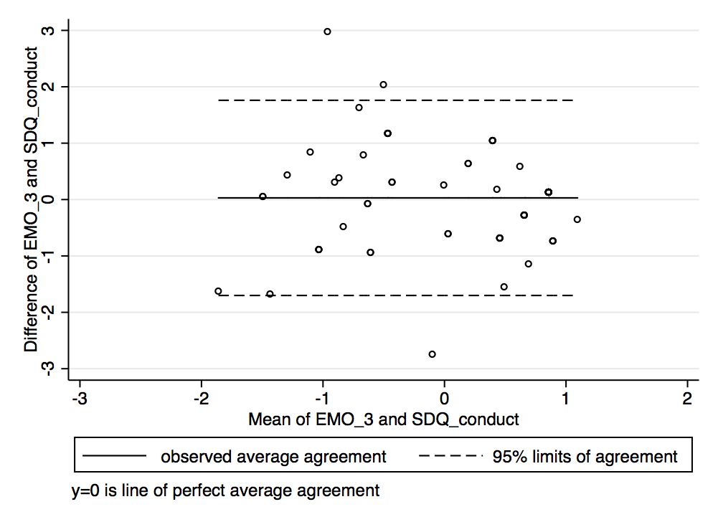  C) ages 5 & 6 [95% limits of agreement: -1.70 to 1.76] | 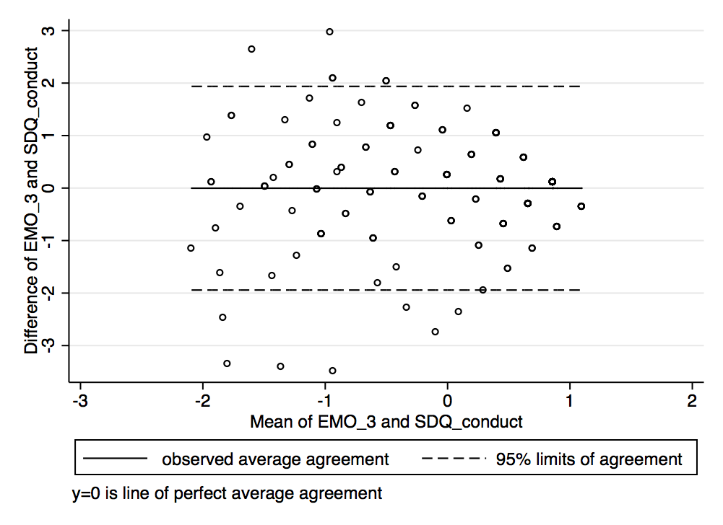  D) overall sample [95% limits of agreement -1.94 to 1.94]

Figure 5: GEDI domain EMO_4 (hyperactive and inattentive behaviour) and SDQ domain hyper (hyperactivity/inattention)
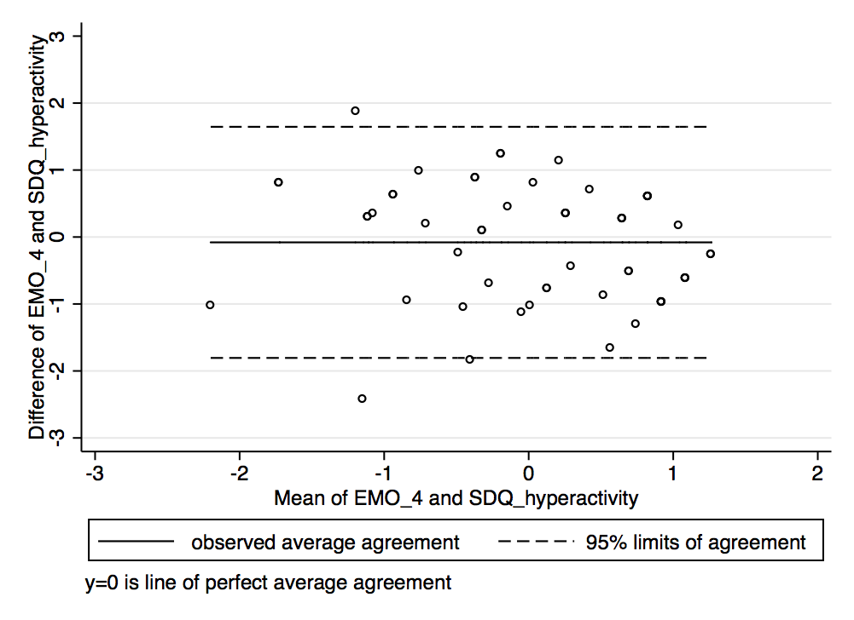  A) age 3 [95% limits of agreement: -1.81 to 1.65] | 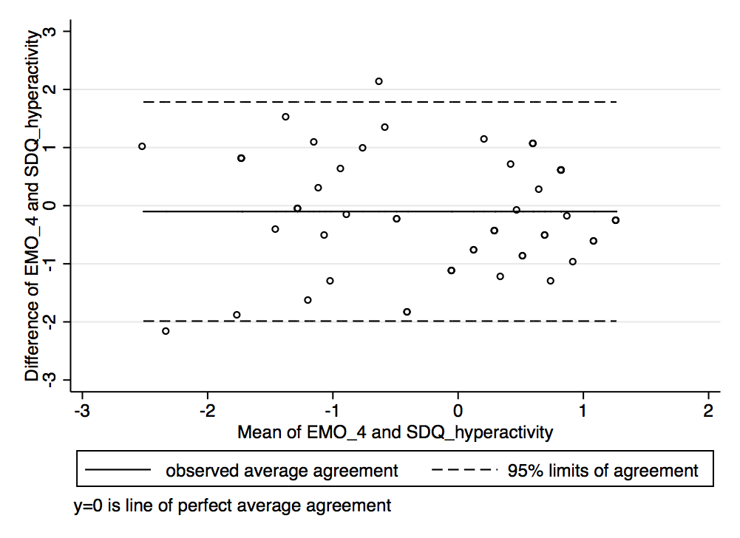  B) age 4 [95% limits of agreement: -1.99 to 1.78]
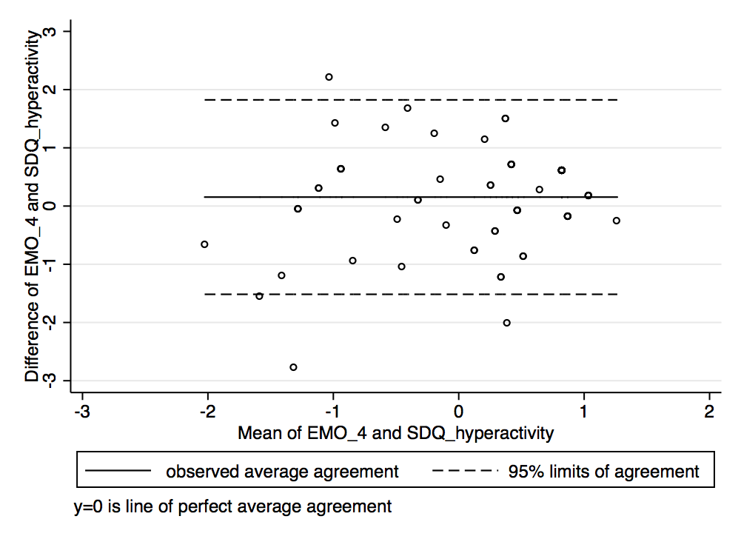  C) ages 5 & 6 [95% limits of agreement: -1.52 to 1.82] | 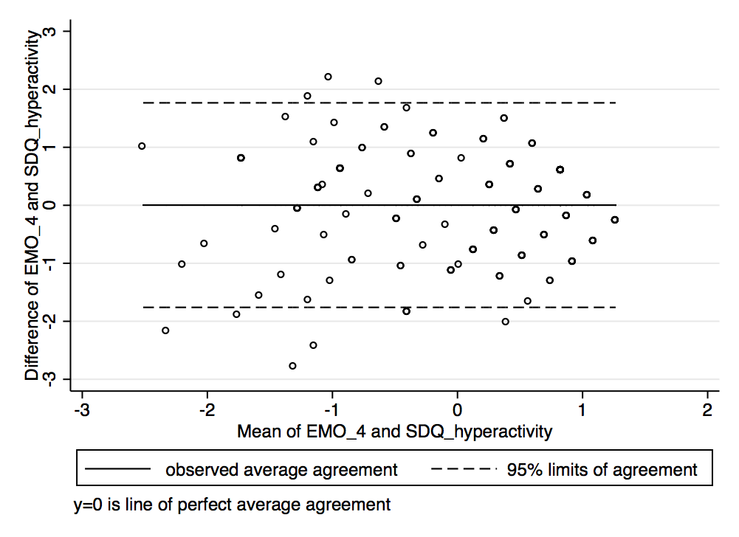  D) overall sample [95% limits of agreement -1.76 to 1.77]

B – Bland Altman Plots with 95% limits of agreement for corresponding GEDI and DESK domains, stratified by age groups

Figure 1: GEDI domain PHY_3 (gross & fine motor skills) and DESK domain FMO (fine motor skills)
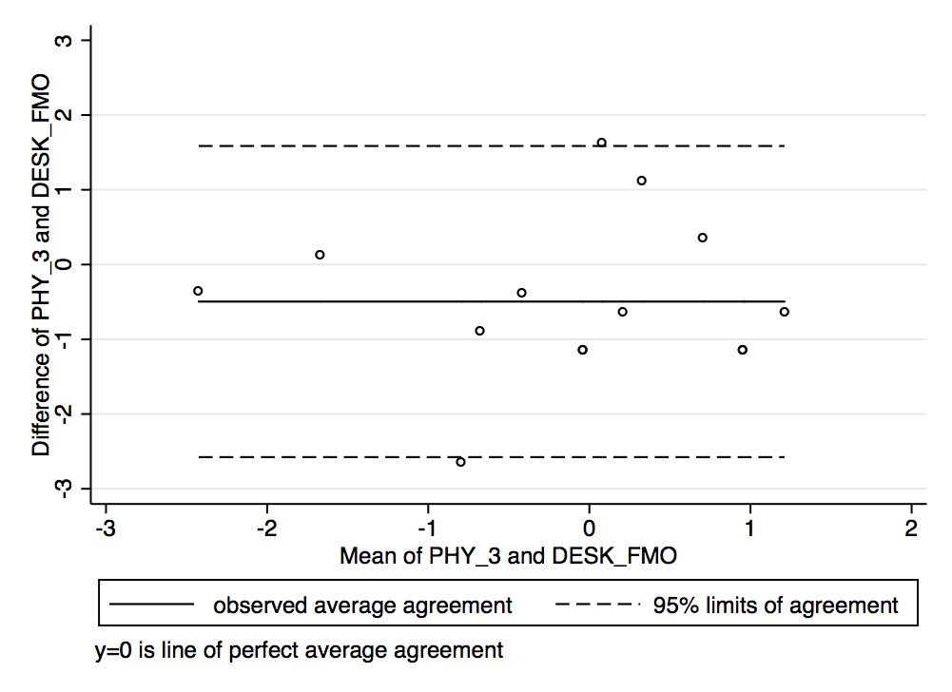  A) age 3 [95% limits of agreement: -2.58 to 1.59] | 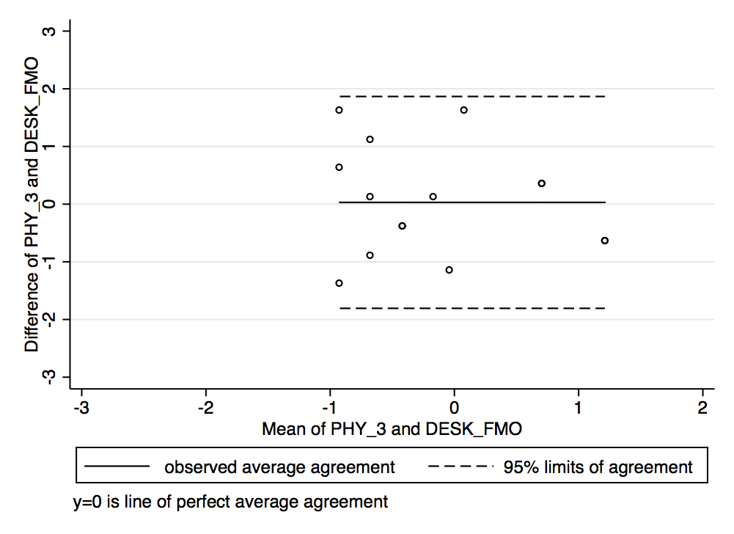  B) age 4 [95% limits of agreement: -1.81 to 1.87]
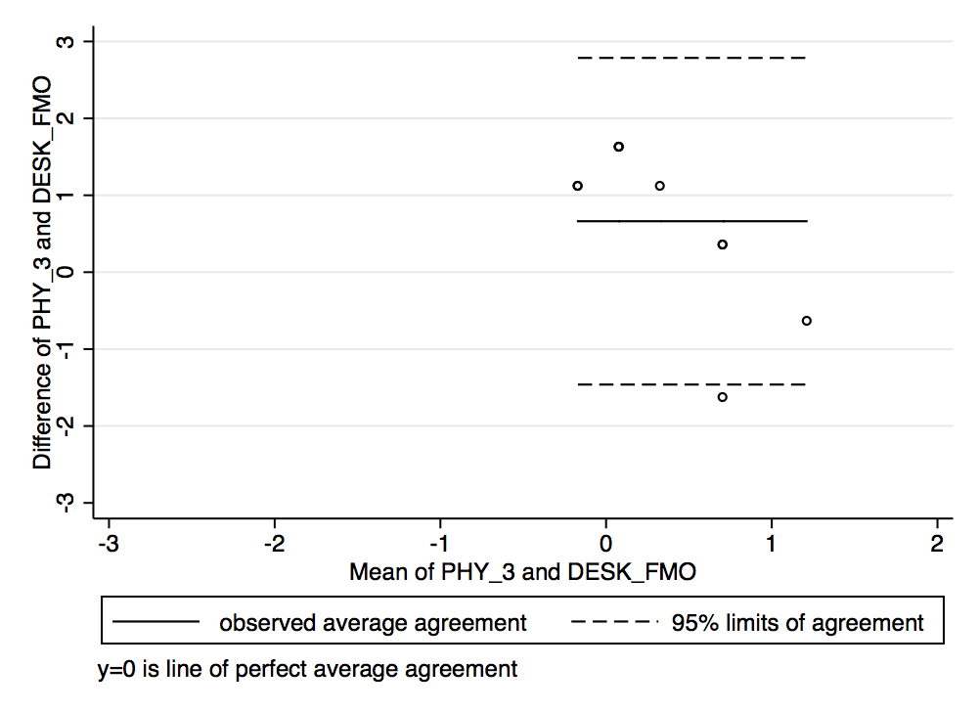  C) ages 5 & 6 [95% limits of agreement: -1.46 to 2.79] | 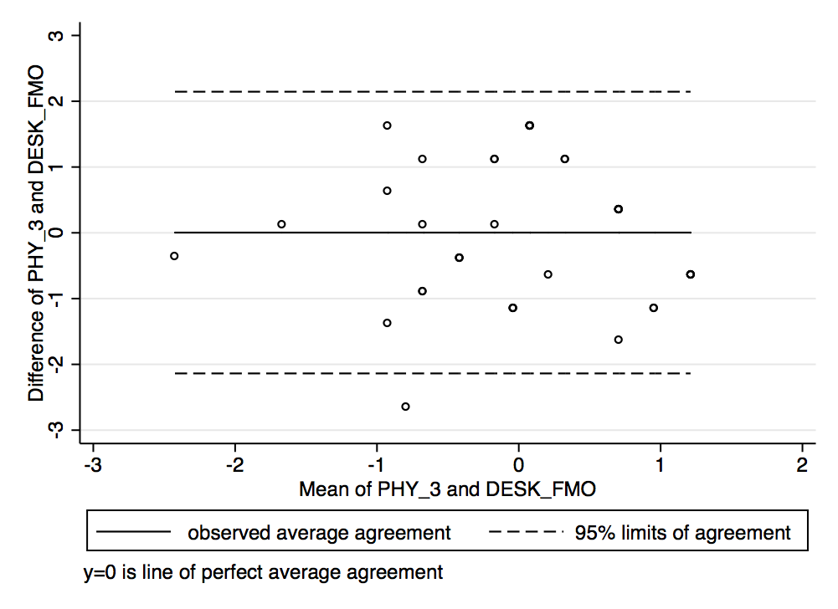  D) overall sample [95% limits of agreement -2.14 to 2.15]

Figure 2: GEDI domain PHY_3 (gross & fine motor skills) and DESK domain GMO (gross motor skills)
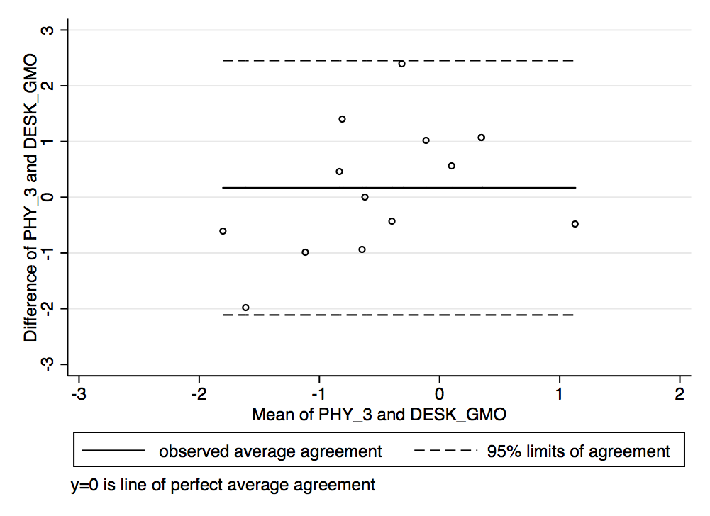  A) age 3 [95% limits of agreement: -2.11 to 2.45] | 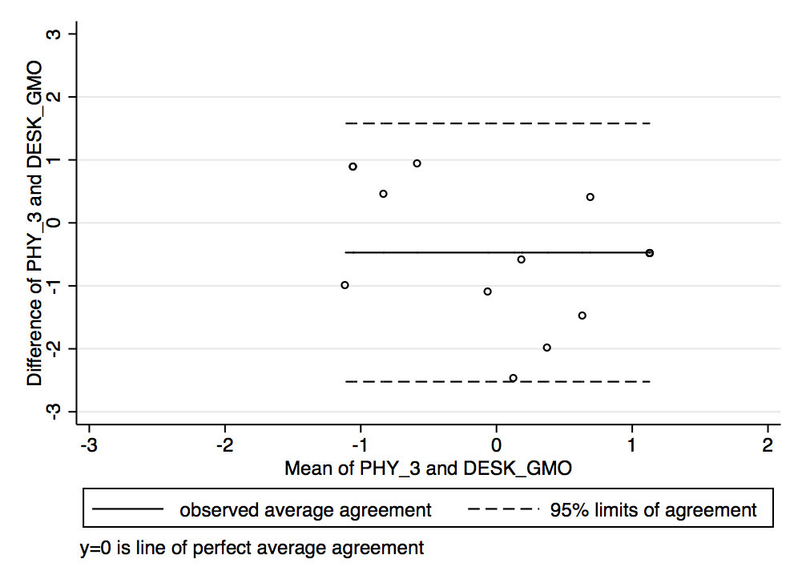  B) age 4 [95% limits of agreement: -2.52 to 1.58]
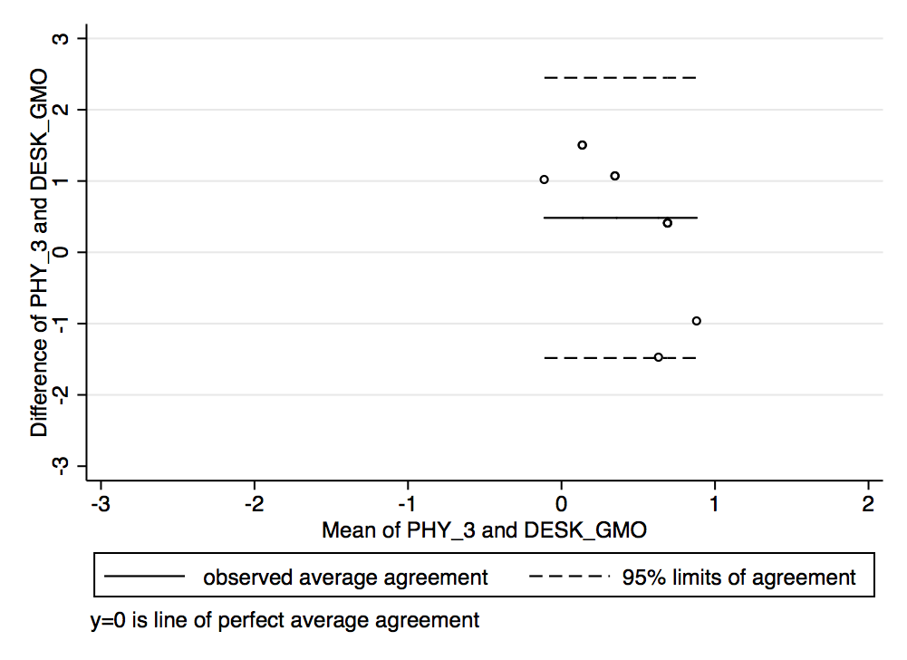  C) ages 5 & 6 [95% limits of agreement: 1.48 to 2.45] | 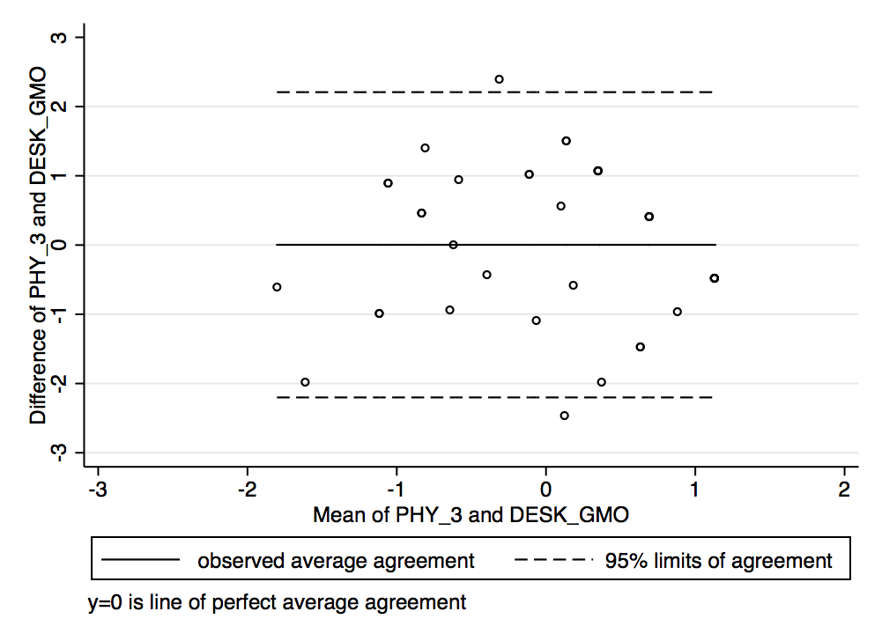  D) overall sample [95% limits of agreement -2.20 to 2.21]

Figure 3: GEDI domain SOC_1 (overall social competence with peers) and DESK domain SZV (social behaviour)
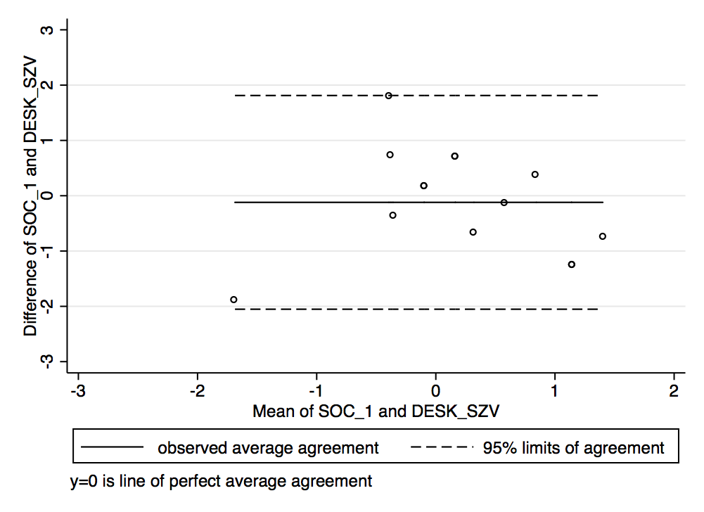  A) age 3 [95% limits of agreement: -2.05 to 1.81] | 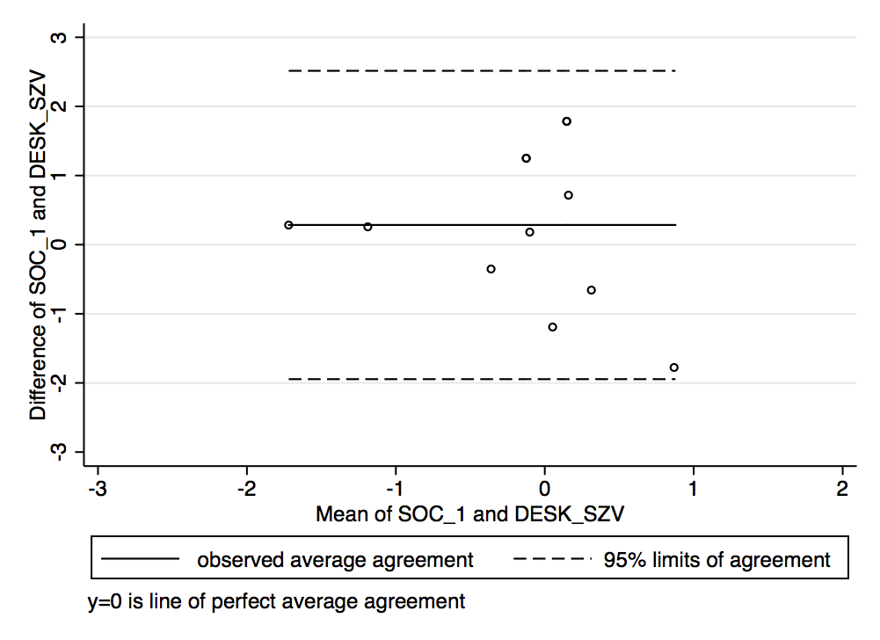  B) age 4 [95% limits of agreement: -1.95 to 2.52]
C) ages 5 & 6  Questionnaires for 5 and 6 year old children do not include the domain “social behavior” | 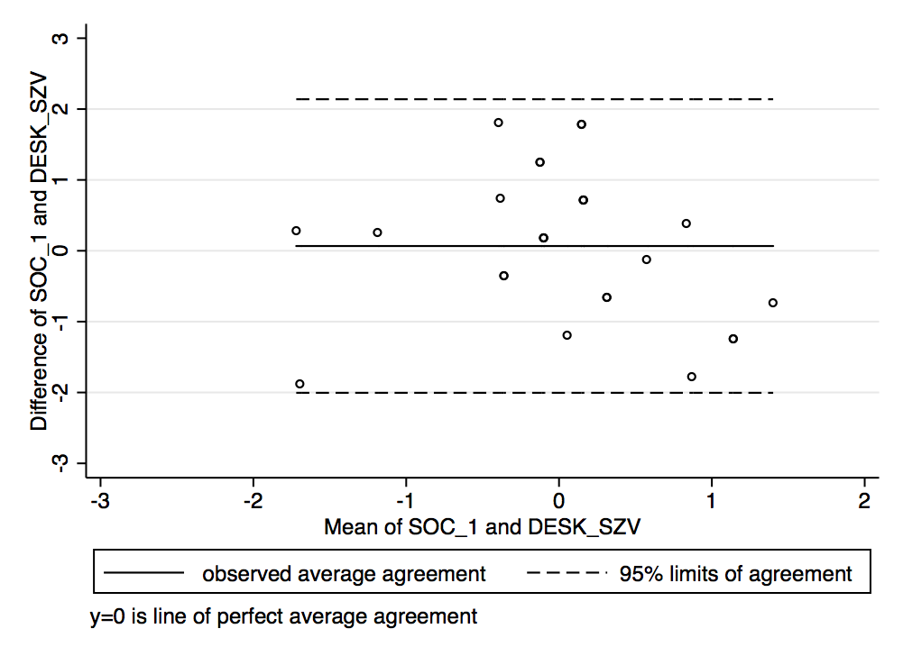  D) overall sample [95% limits of agreement -2.01 to 2.14]

Figure 4: GEDI domain LAN_1 (basic literacy) and DESK domain KOG (cognition)
A) Questionnaire for 3 year old children does not include the domain “cognition” | 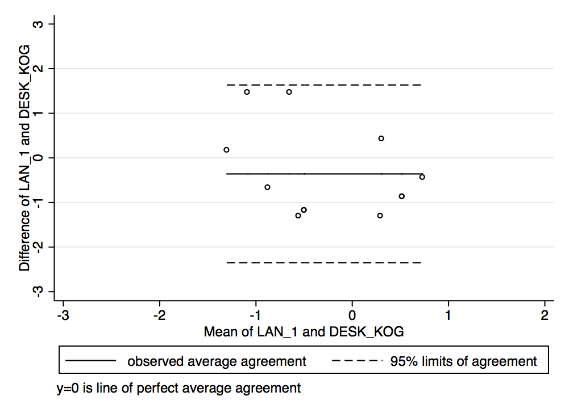  B) age 4 [95% limits of agreement: -2.35 to 1.63]
C) Questionnaire for 5 and 6 year old children does not include the domain “cognition” | 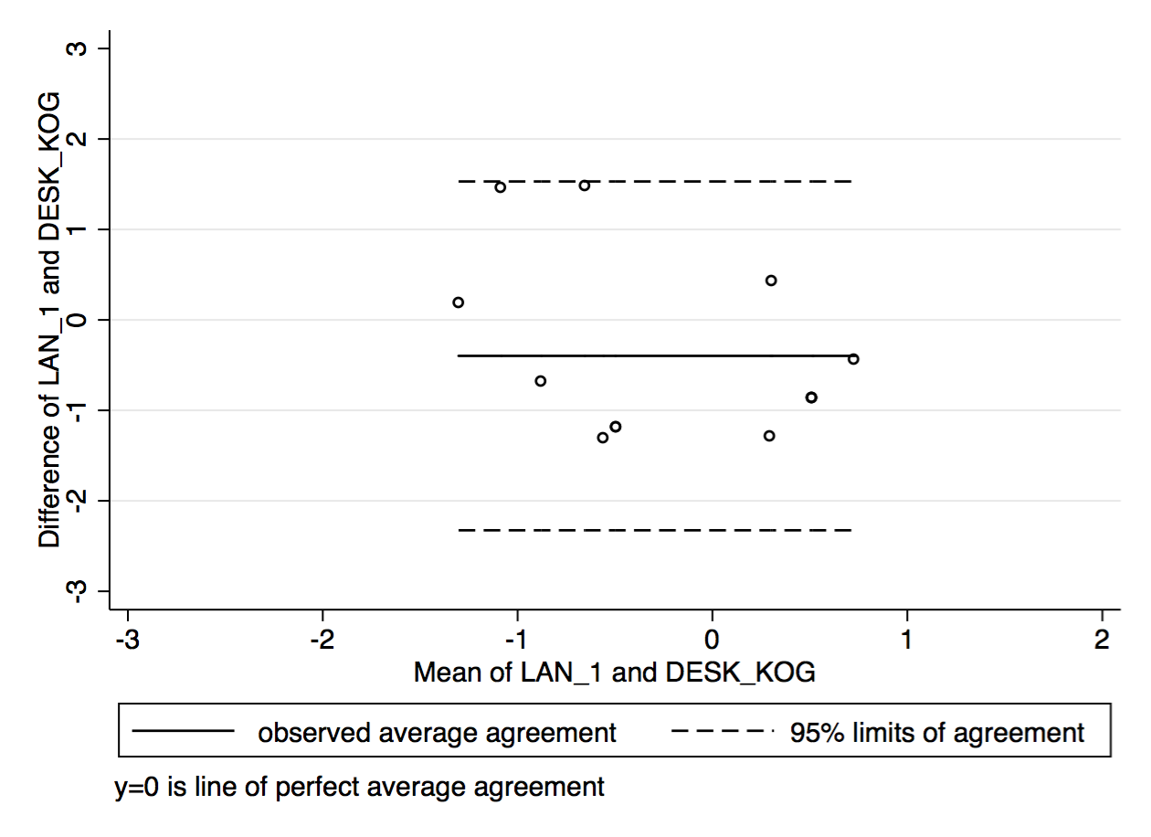  D) overall sample [95% limits of agreement -2.33 to 1.53]

Figure 5: GEDI domain COM (communication and general knowledge) and DESK domain SPK (language and communication)
A) Questionnaire for 3 year old children does not include the domain “language and communication” | 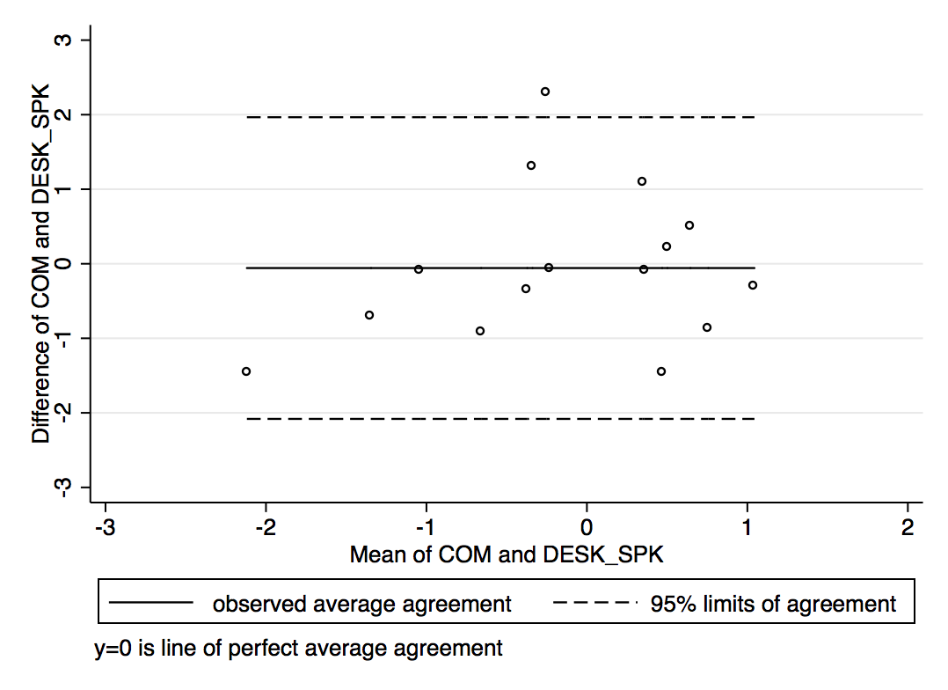  B) age 4 [95% limits of agreement: -2.08 to 1.97]
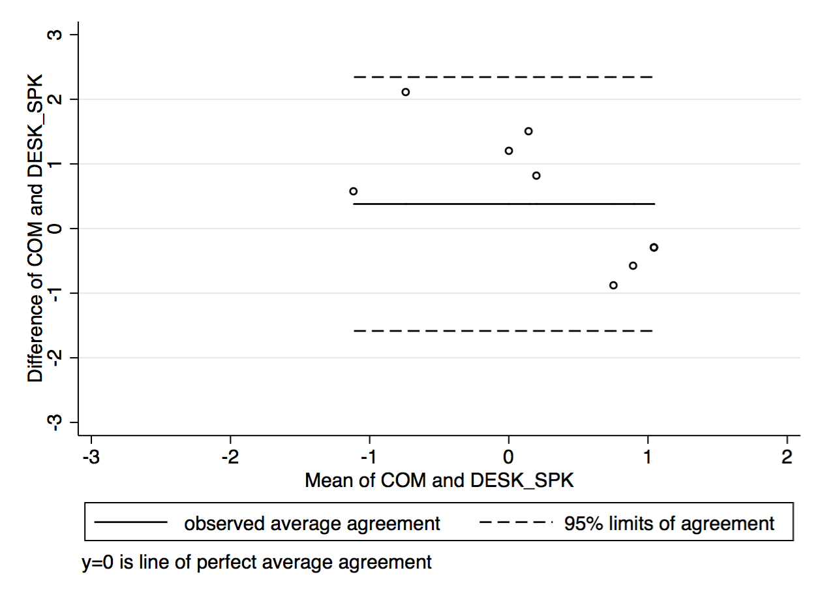  C) ages 5 & 6 [95% limits of agreement: -1.58 to 2.34] | 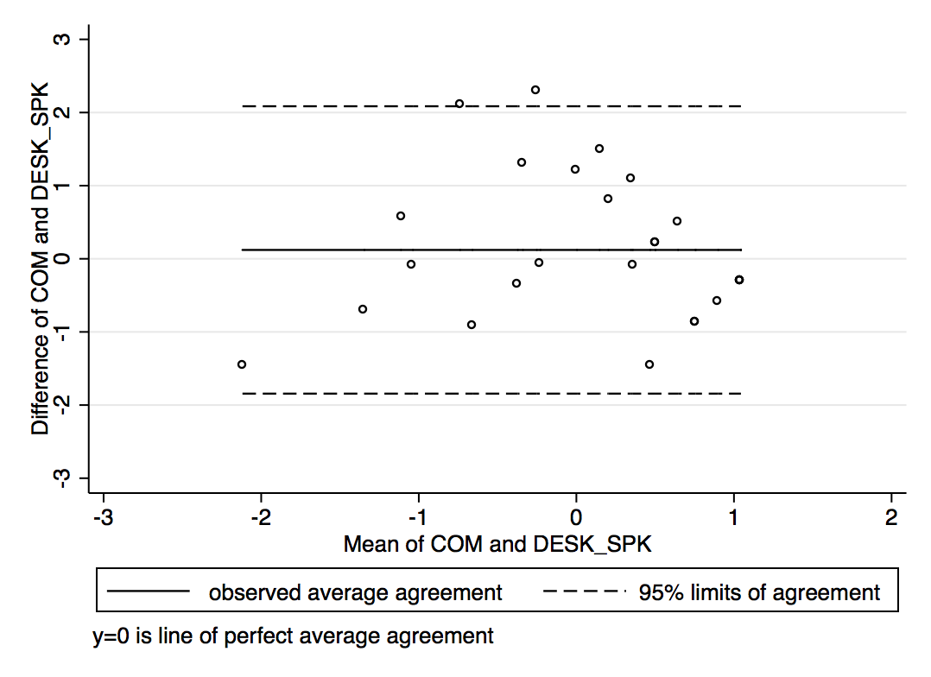  D) overall sample [95% limits of agreement -1.84 to 2.09]

