Supplementary material

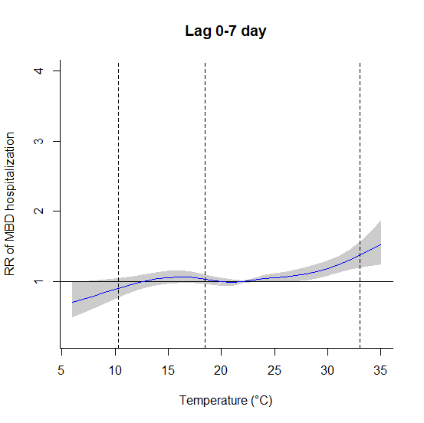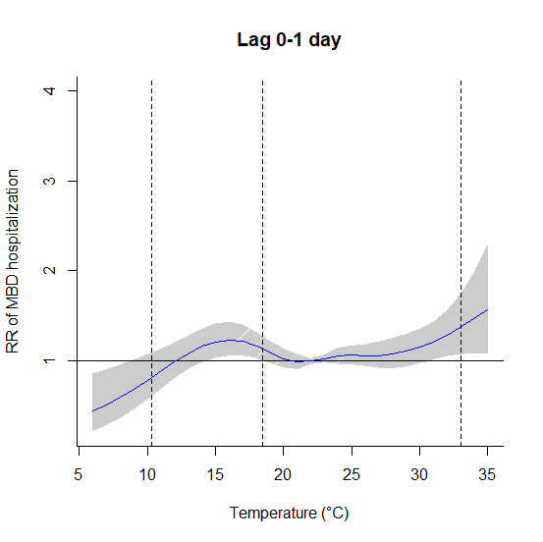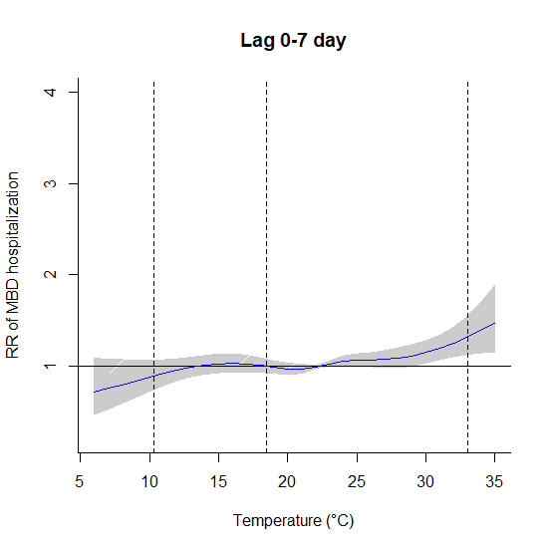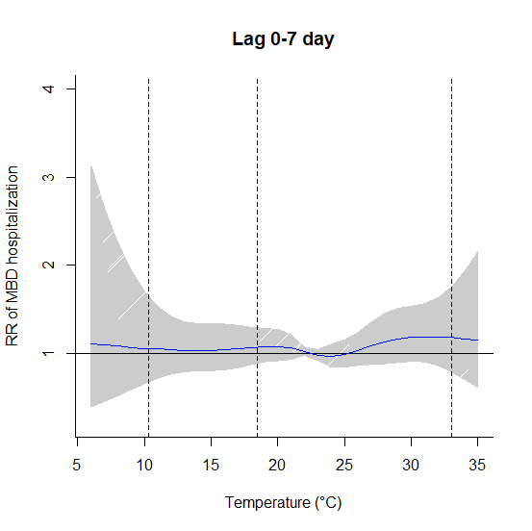
c)
d)
b)
a)
Figure S1: Exposure-response curve of mean temperature (°C) and cumulative relative risk for mental and behavioral disorder (reference temperature at 22.4 °C) for men. a. Group of all men. b. Group of young men. c. Group of adult men. d. Group of elderly men. Vertical lines correspond to the 1st, 25th and 99th temperature percentiles.

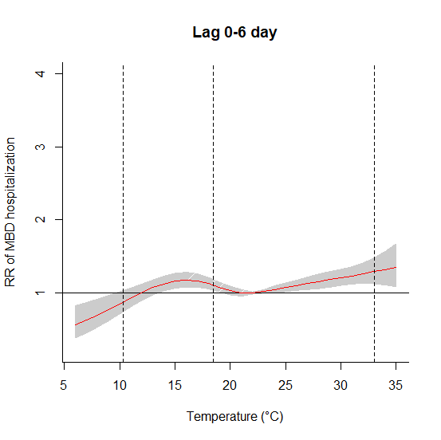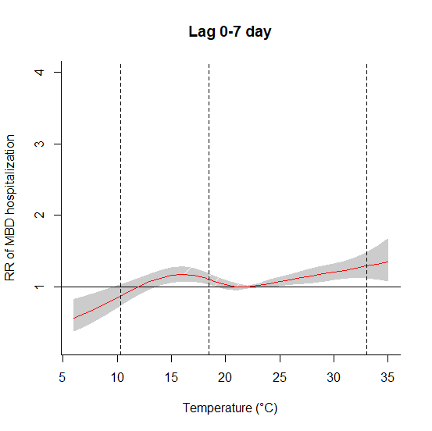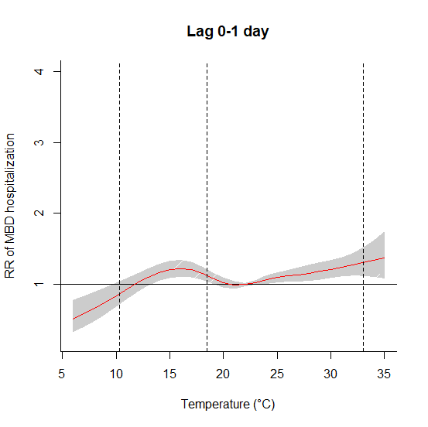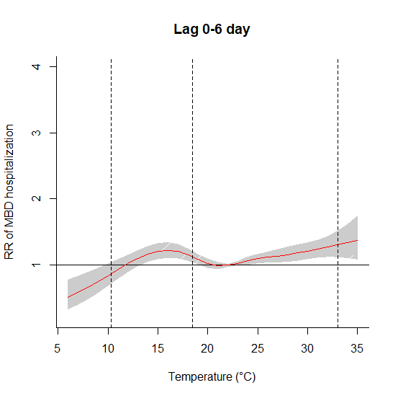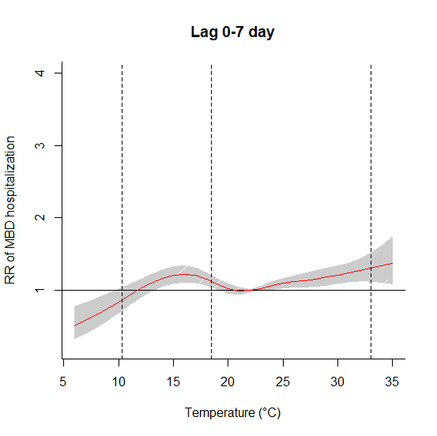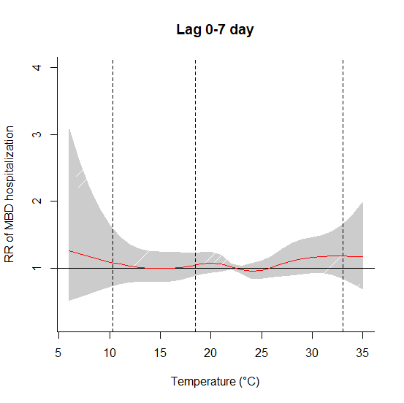
a)
c)
d)
e)
f)
b)
Figure S2: Exposure-response curve of mean temperature (°C) and cumulative relative risk for mental and behavioral disorder (reference temperature at 22.4 °C) for women. a. b. Group of all women. c. d. e. Group of adult women. f. Group of elderly women. Vertical lines correspond to the 1st, 25th and 99th temperature percentiles.

The Stepwise method is a procedure for selecting or deleting variables from a model. It is based on an algorithm that checks the importance of variables, including or excluding them from the model based on a decision rule. The importance of the variable is defined in terms of a measure of statistical significance of the coefficient associated with the variable for the model.
Table S1: P-value used by the method (significance level α = 0.05) for selection of variables in the final model of each group.
Groups | T | RH | SO₂ | NO₂ | O₃ | PM₁₀
Men | <0.0001 | 0.518 | <0.0001 | <0.0001 | <0.0001 | <0.0001
Women | <0.0001 | 0.517 | <0.0001 | 0.528 | <0.0001 | 0.971
Young men (0-24 years old) | <0.0001 | 0.497 | <0.0001 | 0.692 | <0.0001 | <0.0001
Adult men (25-59 years old) | <0.0001 | 0.316 | <0.0001 | <0.0001 | <0.0001 | <0.0001
Elderly men (≤ 60 years old) | <0.0001 | 0.864 | <0.0001 | 0.364 | <0.0001 | 0.058
Young women (0-24 years old) | <0.0001 | 0.644 | <0.0001 | 0.524 | <0.0001 | 0.936
Adult women (25-59 years old) | <0.0001 | 0.923 | <0.0001 | 0.887 | <0.0001 | 0.516
Elderly women (≤ 60 years old) | <0.0001 | 0.517 | <0.0001 | 0.528 | <0.0001 | 0.971

