Additional file 1
An in situ approach to characterizing photosynthetic gas exchange of rice panicle
Tian-Gen Chang, Qing-Feng Song, Hong-Long Zhao, Shuoqi Chang, Changpeng Xin, Mingnan Qu, Xin-Guang Zhu*

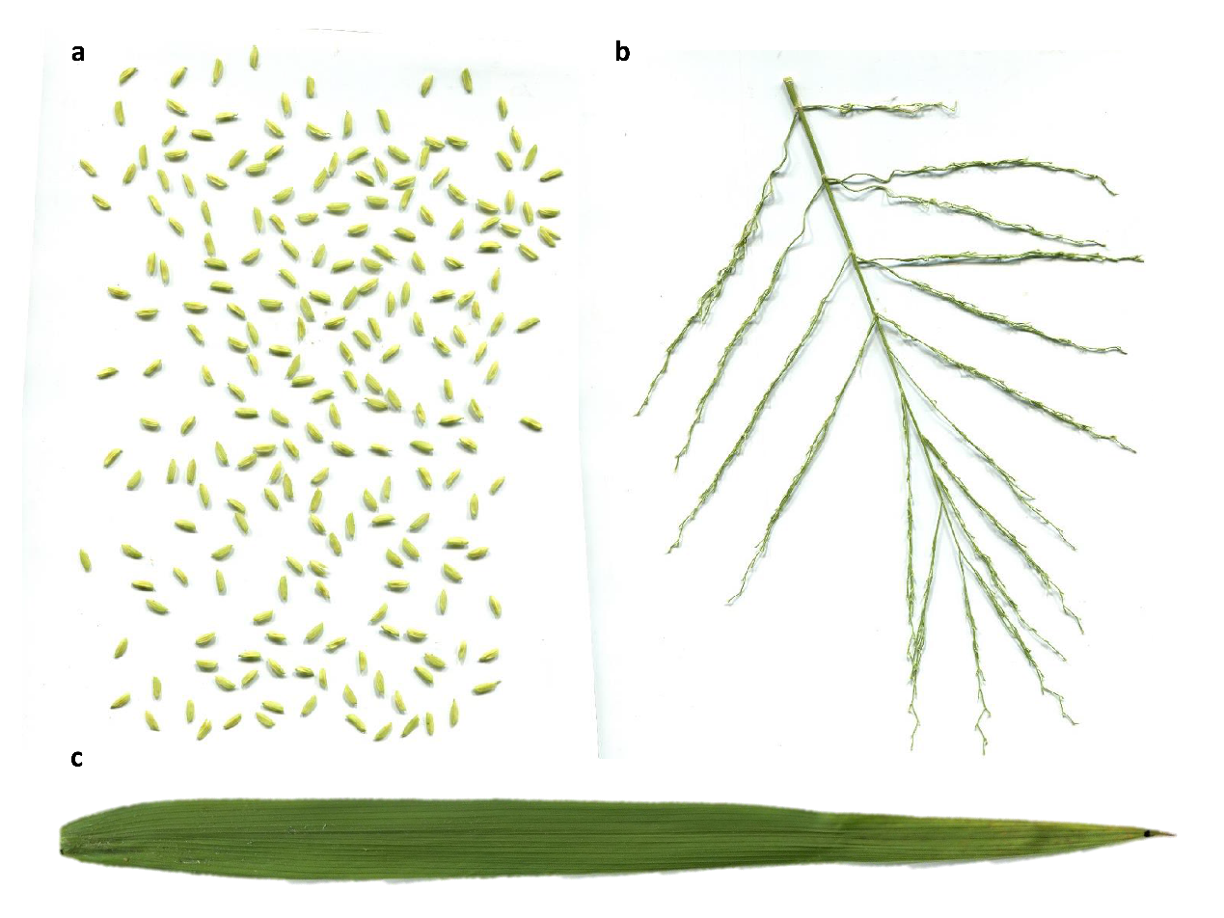
Additional file: Figure S1. Measurements for areas of spikelets, panicle branches and flag leaves 5 days after heading. a, A scan photo of spikelets on a panicle. b, A scan photo of panicle branches. c, A scan photo of a flag leaf.

Additional file: Table S1. Heading date and harvest date of main stems for rice cultivars grown in 2015 and 2016.
Name | Heading date (2015) | Harvest date (2015) | Heading date (2016) | Harvest date (2016)
YLY900 | 2 Sep. | 25 Oct. | 4 Sep. | 28 Oct.
CY1000 | 2 Sep. | 25 Oct. | 4 Sep. | 28 Oct.
SY63 | 27 Aug. | 25 Oct. | 29 Aug. | 28 Oct.
9311 | 27 Aug. | 25 Oct. | 29 Aug. | 28 Oct.
XS134 | 6 Sep. | 5 Nov. | 7 Sep. | 8 Nov.
YY538 | - | - | 7 Sep. | 8 Nov.
YY17 | - | - | 15 Sep. | 8 Nov.

Additional file: Table S2. Ambient air temperature (ºC) during each panicle gas exchange measurement in 2015.
Date | YLY900 | CY1000 | SY63 | 9311 | XS134
1 Sep. |  |  | 29.8-31.2 | 29.8-31.2
7 Sep. | 27.9-30.7 | 27.9-30.7
11 Sep. |  |  |  |  | 27.7-29.3

Additional file: Table S3. Ambient air temperature (ºC) during each panicle gas exchange measurement in 2016.
Date | YLY900 | CY1000 | SY63 | 9311 | XS134 | YY538 | YY17
3 Sep. |  |  | 34.8-35.5 | 34.8-35.5
9 Sep. | 32.9-34.0 | 32.9-34.0 |  | 32.9-34.0
12 Sep. |  |  | 29.8-30.9 |  | 29.8-30.9 | 29.8-30.9
20 Sep. |  |  |  |  |  |  | 27.7-28.6
21 Sep. | 28.0-28.6 | 28.0-28.6
22 Sep. |  |  |  |  | 27.8-29.1 | 27.8-29.1
24 Sep. |  |  | 28.0-29.0 | 28.0-29.0 |  |  | 28.0-29.0
6 Oct. | 28.6-32.6 |  |  |  | 28.6-32.6
7 Oct. |  | 28.4-29.3 |  | 28.4-29.3
8 Oct. |  |  |  |  |  |  | 28.3-29.2
9 Oct. |  |  | 24.5-28.9 |  |  | 24.5-28.9
17 Oct. | 26.6-33.2 | 26.6-33.2
18 Oct. |  |  |  |  | 25.9-32.9 | 25.9-32.9 | 25.9-32.9
1 Nov. |  |  |  |  | 18.3-24.3 | 18.3-24.3 | 18.3-24.3

