The feasibility of a randomised control trial to assess physiotherapy against surgery for recurrent patellar instability

Appendices

Appendix 1 – PKT Principles
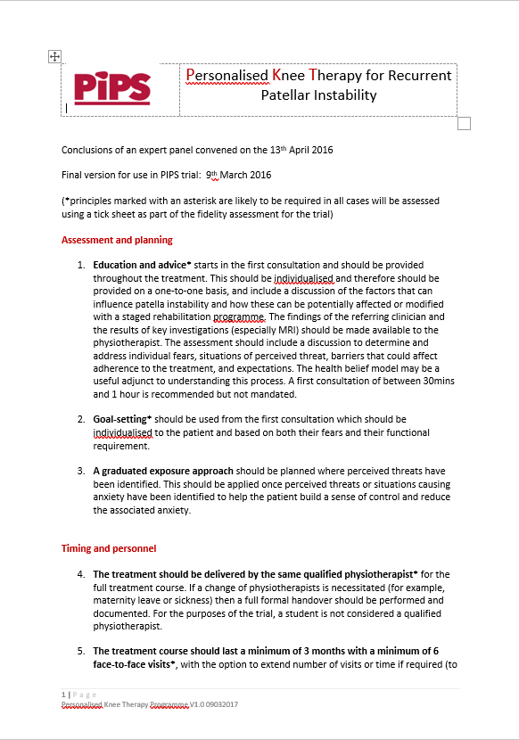

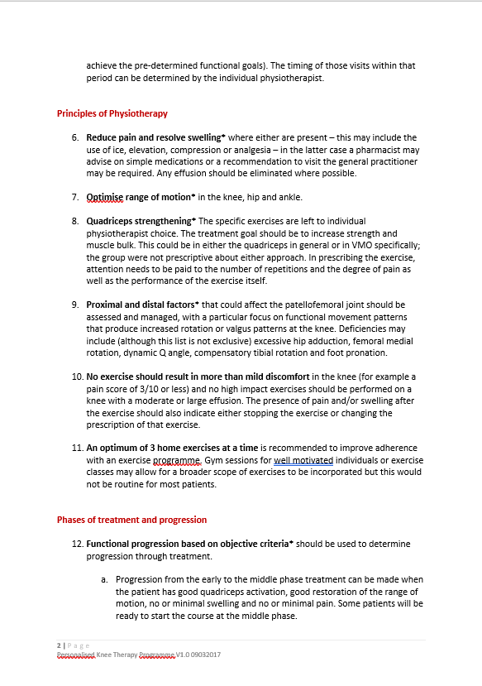

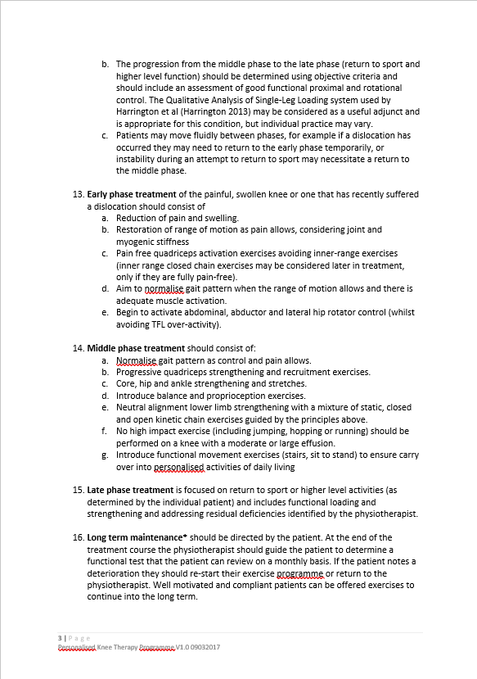

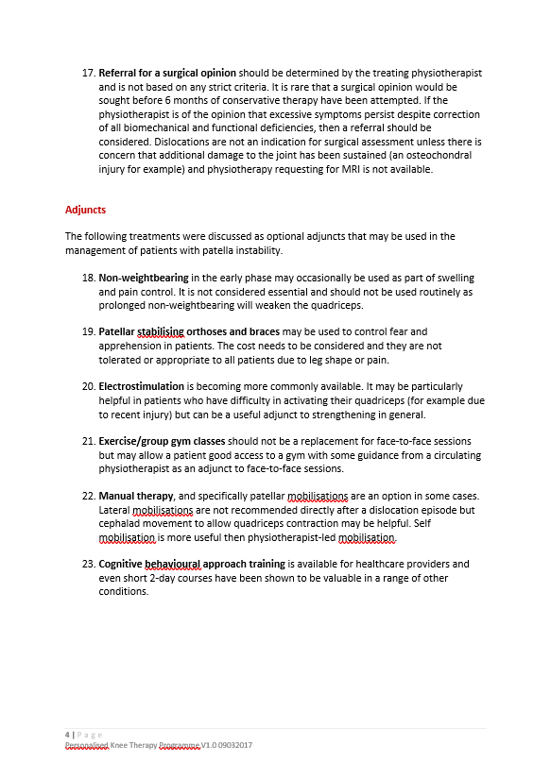

Appendix 2 – Post-Operative Physiotherapy Principles
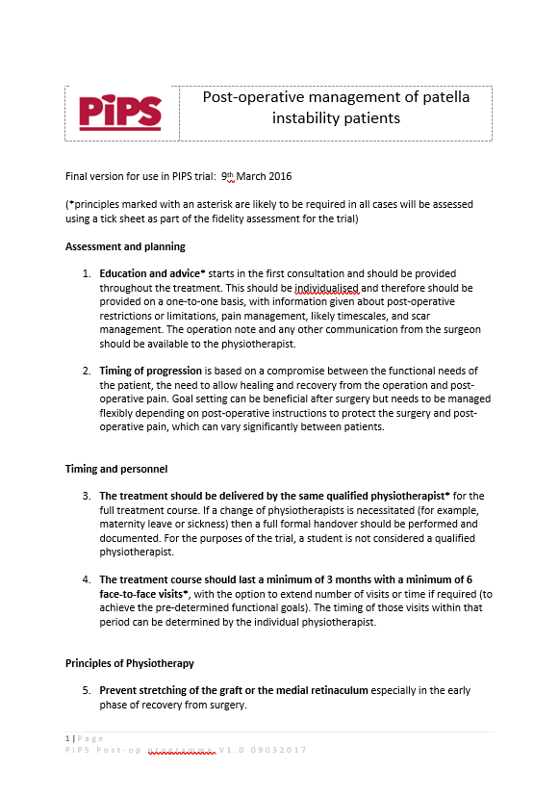

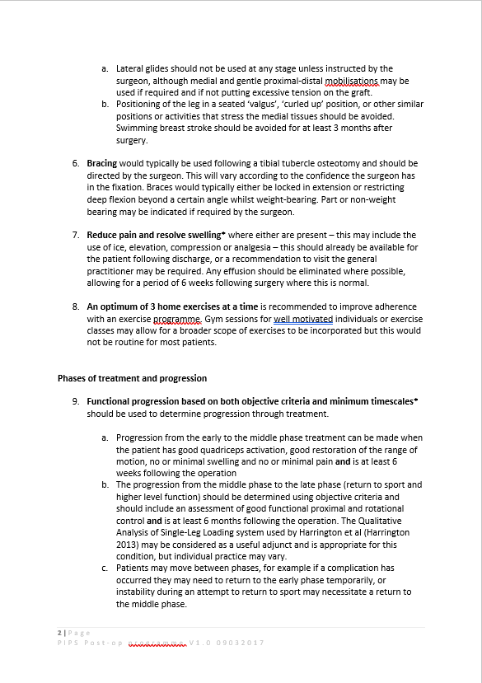

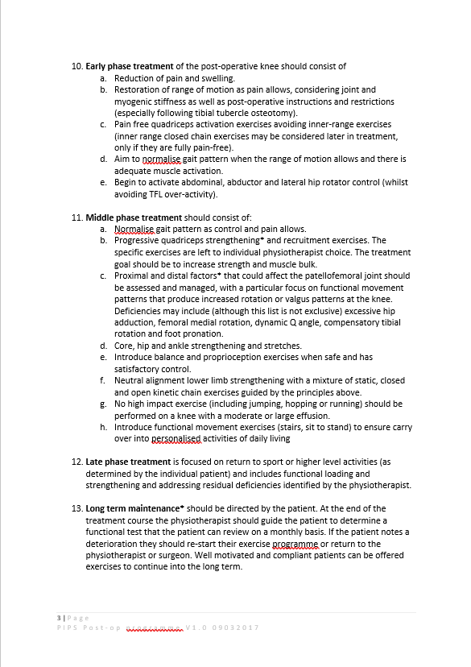

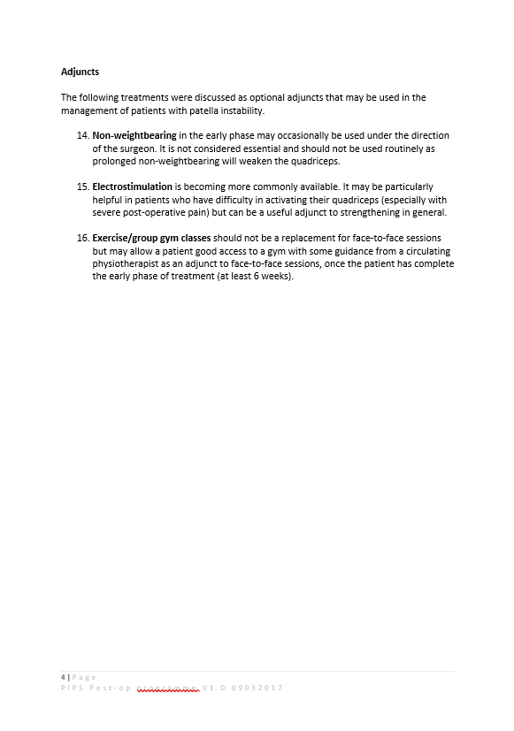

Appendix 3 – Recruitment Charts By Site

Screening variable | UHCW | Oswestry/ Shrewsbury | Bristol | All sites
Number of patients approached | 29 | 96 | 7 | 132
Number ineligible | 2 | 90 | 0 | 92
Number of patients eligible | 27 | 6 | 7 | 40
Number consented to take part | 14 | 0 | 5 | 19
Number randomised | 14 | 0 | 5 | 19

1: Screening & Recruitment per site

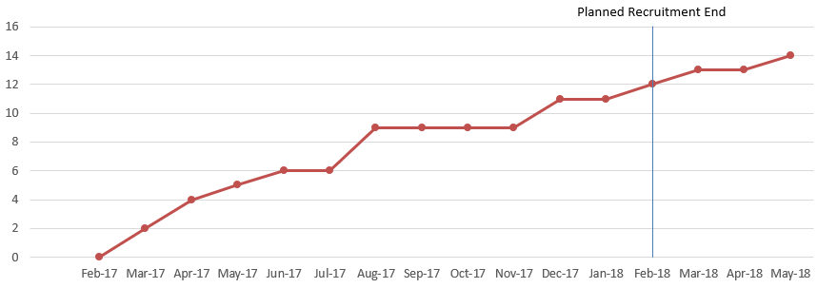
2: Site One Recruitment Chart
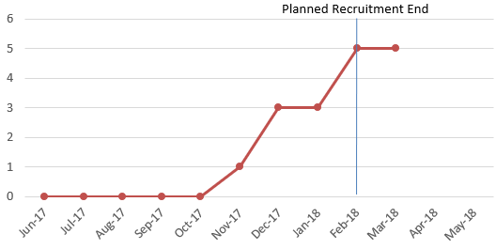
3: Site Three Recruitment Chart

