Supplementary Figures and Methods

Supplementary Figures

Fig.S1 A voucher specimen for Taraxacum officinale F.H.Wigg.(compositae)
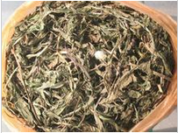

Fig.S2 Supplementary methods for the extraction process of dandelion or taraxasterol
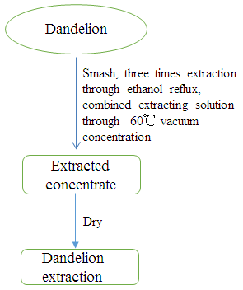
Fig.S2-1 The extraction process of dandelion
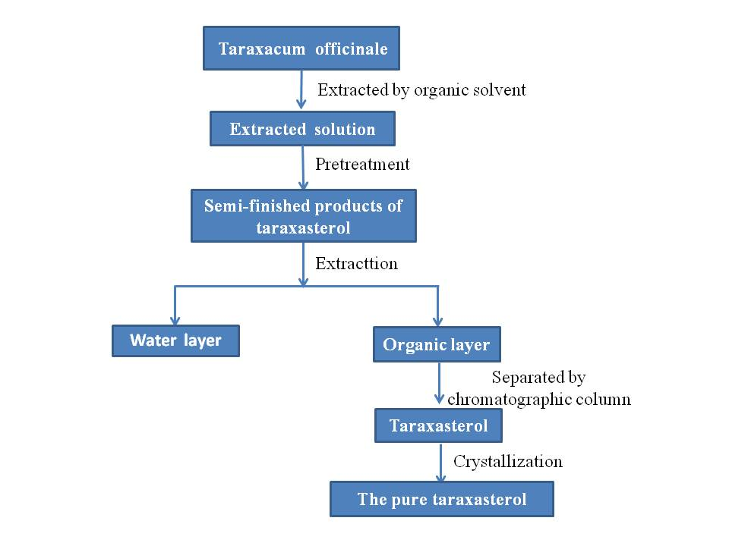
Fig.S2-2 The extraction process of taraxasterol

Fig.S3 Supplementary analysis result of TLC for taraxasterol
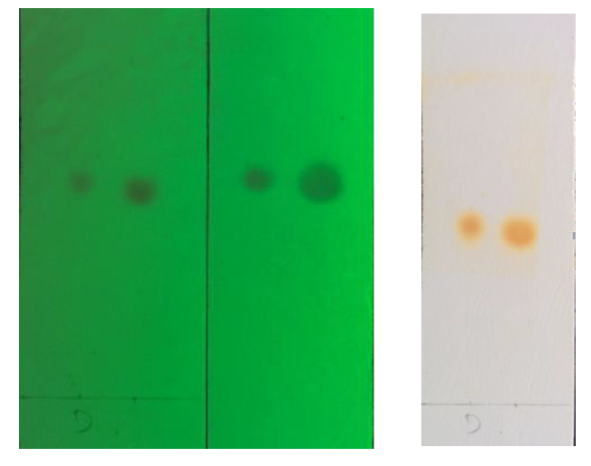
Thin layer chromatography (TLC): the resolving reagent of petroleum ether: ethyl acetate =7:1
The left side of figure is observed under 254 nm fluorescence; the right side of figure is observed under visible light. The results are shown as above.

Fig.S4 Graphical Abstracts. Dandelion extracts and taraxasterol inhibited HBV and the potential mechanism of taraxasterol may be related to the PTBP1 and SIRT1 expression.
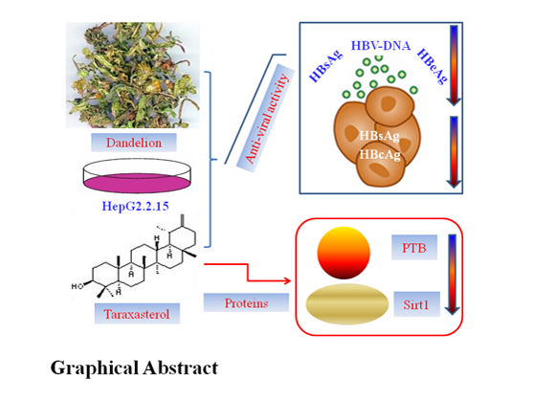

Fig.S5 Cellular toxicity of dandelion and taraxasterol in normal liver cells (A-D) or other cell lines (hepamota cell lines E, F, G and H, monocytic cell line I and J). After these cell lines were treated with dandelion and taraxasterol for 3 or 9 days, the cells were detected by CCK-8. The results represented the mean data from three independent experiments.
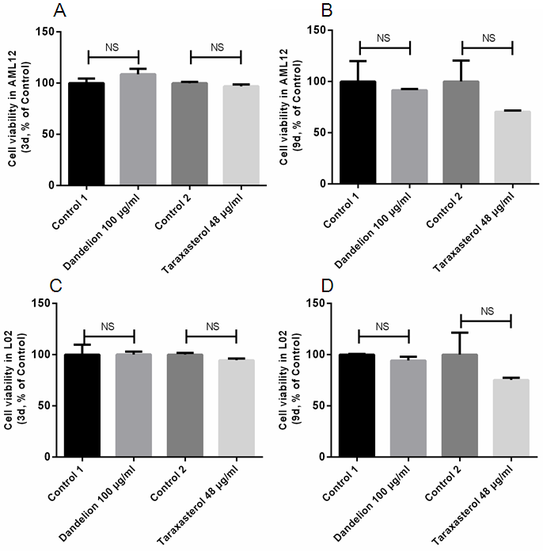
Fig.S5-1 Cellular toxicity of dandelion and taraxasterol in normal liver cells
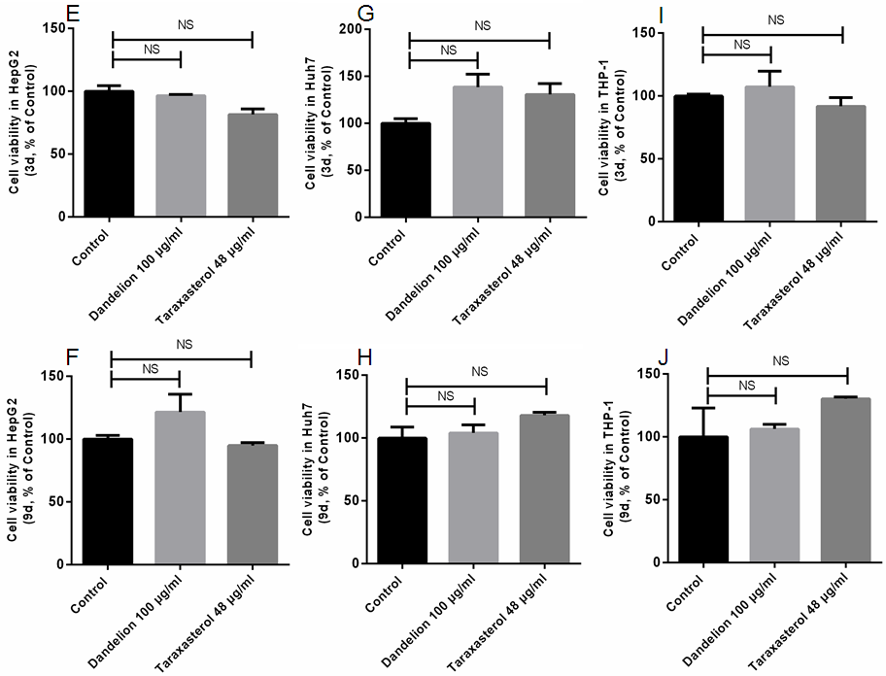
Fig.S5-2 Cellular toxicity of dandelion and taraxasterol in other cell lines

Fig.S6 The expression of IL-6 in the co-culture supernatant of HepG2.2.15 and THP-1. After these cell lines were treated with 100μg/mL dandelion extraction or 24μg/mL taraxasterol for 48h, the IL-6 level was detected by ELISA. The results represented the mean data from three independent experiments.

Supplementary Methods
CCK-8 assay
AML 12 is a mouse normal cell line. L02 is a human normal cell line. HepG2 and Huh7 are hepatoma cell lines. THP-1 is a monocytic cell line. The cell suspension was seeded in 96-well plates at a density of 5 x 10³ per well and treated with different concentrations of dandelion (100 μg/mL) and taraxasterol (48 μg/mL) for 3 or 9 days. The cytotoxic effect of dandelion and taraxasterol was analyzed using Cell Counting Kit (CCK-8) (Invigentech, CA, USA) according to the manufacturer’s instructions. Absorbance at 450 nm was measured using a microplate reader (Bio-Rad, Hercules, CA, USA).

IL-6 ELISA
HepG2.2.15 or THP-1 cell suspension was seeded in 24-well plates at a density of 2 x 10⁵ per well. The co-culture of HepG2.2.15 and THP-1 were treated with 100μg/mL dandelion extraction or 24μg/mL taraxasterol for 48h. The expression of IL-6 in the supernatant was detected using human IL-6 ELISA kit (Dakewe, Shenzhen, China) according to the manufacturer’s instructions. Absorbance at 450 nm was measured using a microplate reader (Bio-Rad, Hercules, CA, USA).

