Mismatch Negativity
As regard audiological evaluation, all subjects of this work were submitted to: a full audiological history, otological examination and basic audiological evaluation including pure tone audiometry for the frequency range 250-8000 Hz and speech audiometry (using GSI-61 audiometer) and Immittancemetry (using Zodiac- Madsen).
Mismatch negativity (MMN) was performed in the oddball paradigm using two types of stimuli (tone and speech) which were presented in two paradigms. In the first paradigm, 1000 Hz and 1050 Hz were used as the standard and deviant stimuli, respectively while in the second paradigm,da/was used as a standard stimulus and/ga/stimuli was used as the deviant stimulus. The duration of tone stimuli were 150ms and speech stimuli was approximately 200ms. Both types of stimuli were presented at 1/s repetition rate, 15% deviant probability and at 50dBSL (re PTA average at 500, 1000, 2000 and 4000 Hz) monaurally to each ear in both groups via an insert-phone. MMN was recorded through four electrodes placed at Fz (‏ve electrode), Fpz (ground electrode), M1 and M2 (mastoids) as reference electrodes according to stimulation side.
The test procedure was explained to all subjects. During test acquisition, every participant was instructed to lie down calmly on comfortable couch and was allowed to browse selected magazines and they were told to try not to concentrate on the presented stimuli. After finishing the test, off-line manipulation of the traces was carried out starting with N100 identification as the negativity occurring at about 80e120ms after stimulus presentation. MMN was calculated in the difference waveform according to manual specification of Smart-IHS. This is done by subtracting the trace occurring in response to the deviant stimulus from that occurring
in response to the standard stimulus. MMN was identified visually as the most prominent negativity following N100 occurring between 150 and 300ms. In each paradigm, both MMN latency and amplitudes are calculated.
Posturography
Computerized dynamic psturography (CDP), sensory organization test (SOT) examines the 3 balance sensory systems; somatosensory, visual and vestibular systems using the Balance Quest provided by Framiral, Cannes, France (Multitest Equilibre 6.1.37.0) with static/dynamic platform by Micromedical Technologies (http://perso.wanadoo.fr/framiral/multi_gb.htm). The examined subject stands on a movable, dual force plate with rotation (toes up–down) and translation (forward–backward) capabilities to measure the vertical forces exerted by the patient’s feet under the precise control of a computer. The subject is asked to maintain normal standing balance during varying conditions by altering the visual field of the subject and/or the support surface on which the subject is standing. CDP can impose varying conditions one might encounter in the environment and record the resulting postural responses. The computer processes signals from the force-sensing support surface to quantify the subject’s postural stability under modified sensory conditions and the motor reactions to unexpected perturbations. The software objectively identifies problems with postural control by assessing the patient’s ability to make effective use of visual, vestibular, and proprioceptive information.
- Spatial orientation:
1– Percentage stability (u) for each condition (C) was computed using this formula: u = [(100 – sx)/100] – [ (100 – sy)/100] where x, y represents the subject’s deviations in anterior, posterior and lateral direction. The sx, sy vary from 0 to 100 and the results were expressed as percentages, with 0 indicating sway exceeding the limit of stability (fall) and 100% indicating perfect stability.
2– The average speed of center of pressure (COP) sway (mm/s).
3– The surface area of the COP displacement (cm²).
4– The sensory analysis (SA) ratios were used to identify possible impairments of individual sensory systems and it includes somatosensory (SOM), visual (VIS) and vestibular (VEST) ratios which measures ability to use somatosensory, visual, and vestibular information. The SOM ratio = (C2 / C1) × 100, the VIS ratio = (C4/ C1) × 100 and the VEST ratio = (C5/ C1) × 100.
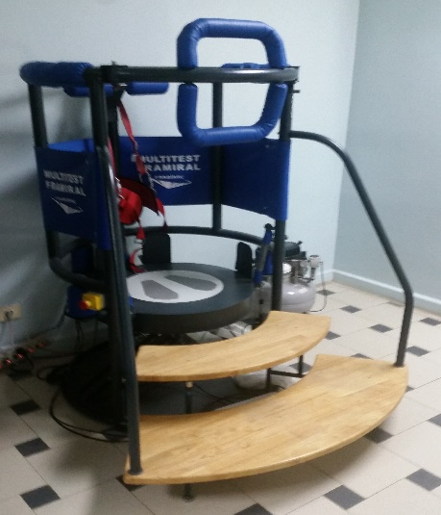 | 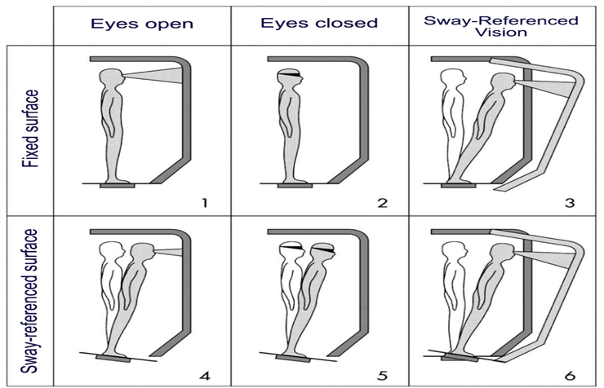
Figure. The different conditions performed in the sensory organization test; (C1) eyes open, surround and platform stable, (C2) eyes closed, surround and platform stable, (C3) eyes open, sway- referenced surround, (C4) eyes open sway-referenced platform, (C5) eyes closed, sway-referenced platform and (C6) eyes open sway referenced surround and platform (Quoted from Massukawa Oda and Ganança, 2015).
References:
- Massukawa Oda DT, Ganança CF. Computerized dynamic posturography in the assessment of body balance in individuals with vestibular dysfunction. Audiol Commun Res. 2015;20(2):89–95. doi: 10.1590/S2317-64312015000200001469
- Visser JE, Carpenter MG, der Kooij Hv, Bloem BR. The clinical utility of posturography. Clinical Neurophysiology. 2008; 119:2424–36. doi: 10.1016/j.clinph.2008.07.220

