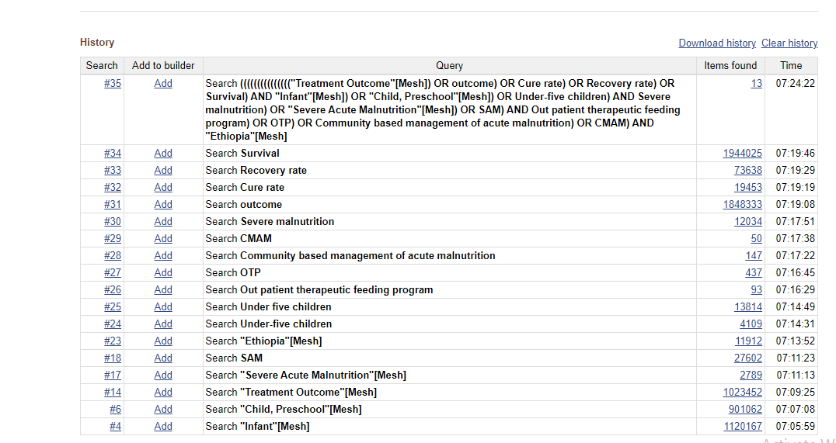
Pubmed
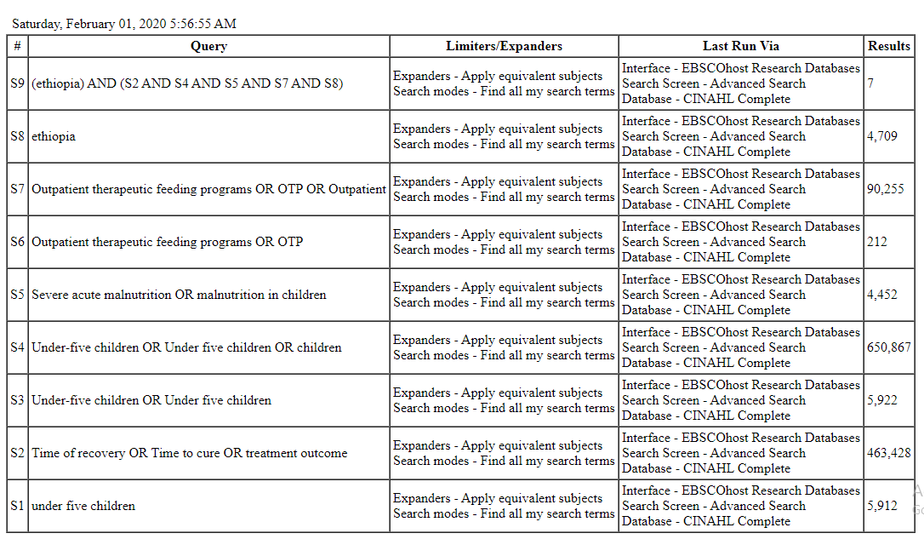
CINAHL
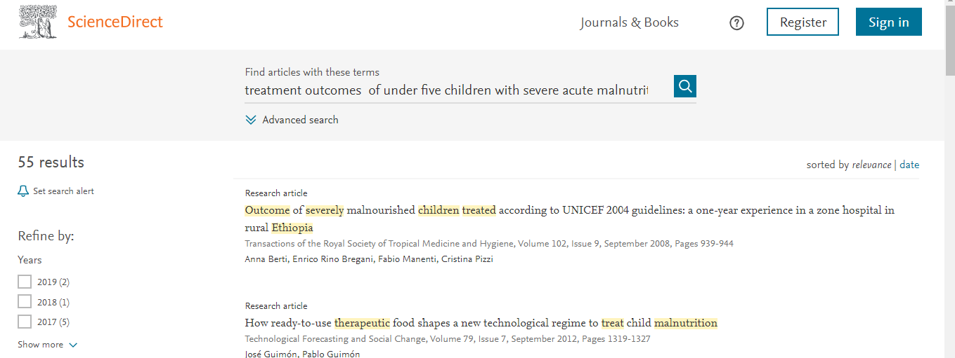
Sceince Direct
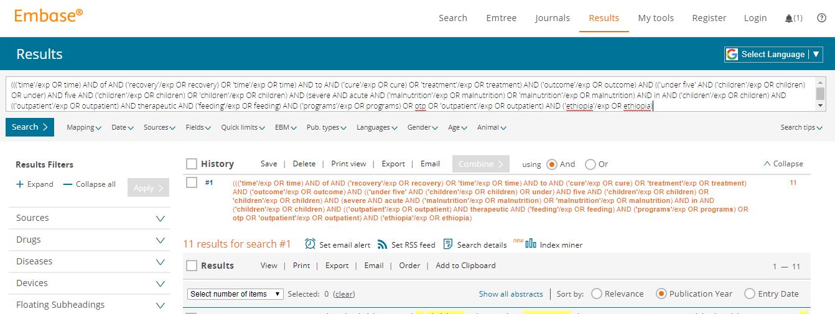
Embase
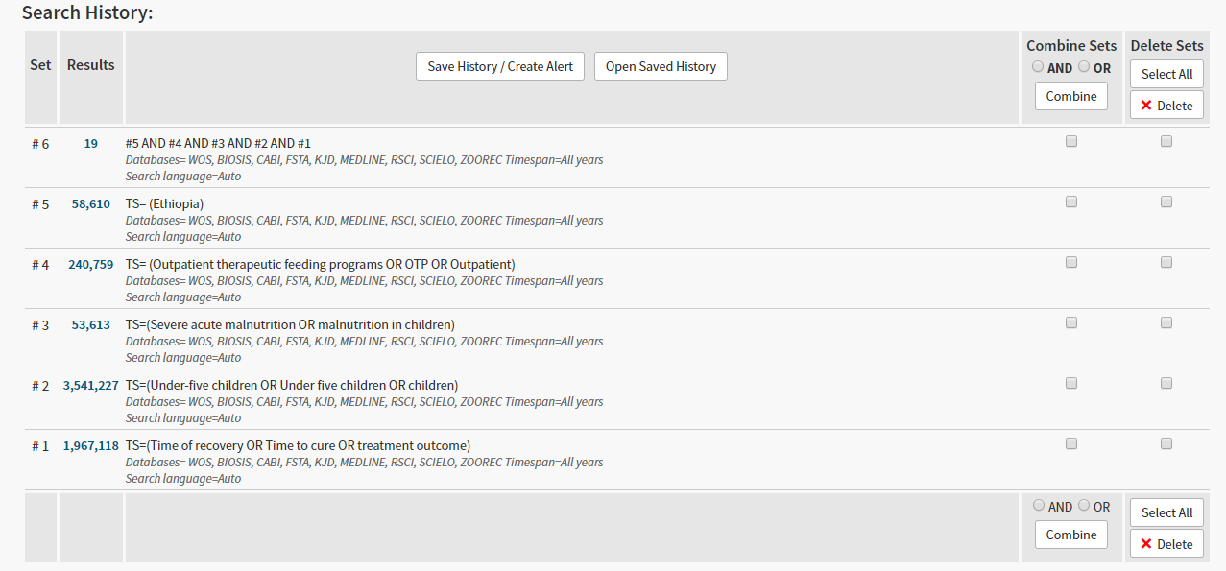
Web science

Accessibility Information and TipsRevised Date: 07/2015

Print Search History
Saturday, February 01, 2020 6:41:49 AM

# | Query | Limiters/Expanders | Last Run Via | Results
S5 | S1 AND S2 AND S3 AND S4 | Expanders - Apply equivalent subjects  Search modes - Find all my search terms | Interface - EBSCOhost Research Databases  Search Screen - Advanced Search  Database - MEDLINE | 15
S4 | Ethiopia | Expanders - Apply equivalent subjects  Search modes - Find all my search terms | Interface - EBSCOhost Research Databases  Search Screen - Advanced Search  Database - MEDLINE | 19,619
S3 | Outpatient therapeutic feeding programs OR OTP OR Outpatient | Expanders - Apply equivalent subjects  Search modes - Find all my search terms | Interface - EBSCOhost Research Databases  Search Screen - Advanced Search  Database - MEDLINE | 183,790
S2 | Under-five children OR Under five children OR children | Expanders - Apply equivalent subjects  Search modes - Find all my search terms | Interface - EBSCOhost Research Databases  Search Screen - Advanced Search  Database - MEDLINE | 1,339,001
S1 | Time of recovery OR Time to cure OR treatment outcome | Expanders - Apply equivalent subjects  Search modes - Find all my search terms | Interface - EBSCOhost Research Databases  Search Screen - Advanced Search  Database - MEDLINE | 1,522,472

Medline 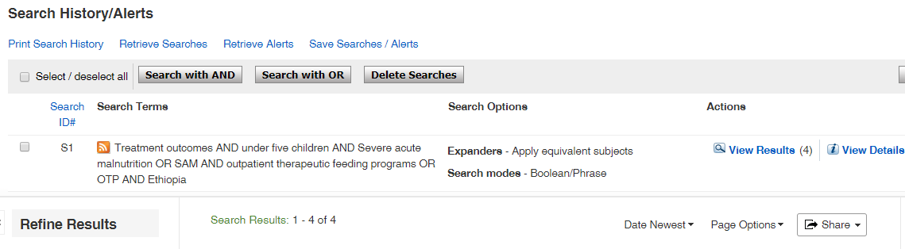
FSTA
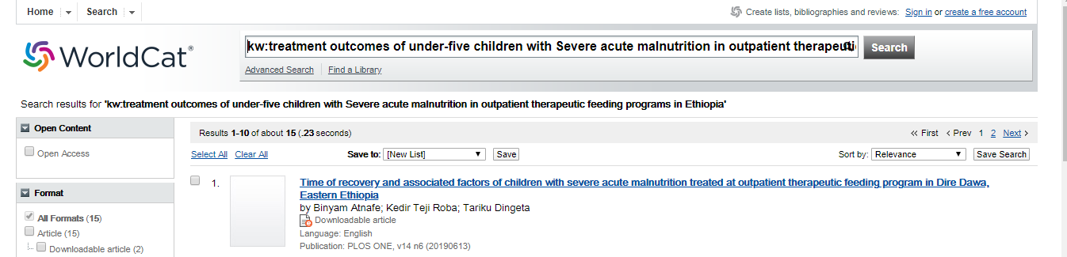
World Cat
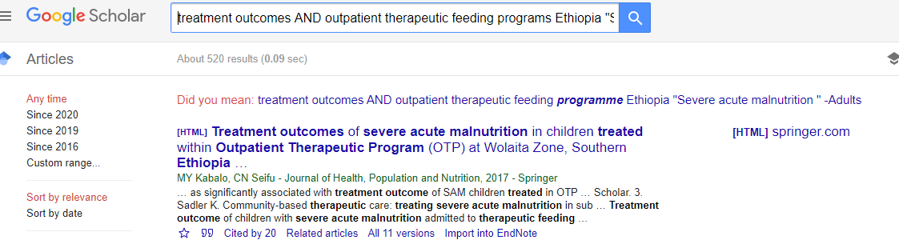
Google scholar

