Supplementary Table 1. Population size and age structure by urbanity: data from the 2015 Population Census of Korea
 | Metropolitan | Urban | Rural
Total population | 41,677,695 | 4,616,802 | 4,774,878
Age group
Under 15 (%) | 14.0 | 15.3 | 9.0
15–64 (%) | 74.8 | 70.4 | 64.3
65+ (%) | 11.2 | 14.4 | 26.7
Mean (yr) | 39.4 | 40.4 | 48.4
Median (yr) | 40.1 | 41.1 | 51.2
Notes. Metropolitan corresponds to dong, urban to eup, and rural to myeon.

Supplementary Table 2. Distribution of numbers of population and deaths among 3,377 small-areas in Korea: findings from the National Health Information Database of Korea, 2013–2017.
 | No. of population |  |  | No. of deaths
 | Median  (IQR) | Minimum | Maximum | Median  (IQR) | Minimum | Maximum
Total | 111,077  (181,207) | 10,244 | 1,476,696 | 677  (547) | 50 | 4,956
Metropolitan | 184,637  (157,904) | 11,991 | 1,476,696 | 827  (516) | 50 | 4,956
Urban | 156,131  (172,083) | 12,165 | 915,262 | 1,212  (742) | 181 | 4,479
Rural | 32,307  (25,027) | 10,244 | 460,205 | 443  (266) | 94 | 2,341
Notes. IQR = Interquartile range.
Metropolitan corresponds to dong, urban to eup, and rural to myeon.

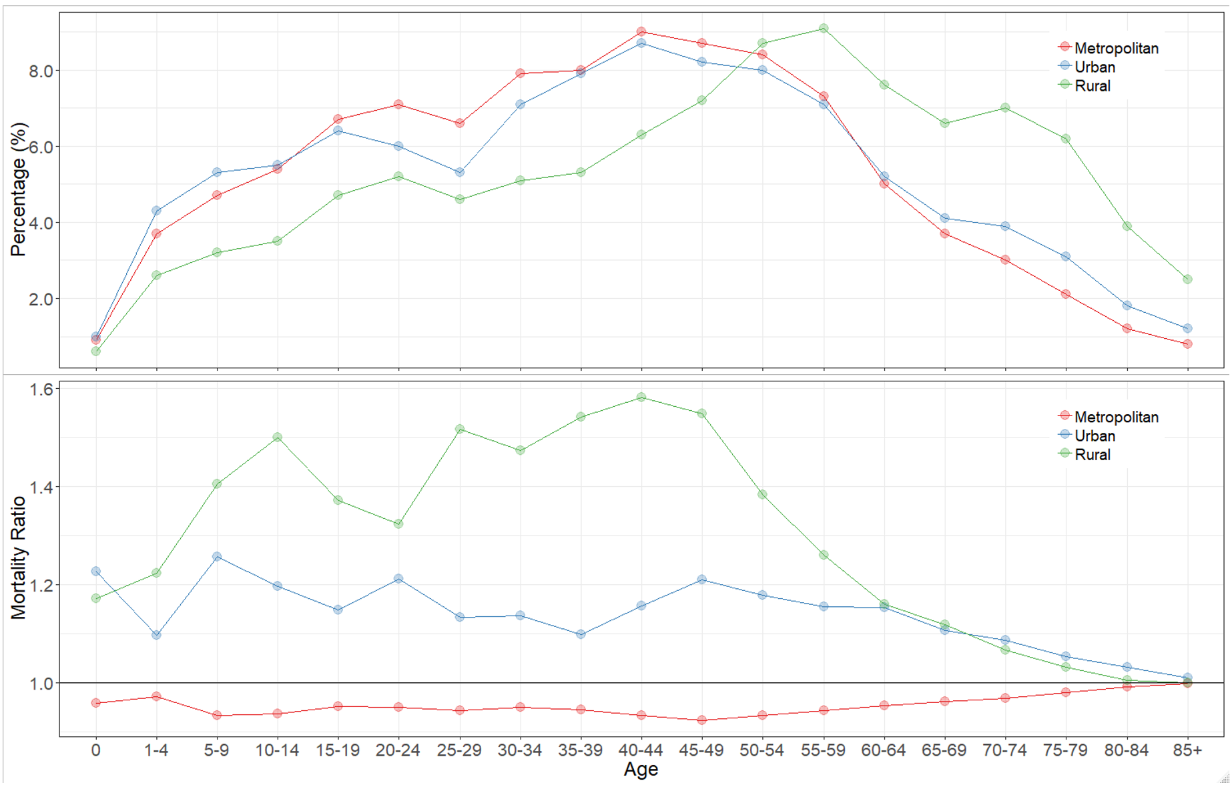
Supplementary Figure 1. Age distribution and age-specific mortality ratios by urbanity with the standard population: findings from the National Health Information Database of Korea, 2013–2017.

Supplementary Table 3. Distribution of SMRs according to urbanity when the age-specific mortality rate was hypothesized to be the same in all small-areas: findings from the National Health Information Database of Korea, 2013–2017.
 | Median | IQR | Min | Max
Metropolitan | 98.5 | 0.6 | 97.5 | 104.6
Urban | 98.5 | 0.3 | 97.6 | 102.0
Rural | 98.3 | 0.3 | 97.7 | 101.2
Notes. IQR = Interquartile range; Max = Maximum; Min = Minimum.
SMF was rescaled by multiplying by 100.
Metropolitan corresponds to dong, urban to eup, and rural to myeon.

Supplementary Table 4. Comparison of the top 30 small-areas with high mortality as measured by CMF with their results for SMR and LE: findings from the National Health Information Database of Korea, 2013–2017
ID | Type | CMF  (95% CI) |  | SMR  (95% CI) |  | LE  (95% CI) | CMF rank  (highest to lowest)  (1) | SMR rank  (highest to lowest)  (2) | LE rank  (lowest to highest)  (3) | (1) - (2) | (1) - (3)
862 | Rural | 189.0  (172.6,207.0) | 181.8  (166.1,198.9) |  | 74.8  (73.6,76.1) |  | 1 | 1 | 3 | 0 | -2
112 | Rural | 164.3  (151.1,178.8) | 153.8  (141.7,166.9) |  | 76.1  (74.1,78.1) |  | 2 | 4 | 13 | -2 | -11
778 | Metropolitan | 164.3  (144.6,186.7) | 157.6  (139.4,178.2) |  | 77.2  (76.1,78.3) |  | 3 | 2 | 7 | 1 | -4
1573 | Rural | 159.5  (133.9,189.9) | 121.8  (108.1,137.2) |  | 76.5  (75.3,77.6) |  | 4 | 227 | 26 | -223 | -22
2685 | Rural | 158.3  (126.2,198.7) | 127.9  (106.5,153.5) |  | 78.4  (77.3,79.3) |  | 5 | 102 | 4 | -97 | 1
2952 | Metropolitan | 156.5  (145.8,168.0) | 153.9  (143.7,164.8) |  | 79.0  (77.6,80.4) |  | 6 | 3 | 32 | 3 | -26
2326 | Rural | 156.5  (128.2,191.0) | 122.8  (106.4,141.7) |  | 78.4  (77.4,79.3) |  | 7 | 194 | 28 | -187 | -21
1757 | Rural | 156.2  (137.5,177.4) | 133.6  (119.3,149.6) |  | 76.4  (71.9,80.0) |  | 8 | 36 | 19 | -28 | -11
260 | Rural | 155.1  (128.5,187.2) | 133.1  (114.6,154.6) |  | 79.1  (78.1,80.2) |  | 9 | 40 | 25 | -31 | -16
1593 | Rural | 154.5  (128.0,186.5) | 134.3  (116.8,154.5) |  | 79.4  (78.3,80.5) |  | 10 | 30 | 5 | -20 | 5
562 | Metropolitan | 154.1  (133.0,178.6) | 131.6  (115.0,150.6) |  | 79.2  (78.3,80.1) |  | 11 | 54 | 27 | -43 | -16
2221 | Rural | 153.5  (125.9,187.3) | 121.2  (104.9,140.1) |  | 78.1  (76.7,79.5) |  | 12 | 249 | 8 | -237 | 4
3266 | Rural | 153.1  (124.0,189.0) | 143.8  (117.7,175.6) |  | 79.0  (77.6,80.3) |  | 13 | 8 | 10 | 5 | 3
1739 | Metropolitan | 152.1  (130.3,177.6) | 132.8  (117.5,150.1) |  | 78.7  (77.7,79.7) |  | 14 | 43 | 14 | -29 | 0
1033 | Rural | 149.5  (124.4,179.7) | 118.5  (103.8,135.3) |  | 79.0  (78.1,80.0) |  | 15 | 353 | 12 | -338 | 3
3143 | Rural | 149.3  (119.7,186.4) | 117.4  (99.7,138.2) |  | 77.7  (74.0,81.1) |  | 16 | 401 | 23 | -385 | -7
2302 | Metropolitan | 148.4  (134.9,163.3) | 151.0  (137.7,165.6) |  | 79.0  (78.3,79.8) |  | 17 | 5 | 78 | 12 | -61
1813 | Rural | 147.1  (120.5,179.4) | 137.8  (115.3,164.7) |  | 78.1  (76.6,79.5) |  | 18 | 16 | 41 | 2 | -23
2812 | Rural | 146.2  (122.5,174.4) | 124.8  (108.6,143.4) |  | 78.6  (75.6,80.9) |  | 19 | 149 | 31 | -130 | -12
1670 | Rural | 146.1  (126.6,168.7) | 130.4  (115.9,146.7) |  | 79.2  (78.1,80.3) |  | 20 | 67 | 36 | -47 | -16
680 | Rural | 146.0  (128.4,166.1) | 133.6  (119.7,149.1) |  | 79.6  (78.6,80.6) |  | 21 | 37 | 52 | -16 | -31
1398 | Rural | 145.9  (119.0,178.8) | 127.8  (110.3,148.0) |  | 78.4  (76.8,79.8) |  | 22 | 105 | 2 | -83 | 20
2820 | Rural | 145.6  (127.4,166.4) | 128.5  (114.2,144.6) |  | 79.0  (77.8,80.2) |  | 23 | 94 | 48 | -71 | -25
2934 | Metropolitan | 145.5  (134.7,157.2) | 144.7  (134.2,156.0) |  | 79.3  (78.4,80.1) |  | 24 | 7 | 76 | 17 | -52
2433 | Rural | 145.5  (120.7,175.3) | 119.1  (103.8,136.7) |  | 79.7  (78.1,81.3) |  | 25 | 330 | 15 | -305 | 10
2747 | Rural | 144.8  (127.5,164.5) | 127.2  (113.8,142.2) |  | 79.1  (78.2,80.0) |  | 26 | 114 | 22 | -88 | 4
966 | Rural | 144.7  (127.9,163.6) | 130.5  (116.8,145.8) |  | 78.3  (77.0,79.6) |  | 27 | 65 | 65 | -38 | -38
2638 | Rural | 144.5  (123.0,169.8) | 119.4  (105.6,135.1) |  | 78.8  (77.7,80.0) |  | 28 | 315 | 9 | -287 | 19
197 | Metropolitan | 144.3  (128.8,161.7) | 135.9  (122.0,151.4) |  | 79.1  (77.5,80.6) |  | 29 | 18 | 56 | 11 | -27
2651 | Rural | 144.3  (120.4,172.9) | 110.5  (97.3,125.5) |  | 79.1  (77.9,80.1) |  | 30 | 905 | 37 | -875 | -7
Notes. CI = Confidence interval; CMF = Comparative mortality figure; LE = Life expectancy; SMR = Standardized mortality ratio.
SMR and CMF were rescaled by multiplying by 100.
Metropolitan corresponds to dong, urban to eup, and rural to myeon.

Supplementary Table 5. Comparison of the top 30 small-areas with low mortality as measured by CMF with their results for SMR and LE: findings from the National Health Information Database of Korea, 2013–2017
ID | Type | CMF  (95% CI) | SMR  (95% CI) | LE  (95% CI) | SMR rank  (lowest to highest) (1) | CMF rank  (lowest to highest)  (2) | LE rank  (highest to lowest)  (3) | (1) - (2) | (1) - (3)
1016 | Metropolitan | 49.4  (42.4,57.7) | 51.4  (44.1,59.9) | 89.8  (88.9,90.8) | 1 | 1 | 2 | 0 | -1
1864 | Metropolitan | 55.3  (50.3,60.8) | 57.7  (52.5,63.4) | 88.6  (88.0,89.3) | 2 | 4 | 4 | -2 | -2
1290 | Metropolitan | 58.2  (49.1,69.0) | 57.8  (48.9,68.3) | 89.2  (87.9,90.5) | 3 | 5 | 3 | -2 | 0
1270 | Metropolitan | 59.1  (51.9,67.4) | 57.0  (50.2,64.7) | 87.7  (86.8,88.6) | 4 | 3 | 12 | 1 | -8
2776 | Metropolitan | 59.5  (54.9,64.5) | 60.3  (55.6,65.4) | 87.9  (87.4,88.5) | 5 | 10 | 6 | -5 | -1
231 | Metropolitan | 60.2  (52.1,69.4) | 55.3  (48.2,63.5) | 87.6  (86.5,88.7) | 6 | 2 | 14 | 4 | -8
502 | Metropolitan | 60.3  (53.6,67.8) | 61.2  (54.5,68.7) | 88.0  (87.0,89.0) | 7 | 11 | 5 | -4 | 2
3360 | Metropolitan | 60.5  (54.4,67.4) | 58.5  (52.6,65.0) | 87.5  (86.8,88.2) | 8 | 7 | 17 | 1 | -9
3115 | Metropolitan | 60.7  (53.5,68.8) | 59.8  (52.8,67.7) | 87.6  (86.8,88.5) | 9 | 8 | 13 | 1 | -4
318 | Metropolitan | 60.7  (55.0,66.9) | 57.8  (52.5,63.6) | 87.7  (87.0,88.4) | 10 | 6 | 11 | 4 | -1
1298 | Metropolitan | 61.0  (54.3,68.6) | 60.0  (53.4,67.4) | 87.8  (87.0,88.7) | 11 | 9 | 8 | 2 | 3
311 | Metropolitan | 62.2  (56.9,68.0) | 62.7  (57.4,68.5) | 87.6  (86.9,88.2) | 12 | 17 | 15 | -5 | -3
1111 | Metropolitan | 62.8  (56.1,70.2) | 63.3  (56.6,70.8) | 86.9  (86.2,87.7) | 13 | 21 | 32 | -8 | -19
2665 | Metropolitan | 63.0  (55.4,71.6) | 62.8  (55.3,71.4) | 87.7  (86.7,88.6) | 14 | 18 | 10 | -4 | 4
1303 | Metropolitan | 63.1  (57.7,69.1) | 64.2  (58.7,70.2) | 87.4  (86.7,88.1) | 15 | 26 | 19 | -11 | -4
1480 | Metropolitan | 63.7  (58.3,69.5) | 63.3  (58.2,68.9) | 87.2  (86.6,87.9) | 16 | 22 | 25 | -6 | -9
1756 | Metropolitan | 63.8  (59.1,68.9) | 62.5  (57.9,67.5) | 87.0  (86.5,87.5) | 17 | 15 | 31 | 2 | -14
1371 | Metropolitan | 64.1  (58.8,69.9) | 62.8  (57.7,68.4) | 86.9  (86.3,87.4) | 18 | 19 | 35 | -1 | -17
2828 | Metropolitan | 64.3  (57.4,71.9) | 64.4  (57.6,72.0) | 87.2  (86.3,88.0) | 19 | 27 | 26 | -8 | -7
3214 | Metropolitan | 64.4  (57.5,72.3) | 63.8  (57.0,71.4) | 87.9  (87.0,88.7) | 20 | 24 | 7 | -4 | 13
1269 | Metropolitan | 64.7  (57.5,72.8) | 63.4  (56.7,70.9) | 87.8  (86.8,88.7) | 21 | 23 | 9 | -2 | 12
2728 | Metropolitan | 64.8  (56.8,74.0) | 64.8  (56.9,73.8) | 87.6  (86.5,88.6) | 22 | 28 | 16 | -6 | 6
3067 | Metropolitan | 65.3  (58.1,73.4) | 62.5  (55.7,70.1) | 87.4  (86.5,88.2) | 23 | 16 | 21 | 7 | 2
2232 | Metropolitan | 65.3  (59.0,72.4) | 63.2  (57.2,69.9) | 86.8  (86.1,87.5) | 24 | 20 | 37 | 4 | -13
2568 | Metropolitan | 65.8  (58.6,73.8) | 65.9  (58.8,73.8) | 86.7  (85.8,87.6) | 25 | 34 | 39 | -9 | -14
879 | Metropolitan | 66.2  (59.1,74.1) | 64.1  (57.5,71.5) | 86.7  (85.8,87.5) | 26 | 25 | 43 | 1 | -17
965 | Metropolitan | 66.2  (60.8,72.1) | 65.2  (59.9,70.9) | 87.1  (86.5,87.7) | 27 | 30 | 27 | -3 | 0
1427 | Metropolitan | 66.6  (61.6,72.0) | 65.2  (60.3,70.5) | 86.5  (86.0,87.1) | 28 | 31 | 50 | -3 | -22
2103 | Metropolitan | 66.8  (58.3,76.4) | 65.2  (57.1,74.4) | 86.7  (85.7,87.6) | 29 | 32 | 44 | -3 | -15
1871 | Metropolitan | 66.8  (60.8,73.3) | 61.6  (56.3,67.5) | 86.6  (86.0,87.3) | 30 | 13 | 45 | 17 | -15
Notes. CI = Confidence interval; CMF = Comparative mortality figure; LE = Life expectancy; SMR = Standardized mortality ratio.
SMR and CMF were rescaled by multiplying by 100.
Metropolitan corresponds to dong, urban to eup, and rural to myeon.

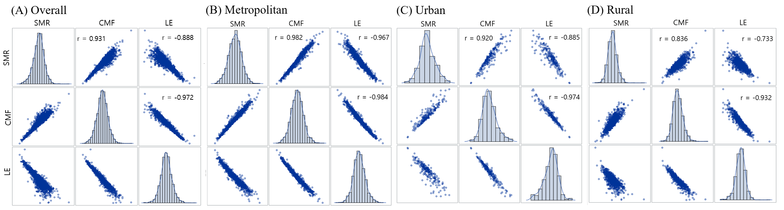
Supplementary Figure 2. Scatter plots and correlation coefficients [r] for SMR, CMF, and LE over all areas and stratified by urbanity: findings from the National Health Information Database of Korea, 2013–2017.
Notes. CMF = Comparative mortality figure; LE = Life expectancy; SMR = Standardized mortality ratio.
SMR and CMF were rescaled by multiplying by 100.
Metropolitan corresponds to dong, urban to eup, and rural to myeon.

Supplementary Table 6. Age structure, observed and expected deaths using national age-specific mortality in 2015 and age-specific mortality of the standard population, and their differences in small-areas with the minimum, maximum, and median SMR: findings from the National Health Information Database of Korea, 2013–2017
Age group | Age-specific mortality of the SP  (1) | National age-specific mortality in 2015  (2) | (1)-(2) |  | Study population 1 |  |  |  |  | Study population 2 |  |  |  |  | Study population 3
 |  |  |  |  | POP  (%) | EXP | OBS | EXP-OBS  (%) |  | POP  (%) | EXP | OBS | EXP-OBS  (%) |  | POP  (%) | EXP | OBS | EXP-OBS  (%)
0 | 0.00057 | 0.00282 | -0.00225 |  | 124  (0.3) | 0.07 | 0.35 | -0.28  (-4.0) |  | 871  (3.4) | 0.50 | 2.46 | -1.95  (89.6) |  | 1016  (1.0) | 0.58 | 2.86 | -2.28  (-30.0)
1-4 | 0.00014 | 0.00065 | -0.00051 |  | 548  (1.3) | 0.08 | 0.36 | -0.28  (-4.1) |  | 2319  (9.1) | 0.33 | 1.52 | -1.19  (54.6) |  | 3591  (3.4) | 0.50 | 2.35 | -1.85  (-24.3)
5-9 | 0.00009 | 0.00009 | 0.00000 |  | 872  (2.1) | 0.08 | 0.08 | 0.00  (0.0) |  | 763  (3.0) | 0.07 | 0.07 | 0.00  (-0.1) |  | 3834  (3.7) | 0.35 | 0.34 | 0.01  (0.1)
10-14 | 0.00009 | 0.00009 | 0.00000 |  | 1329  (3.2) | 0.13 | 0.11 | 0.01  (0.2) |  | 509  (2.0) | 0.05 | 0.04 | 0.00  (-0.2) |  | 4229  (4.0) | 0.40 | 0.36 | 0.03  (0.5)
15-19 | 0.00025 | 0.00021 | 0.00004 |  | 2122  (5.1) | 0.53 | 0.44 | 0.09  (1.3) |  | 1112  (4.4) | 0.28 | 0.23 | 0.05  (-2.1) |  | 5836  (5.6) | 1.46 | 1.22 | 0.25  (3.2)
20-24 | 0.00034 | 0.00033 | 0.00001 |  | 2628  (6.4) | 0.89 | 0.86 | 0.03  (0.4) |  | 2033  (8.0) | 0.69 | 0.67 | 0.02  (-1.0) |  | 7617  (7.3) | 2.59 | 2.51 | 0.08  (1.1)
25-29 | 0.00046 | 0.00047 | -0.00001 |  | 2356  (5.7) | 1.09 | 1.11 | -0.02  (-0.3) |  | 3477  (13.6) | 1.61 | 1.64 | -0.03  (1.5) |  | 7795  (7.4) | 3.61 | 3.68 | -0.07  (-1.0)
30-34 | 0.00062 | 0.00061 | 0.00001 |  | 2521  (6.1) | 1.57 | 1.54 | 0.03  (0.5) |  | 4963  (19.5) | 3.09 | 3.03 | 0.06  (-2.8) |  | 9756  (9.3) | 6.07 | 5.95 | 0.12  (1.6)
35-39 | 0.00085 | 0.00080 | 0.00005 |  | 2433  (5.9) | 2.07 | 1.95 | 0.12  (1.8) |  | 2718  (10.7) | 2.31 | 2.17 | 0.14  (-6.3) |  | 8352  (8.0) | 7.10 | 6.68 | 0.42  (5.5)
40-44 | 0.00129 | 0.00126 | 0.00003 |  | 3014  (7.3) | 3.88 | 3.78 | 0.10  (1.5) |  | 1454  (5.7) | 1.87 | 1.83 | 0.05  (-2.2) |  | 7918  (7.6) | 10.20 | 9.94 | 0.26  (3.5)
45-49 | 0.00200 | 0.00197 | 0.00003 |  | 3588  (8.7) | 7.19 | 7.08 | 0.12  (1.7) |  | 1386  (5.4) | 2.78 | 2.73 | 0.05  (-2.1) |  | 8096  (7.7) | 16.23 | 15.97 | 0.27  (3.5)
50-54 | 0.00305 | 0.00296 | 0.00009 |  | 4208  (10.2) | 12.81 | 12.44 | 0.38  (5.5) |  | 1588  (6.2) | 4.84 | 4.69 | 0.14  (-6.5) |  | 9305  (8.9) | 28.33 | 27.50 | 0.83  (11.0)
55-59 | 0.00428 | 0.00416 | 0.00012 |  | 4352  (10.5) | 18.64 | 18.10 | 0.55  (8.0) |  | 1079  (4.2) | 4.62 | 4.49 | 0.14  (-6.2) |  | 8953  (8.5) | 38.35 | 37.23 | 1.13  (14.8)
60-64 | 0.00631 | 0.00615 | 0.00016 |  | 3565  (8.6) | 22.51 | 21.92 | 0.59  (8.5) |  | 569  (2.2) | 3.59 | 3.50 | 0.09  (-4.3) |  | 6375  (6.1) | 40.25 | 39.20 | 1.05  (13.8)
65-69 | 0.00989 | 0.00943 | 0.00046 |  | 2772  (6.7) | 27.43 | 26.15 | 1.28  (18.6) |  | 275  (1.1) | 2.72 | 2.59 | 0.13  (-5.8) |  | 4634  (4.4) | 45.85 | 43.72 | 2.13  (28.1)
70-74 | 0.01789 | 0.01710 | 0.00079 |  | 2256  (5.5) | 40.35 | 38.59 | 1.77  (25.7) |  | 143  (0.6) | 2.56 | 2.45 | 0.11  (-5.1) |  | 3435  (3.3) | 61.44 | 58.75 | 2.69  (35.4)
75-79 | 0.03260 | 0.03152 | 0.00108 |  | 1542  (3.7) | 50.27 | 48.60 | 1.66  (24.2) |  | 87  (0.3) | 2.84 | 2.74 | 0.09  (-4.3) |  | 2269  (2.2) | 73.96 | 71.52 | 2.45  (32.2)
80-84 | 0.05894 | 0.05670 | 0.00224 |  | 800  (1.9) | 47.15 | 45.36 | 1.79  (26.1) |  | 71  (0.3) | 4.18 | 4.03 | 0.16  (-7.3) |  | 1068  (1.0) | 62.94 | 60.55 | 2.39  (31.5)
85+ | 0.12728 | 0.13056 | -0.00328 |  | 322  (0.8) | 40.98 | 42.04 | -1.06  (-15.4) |  | 71  (0.3) | 9.04 | 9.27 | -0.23  (10.7) |  | 707  (0.7) | 89.99 | 92.30 | -2.32  (-30.5)
Total |  |  |  |  | 41352  (100.0) | 277.73 | 270.85 | 6.87  (100.0) |  | 25488  (100.0) | 47.96 | 50.14 | -2.18  (100.0) |  | 104786  (100.0) | 490.23 | 482.63 | 7.59  (100.0)
SMR |  |  |  |  | $100∙\left(1-\frac{6.87}{277.73}\right)=$ 97.5 |  |  |  |  | $100∙\left\{1-(\frac{-2.18}{47.96})\right\}=$104.6 |  |  |  |  | $100∙\left(1-\frac{7.59}{490.23}\right)=$98.5
Notes. EXP = Expected number of deaths; MR = Mortality ratio; OBS = number of observed deaths; POP = Population; SMR = Standardized mortality ratio; SP = Standard population.
SMR and CMF were rescaled by multiplying by 100.

