Figure S2. The average predicted number of a) Chronic Lower Respiratory Disease (CLRD), b) Ischaemic Heart Disease (IHD), and c) Cerebrovascular Disease (CVD) visits relating to daily mean PM₁₀ exposure.
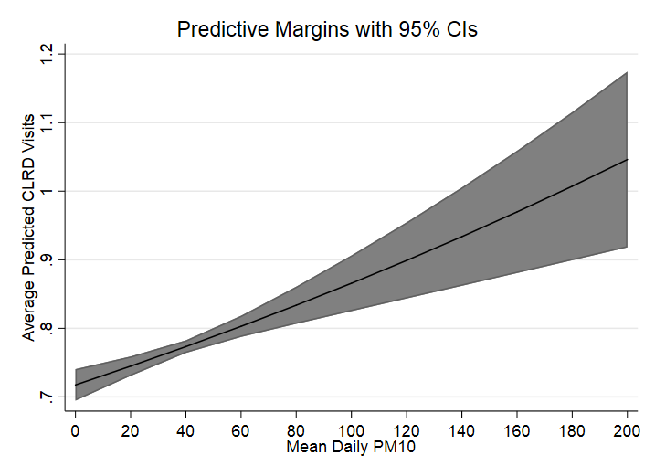
a)

b)

c)

