Supplemental Materials: Space use and relative habitat selection for immature green turtles within a Caribbean Marine Protected Area

Lucas P. Griffin ¹*, Brian J. Smith², Michael S. Cherkiss³, Andrew G. Crowder³, Clayton G. Pollock⁴, Zandy Hillis-Starr⁴, Andy Danylchuk¹, Kristen M. Hart³

*Corresponding author email: lucaspgriffin@gmail.com, (413) 552-8425

Supplement

Fig. S1: Abacus plot for the 68 transmitters deployed on 58 green turtles in Buck Island Reef National Monument, St. Croix. Black dots indicate presence (i.e., detections), open red circles represent the original capture event of a given turtle, and filled red dots represent the second recapture event of a given turtle.

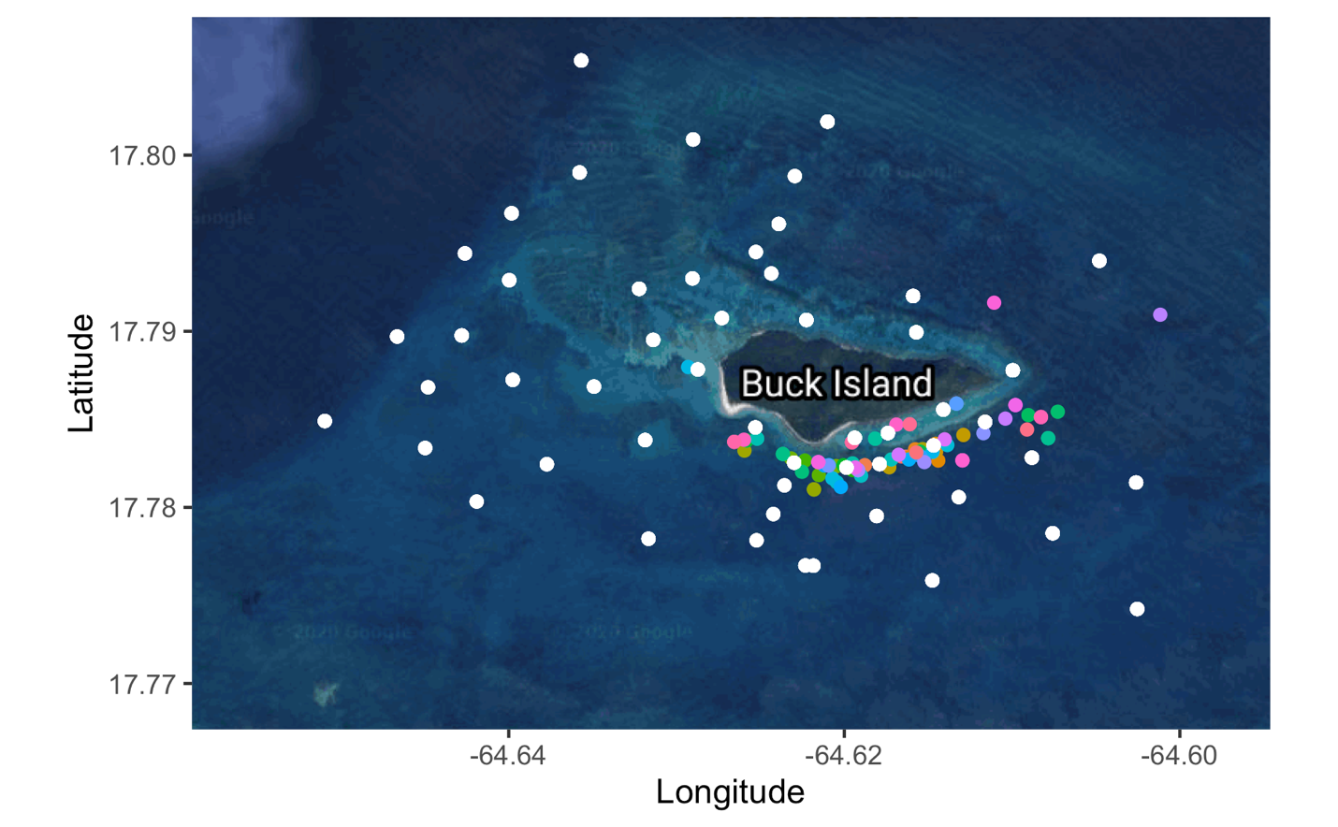

Fig. S2: Capture and transmitter application sites for 68 transmitters deployed on 58 green turtles in Buck Island Reef National Monument, St. Croix. Colored dots indicate the different capture events and white dots indicate receiver locations where 400 m buffers were generated around.
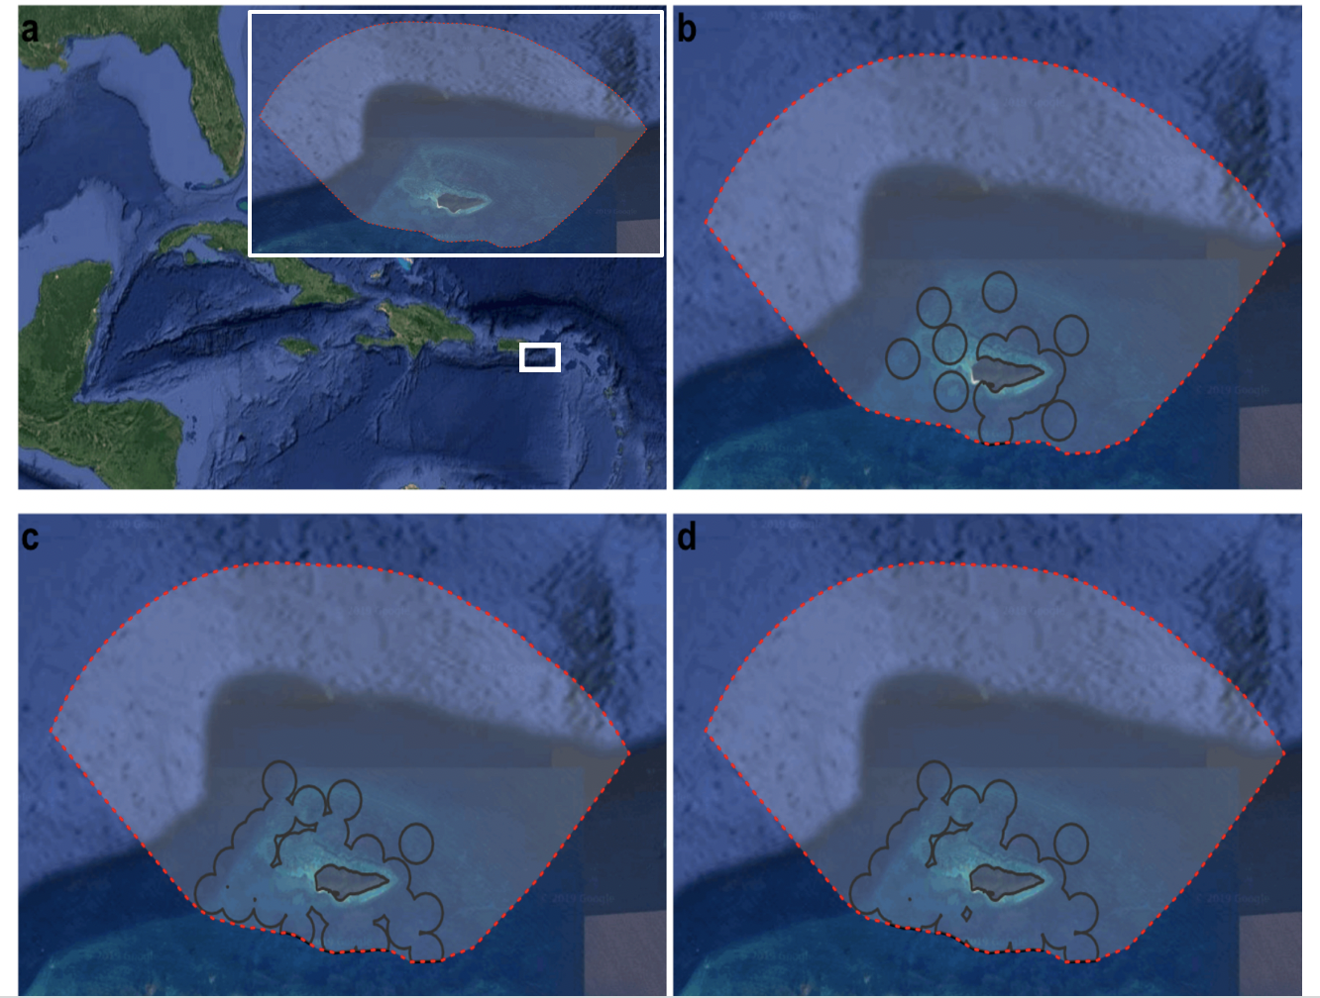

Fig. S3: Panel a) shows Buck Island Reef National Monument (BIRNM) study area. Panels b, c, and d show acoustic telemetry detection coverage within BIRNM by year, b) 2012, c) 2013, and d) 2014. A 400 m buffer, representing detection area, was applied to all receiver locations. The BIRNM boundary designated by red dashed line.

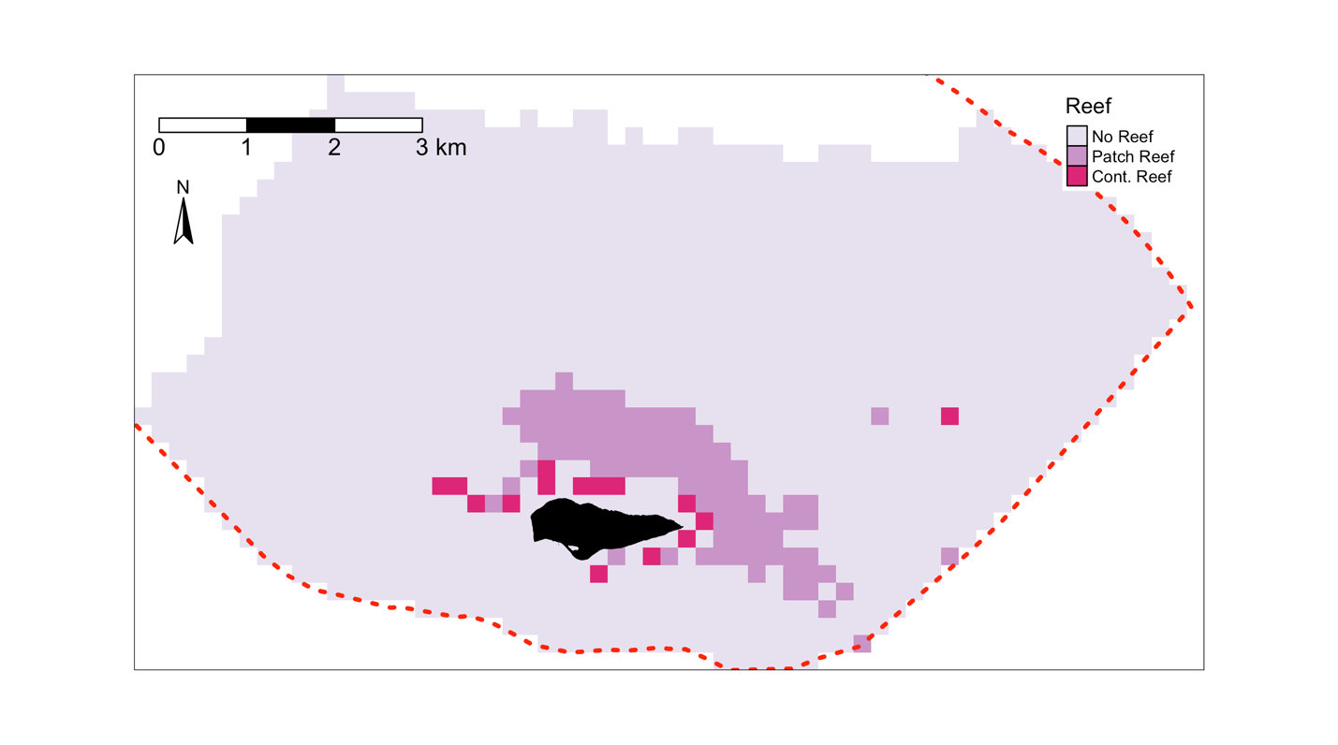

Fig. S4: Map of the original habitat covariate reef type. Variable was removed from the model due to high correlation with habitat covariate zone type.
Table S1: Tagging and detection data for the 68 transmitters deployed on 58 green turtles in Buck Island National Monument, St. Croix.

Turtle | Tag ID | Det. Num. | Stat. Num. | COA | Days Det. | Days at Liberty | Residency | Cap. Date | SCLn | SCLt
T_01 | 32179 | 84744 | 5 | 1561 | 116 | 117 | 0.99 | 3/14/12 | 57.5 | 57.7
T_01 | 28624 | 25436 | 8 | 1073 | 105 | 105 | 1 | 4/17/13 | 61.1 | 61.4
T_02 | 44444 | 3820 | 7 | 770 | 147 | 193 | 0.76 | 3/15/12 | 33.8 | 34.6
T_03 | 32170 | 63487 | 6 | 2644 | 131 | 133 | 0.98 | 3/15/12 | 50.9 | 51.4
T_04 | 32173 | 22195 | 7 | 2239 | 178 | 180 | 0.99 | 3/15/12 | 48.8 | 49.1
T_05 | 44446 | 540 | 3 | 79 | 47 | 116 | 0.41 | 3/18/12 | 36.9 | 37
T_05 | 27566 | 43452 | 5 | 856 | 47 | 47 | 1 | 9/8/13 | 41.8 | 42.1
T_06 | 44447 | 3274 | 3 | 469 | 101 | 102 | 0.99 | 3/18/12 | 40 | 40.2
T_06 | 8803 | 128076 | 22 | 5688 | 502 | 505 | 0.99 | 4/17/13 | 43.6 | 43.8
T_07 | 31078 | 851 | 5 | 123 | 54 | 91 | 0.59 | 3/18/12 | 57.3 | 58.4
T_08 | 32177 | 12 | 2 | 6 | 6 | 19 | 0.32 | 3/18/12 | 48 | 48.8
T_08 | 28633 | 546260 | 13 | 8673 | 459 | 472 | 0.97 | 4/17/13 | 55.3 | 55.9
T_09 | 44448 | 39 | 2 | 12 | 4 | 5 | 0.8 | 3/19/12 | 41.5 | 42.3
T_10 | 44449 | 881 | 1 | 143 | 26 | 45 | 0.58 | 3/19/12 | 34.3 | 35
T_11 | 44458 | 27 | 1 | 10 | 6 | 102 | 0.06 | 3/19/12 | 45.1 | 45.6
T_12 | 31082 | 17952 | 7 | 1506 | 178 | 184 | 0.97 | 3/19/12 | 51.8 | 52.5
T_12 | 28625 | 42594 | 11 | 1685 | 133 | 133 | 1 | 4/12/13 | 56.9 | 57.9
T_13 | 31094 | 18731 | 8 | 1925 | 107 | 107 | 1 | 3/19/12 | 44.5 | 44.9
T_14 | 44459 | 1 | 1 | 1 | 1 | 1 | 1 | 3/20/12 | 44.1 | 44.2
T_15 | 31091 | 9884 | 7 | 543 | 133 | 166 | 0.8 | 3/20/12 | 48 | 48.9
T_15 | 28629 | 82260 | 15 | 2931 | 218 | 218 | 1 | 4/13/13 | 53.1 | 54
T_16 | 44450 | 309 | 7 | 88 | 42 | 114 | 0.37 | 3/21/12 | 43.9 | 44.2
T_17 | 44451 | 70 | 2 | 9 | 7 | 40 | 0.18 | 3/21/12 | 40.3 | 40.6
T_17 | 28632 | 49416 | 12 | 1192 | 107 | 111 | 0.96 | 4/11/13 | 45.5 | 46
T_18 | 31085 | 3692 | 6 | 666 | 64 | 64 | 1 | 3/21/12 | 46.2 | 46.6
T_19 | 31093 | 8012 | 7 | 1124 | 262 | 266 | 0.98 | 3/21/12 | 51.4 | 52.2
T_20 | 31090 | 7934 | 5 | 743 | 64 | 64 | 1 | 4/10/12 | 48.1 | 48.4
T_21 | 31096 | 9614 | 8 | 876 | 117 | 156 | 0.75 | 4/10/12 | 45.9 | 46.3
T_22 | 44456 | 8 | 1 | 2 | 1 | 1 | 1 | 4/11/12 | 39 | 39.3
T_22 | 27573 | 16950 | 9 | 426 | 41 | 41 | 1 | 9/6/13 | 44.5 | 44.6
T_23 | 31077 | 14716 | 5 | 1282 | 70 | 70 | 1 | 4/11/12 | 43.7 | 44.3
T_24 | 44454 | 23 | 1 | 7 | 6 | 30 | 0.2 | 4/12/12 | 36.3 | 36.8
T_25 | 31080 | 93150 | 8 | 4178 | 201 | 202 | 1 | 4/13/12 | 48.3 | 48.8
T_26 | 31087 | 3076 | 11 | 455 | 148 | 221 | 0.67 | 4/13/12 | 47.7 | 48.7
T_27 | 31092 | 15742 | 12 | 1277 | 223 | 260 | 0.86 | 4/13/12 | 46.5 | 46.9
T_28 | 31086 | 5162 | 8 | 194 | 59 | 177 | 0.33 | 4/14/12 | 53.8 | 54.4
T_28 | 28631 | 14658 | 16 | 708 | 128 | 207 | 0.62 | 4/12/13 | 56.7 | 57.5
T_29 | 31088 | 15234 | 8 | 749 | 97 | 120 | 0.81 | 4/14/12 | 48.2 | 49.1
T_30 | 30318 | 1550 | 6 | 171 | 57 | 93 | 0.61 | 9/13/12 | 44.4 | 44.9
T_31 | 30296 | 23176 | 7 | 1386 | 75 | 75 | 1 | 9/14/12 | 46.9 | 47.3
T_32 | 30290 | 30251 | 10 | 3120 | 174 | 174 | 1 | 9/15/12 | 53.8 | 54.7
T_33 | 30317 | 514 | 3 | 123 | 35 | 109 | 0.32 | 9/15/12 | 56.2 | 57.6
T_34 | 6788 | 34244 | 8 | 2234 | 175 | 181 | 0.97 | 9/15/12 | 41.2 | 41.4
T_35 | 6784 | 3472 | 10 | 435 | 121 | 135 | 0.9 | 9/16/12 | 38.5 | 39
T_36 | 30293 | 128154 | 11 | 5837 | 315 | 315 | 1 | 9/18/12 | 52.2 | 52.4
T_37 | 30309 | 53530 | 11 | 3589 | 194 | 195 | 0.99 | 9/18/12 | 64.5 | 66.5
T_38 | 6786 | 16764 | 6 | 1052 | 143 | 143 | 1 | 9/18/12 | 44.4 | 45.2
T_38 | 28630 | 16420 | 6 | 896 | 110 | 112 | 0.98 | 4/16/13 | 46.2 | 46.8
T_39 | 28634 | 49713 | 9 | 3116 | 144 | 144 | 1 | 4/11/13 | 42.6 | 43.5
T_40 | 8804 | 3124 | 9 | 481 | 96 | 107 | 0.9 | 4/12/13 | 48.9 | 49.7
T_41 | 28627 | 36649 | 12 | 2307 | 207 | 210 | 0.99 | 4/13/13 | 51.7 | 52.2
T_42 | 8807 | 16306 | 15 | 1755 | 274 | 283 | 0.97 | 4/13/13 | 46.2 | 46.5
T_43 | 28628 | 43405 | 15 | 2735 | 207 | 208 | 1 | 4/15/13 | 53.8 | 54.5
T_44 | 8806 | 22597 | 10 | 1592 | 190 | 192 | 0.99 | 4/15/13 | 46.6 | 46.9
T_45 | 28626 | 9388 | 14 | 986 | 183 | 211 | 0.87 | 4/16/13 | 52 | 52.7
T_46 | 8805 | 13309 | 8 | 881 | 70 | 73 | 0.96 | 4/16/13 | 46.6 | 47.3
T_47 | 8801 | 18742 | 11 | 3437 | 406 | 429 | 0.95 | 4/17/13 | 41.5 | 42
T_48 | 8802 | 596 | 5 | 88 | 35 | 88 | 0.4 | 4/17/13 | 40.5 | 41
T_49 | 27571 | 1207 | 8 | 207 | 36 | 48 | 0.75 | 9/4/13 | 40.7 | 41.6
T_50 | 11825 | 26605 | 8 | 1092 | 77 | 99 | 0.78 | 9/6/13 | 37.5 | 38.1
T_51 | 27567 | 6977 | 25 | 516 | 96 | 128 | 0.75 | 9/7/13 | 65.5 | 66.1
T_52 | 27569 | 24494 | 9 | 1633 | 99 | 132 | 0.75 | 9/7/13 | 58.2 | 58.9
T_53 | 11823 | 23701 | 23 | 2927 | 211 | 229 | 0.92 | 9/8/13 | 37.5 | 38.1
T_54 | 27565 | 16676 | 9 | 902 | 66 | 71 | 0.93 | 9/8/13 | 41.8 | 42.5
T_55 | 27563 | 50982 | 10 | 1722 | 108 | 108 | 1 | 9/9/13 | 42.9 | 44.1
T_56 | 27568 | 14620 | 7 | 1031 | 65 | 65 | 1 | 9/9/13 | 48.5 | 49.2
T_57 | 11822 | 11196 | 14 | 1403 | 123 | 128 | 0.96 | 9/10/13 | 35.6 | 36.3
T_58 | 11827 | 25424 | 12 | 2852 | 266 | 276 | 0.96 | 9/10/13 | 41.5 | 42.1

Table S2: The top 10 models, as indicated by AIC, after running all possible fixed effect subsets. A plus or minus indicate if the variable of interest was included or excluded from that particular model, respectively.

Model Rank | Diel | Zone | Diel:Depth | Diel:SG Dist. | Diel:Zone | df | Log-Likelihood | AIC | Delta | Weight
1 | + | + | + | + | + | 14 | -10412.29 | 20852.59 | 0.00 | 0.67
2 | + | + | - | + | + | 13 | -10414.11 | 20854.25 | 1.65 | 0.29
3 | + | + | + | - | + | 13 | -10416.41 | 20858.84 | 6.25 | 0.03
4 | + | + | - | - | + | 12 | -10419.91 | 20863.83 | 11.24 | 0.00
5 | + | + | + | - | - | 10 | -10477.21 | 20974.44 | 121.85 | 0.00
6 | + | + | + | + | - | 11 | -10476.25 | 20974.51 | 121.92 | 0.00
7 | + | + | - | + | - | 10 | -10491.45 | 21002.91 | 150.32 | 0.00
8 | - | + | - | - | - | 8 | -10512.00 | 21040.00 | 187.41 | 0.00
9 | + | + | - | - | - | 9 | -10511.90 | 21041.81 | 189.22 | 0.00
10 | + | + | - | + | + | 12 | -10991.71 | 22007.44 | 1154.85 | 0.00

Table S3: Prediction accuracy of categorical variables.

Variable | Classification | Accuracy Percent
Zone | Other | 100
Zone | Reef | 74.52
Zone | Lagoon | 73.69
Zone | Bank/Shelf | 69.78
Diel | Night | 73.1
Diel | Day | 71.7

