Supporting information data
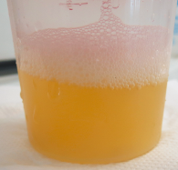
Additional file 1
Urine sample
(10 mL)

Bacterial cells enrichment
centrifugation (1 min 1000 g, RT)

Washing steps - with buffer
centrifugation (16000 g for 5 min, 4°C)

Protein extraction
B-PER protocol
In-solution digestion
thermoshaker (18 h, 37°C, 500 rpm)

Peptide fractionation
automated liquid handling platform Bravo

Mass spectrometry analysis MALDI TOF/TOF
- MS1 (precursor spectra)
- MS2 (fragmentation spectra)

Bioinformatic data analysis
MASCOT search engine
Identification of bacteria

Figure S1: Experimental workflow for the identification of uropathogen from a native urine sample. The workflow covers sample preparation, sample fractionation, mass spectrometry analysis and data analysis.

Sample UR1
A) B) 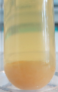 C) 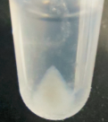
Sample UR2
- 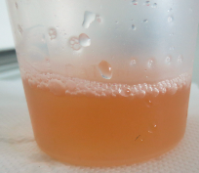 B) 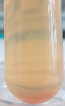 C) 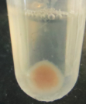
Sample UR3
- 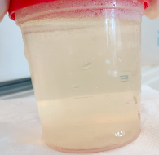 B) 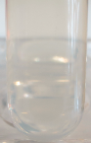 C) 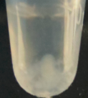
Sample UR4
- 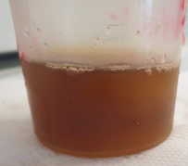 B) 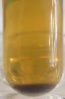 C) 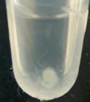
Sample UR5
- 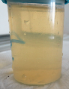 B) 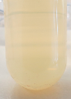 C) 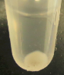
Sample UR6
- 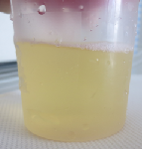 B) 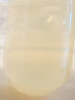 C) 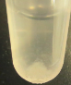

Sample UR7
- 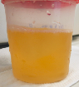 B) 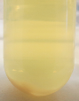 C) 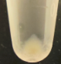
Sample UR8
- 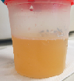 B) 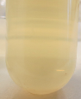 C) 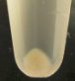
Sample UR9
- 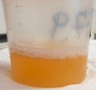 B) 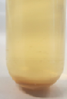 C) 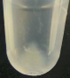
Sample UR10
- 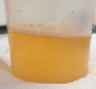 B) 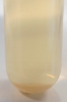 C) 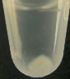
Sample UR11
- 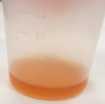 B) 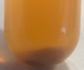 C) 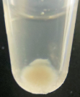
Sample UR12
- 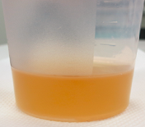 B) C) 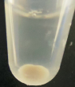

Sample UR13
- 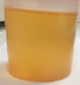 B) 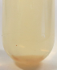 C) 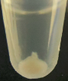
Sample UR14
- 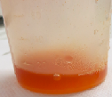 B) 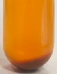 C) 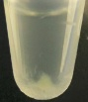
Sample UR15
- 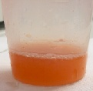 B) 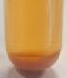 C) 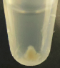
Sample UR16
- 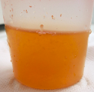 B) 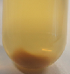 C) 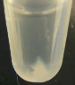

Figure S2: Images of 16 urine specimens.
(A) Urine sample in container, (B) Urinary pellet (before washing step),
(C) Urinary cell pellet in B-PER.

Figure S3: Protein content of each fraction as a percentage of the total protein.

Figure S4: Cumulative number of bacterial and human proteins for each sample per fraction.

