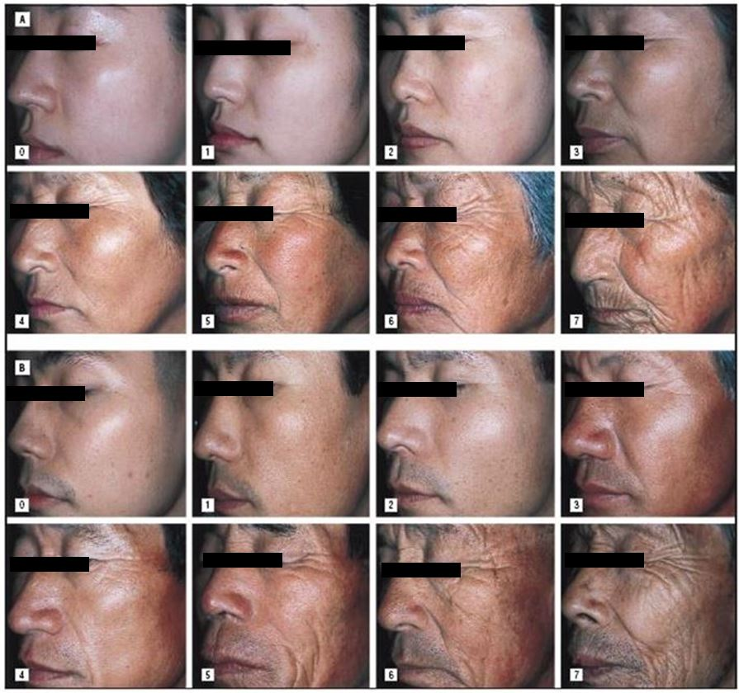

Figure S1. Visual evaluation criteria of wrinkles. 0, none; 1, none ⁄ mild; 2, mild; 3, mild ⁄ moderate; 4, moderate; 5, moderate ⁄ severe; 6, severe; and 7, very severe

