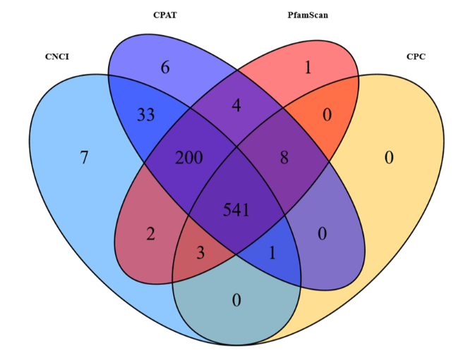
Supplemental file 3. Venn Diagram of screening novel lncRNA using four coding potential prediction software. Blue represents CNCI software, purple represents CPAT software, red represents PfamScan software, and yellow represents CPC software.

