Additional figures

Figure S1. The age-standardized incidence rate (ASIR) of ALL in 2017 and the changing trends of ALL ASIR between 1990 and 2017.
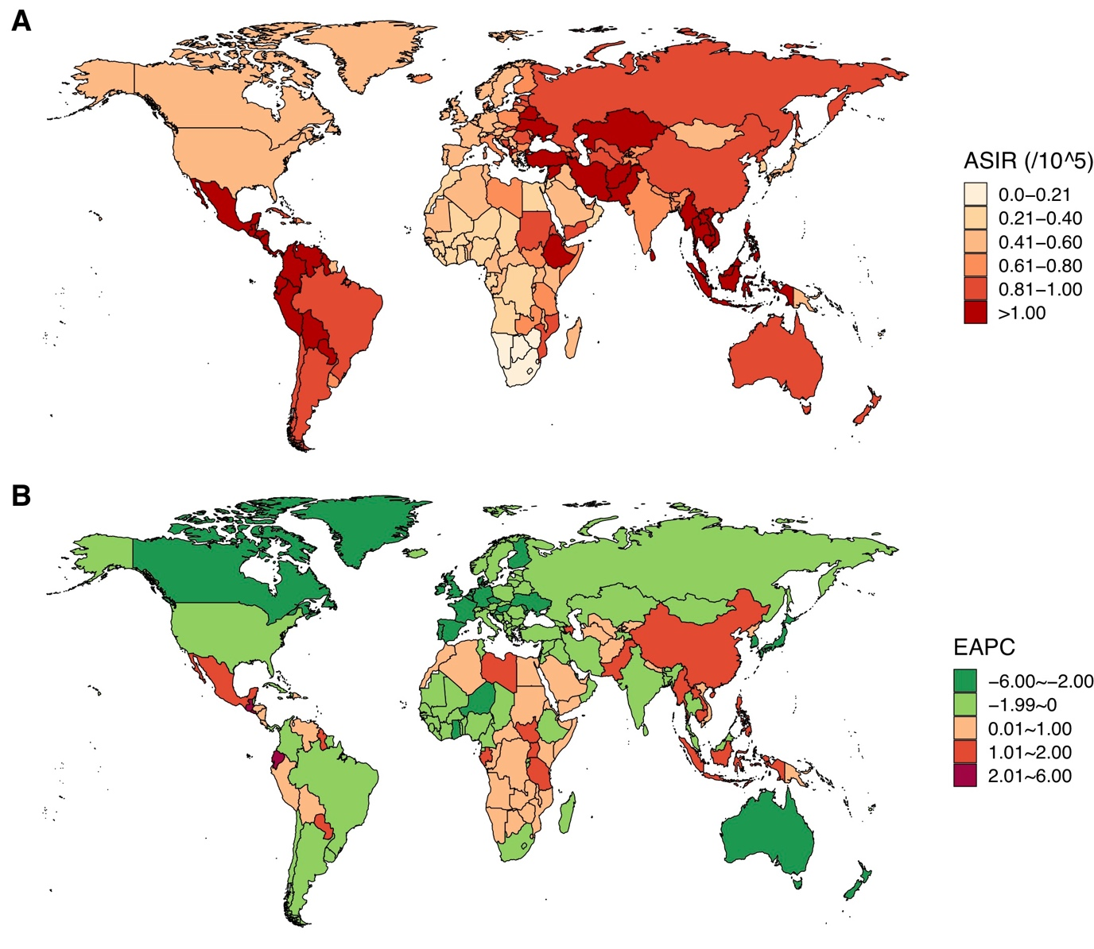

Figure S2. The age-standardized incidence rate (ASIR) of CLL in 2017 and the changing trends of CLL ASIR between 1990 and 2017.
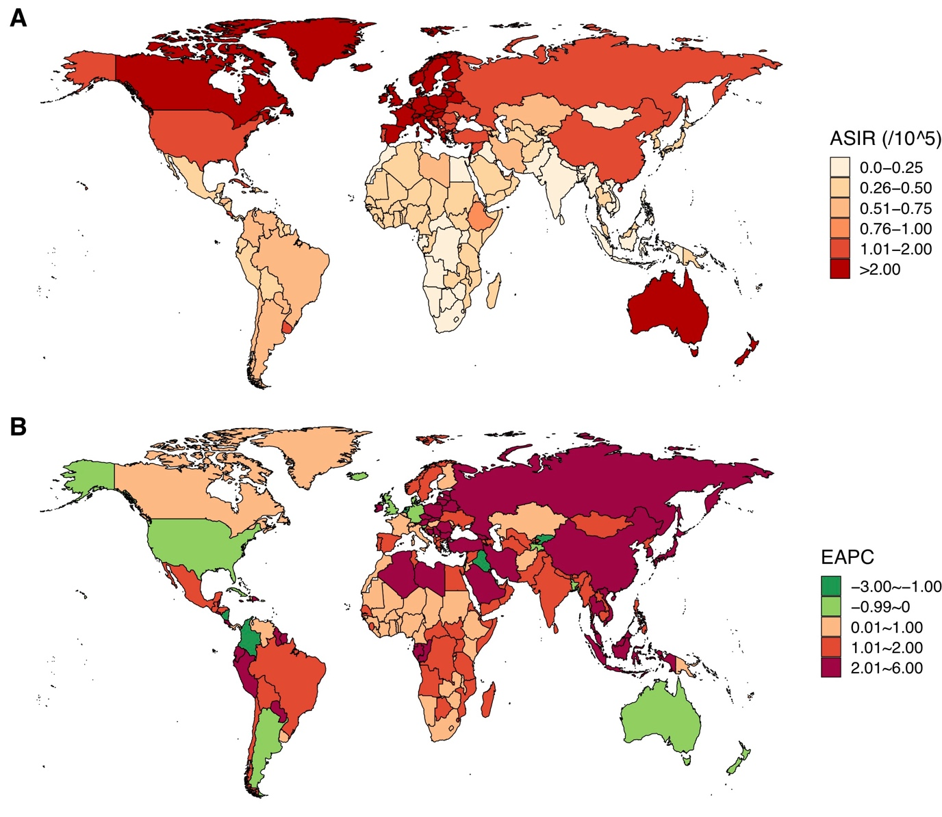

Figure S3. The age-standardized incidence rate (ASIR) of AML in 2017 and the changing trends of AML ASIR between 1990 and 2017.
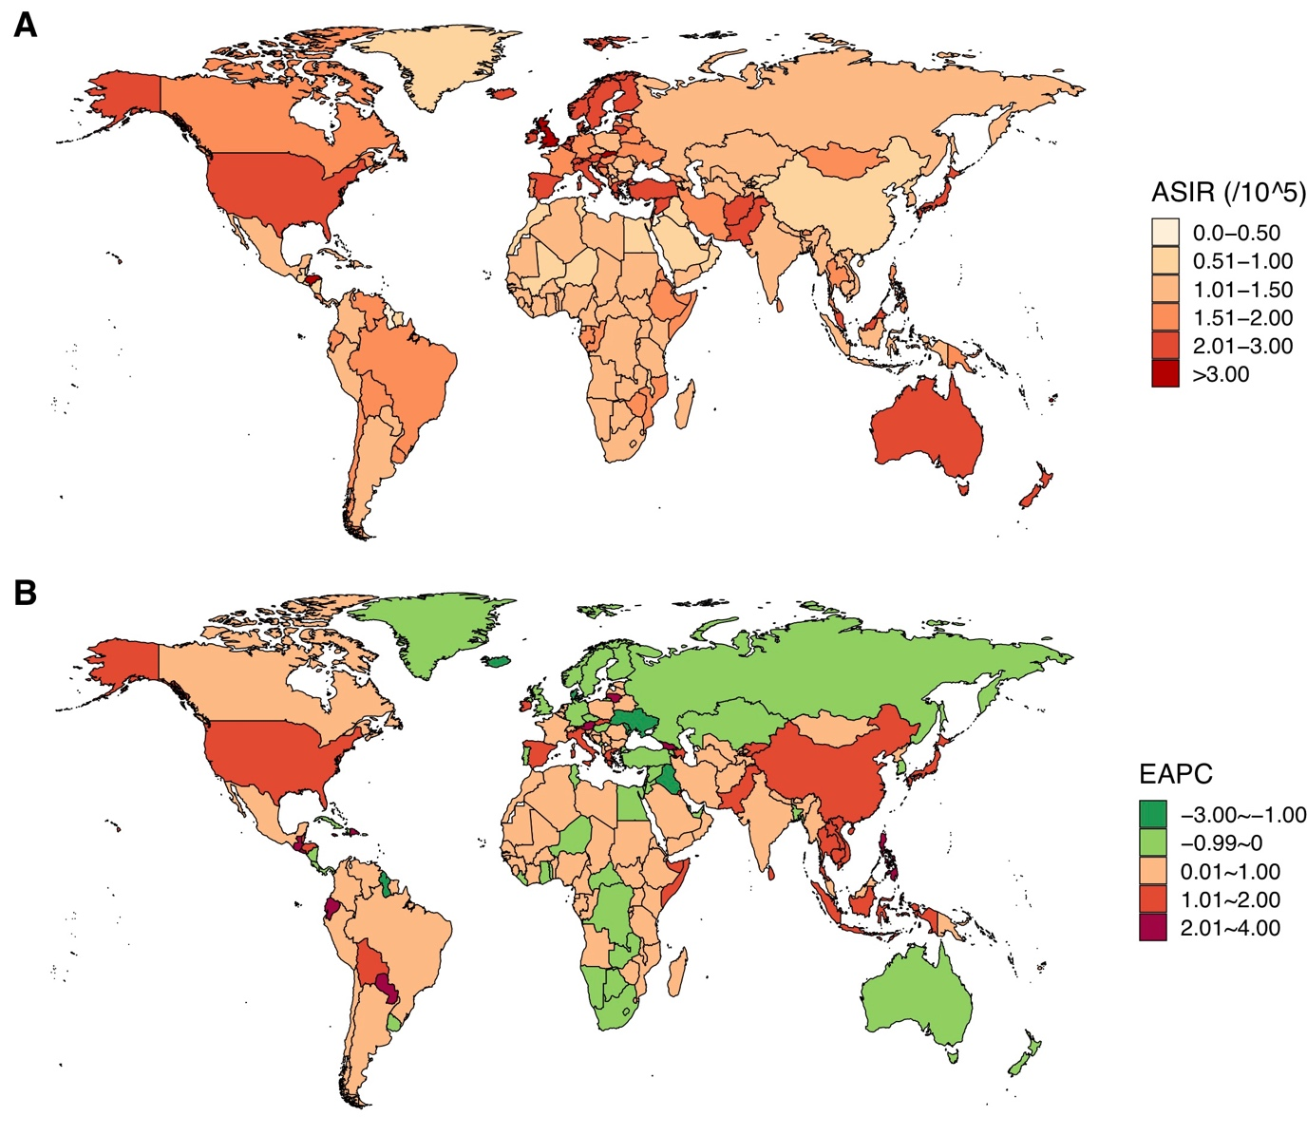

Figure S4. The age-standardized incidence rate (ASIR) of CML in 2017 and the changing trends of CML ASIR between 1990 and 2017.
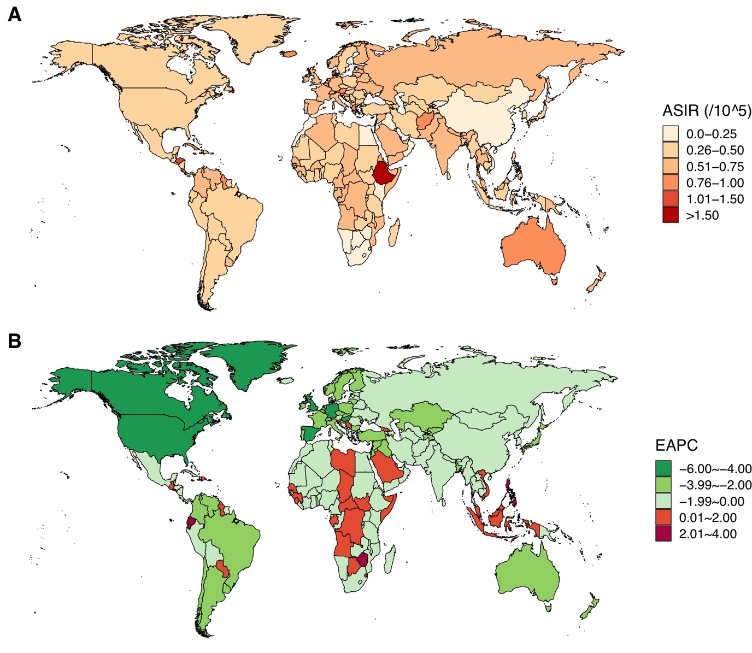

Figure S5. The age-standardized incidence rate (ASIR) of other leukemias in 2017 and the changing trends of other leukemias ASIR between 1990 and 2017.
