Table S1. Sequencing output of soil bacterial sequences
Sample_ID | PE_Reads | Raw_Tags | Clean_Tags | AvgLen(bp) | GC(%) | Q20(%) | Q30(%) | Effective(%)
AP0-1 | 66685 | 63779 | 56461 | 454 | 54.6 | 96.47 | 93.29 | 84.67
AP0-2 | 79106 | 77333 | 68166 | 453 | 54.96 | 97.86 | 95.89 | 86.17
AP1-1 | 71436 | 67914 | 59218 | 456 | 55.57 | 96.17 | 92.69 | 82.9
AP1-2 | 66788 | 65154 | 57857 | 456 | 55.91 | 97.71 | 95.57 | 86.63
AP2-1 | 77642 | 73823 | 64672 | 457 | 56.01 | 96.45 | 93.18 | 83.3
AP2-2 | 79522 | 77684 | 69089 | 456 | 56.43 | 97.74 | 95.57 | 86.88

Table S2. Sequencing output of soil fungal sequences
Sample_ID | PE_Reads | Raw_Tags | Clean_Tags | AvgLen(bp) | GC(%) | Q20(%) | Q30(%) | Effective(%)
AP0-1 | 101723 | 93697 | 92107 | 345 | 41.75 | 97.82 | 96.09 | 90.55
AP0-2 | 72639 | 66856 | 65607 | 345 | 42.75 | 98.6 | 97.67 | 90.32
AP1-1 | 118767 | 114501 | 113433 | 306 | 44.26 | 98.31 | 96.92 | 95.51
AP1-2 | 97751 | 94381 | 93624 | 313 | 44.17 | 98.82 | 98 | 95.78
AP2-1 | 118437 | 114789 | 114088 | 292 | 44.56 | 98.86 | 97.95 | 96.33
AP2-2 | 99496 | 97363 | 96996 | 302 | 49.73 | 99.11 | 98.7 | 97.49

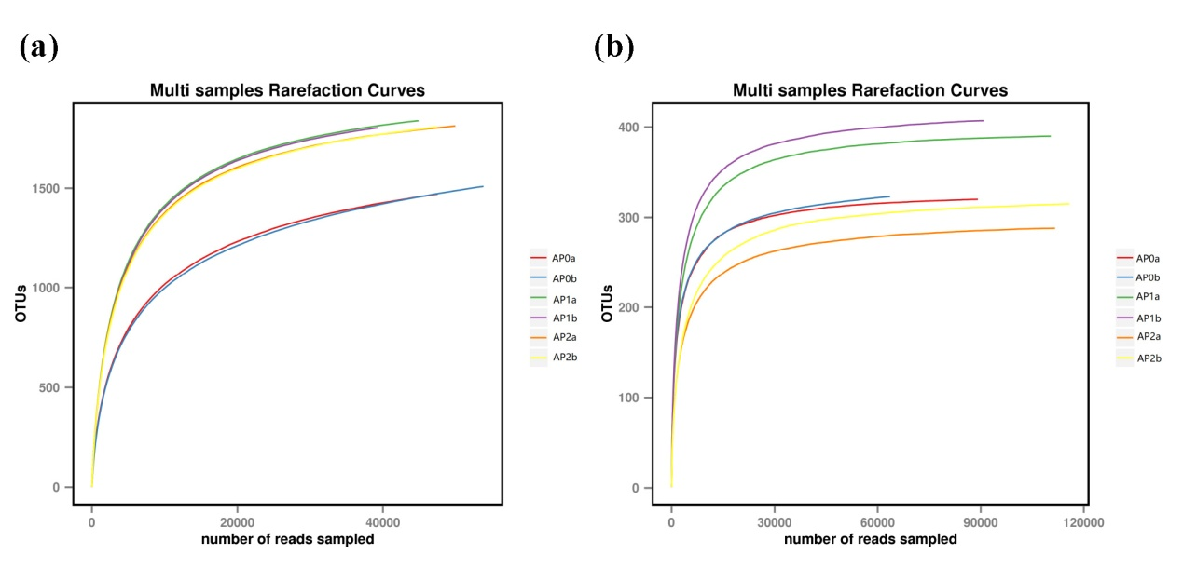
Fig. S1. Rarefaction curves of soil microbial communities based on OTUs at the 97% similarity cut-off level for individual samples. (a) and (b) are the rarefaction curves of OTU for bacterial and fungal communities, respectively. AP0, AP1 and AP2 represent soil with continuously cropping histories of A. paniculata for 0, 1 and 2 years. “a” and “b” mean the two replicates.

