Additional material

Additional text .................................................................................................................................................. 2
Exercise Stress Test (EST)
Exercise training
Statistical analysis
Additional Table 1. Inclusion and exclusion criteria .............................................................................................. 3
Additional Figure 1. HIIT session examp............................................................................................................... 4
Additional Figure 2. HIIT session example 2 ......................................................................................................... 5
Additional Figure 3. MICT session example 1 ....................................................................................................... 6
Additional Figure 4. MICT session example 2 ....................................................................................................... 7

Additional text

Exercise Stress Test (EST)
The EST was performed on either an upright or an inclined cycle ergometer, using a ramp test increasing by 25W resistance every 2 minutes (25-2-25R). Rate of perceived exertion (RPE) was used to guide the test because it is not influenced by dysrhythmia or beta-blockers (thus being more relevant than max HR) when determining maximum or sub-maximum exercise capacity.

Exercise training
HIIT group
The HIIT sessions consisted of a 10-minute warm-up (on a cycle ergometer, NuStep, or pedal exerciser), 15 minutes of HIIT (8 one-minute intervals of active exercise alternating with 7 one-minute intervals of passive rest), and 5 minutes of passive cool-down, making a total of 30 minutes per session (18 minutes of active exercise) and 120 minutes per week (72 minutes of active exercise).
At the initial evaluation, patients tested four different exercises (A–D) to evaluate their performance capacity, and the exercises were adapted to patients’ abilities and limitations (Table 2).
The patient’s RPE, measured according to a modified Borg scale, was recorded at baseline (before the beginning of the session), after the warm-up, after each effort interval, and after the cool-down period. The intensity of the exercise was adjusted after each interval.
MICT group
The MICT sessions consisted of a 10-minute warm-up (exercises targeting the upper and lower body), 25 minutes of Pedal Exerciser, and 5 minutes of active cool-down, making a total of 40 minutes per session (40 minutes of active exercise) and 120 minutes per week (120 minutes of active exercise). Exercises targeted muscular reinforcement, flexibility, balance, and aerobics, and intensity was adjusted using the Talk-Test, in which the patient must be able to maintain a conversation while exercising.
RPE was recorded, as per usual care, at baseline, during the pedal exerciser exercise, and after the cool-down.

Statistical analysis
Patients’ performances (6MWT, step variability, and muscle strength) at their first and last visits were described as means and standard deviations, based on available data. The overall training effect, i.e., the performance difference between first and last visits, was assessed using a linear mixed-effects regression model, with patients as the random effect and the visit factor as the fixed effect. The equation model can be written as Performance = β₀ + β₁ Visit + ε, where the coefficient of interest, β₁, represents the mean change score (last visit – first visit).
The group effect on patients’ performances was evaluated as the difference in mean change score between the first and last visits. For this purpose, and for each performance outcome, we used a linear mixed-effects regression model where the parameter of interest was the interaction term between group factor and time (i.e., visit) factor. Group and time factors were the fixed effects and the patient was the random effect. The equation model can be written as Performance = β₀ + β₁ Group + β₂ Visit + β₃ Group*Visit + ε, where the coefficient of interest, β₃, represents the difference between the mean change scores of each group. The training effect by group was estimated according to this model as β₂ in HIIT group and β₂ + β₃ in MICT group.

Additional figures and tables
Table 1. Inclusion and exclusion criteria
Inclusion criteria
≥ 65 years old
Hospitalized for rehabilitation after an acute medical condition
Expected duration of rehabilitation ≥ 2 weeks
Able to follow instructions to perform a Timed Up and Go test
Able to perform exercises
Willing to participate in 4 sessions of HIIT per week for 2 weeks
Exclusion criteria
Any acute condition involving tachycardia, hypotension, or fever
Abnormal cycle ergometer stress test result with
  - significant ECG modification
  - decrease of more than 20 mmHg in blood pressure with exercise
  - angina
  - ST depression at a workload < 6 METs
  - unable to reach an intensity of 15 out of 20 on the Borg scale of perceived exertion
Any unresolved acute medical or surgical condition of the following kinds:
- acute heart failure
  - acute coronary syndrome in the last month
  - active pericarditis/myocarditis/endocarditis
  - thromboembolic disease with < 2 weeks of anticoagulation
  - acute infection requiring intravenous treatment
  - ongoing intravenous perfusion
  - surgery in the last 2 months
  - recent bone fracture
Any previous episode of primary cardiac arrest (i.e., cardiac arrest that did not occur in the presence of an acute myocardial infarction or during a cardiac procedure)
Severe heart failure (NYHA III and IV)
Severe stenotic or regurgitant valvular disease
Uncontrolled hypertension at rest (SBP ≥ 160 mmHg, DBP ≥ 100 mmHg)
Uncontrolled dysrhythmia
Non-sustained ventricular tachycardia with exercise
Implanted defibrillator
Obstructive cardiomyopathy
Resting HR > 100/min
Severe peripheral artery disease
Severe COPD (VEMS < 50%)
Exercise-induced asthma
Oxygen dependency
Musculoskeletal anomaly that may limit exercise participation
Delirium
Inability to follow instructions
Inability to give consent

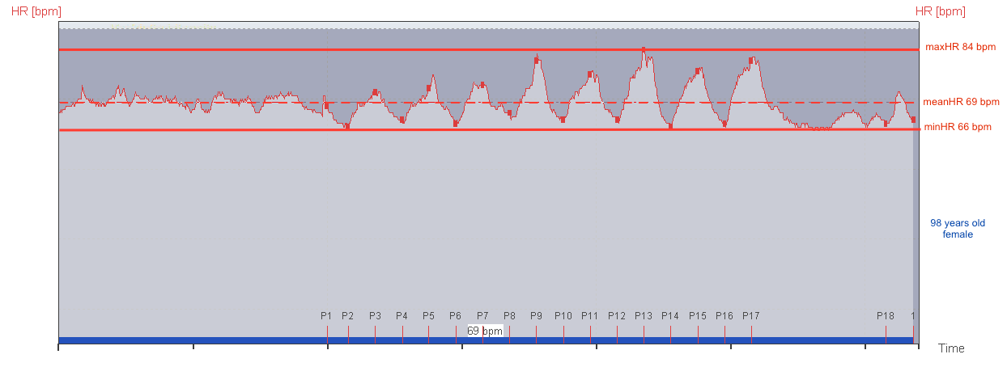
Additional Figure 1. HIIT session example 1
Figure 2. MICT session example 1

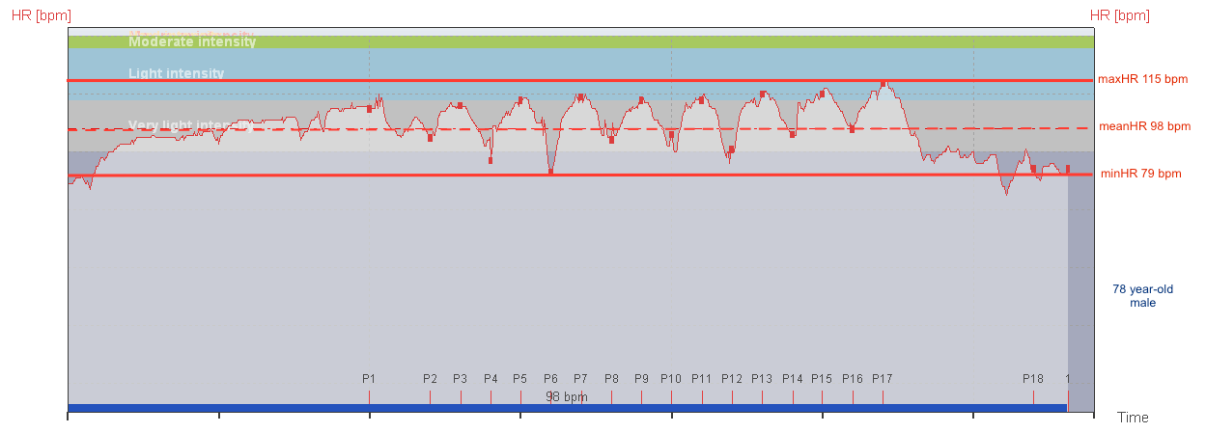
Additional Figure 2. HIIT session example 2

Additional Figure 3. MICT session example 1
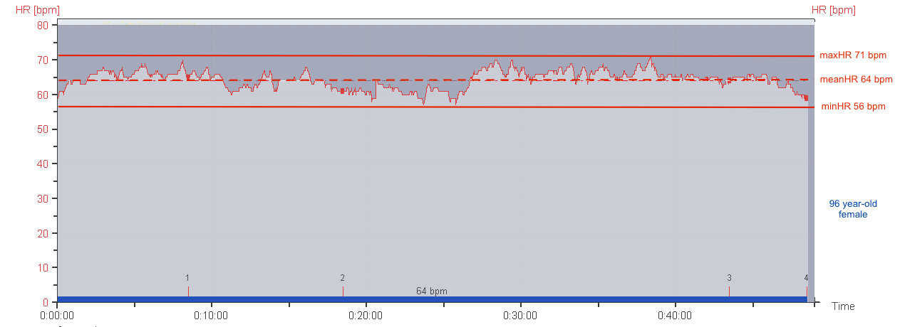
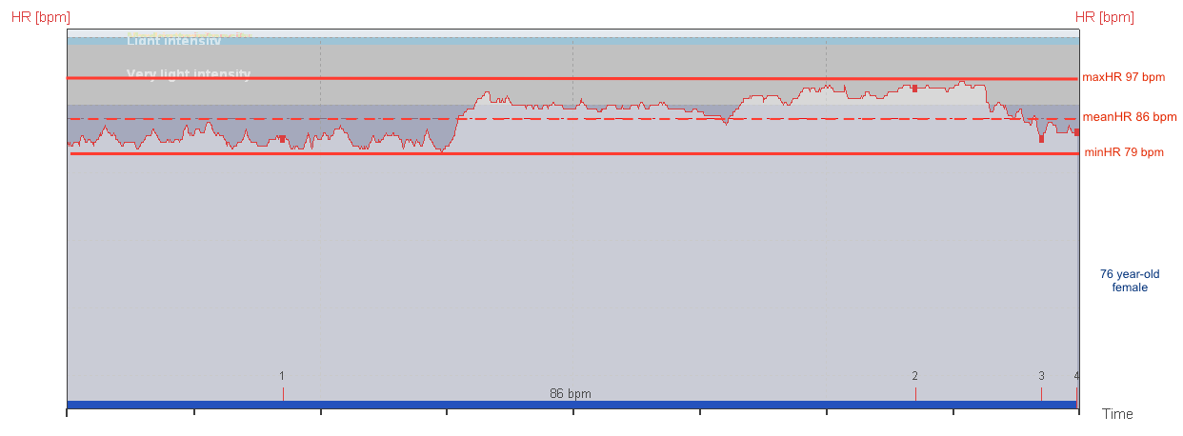
Additional Figure 4. MICT session example 2

