Additional file 4: Supplementary Figure

Supplementary Figure S3
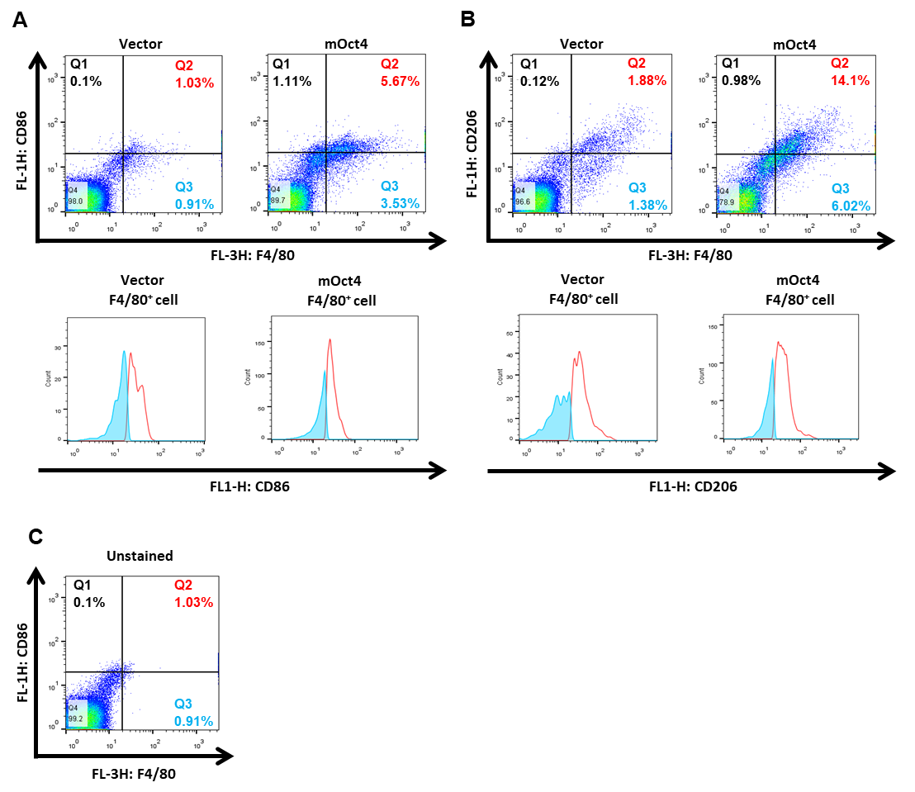
Supplementary Figure S4. Analysis of M1 and M2 macrophages in the mouse tumors at day 15 after inoculation of LL2-Oct4 or control LL2 tumor cells. The isolated cells were stained with PE-Cy7-conjugated rat anti-mouse F4/80, FITC-conjugated rat anti-mouse CD86, or FITC-conjugated rat anti-mouse CD206 antibody. Cells were first gated to exclude debris and dead cells (FSC vs. SSC), and then gated to exclude cell doublets (FL2-A vs. FL2-H). Within the CD68⁺ cells, differential expression of the M1 macrophage marker CD86 and M2 macrophage marker CD206 is based on CD86hi and CD206hi expression, respectively. Representative dot plots (upper) and histograms (lower) are shown. C, unstained cells.

