**Additional file 1: Fine-scale magnetic field map of Glacier Bay**

We created a 100-m grid of the total magnetic field in Glacier Bay, Alaska, USA, based on observations from a combination of fine-scale marine vessel and aerial survey data. We estimated the intensity of the magnetic field at locations visited during seven marine vessel surveys conducted over the course of one year (July 1, 2013 to July 1, 2014) using a mixed effects model as described below. To estimate magnetic field values for grid cells not measured during the vessel survey, we used the geostatistical technique of co-Kriging to leverage fine-scale aerial survey data available for the entire study area. This resulted in a fine-scale map that covers all of Glacier Bay and the waters extending into Icy Strait and into the Gulf of Alaska (main manuscript Figure 3B).

A GEM (Markham, Ontario, Canada) GSM-17 Overhauser magnetometer/gradiometer was attached to the bow of an aluminum vessel (Figure 1-1). The instrument recorded magnetic field readings (resolution 0.01 nT) and GPS coordinates every second. The two sensors were mounted on a vertical bar and placed 0.5 m apart to sense gradients in the vertical component of the magnetic field. Because the vessel was aluminum, and the sensors were located far enough from electronic components to prevent interference, the change in magnetic field with change in direction of the vessel was negligible (< 50 nT). The magnetometer was deployed during 7 tracking trips; 5 during the summer of 2013 and 2 during the summer of 2014. Vessel speeds were generally < 7 knots when magnetic data were collected. After spurious records were removed, this generated a data set of 881,292 observations collected over a time period of July 1, 2013 to July 1, 2014 (Figure 1-2).

Stationary test tags and magnetic observatory data were used to control for temporal change in magnetic field strength during the vessel survey. While the magnetometer on board the vessel was recording data, a stationary archival tag (SeaTagMOD, Desert Star, Marina, California, USA) was placed on shore to monitor changes in the magnetic field due to solar activity. The tag was put on ice in a darkened cooler so that it would maintain a constant temperature. If the tags are not exposed to light, changing temperature, or a change in orientation, the tag resolution in the measurement of the total magnetic field has a range of approximately ± 100 nT (Additional file 2). In addition, magnetic field values from the Sitka Magnetic Observatory (SMO, approximately 100 miles from Glacier Bay) were available each minute as an additional source of information on the magnitude of change in the magnetic field over time during the surveys. Although the absolute value of SMO differed from the stationary archival tag measurements, changes were of similar magnitude (Figure 1-3). A good agreement between stationary test tags and the SMO data, albeit with a slight lag at times, suggests that the detailed data recorded by the SMO provided a reasonable indication of temporal change in the magnetic field in the study area.

We aggregated the magnetic field observations into 100 m x 100 m cells that reflected the range of spatial autocorrelation present in the vessel data. First, we removed the annual temporal trend in the main field (-85.147 nT/year, p < 2e-16) using a linear regression on all data available from SMO over the course of the year (Figure 1-2). Then we divided the observations into segments that corresponded to each transit through each 100 m2 grid cell on each trip to account for potential differences in the magnetic field measurements due to the direction of vessel travel and small-scale temporal magnetic fluctuations. We fit a hierarchical linear model for observations vs. magnetic field gradient, using trip ID and transit ID as grouping variables. The intercept was the “population” estimate of the magnetic field in each cell. If just one observation was available, that value was recorded as the cell value. Mapped values were converted to anomaly data by subtracting International Geomagnetic Reference Field (IGRF) values for July 1, 2013. All analyses were conducted using the R statistical program (R Core Team, 2017).

Total magnetic field values collected from the vessel survey revealed several distinct anomaly areas in the study area (Figure 1-4A). The standard deviation of aggregated magnetic field observations in each 100 m grid cell was usually less than 150 nT (Figure 1-4B). The primary purpose of the survey trips was to track Pacific halibut (*Hippoglossus stenolepis*) with acoustic telemetry, so most time was spent in the vicinity of tagged fish that tended to establish home ranges (Nielsen and Seitz, 2017). As a result, some locations received many more observations than others (Figure 1-4C).

Aerial survey data for the study area (Figure 1-5) were used to estimate magnetic field values for grid cells not visited during the marine vessel survey. Aerial data for Glacier Bay were collected in 1976 (Brew et al., 1978; Connard et al., 1999) using a modified ASQ-10 fluxgate magnetometer (precision 0.1 nT). Magnetic field observations were 200 m apart on flight transects spaced 1600 m apart. Magnetic field measurements were adjusted to an elevation of 305 m above sea level (Brew et al., 1978; Connard et al., 1999).

Because the marine vessel collected magnetic field data at sea level while the aerial survey data provided magnetic field values for an elevation of 305 m, values were assumed to vary similarly in space though the absolute magnitude would not be the same for the two data sets. We used the geostatistical technique of co-Kriging to apply information about the spatial variation observed in the aerial survey while preserving the magnitudes from the vessel-based data. Co-kriging was conducted using the Geostatistical Analyst extension in ArcGIS 10.3.1 for Desktop. Following co-Kriging, IGRF values for July 1, 2013 were added to the combined anomaly map to represent total magnetic field values on that day.

Literature cited

Authro, 1978. Mineral resources of the Glacier Bay National Monument wilderness study area, Alaska.

Authro, 1999. Alaska digital aeromagnetic database description.

Nielsen, J.K., Seitz, A.C., 2017. Interannual site fidelity of Pacific halibut: potential utility of protected areas for management of a migratory demersal fish. ICES J Mar Sci 74, 2120–2134.

R Core Team, 2017. R: A language and environment for statistical computing. R Foundation for Statistical Computing, Vienna.

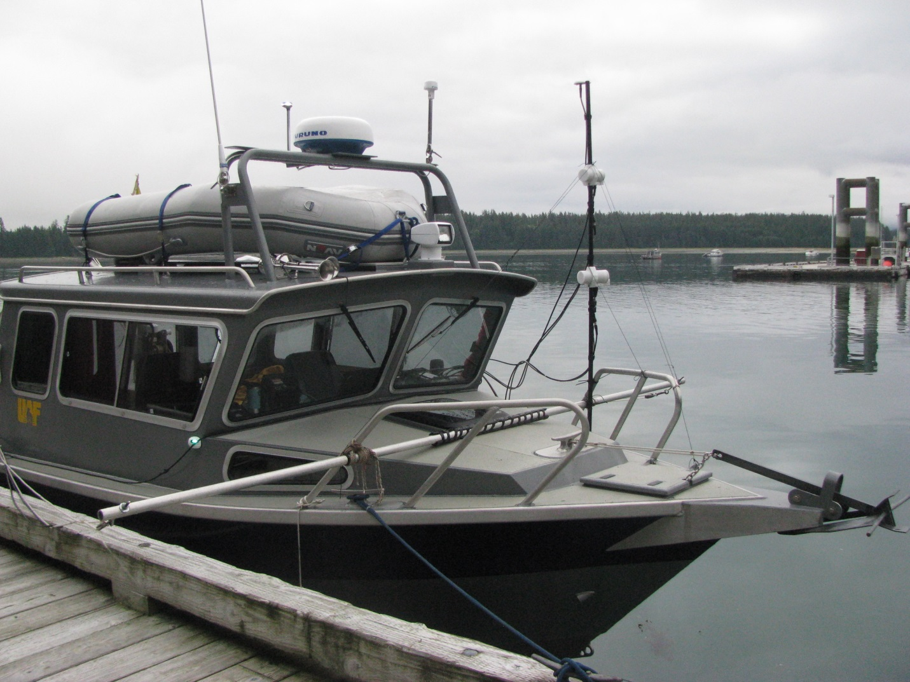

Figure 1-1. Configuration of magnetometer mounted to the bow of an aluminum vessel that conducted surveys in Glacier Bay National Park, Alaska. Horizontal bar for deploying hydrophones was also aluminum. Two vertically mounted sensors on the magnetometer detected magnetic field magnitude and gradients.



Figure 1-2. Temporal fluctuations in the magnetic field over the course of the study in Glacier Bay National Park, Alaska during 2013 and 2014. Measurements from the nearby Sitka Magnetic Observatory, Alaska (black line) indicate the effects of solar storms (spikes) and slow change in the main field (linear decline over time). Colored bars indicate times when magnetic data were collected for mapping (Trip 1 = orange, Trip 2 = red, Trip 3 = blue, Trip 4 = green, Trip 5 = purple, Trip 6 = yellow, and Trip 7 = gray).



Figure 1-3. Temporal fluctuation in the total magnetic field during survey Trip 3 in Glacier Bay National Park, Alaska. Total magnetic field measurements from a stationary Desert Star archival tag adjusted for temperature at 30 second intervals (black line) and simultaneous magnetic field measurements from the Sitka Magnetic Observatory (SMO) at one-minute intervals (yellow line). SMO values were adjusted by +1880 nT to match the tag baseline.

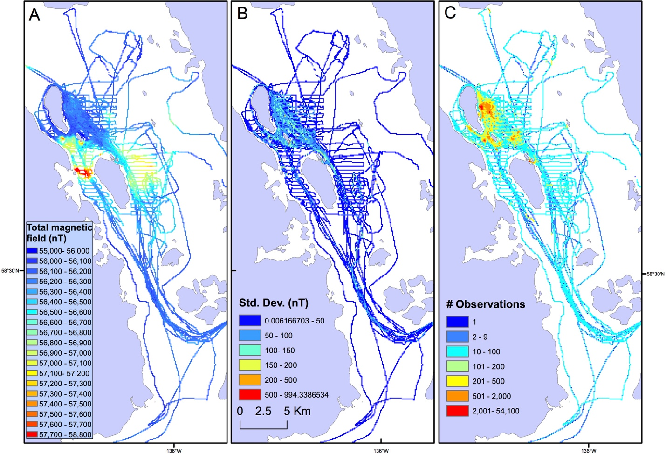

Figure 1-4. Magnetic field map data collected by vessel during seven surveys over the course of one year in Glacier Bay National Park, Alaska. Total magnetic field values (A) and standard deviation of aggregated values (B) for each 100 m grid cell. C) Observations were clustered in areas where tagged fish were being tracked with acoustic telemetry (the primary purpose of the surveys; Nielsen and Seitz 2017) with vessel transects conducted in regions adjacent to areas where tagged fish resided (i.e., grid cells with number of observations > 200).

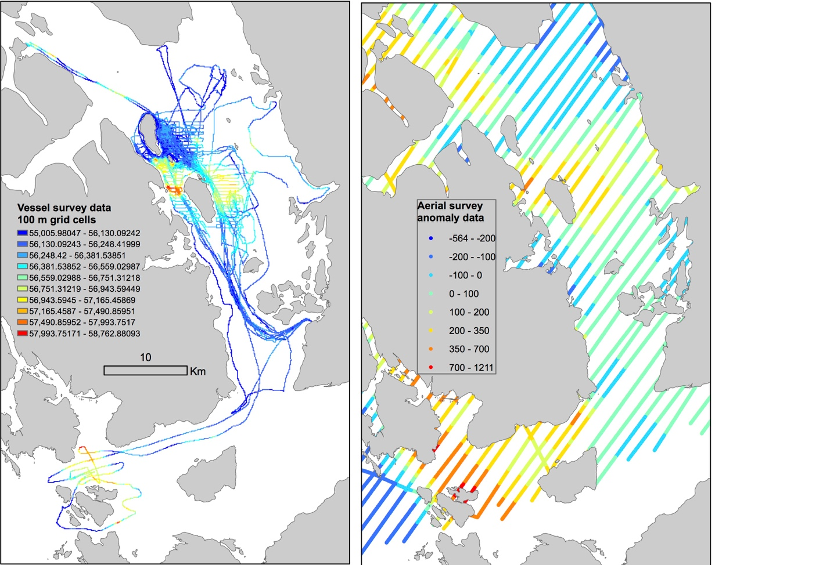

Figure 1-5. Vessel survey total magnetic field map (100 m resolution), left, and aerial survey magnetic anomaly observations for Glacier Bay National Park, Alaska (Brew et al., 1978; Connard et al., 1999), right.