Additional file 5: Comparison of the prevalence of frequent pathogenic mutations observed in our cohort against the TCGA data and a Japanese cohort study (19-21)

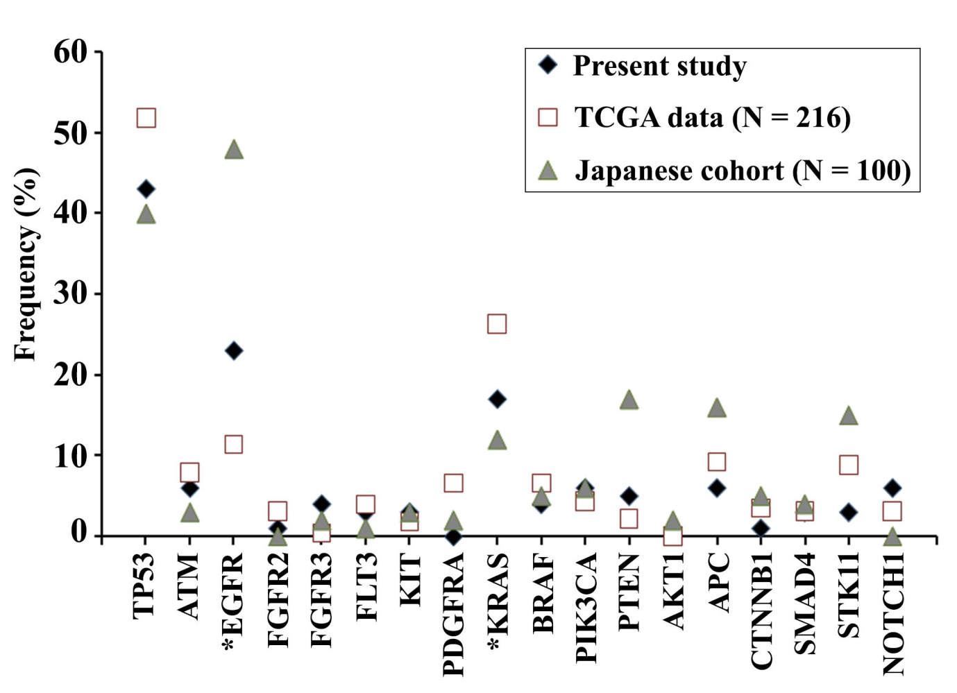
*Differ significantly

