Supplementary Material
Table S1. Parameters descriptors of the tree vegetation structure (DBH > 5 cm) sampled in the Véu de Noiva Forest Valley, located in the Chapada dos Guimarães National Park, Mato Grosso State, Brazil. NS= number of stems; BA = basal area, AGB = Above-ground biomass; M = mortality rate in stems; R = recruitment rate in stems; L = rate of loss in basal area; G = rate of gain in basal area and AIP = annual increment periodic.
Ano | Site | NS | BA | AGB | M | R | L | G | AIP
 |  | Stems.ha⁻¹ | m².ha⁻¹ | ton.ha⁻¹ | %.year⁻¹ | %.year⁻¹ | %.year⁻¹ | %.year⁻¹ | cm.year⁻¹
1996 | Fire | 1,547 | 19.014 | 93.66 |  | -
 | No Fire | 1,448 | 27.480 | 138.24
 | Total | 1,492 | 23.717 | 118.42
1999 | Fire | 1,604 | 19.637 | 100.71 | 3.28 | 3.31 | 1.78 | 2.65 | 0.165
 | No Fire | 1,395 | 27.403 | 144.47 | 4.36 | 4.25 | 2.17 | 2.13 | 0.162
 | Total | 1,487 | 23.951 | 125.02 | 3.86 | 3.80 | 2.15 | 2.41 | 0.164
2002 | Fire | 1,585 | 20.751 | 112.48 | 3.77 | 3.19 | 1.50 | 2.44 | 0.142
 | No Fire | 1,386 | 27.674 | 160.11 | 4.87 | 5.01 | 2.38 | 2.81 | 0.167
 | Total | 1,475 | 24.597 | 138.94 | 4.34 | 4.12 | 2.18 | 2.80 | 0.155
2006 | Fire | 1,418 | 21.169 | 119.08 | 4.82 | 3.23 | 4.48 | 4.43 | 0.274
 | No Fire | 1,440 | 28.433 | 175.81 | 3.23 | 4.06 | 2.40 | 3.71 | 0.268
 | Total | 1,430 | 25.205 | 150.60 | 4.57 | 3.75 | 3.37 | 4.15 | 0.271
2010 | Fire | 1,258 | 20.177 | 115.62 | 7.49 | 5.10 | 5.37 | 3.27 | 0.209
 | No Fire | 1,445 | 28.213 | 188.70 | 4.83 | 5.14 | 2.14 | 2.4 | 0.171
 | Total | 1,362 | 24.641 | 156.22 | 6.15 | 4.97 | 3.48 | 2.81 | 0.186
2016 | Fire | 1,237 | 18.655 | 102.16 | 6.35 | 7.00 | 4.98 | 3.73 | 0.234
 | No Fire | 1,388 | 27.194 | 168.43 | 5.69 | 4.97 | 3.21 | 2.46 | 0.180
 | Total | 1,321 | 23.399 | 138.97 | 6.19 | 5.58 | 4.15 | 3.06 | 0.201

Table S2. Statistical results of the Generalized Estimation Equation (GEE) for the dependent variables mortality rate (M) and recruitment (R) in relation to fire predictor variables and monitoring period. χ² Wald: Chi-quadrad of Wald, DF: Degrees of freedom.
 | M |  |  | R
 | χ² Wald | DF | p-value | χ² Wald | DF | p-value
(Intercept) | 172,498 | 1 | 0,000 | 88,435 | 1 | 0,000
Forest Fire | 11,584 | 1 | 0,001 | 0,182 | 1 | 0,670
Interval | 116,085 | 4 | 0,000 | 40,209 | 4 | 0,000
Forest Fire*Interval | 38,809 | 4 | 0,000 | 11,132 | 4 | 0,025

Tabela S3. Statistical results of the Generalized Estimation Equation (GEE) for the dependent variables Above-ground Biomass (AGB) and number of stems (NS) in relation to prediction variables forest fire (FF) and year of monitoring (Year).
 | AGB |  |  | NS
 | χ² Wald | DF | p-value | χ² Wald | DF | p-value
(Intercepto) | 103,960 | 1 | 0,000 | 8768,950 | 1 | 0,000
FF | 6,220 | 1 | 0,013 | 3,034 | 1 | 0,082
Year | 65,453 | 5 | 0,000 | 17,445 | 5 | 0,004
FF*Year | 8,215 | 5 | 0,145 | 20,627 | 5 | 0,001

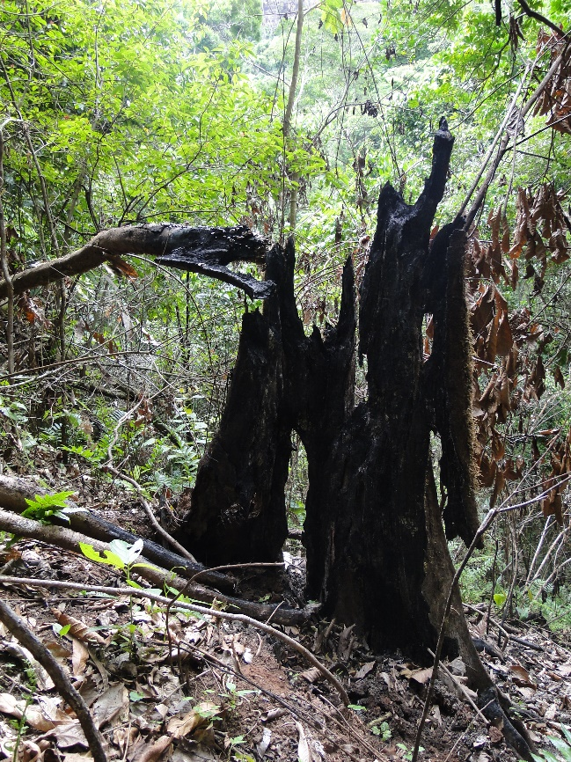 | 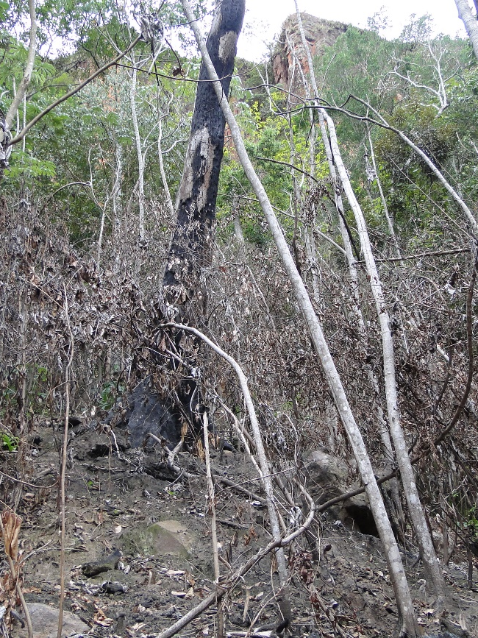
Figure S1: Evidence of the occurrence of the natural forest fire, registered in July 2010 in the Forest of Vale Véu de Noiva (FVVN) within the National Park of Chapada dos Guimarães, Brazil.

